NumPy –Notes
Array Creation & Attributes

1. What is NumPy?
NumPy (Numerical Python) is a Python library used for numerical calculations and scientific computing.
It provides a powerful data structure called an array (ndarray), which allows us to store and perform operations on large amounts of numerical data efficiently.
Example:
import numpy as np
arr = np.array([10, 20, 30, 40])
print(arr)
Output:
[10 20 30 40]
Here:
- import numpy imports the NumPy library.
- as np gives NumPy a short name (alias).
- np.array() creates a NumPy array.

2. Why Use NumPy?
NumPy is useful because:
- Fast calculations: Performs numerical operations efficiently.
- Less code: Allows operations on entire arrays without writing loops.
- Memory efficient: NumPy arrays generally use less memory than equivalent Python lists of numbers.
- Multidimensional arrays: Supports 1D, 2D, 3D and higher-dimensional arrays.
- Mathematical operations: Provides functions for statistics, algebra and scientific calculations.
- Data science: Widely used in Machine Learning, Data Analysis and AI.
Example:
Python list:
a = [10, 20, 30]
b = [1, 2, 3]
result = []
for i in range(len(a)):
result.append(a[i] + b[i])
print(result)
Output:
[11, 22, 33]
NumPy array:
import numpy as np
a = np.array([10, 20, 30])
b = np.array([1, 2, 3])
print(a + b)
Output:
[11 22 33]
NumPy performs element-wise addition directly.

3. Python Lists vs NumPy Arrays
Feature | Python List | NumPy Array
Data types | Can contain mixed types | Usually one common dtype
Speed | Generally slower for numerical operations | Generally faster
Memory | Generally uses more memory | Generally more memory efficient
Mathematical operations | Often require loops | Supports vectorized operations
Multidimensional data | Nested lists | Native multidimensional arrays
Library | Built into Python | Requires NumPy
Example:
import numpy as np
# Python list
my_list = [1, 2, 3]
# NumPy array
my_array = np.array([1, 2, 3])
print(my_list * 2)
print(my_array * 2)
Output:
[1, 2, 3, 1, 2, 3]
[2 4 6]
Important: Multiplying a Python list by 2 repeats the list, whereas multiplying a NumPy array by 2 multiplies each element by 2.

4. Installing and Importing NumPy

Installation
Open your terminal or command prompt:
pip install numpy

Importing
import numpy as np
Check the installed version:
print(np.__version__)

5. NumPy Arrays

What is an Array?
An array is a collection of elements stored in a structured format.
NumPy supports different dimensions of arrays.

A. 1D Array (One-Dimensional)
A 1D array contains elements in a single row-like sequence.
import numpy as np
arr = np.array([10, 20, 30, 40])
print(arr)
Output:
[10 20 30 40]
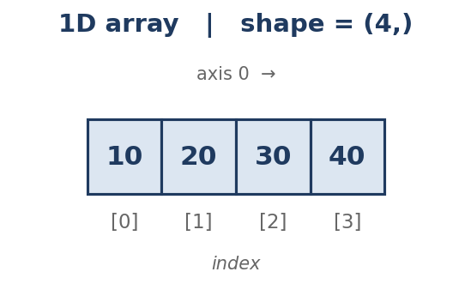

B. 2D Array (Two-Dimensional)
A 2D array contains rows and columns, similar to a matrix or table.
arr = np.array([
[10, 20, 30],
[40, 50, 60]
])
print(arr)
Output:
[[10 20 30]
[40 50 60]]
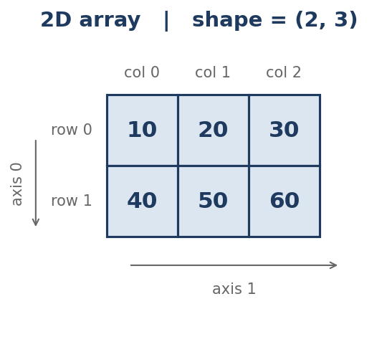

C. 3D Array (Three-Dimensional)
A 3D array is a collection of 2D arrays (matrices).
arr = np.array([
[[1, 2], [3, 4]],
[[5, 6], [7, 8]]
])
print(arr)
Output:
[[[1 2]
[3 4]]
[[5 6]
[7 8]]]
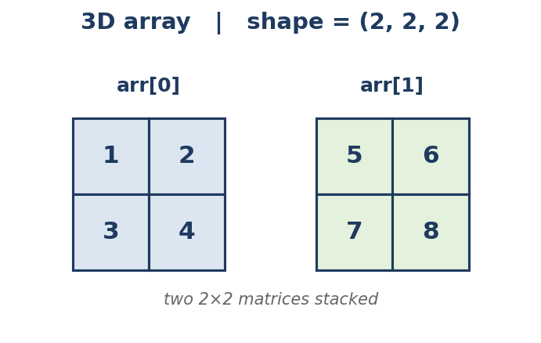

Difference Between 1D, 2D and 3D
Dimension | Structure | Example shape
1D | Single sequence | (4,)
2D | Rows and columns | (2, 3)
3D | Collection of matrices | (2, 2, 2)

6. Array Data Types (dtype)
Every NumPy array has a data type that determines the type of values it stores.
NumPy supports different data types:
Data type | Meaning | Example
int32 | 32-bit integer | 10
int64 | 64-bit integer | 100
float32 | 32-bit decimal | 10.5
float64 | 64-bit decimal | 20.75
bool | Boolean | True
complex128 | Complex number | 2+3j
str_ | String | "Hello"

Checking dtype
import numpy as np
arr = np.array([10, 20, 30])
print(arr.dtype)
Output (commonly):
int64
The exact integer type can depend on your system.

Specifying dtype
arr = np.array([1, 2, 3], dtype=float)
print(arr)
print(arr.dtype)
Output:
[1. 2. 3.]
float64

Changing Data Type
Use astype() to convert an array into another data type.
arr = np.array([1.5, 2.5, 3.5])
new_arr = arr.astype(int)
print(new_arr)
Output:
[1 2 3]
Note: Converting floats to integers removes the decimal part; it does not round the numbers.

7. Array Creation Functions
These are the most important NumPy functions for creating arrays.

A. np.array()
Creates an array from a list or another sequence.
arr = np.array([10, 20, 30, 40])
print(arr)
Output:
[10 20 30 40]
2D example:
arr = np.array([[1, 2], [3, 4]])
print(arr)

B. np.zeros()
Creates an array filled with zeros.
Syntax:
np.zeros(shape)
Example:
arr = np.zeros((3, 3))
print(arr)
Output:
[[0. 0. 0.]
[0. 0. 0.]
[0. 0. 0.]]
Here (3, 3) means 3 rows and 3 columns.

C. np.ones()
Creates an array filled with ones.
arr = np.ones((2, 4))
print(arr)
Output:
[[1. 1. 1. 1.]
[1. 1. 1. 1.]]

D. np.arange()
Creates an array containing evenly spaced values within a given interval.
Syntax:
np.arange(start, stop, step)
- start: Starting value (included).
- stop: Ending value (excluded).
- step: Difference between consecutive values.
Example:
arr = np.arange(1, 11)
print(arr)
Output:
[ 1 2 3 4 5 6 7 8 9 10]
With step:
arr = np.arange(2, 11, 2)
print(arr)
Output:
[ 2 4 6 8 10]

E. np.linspace()
Creates a specified number of equally spaced values between two endpoints.
Syntax:
np.linspace(start, stop, num)
Example:
arr = np.linspace(1, 10, 5)
print(arr)
Output:
[ 1. 3.25 5.5 7.75 10. ]
Here:
- Start = 1
- Stop = 10
- Number of values = 5
Difference between arange() and linspace():
arange() | linspace()
Specifies step size | Specifies number of values
Stop is excluded | Stop is included by default
Example: arange(1, 10, 2) | Example: linspace(1, 10, 5)

F. np.eye()
Creates an identity matrix.
An identity matrix contains:
- 1 on the main diagonal.
- 0 everywhere else.
arr = np.eye(3)
print(arr)
Output:
[[1. 0. 0.]
[0. 1. 0.]
[0. 0. 1.]]

G. np.full()
Creates an array filled with a specified constant value.
Syntax:
np.full(shape, fill_value)
Example:
arr = np.full((2, 3), 7)
print(arr)
Output:
[[7 7 7]
[7 7 7]]

Summary of Array Creation Functions
Function | Purpose | Example
np.array() | Create array | np.array([1,2,3])
np.zeros() | Fill with zeros | np.zeros((2,3))
np.ones() | Fill with ones | np.ones((2,3))
np.arange() | Generate range | np.arange(1,10)
np.linspace() | Equally spaced values | np.linspace(1,10,5)
np.eye() | Identity matrix | np.eye(3)
np.full() | Fill with constant | np.full((2,3),5)

8. NumPy Array Attributes
Attributes provide information about an array.
Consider this array:
import numpy as np
arr = np.array([
[10, 20, 30],
[40, 50, 60]
])
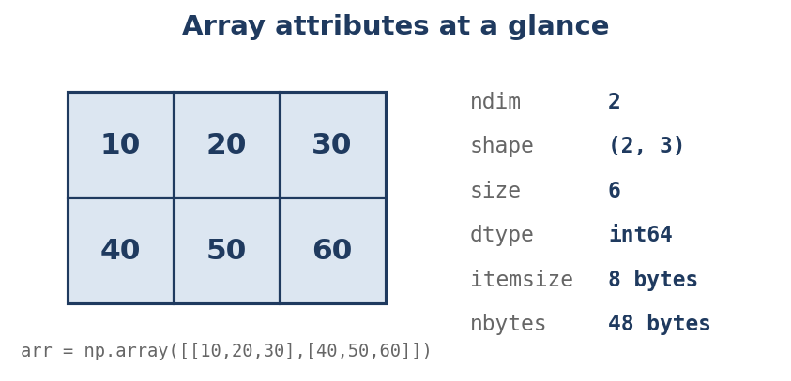

A. ndim
Returns the number of dimensions of an array.
print(arr.ndim)
Output:
2
Because the array is 2-dimensional.

B. shape
Returns the number of elements along each dimension.
print(arr.shape)
Output:
(2, 3)
Meaning:
- 2 rows.
- 3 columns.
For a 1D array of 4 elements, shape is (4,).

C. size
Returns the total number of elements.
print(arr.size)
Output:
6
Because there are 2 × 3 = 6 elements.

D. dtype
Returns the data type of the elements.
print(arr.dtype)
Output (commonly):
int64

E. itemsize
Returns the memory occupied by each individual array element, in bytes.
print(arr.itemsize)
Output for an int64 array:
8
Because 64 bits = 8 bytes.

F. nbytes
Returns the total memory occupied by the array elements, in bytes.
print(arr.nbytes)
Output for this int64 array:
48
Because:
6 elements × 8 bytes = 48 bytes.

Summary of Array Attributes
Attribute | Meaning | Example output
ndim | Number of dimensions | 2
shape | Size of each dimension | (2, 3)
size | Total number of elements | 6
dtype | Data type | int64
itemsize | Bytes per element | 8
nbytes | Total element memory | 48

9. Complete Practical Example
import numpy as np
# Creating a 2D array
arr = np.array([
[10, 20, 30],
[40, 50, 60]
])
# Printing array
print("Array:")
print(arr)
# Attributes
print("Dimensions:", arr.ndim)
print("Shape:", arr.shape)
print("Size:", arr.size)
print("Data Type:", arr.dtype)
print("Item Size:", arr.itemsize)
print("Total Bytes:", arr.nbytes)
# Array creation
a = np.zeros((3, 3))
b = np.ones((2, 4))
c = np.arange(1, 11)
d = np.linspace(1, 10, 5)
e = np.eye(3)
f = np.full((2, 3), 7)
print(a)
print(b)
print(c)
print(d)
print(e)
print(f)

10. Assignment

Array creation exercises
- ☐ Create a 1D array containing numbers from 1 to 10.
- ☐ Create a 2D array with 3 rows and 3 columns.
- ☐ Create a 3D array containing two 2×2 matrices.
- ☐ Create an array of 5 zeros.
- ☐ Create an array of 10 ones.
- ☐ Create an array from 10 to 50 with a step of 5.
- ☐ Create 10 equally spaced values between 0 and 100.
- ☐ Create a 4×4 identity matrix.
- ☐ Create a 3×3 array filled with the number 9.
- ☐ Create an array containing integers and explicitly specify its dtype as float.

Important Interview Questions
- What is NumPy?
- Why is NumPy faster than Python lists for numerical operations?
- What is an ndarray?
- What is the difference between 1D, 2D and 3D arrays?
- What is the difference between arange() and linspace()?
- What is the difference between zeros() and ones()?
- What is an identity matrix?
- What is the difference between ndim, shape and size?
- What is the difference between itemsize and nbytes?
- How can you change the data type of an array?

