1. Find “application/views/admin/includes/header.php”

* This hook to show the Check-in/Checkout Icon on the Header menu when using a Mobile device
* Line 93 add new Code like the picture

Code:

<?php hooks()->do_action('admin_navbar_start'); ?>

* Line 114 add new code

Code:

<?php hooks()->do_action('admin_navbar_end'); ?>

* Image

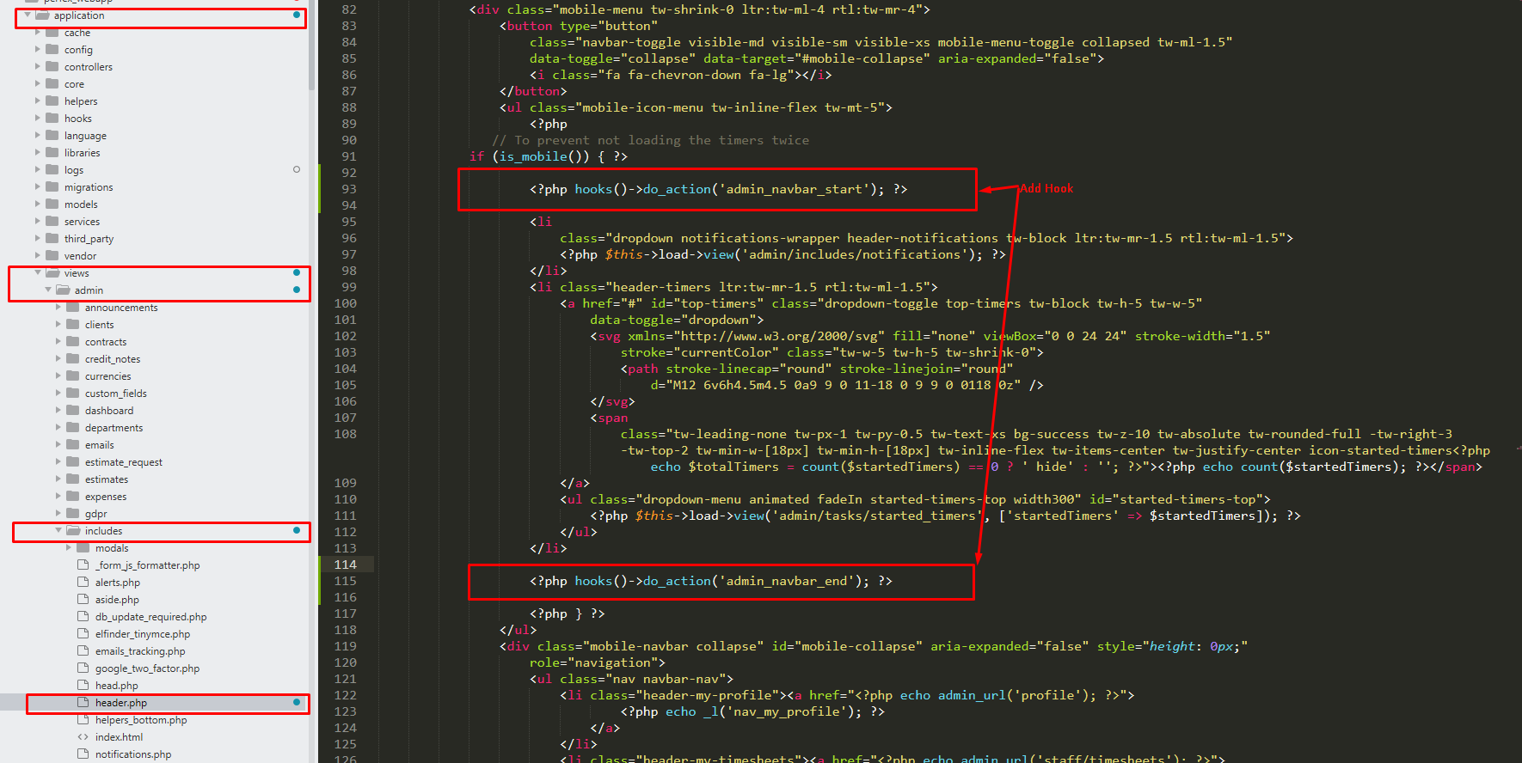

1. Update date config for call API

* Find “application/config/config.php”
* Line 488 update code like below
* Code

$config['csrf_exclude_uris'] = ['forms/wtl/[0-9a-z]+', 'forms/ticket', 'forms/quote/[0-9a-z]+', 'admin/tasks/timer_tracking', 'api\/.+', 'timesheets/api\/.+'];

* Image

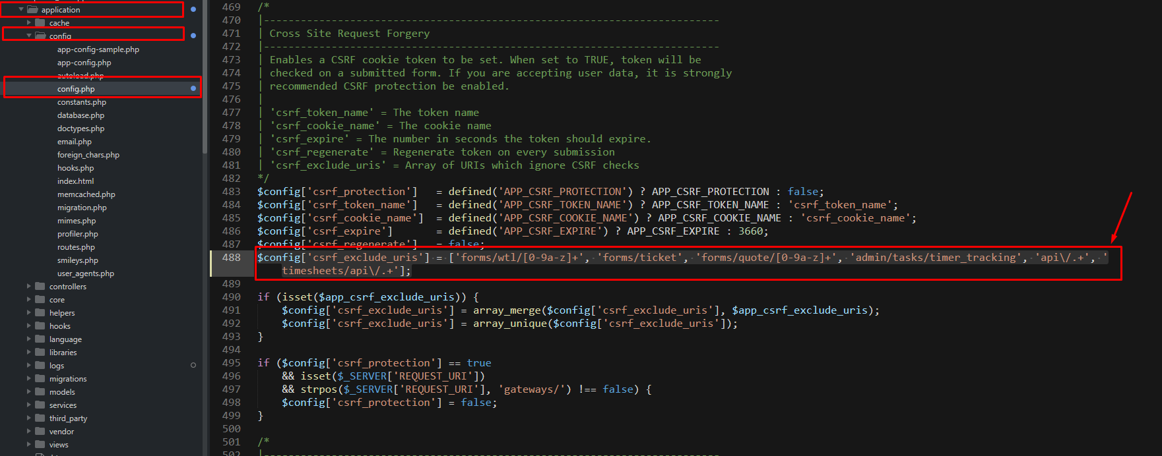

1. Change file Session_driver.php

Find file “system/libraries/Session/Session_driver.php”

*if your server uses PHP8.1 or later, you need to change below (because this function is not compatible with PHP 8.1 and above)*

*Change NULL to ‘’ ( like the image)*

*After Changed*

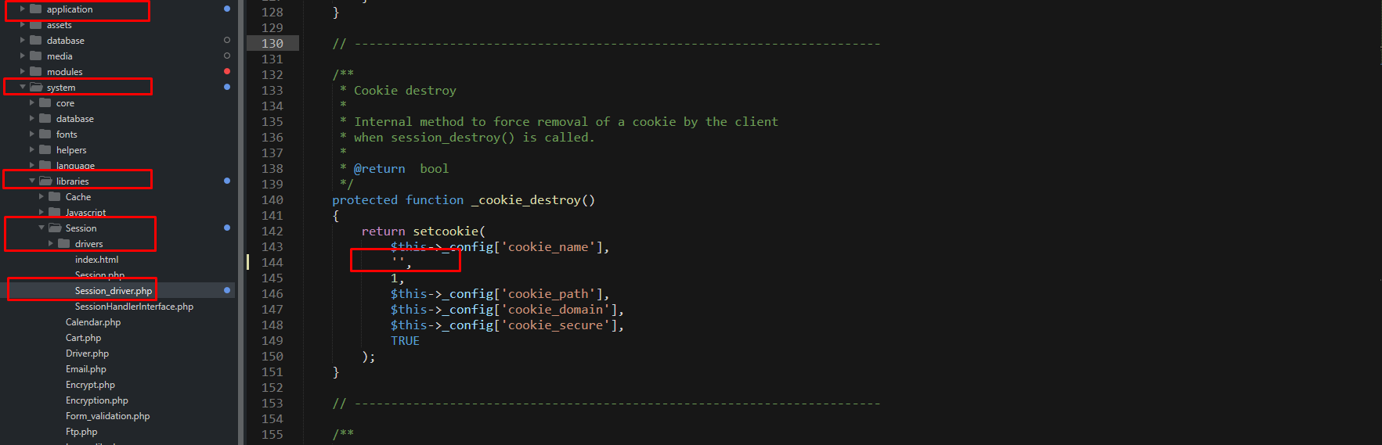

Before change

