**Title of project**



Your name

C4 IN IT

## Title of project

Project presented to the faculty of “Centre for Information Technology Management”, Republic of Maldives in partial fulfillment of the requirements for the Certificate 4 in Information Technology.

By:

Student Name:

Lecturer Name:

C4 IN IT

**Certificate of Approval**



Building Your Career.

Professionally!

I admire that this project **Title of project** is a genuine project work done by **your name** who did this project under my control.

Submitted to the **VIVA-Voice** examination held on: ______________.

Name of the course coordinator Signature of the course coordinator

…………………………………. ...…………………………………

Name of the Internal Examiner Signature of the Internal Examiner

………………………………… …………………………………….

Name of the external examiner Signature of the external examiner

………………………………… ……………………………………

**Acknowledgement**



**ACKNOWLEDGEMENT**

I would like to thank **Mr. Mohamed Tholaal,** chairman of Center for information Technology Management for giving a beautiful chance to learn about various things and to show our talents.

I also wish to thank **Mr. Ravikumar P,** IT lecturer for the help and support towards the completion of this mini project.

Last but not least I would like to thank my family and friends for lending a hand for me to complete this project successfully.

**Content**

|  |  |  |
| --- | --- | --- |
| No | Details | Page No |
| 1 | Introduction | 5 |
| 2 | About Title of project | 6 |
| 3 | HTML | 7 |
| 4 | Lists | 10 |
| 5 | Tables | 11 |
| 6 | Frames | 13 |
| 7 | Website Features | 14 |
| 8 | Conclusion | 69 |

**Introduction**

Restaurant Management System is a very useful website for managing the Services and Customer Requests which is our selected domain of implementation for the project. To do it more effectively and correctly a better Restaurant Management Systemis required. This is provided by our website. Our website helps to manage the Services and Customer Request details. Restaurant management system is a large website which can be used for Restaurants daily work. It is configurable and can be configuring to meet most individual needs. We have included Our Blogs, Menus, Contact procedures, Caterings, photo gallery etc….

**About Spicy Bite Restaurant**

Spicy Bite is an authentic and Spicy Maldivian Restaurant, opened in 2015 and was a result of a passion for food. Our Aim is to fill your dining table with the most delicious and aromatic foods. Everything we offer is meticulously prepared from the finest, natural and locally sourced ingredients. We think of our customers as our extended family deserving the unsurpassed care. Making Our customers happy with memorable and delicious food is what matters with us...



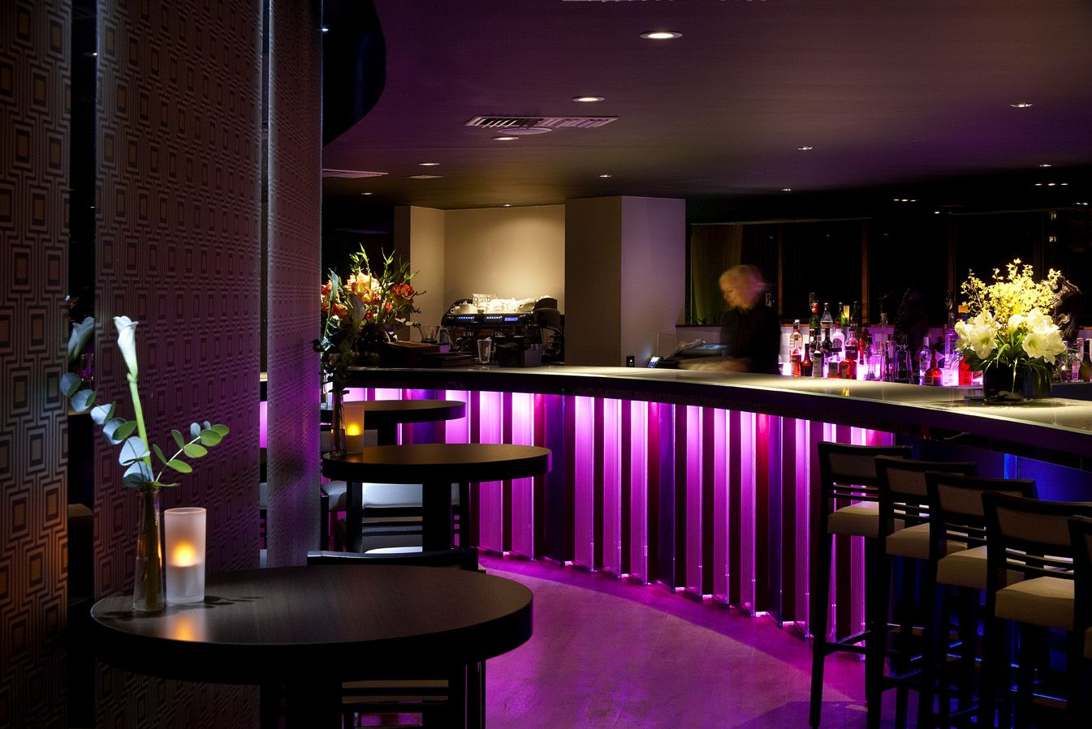

**HTML**

HTML which stands for **Hypertext Markup Language,** The **.html** extension is what turns a regular text file into an HTML file. It only needs to be added at the time you create the file, once it's made simply save the file each time you edit the code. Save your file in a folder where you can easily find it. The saved code can be opened and edited from within the text editor (make sure that "All Files" is selected from the drop down menu in the editor's dialog box). To open the webpage in your browser simply go to the folder in which it is saved and click on the webpage icon. The file name for the main web page of any website must be **index.html** All other pages within a site can be given any name you like.

**ATTRIBUTES**

We can change the way tags display things on web pages by putting what’s called an "attribute" into an opening tag. Many of the things that were done with attributes are now done with CSS, so this lesson will show you how to put CSS code into tags by the use of the style attribute:

<h1 style="text-align: center;">My Webpage</h1>

The style attribute’s job is to hold CSS code, that’s the stuff in the quotation marks. In the above example it's telling the h1 tag to center the text on the web page. Notice that there is a colon between text-

-align and center and at the end of center there is a semi colon. This is how CSS commands are structured.

The text in our example can further be changed by adding another CSS command to the style attribute:

<h1 style="text-align: center; color: red;">My Webpage</h1>

The result would be red text centered on the web page. An unlimited amount of CSS commands can be added to the style attribute as long as they are enclosed between the quotation marks and each command ends with a semi colon.

The style attribute can be put in any opening tag to change some aspect of the tag, for instance when used with the body tag, all the text on a web page can be displayed in a different font:

<body style="font-family: arial;">

Making a website is not complete without adding graphics to make it look nice and pretty. Placing a picture on a web page is done with the img tag. The imgtag is a single tag so does not require a closing tag:

<img src="filename.jpg">

The img stands for "image", src is an attribute, it tells the browser where to find the picture. The stuff in the quotation marks is the file name of the graphic, replace filename.jpg with the file name of your picture and be sure it’s between the quotes.

The file name of the picture must also include its format, e.g. jpg as in the above example. More on image format later in this lesson.

To keep things simple, for now store your pictures in the same place as your web pages, for example if you keep your HTML files in a folder called "my pages", put your pictures there too.

Every picture on a web page has its very own img tag:

<img src="button.gif">  
<img src="button2.gif">

That will put two pictures side by side on the page:

 If an img tag is enclosed between the opening and closing p tags, the other image will start on a new line:

<p><img src="button.gif"></p>  
<img src="button2.gif">

**LISTS**

There may come a time when you would like to add a list to a web page, or maybe not, but just in case here is how to make a list. A list starts and ends with the *"unordered"* list tags:

<ul></ul>

The ul stands for *“unordered list”*, it will get you bulleted text, you know, a dot beside the text. The opening ul tag starts the list and the closing ul tag ends the list, in between goes the text surrounded by the opening and closing *"list item"* tag:

**TABLES**

We’re talking here tables for holding data not the dinner table. Tables are useful in laying out the design of web pages so it’s well worth the time to learn how to make them. A table starts and ends with the table tag:

<table></table>

Between the opening and closing table tags go a couple of other tags, the tr tag:

<tr></tr>

It stands for *“table row”* and will make up one row across the table. Between the trtags are found the td tags:

<td></td>

The td stands for *“table data”* it forms one box called a *“cell”* which contains content seen on the web page such as text or graphics. Here’s how the table code is put together:

<table border="1">   
  
<tr>   
<td>Beagle</td>   
<td>Chihuahua</td>   
</tr> 

<tr>   
<td>Terrier</td>   
<td>Collie</td>   
</tr>   
  
</table>

Putting a border attribute in the table tag will help you see how the table and cells are formed, setting the border attribute to "0" will remove the borders altogether.

**FRAMES**

A web page with frames is actually made up of several pages put together into one. This page for example is made of three pages: One for the top, another for the main section, and a third one which brings them together.

You can see that this page has two frames, the top frame containing the page with the title, and the bottom frame containing the page with the sidebar and main content. Webpages within the frames are written just like any other html file but the page which brings them together has it's own set of html tags. Here's how the code looks for this page:

<html>

<head>  
<title>frames</title>  
<head>  
  
<frameset rows="30%,70%">  
<frame src="title.html">  
<frame src="main.html">  
</frameset>  
  
</html>

* Notice that the html file starts out just like any other web page except there are no body tags. In their place are the **opening** and **closing** frameset tags

**Screenshot and coding**

**CONCLUSION**

 The Restaurant management website project is specially created for helping Restaurant. Developing such a computerization system is to reduce the paper work. The efficiency and decreasing the work load. This is very useful project for future. Because always writing with hands and doing all the calculations are not easy for anyone. Our website helps to manage the service and details of our restaurant. This is totally a different experience in my life. I got a lot of information about Hypertext Markup Language.

Name : Aishath Ibrahim

Name of the project : Restaurant Website

Date of submission : 8th November 2018

Total marks : 100 marks

Total no. of pages : 70

To be included in the project:

* Front page (Project title, Project addressable, Students Name)
* Certificate Approval.
* Acknowledgement
* Contents
* Introduction
* Body (Project Contact/ related pictures)

|  |  |  |
| --- | --- | --- |
| **Project Mark Details** | | |
| Topics | Maximum Marks | Allotted Marks |
| Class Performance | 10 |  |
| Project Analysis |
| Documentation | 30 |  |
| Project Implementation | 40 |  |
| ViVa | 20 |  |