1. Overview:

A movie showtime finder, a web app with email message notifications is built under the scope of this project. It notifies the application’s user, by email, about showtimes for potentially interesting movies playing at user’s nearby cinema. The concept of an 'interesting movie' is derived using machine learning recommendation algorithm in this web application.

1. Functional design:
   1. User signup:

Potential user can visit the web application on his/her preferred internet browser. User can create account with the application by click on the Register link on the application landing page.

Required information for registering with the application are as follows:

1. Username
2. Password
3. E-mail id
4. Phone no.
5. Address {Line1, Line2, City, State, Zip code}

**E-mail verification:** Once the registration form is submitted, the application will send an e-mail to the user’s e-mail id for e-mail verification. The email contains a link that is required to be clicked by the user for completing the verification.

Once e-mail id is verified and uniqueness of the username is ensured, the user account is created in the application i.e. the user record is created in Database (table name: XXMSF_USER_DTL_TBL).

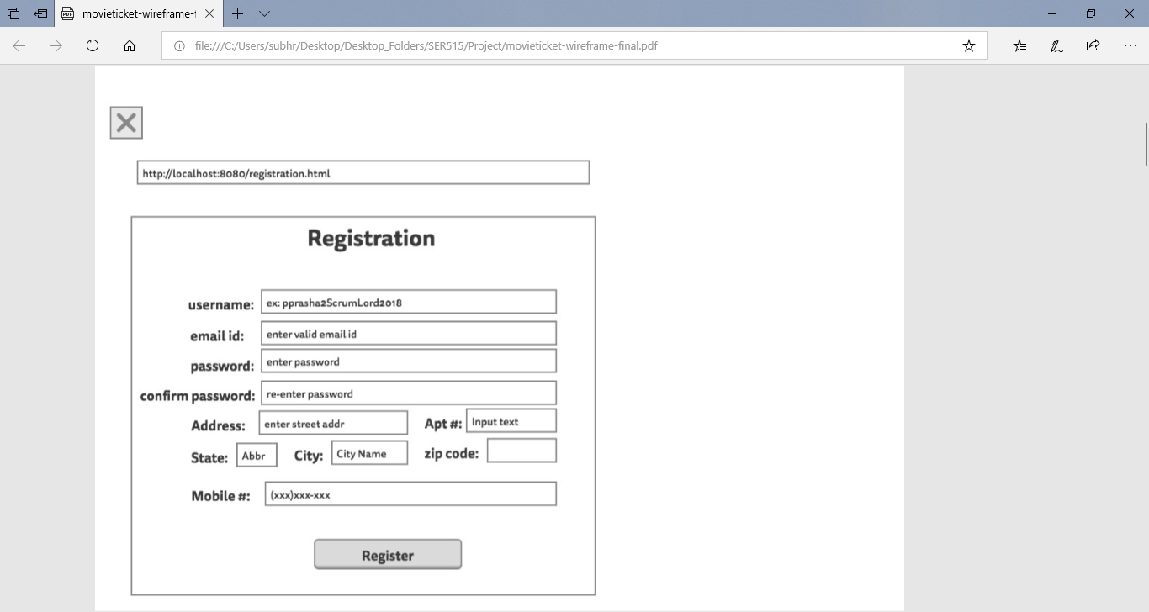

Fig1: Proposed screenshot for Registration/Signup page

* 1. User login:

Registered users can access the application’s complete functionality by signing in to the application through login link on the landing page. During sign in process, the user must authenticate him/herself by entering his/her username and password on the login screen. On first time login, the application captures for user’s likings and interests in terms of movie genre, actor preferences, example of favorite movies etc. Relevant information is stored in application’s database (Table name: XXMSF_USER_PREFS_TBL).

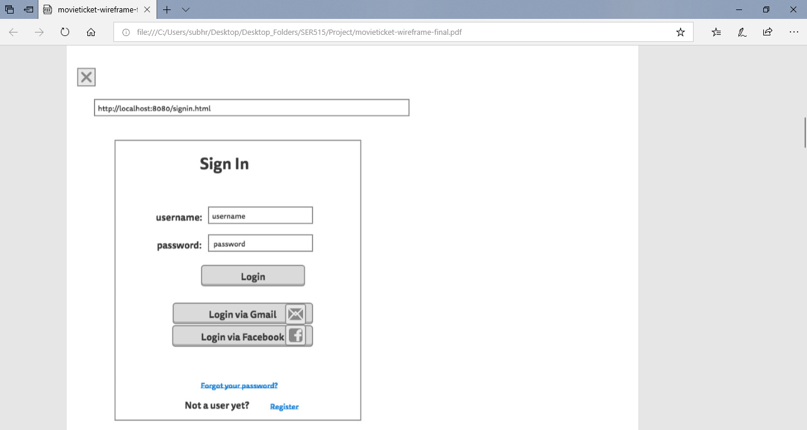

Fig2: Proposed screen for Login page

* 1. Show/Edit User Profile:

The user can view and edit his/her personal information on the ‘User Profile’ page. The user can access the User Profile page by clicking on the profile button (top right corner) on the home page.

All personal details entered by the user during sign up are displayed. The user can edit any of the personal details except the username.

If the user chooses to edit the e-mail id, the application performs the e-mail verification process again, as described in User Signup section, for the new e-mail id.

* 1. Movie Recommendation:

There are two ways the web application recommends movies that are running in the theatre.

* + 1. The application tracks the movie preferences entered by the user during 1st login. Alongside, the user’s online activity/selection pattern on the Movie Showtime Finder application is analyzed. Based on the analysis, the application’s recommendation engine looks through the recent releases (with IMDB rating 7 or higher) that are presently running in cinema near user’s location (zip code). The it sends e-mail notification to the user about the movie and its showtimes in nearby cinema.
    2. The user can see the movie suggestions on the home page of his/her account as well. In the suggestion listing on homepage, application displays the movie synopsis, poster, trailer and ticket booking URLs for each suggested movie running in nearby cinema.

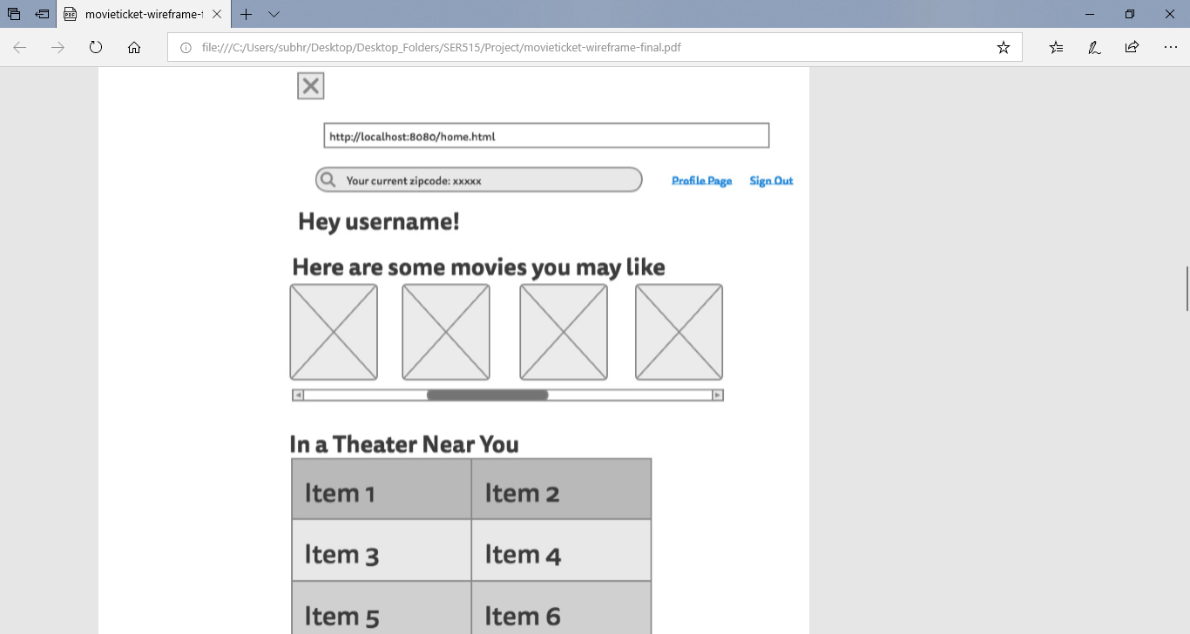

Fig3: Proposed home page for registered user

* 1. Suggestion Search for new Zip code:

The user may want to get suggestions for a new location. The user must search with the zip code (different from the address in personal details) on the home page search bar. With the help of its recommendation engine, the application displays the list of suggested movies presently running near the zip code entered by the user.

1. Sequence Diagram:

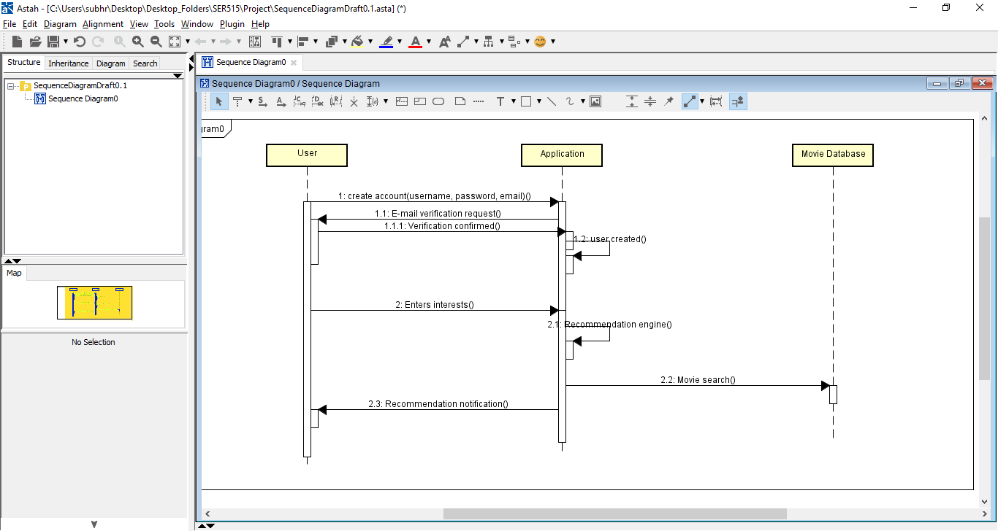

1. Activity Diagram:

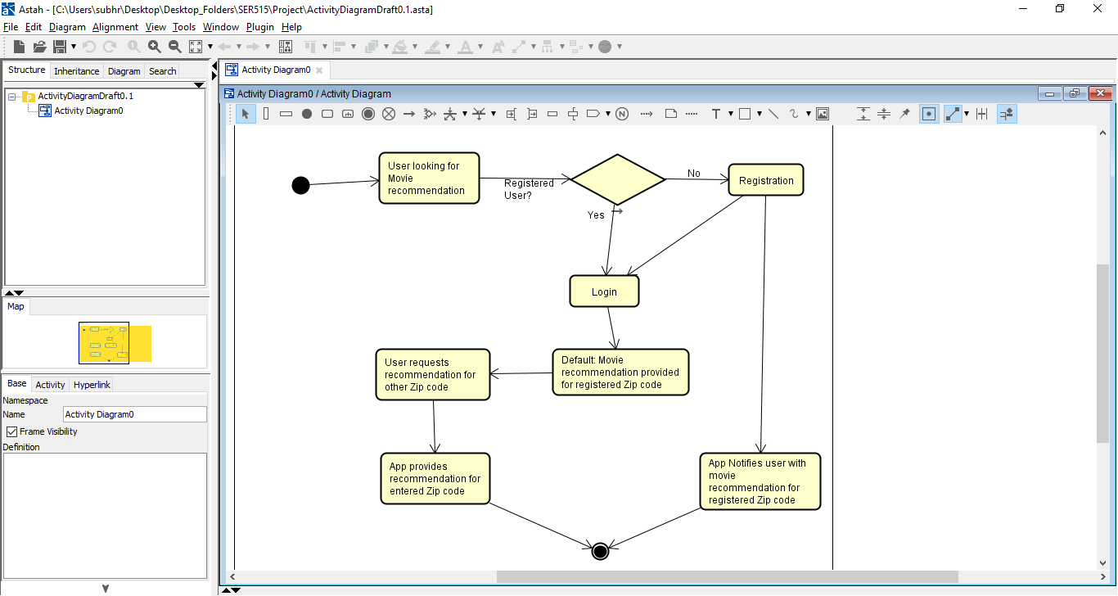

1. Open Issues: