|  |  |  |  |  |
| --- | --- | --- | --- | --- |
| **Exp.No.** | **03** | **Linux Commands** | **Year/Sem** | II/4th |
| **Date** | 26/04/2025 | **Branch** | AI&ML |

**Aim:**

The aim of this experiment is to explore and practice basic Linux commands for file management, system navigation, and process control. It aims to develop proficiency in using the Linux command-line interface (CLI) for effective system management.

## Linux:

Linux is an open-source operating system, with the kernel acting as its core, facilitating communication between hardware and software. The main advantage of Linux is that programmers can modify and use the Linux kernel to create custom operating systems tailored to specific needs.

**Linux Commands:**

All basic and advanced tasks can be done by executing commands. The commands are executed on Linux terminal. Linux commands are case sensitive.

## Commands:

1. **ls command :** The ls command is used to display a list of content of a directory.

**Syntax : ls**

**Output :**

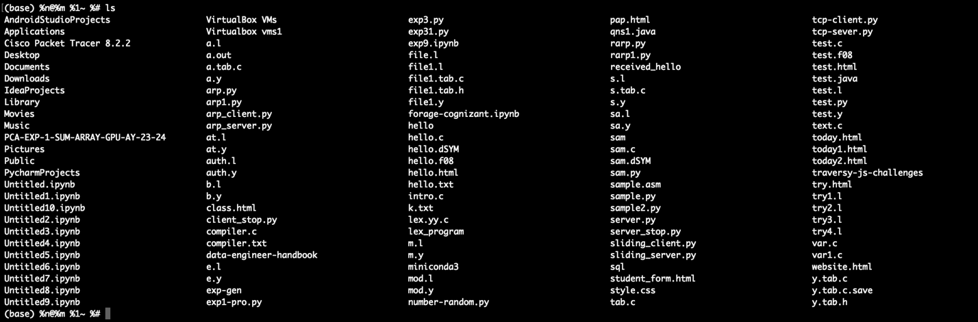

1. **pwd command :** The pwd command is used to display the location of the current working directory.

**Syntax :** pwd

**Output :**

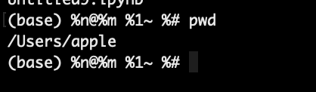

1. **mkdir command :** The mkdir command is used to create a new directory under any directory.

**Syntax : mkdir <directory name>**

**Output :**

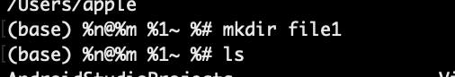

1. **rmdir command :** The rmdir command is used to delete a directory.

**Syntax : rmdir <directory name>**

**Output:**

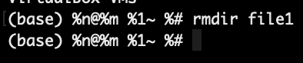

1. **cd Command :** The cd command is used to change directory.

**Syntax : cd <directory name>**

**Output :**

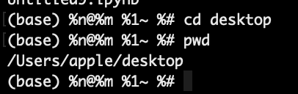

1. **cat command :** The cat command is a multi-purpose utility in the Linux system. It can be used to create a file, display content of the file, copy the content of one file to another file, and more.

**Syntax : cat [option][file]**

**Output :**

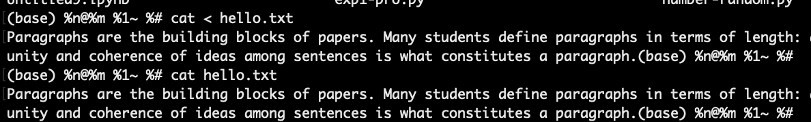

1. **Cp command :** The cp command used to copy file or directory from one to another.

**Syntax : cp <source file><Destination file>**

**Output :**

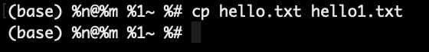

1. **Gedit command :** The gedit is a general-purpose text editor. . It can be used to create and edit all kinds of text files.

**Syntax : gedit <file_name>**

**Output :**

1. **Su command :** The su command provides administrative access to another user. In other words, it allows access of the Linux shell to another user.

**Syntax :** **su <user name>**

**Output :**

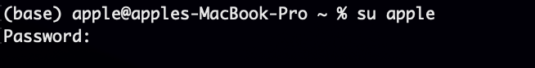

1. **Mv command :** The mv command is used to move a file or a directory form one location to another location.

**Syntax : mv <file name><directory>**

**Output :**

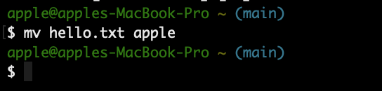

1. **Rename command :** The rename command is used to rename files. It is useful for renaming a large group of files.

**Syntax : rename 's/old-name/new-name/' files**

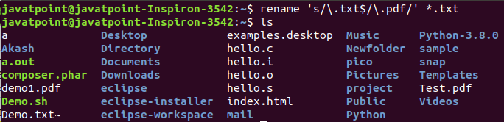**Output :**

1. **Head Command :** The head command is used to display the content of a file. It displays the first 10 lines of a file.

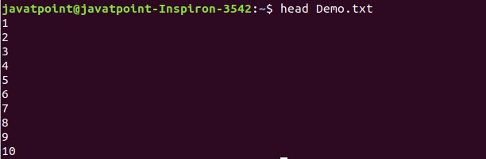 **Syntax:** head **<file** name**>**

1. **Tail Command :**The tail command is similar to the head command. The difference between both commands is that it displays the last ten lines of the file content. It is useful for reading the error message.

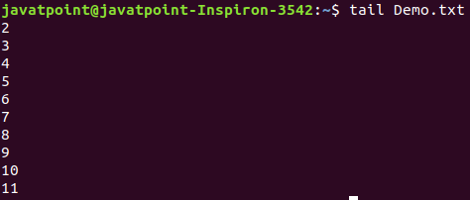**Syntax:** tail **<file** name**>**

1. **Id command :** The id command is used to display the user ID (UID) and group ID (GID).

## Syntax: id



1. **grep Command :** The grep is the most powerful and used filter in a Linux system. The 'grep' stands for "**global regular expression print**." It is useful for searching the content from a file. Generally, it is used with the pipe.

**Syntax:** command | grep **<search word>**



1. **tr Command :**The tr command is used to translate the file content like from lower case to upper case.

**Syntax:** command | tr **<**'old'**> <**'new'**>**

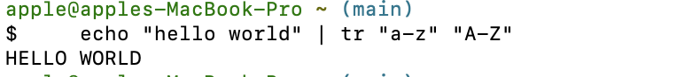

## chmod Command : The chmod command is used to change the access mode of a file (i.e., read, write or execute)

**Syntax:** chmod<options><permissions><file_name>



## tar Command

The tar command is used for creating Archieve and extracting the archieve files.

**Syntax:** tar[options][archieve-file] [file to be archieved]



## chown Command : The chown command is used to change ownership.

**Syntax:** chown owner_name file_name

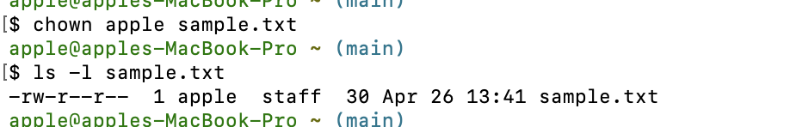

## make Command : The make command is used for building and maintaining group of program.

**Syntax:** make [-f makefile][options]…….[targets]….

## ifconfig Command : The ifconfig command is used to configure kernel-resident network interface.

**Syntax:** ifconfig[options][interface]

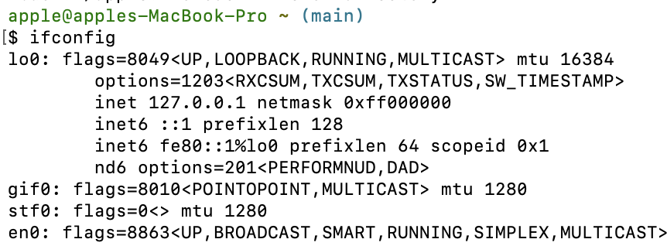

1. **host Command**

The host command is used to display the IP address for a given domain name and vice versa. It performs the DNS lookups for the DNS Query.

**Syntax:** host **<domain** name**>** or **<ip** address**>**

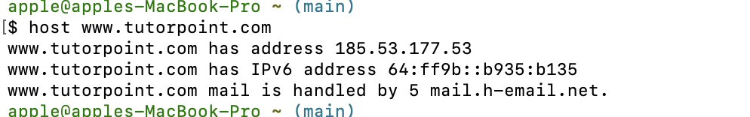

1. **gzip Command :** The gzip command is used to truncate the file size. It is a compressing tool. It replaces the original file by the compressed file having '.gz' extension.

## Syntax: gzip <file1> <file2> <file3>..

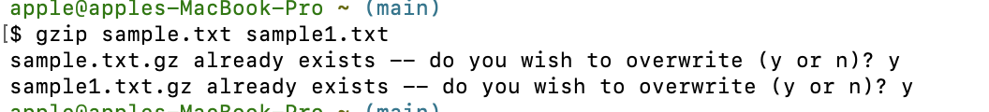

1. **sort Command :** The sort command is used to sort files in alphabetical order.

**Syntax:**sort **<file** name**>**

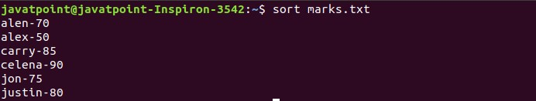

1. **Cal Command :** The cal command is used to display the current month's calendar with the current date highlighted.

**Syntax:** cal

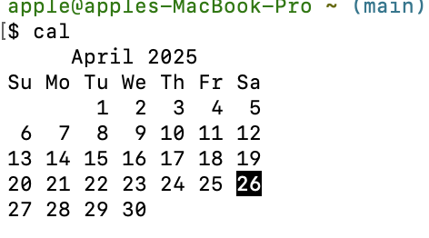

1. **Clear Command :**Linux clearcommand is used to clear the terminal screen.

**Syntax:** clear

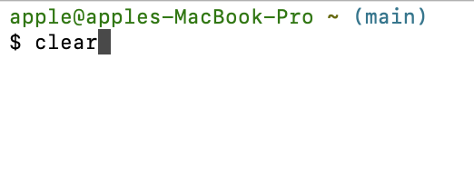

1. **mail Command :**The mail command is used to send emails from the command line.

**Syntax:** mail -s "Subject" **<recipient** address**>**

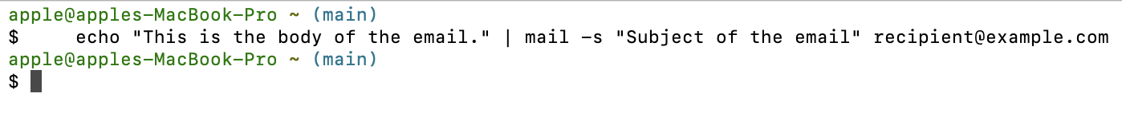

1. **df Command :** The df command is used to display the disk space used in the file system. It displays the output as in the number of used blocks, available blocks, and the mounted directory.

## Syntax: df

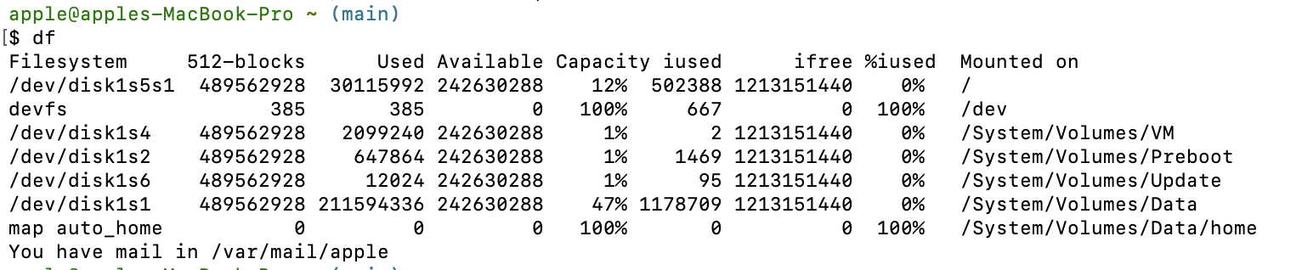

1. **Find command :** The find command is used to find a particular file within a directory.

**Syntax:** find.-name”*.pdf”

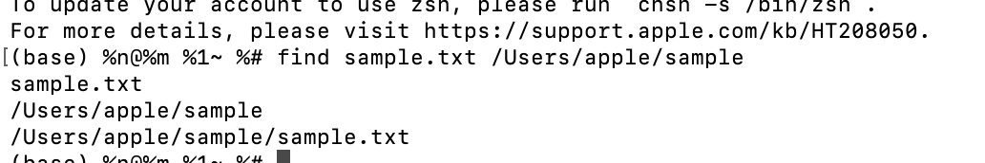

**RESULT:**

All basic and advanced operations were successfully performed through appropriate Linux commands, with the system responding accurately to each, confirming correct execution and expected behavior, thereby demonstrating the effectiveness and reliability of the Linux command-line interface for comprehensive system management.