|  |  |  |  |  |
| --- | --- | --- | --- | --- |
| Exp.No. | 02 | Cloud Service : S3 and EC2 Services | Year/Sem | II/4th |
| Date | 22/03/2025 | Branch | B.tech AIML |

# S3 service

Aim:

To create a cloud instance in the AWS server for creating a cloud storage (S3 Bucket)

# Procedure:

1. Sign in to AWS Management Console (Preview Version)
2. Open your web browser and go to the [AWS Management Console](https://aws.amazon.com/console/).
3. Enter your AWS credentials (email and password) and sign in.
4. Make sure you are using the preview version of the AWS Management Console if applicable.
5. Navigate to the Amazon S3 Service
6. On the AWS Management Console homepage, find the "Services" menu.
7. Under "Storage & Content Delivery," select Amazon S3 to open the S3 dashboard.
8. Create a New S3 Bucket
9. On the Amazon S3 dashboard, locate and click the "Create Bucket" button to start the setup process.
10. Enter a Unique Bucket Name
11. In the "Bucket Name" field, enter a unique name for your S3 bucket.
12. The name must follow AWS naming rules and be globally unique, meaning no other AWS user has the same bucket name.
13. Select the AWS Region
14. In the "Region" dropdown, choose a region where your bucket will be hosted.
15. For this setup, select Oregon (us-west-2) as the region.
16. Create the Bucket
17. Scroll down and click the "Create" button to finalize the bucket creation process.
18. Bucket Creation Confirmation
19. If the bucket is successfully created, it will appear in the "Buckets" pane on the Amazon S3 dashboard.
20. The newly created bucket will initially be empty until objects are uploaded.
21. Next Steps
22. You can now upload files, configure permissions, and enable security settings like versioning and access control for your new bucket.

# Applications & Use-Cases:

1. Data Storage & Backup – Securely store and retrieve any amount of data, including documents, images, and logs.
2. Website Hosting – Host static websites with S3, eliminating the need for a traditional web server.
3. Big Data Analytics – Store large datasets for analytics processing with AWS services like Athena and Redshift.
4. Media Content Delivery – Distribute images, videos, and software updates efficiently using AWS CloudFront.
5. Disaster Recovery – Implement backup and recovery strategies to ensure data protection and business continuity.
6. Machine Learning & AI – Store training datasets for AI models in services like AWS SageMaker.
7. Serverless Computing – Integrate with AWS Lambda to process and manage files dynamically without servers.
8. Log Storage & Analysis – Store application logs for security audits and real-time monitoring using AWS CloudWatch.

# Output:

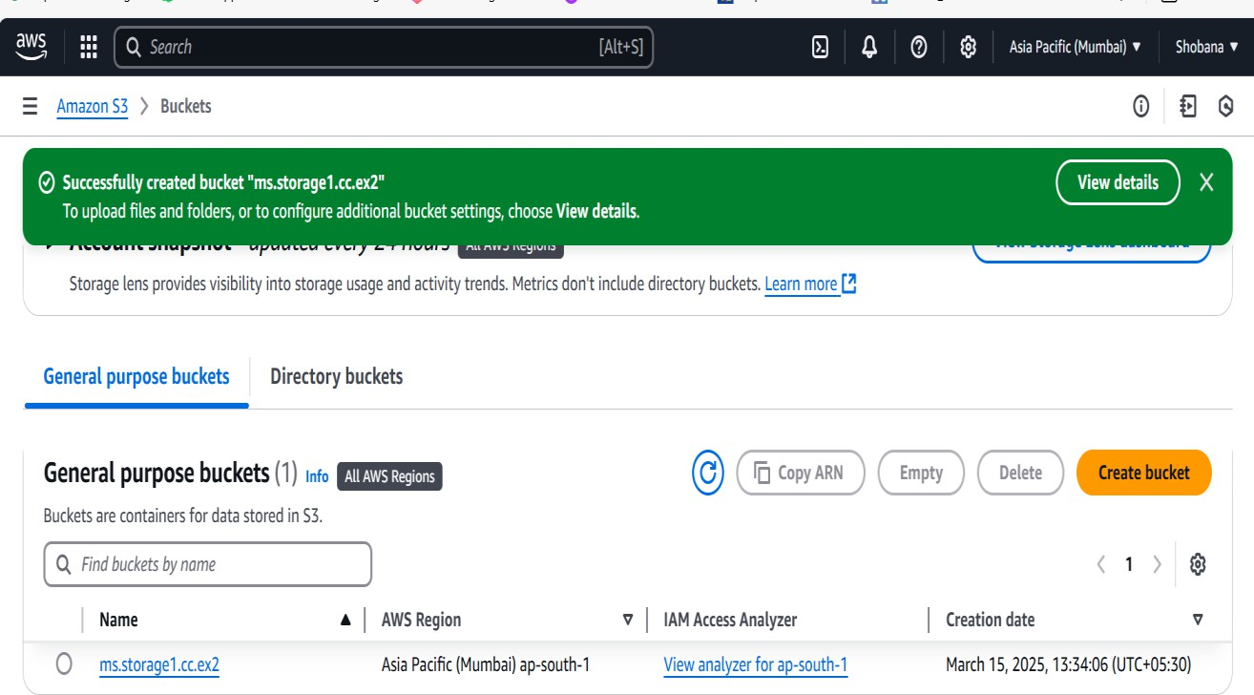

Fig 1. Creating a cloud storage - S3 bucket in AWS Platform

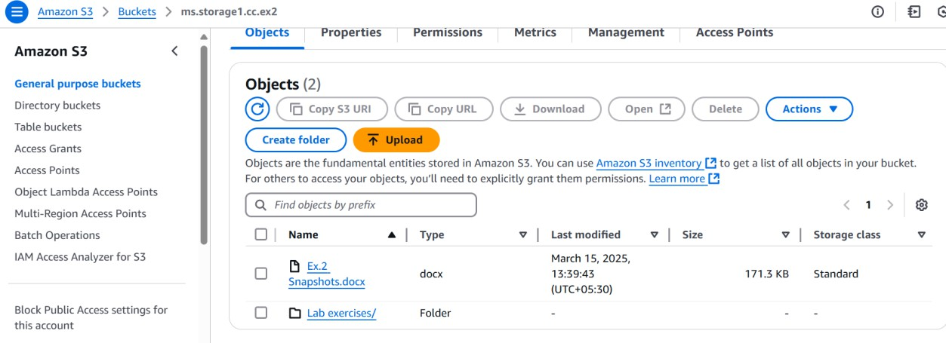

Fig 2 Creating a folder inside the S3 bucket.

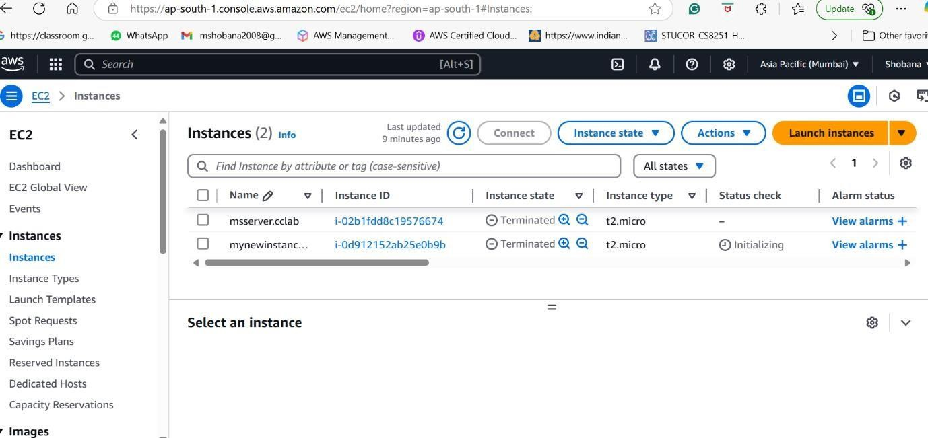

Fig 3 Uploaded an object into the S3 bucket folder – Lab Exercises

# Result:

The S3 bucket is successfully created and appears in the Buckets list on the Amazon S3 dashboard. It is initially empty, allowing you to upload files and configure settings like permissions, encryption, and lifecycle rules. The bucket can now be accessed via the AWS Console, CLI, SDKs, or API for storage and management.

# EC2 service

Aim:

To create a cloud instance in the AWS server for creating a virtual machine (EC2)

# Procedure:

1. Open your web browser and go to the AWS Management Console.
2. Enter your AWS credentials (email and password) and sign in.
3. Make sure you are using the preview version of the AWS Management Console if applicable.
4. On the AWS Management Console homepage, find the "Services" menu.
5. Under "Compute," select EC2 to open the EC2 dashboard.
6. On the EC2 dashboard, locate and click the "Launch Instance" button to start the setup process.
7. In the "Choose an Amazon Machine Image (AMI)" section, select a desired AMI (e.g., Amazon Linux 2, Ubuntu, etc.).
8. Click "Select" to proceed to the next step.
9. In the "Choose an Instance Type" section, select the instance type based on your requirements (e.g., t2.micro for the free tier).
10. Click "Next: Configure Instance Details" to continue.
11. Configure the instance details like number of instances, network, and subnet.
12. Click "Next: Add Storage" to proceed.
13. Modify the storage settings if needed. For a basic setup, the default root volume size is usually sufficient.
14. Click "Next: Add Tags" to continue.
15. Optionally, add tags to your instance to help identify it.
16. Click "Next: Configure Security Group" to proceed.
17. Select an existing security group or create a new one.
18. Add necessary rules (e.g., allow SSH access for Linux instances).
19. Click "Review and Launch" to continue.
20. Review the configuration settings for your EC2 instance.
21. Click "Launch" to proceed with instance creation.
22. Select an existing SSH key pair or create a new one to securely connect to your EC2 instance.
23. Download and save the key pair, as it will be required to access the instance.
24. Click "Launch Instances" to finalize the process.
25. Once launched, the instance will appear in the "Instances" section of the EC2 dashboard with a status of "running."
26. Once the instance is running, note the public IP or DNS name of the instance.
27. Use SSH to connect to the instance (e.g., using the terminal or an SSH client with the downloaded key pair).

# Applications & Use-Cases:

1. Web Hosting: EC2 instances can be used to host websites or web applications, providing scalable infrastructure to support varying levels of web traffic.
2. Application Hosting: You can deploy backend applications or microservices on EC2 instances, allowing you to run custom software environments.
3. Development and Testing: Developers can spin up EC2 instances to create isolated environments for development, testing, and staging without impacting production systems.
4. Big Data Processing: EC2 instances are commonly used for running big data applications and data analytics, such as Hadoop or Spark clusters.
5. Machine Learning: EC2 can be used to train and deploy machine learning models, especially when paired with specialized instances (e.g., GPU-powered instances) for intensive computational tasks.
6. Database Hosting: EC2 can be used to host relational databases (e.g., MySQL, PostgreSQL) or NoSQL databases (e.g., MongoDB, Cassandra).
7. Game Servers: EC2 instances are often used to host multiplayer game servers for online gaming.
8. Backup and Disaster Recovery: You can use EC2 for creating backup systems or setting up disaster recovery environments, ensuring data redundancy and availability.

# Output:

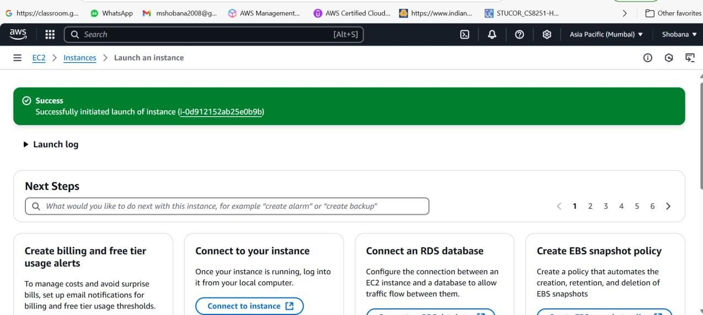

Fig 1 Created Instance for Ec2

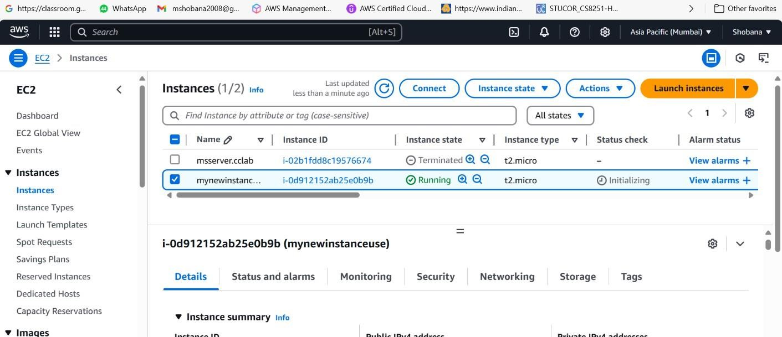

Fig 2 Running the Instance in EC2



Fig 3 Terminated the Instance in EC2

# Result:

After launching the EC2 instance, it will appear in the "Instances" section of the EC2 dashboard with a "running" status. A public IP or DNS name is assigned to the instance, allowing remote access. You can connect to the instance securely using the generated SSH key pair for Linux instances or RDP for Windows instances. The instance is now ready for use and can be managed through the EC2 dashboard for tasks like stopping, starting, or modifying configurations.