Ministerul Educaţiei și Cercetării al Republicii Moldova
Universitatea Tehnică a Moldovei
Facultatea Calculatoare, Informatică și Microelectronică

Laboratory work 2:
Study and empirical analysis of sorting algorithms. Analysis of quickSort, mergeSort, heapSort, bubbleSort

Elaborated:
st. gr. FAF-233 Nicologlo Victoria

Verified:
asist. univ. Fiștic Cristofor

Chişinău - 2025

BASIC TASK:
1. Implement the algorithms listed above in a programming language
2. Establish the properties of the input data against which the analysis is performed
3. Choose metrics for comparing algorithms
4. Perform empirical analysis of the proposed algorithms
5. Make a graphical presentation of the data obtained
6. Make a conclusion on the work done.

THEORETICAL NOTES:

Comparison and Evaluation of Sorting Algorithms
Sorting is a fundamental operation in computer science used in searching, databases, and data processing. To compare sorting algorithms effectively, we analyze their execution time, number of comparisons, number of swaps, space complexity, and stability under different conditions. This study focuses on QuickSort, MergeSort, HeapSort, and BubbleSort, evaluating their efficiency based on input size and distribution.

Comparison Criteria
- Execution Time – Measures how quickly an algorithm sorts an array of size N.
- Number of Comparisons – The fewer comparisons an algorithm makes, the faster it executes.
- Number of Swaps – Swap operations are computationally expensive.
- Space Complexity
- Stability – Stable sorting algorithms maintain the relative order of equal elements.

Experimental Methodology
To test sorting efficiency, we use different types of input:
- Random Data: Elements are randomly distributed.
- Sorted Data: Already in increasing order (QuickSort’s worst case).
- Reversed Data: Sorted in descending order (BubbleSort’s worst case).
- Nearly Sorted Data: Few elements are misplaced (BubbleSort benefits).
- Half-Sorted Data & Duplicates: Test how algorithms handle structured data.
- Negative Numbers: Ensures algorithms correctly handle signed values.
Sorting performance is evaluated for input sizes 10, 100, 1000, and 10000, with execution time measured in milliseconds.

INTRODUCTION:
Sorting is a fundamental operation in computer science that involves arranging elements in a specific order. Efficient sorting is critical for databases, searching algorithms, machine learning, and various real-world applications.
This report focuses on the empirical analysis of four well-known sorting algorithms:
- QuickSort – A fast, divide-and-conquer algorithm, widely used in practice.
- MergeSort – A stable, efficient, recursive sorting algorithm with consistent performance.
- HeapSort – A comparison-based sorting algorithm that uses a binary heap structure.
- BubbleSort – A simple but inefficient sorting algorithm mainly used for educational purposes.
Our goal is to evaluate and compare their performance under different conditions, including different input distributions, array sizes, and the presence of negative numbers.

IMPLEMENTATION
1. QuickSort
QuickSort is a divide-and-conquer sorting algorithm that works by selecting a pivot element, partitioning the array so that elements smaller than the pivot are on the left and elements larger than the pivot are on the right, and recursively sorting the subarrays.
Algorithm Steps
- Choose a Pivot – The pivot can be selected as the first element, last element, median, or randomly.
- Partition the Array – Rearrange elements such that:
  - Elements smaller than pivot are placed on the left.
  - Elements greater than pivot are placed on the right.
- Recursively Apply QuickSort – QuickSort is called separately on both left and right subarrays.
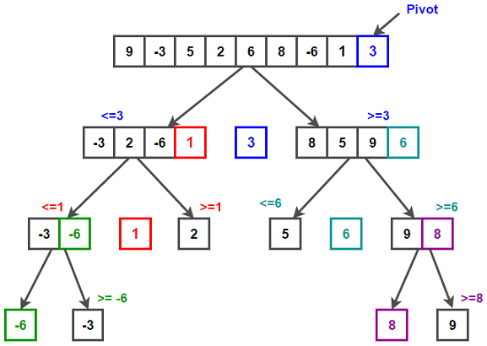
- Base Case – If the subarray contains only one element, it is already sorted.
Figure 1: Quick Sort
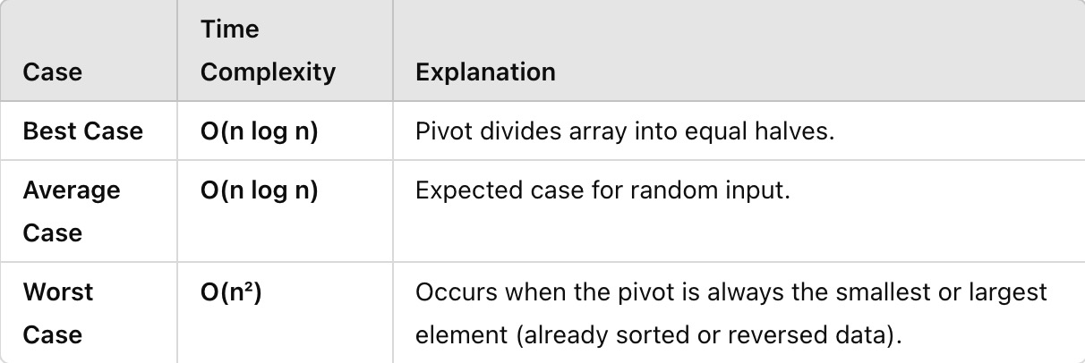
Time Complexity Analysis

Figure 2: Quick Sort Time Complexity Analysis
Space complexity:
-O(log n) (due to recursive calls)
-In-place sorting algorithm (does not require extra memory for merging).
Pceudocode:
QUICKSORT(A, low, high)
IF low < high THEN
pivotIndex ← PARTITION(A, low, high)
QUICKSORT(A, low, pivotIndex - 1) // Sort left subarray
QUICKSORT(A, pivotIndex + 1, high) // Sort right subarray

PARTITION(A, low, high)
pivot ← A[high] // Choose last element as pivot
i ← low - 1 // Pointer for smaller elements
FOR j ← low TO high - 1 DO
IF A[j] ≤ pivot THEN
i ← i + 1
SWAP(A[i], A[j])
SWAP(A[i + 1], A[high]) // Place pivot at correct position
RETURN i + 1 // Return pivot index
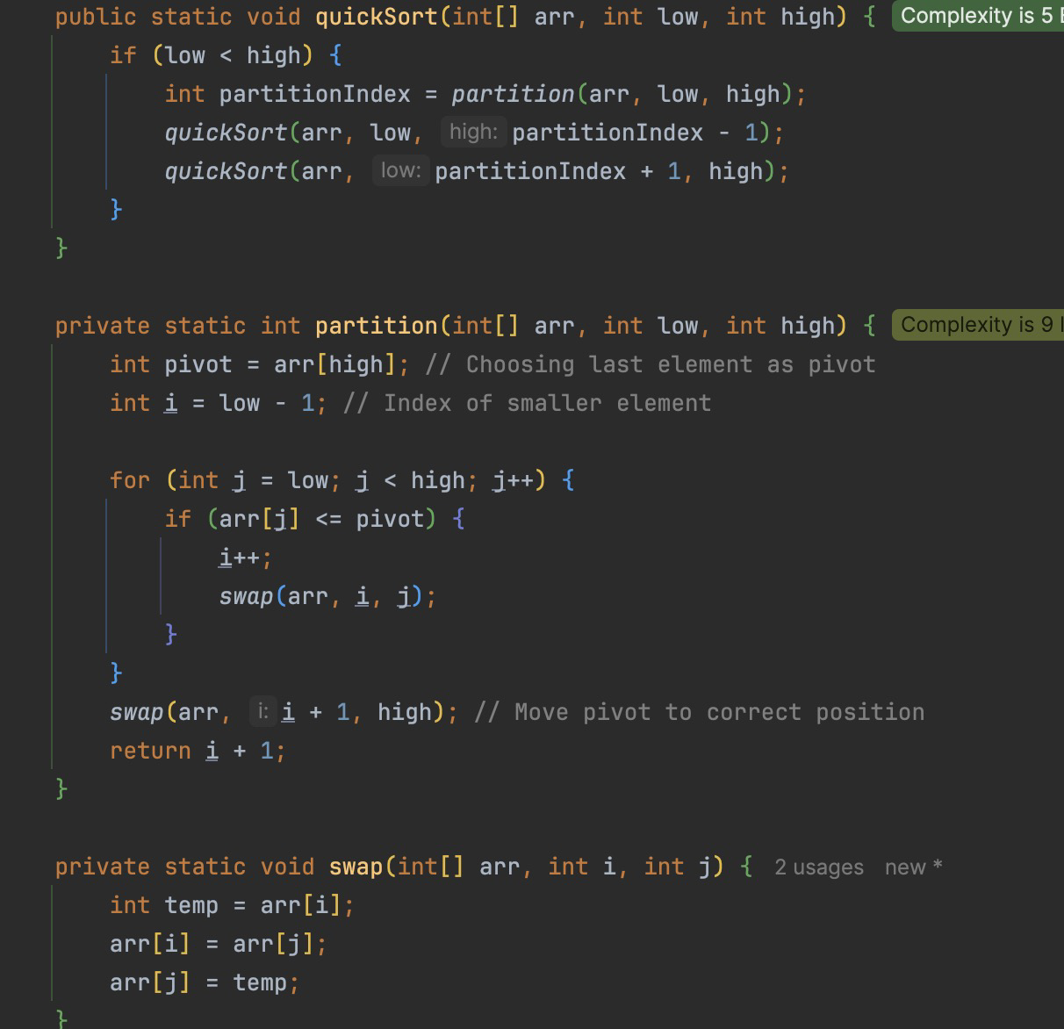
Code:

Figure 3: Quick Sort Algorithm
Figure 3: Quick Sort

Results:
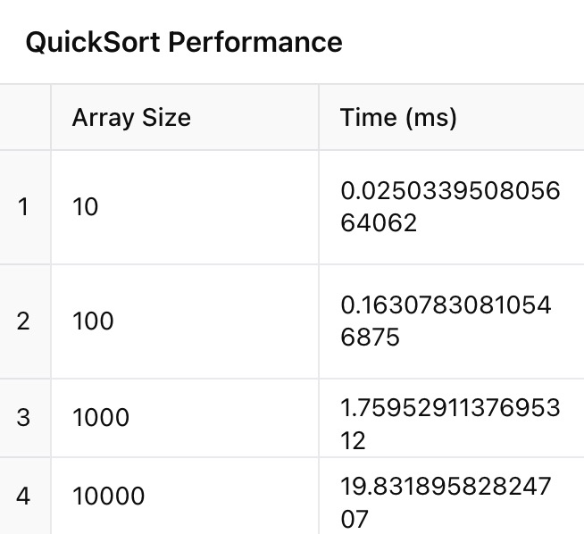

Figure 4: Quick Sort Execution Time
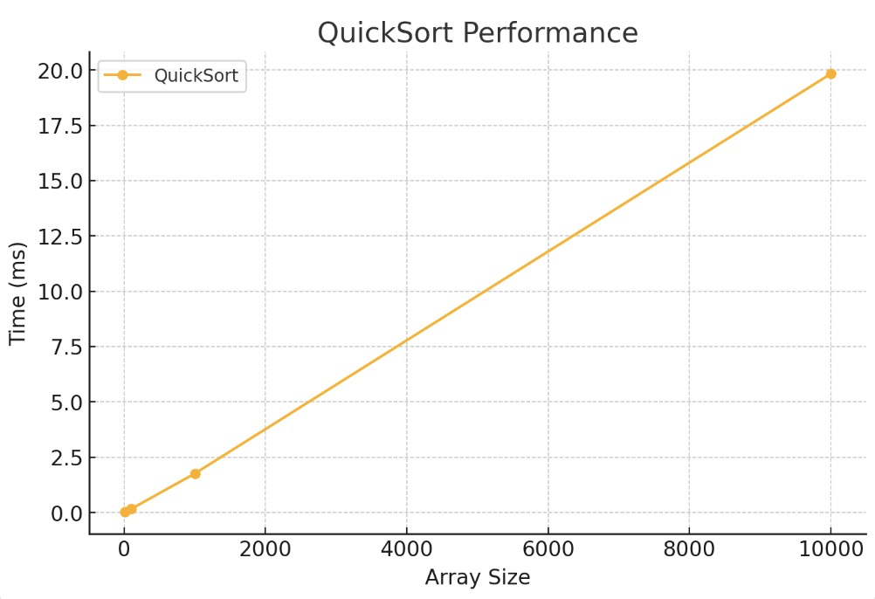

Figure 5: Quick Sort Results

The results confirm QuickSort’s O(n log n) efficiency, showing a gradual increase in execution time as the array size grows. For small inputs (10–100 elements), sorting is nearly instantaneous, while for larger arrays (1000–10,000 elements), execution time increases predictably.
The graph shows a steady rise, indicating efficient partitioning. QuickSort remains fast for large datasets, but performance depends on pivot selection—poor choices can lead to O(n²) worst-case complexity. Overall, it is a highly efficient algorithm for general sorting tasks.
Stability
Not stable – Equal elements may change their relative order during partitioning.
Efficiency Based on Data Properties:
✅Highly efficient for random and large datasets
❌ Performs poorly on nearly sorted arrays unless optimized with random pivot selection
✅ Handles negative numbers efficiently (works with any numeric values)
❌ For small arrays, QuickSort may be slower than simpler sorting methods (e.g., Insertion Sort)

2. Merge Sort
MergeSort is a divide-and-conquer algorithm that recursively splits an array into two halves, sorts each half, and then merges the sorted halves back together.
Algorithm Steps
- Divide – The array is split into two equal halves.
- Recursively Sort Both Halves – MergeSort is applied to each half separately.
- Merge – The two sorted halves are merged back into a single sorted array.
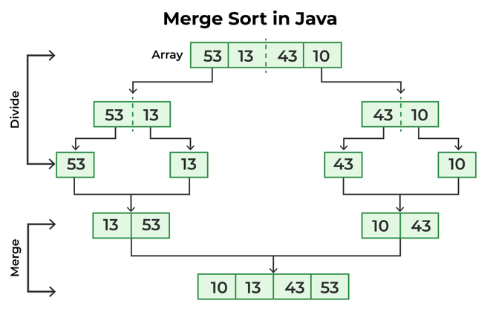

Figure 6: Merge Sort

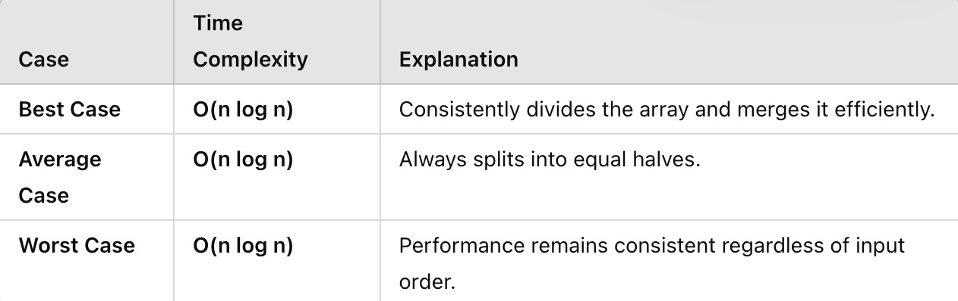
Time Complexity Analysis

Figure 7: Merge Sort Time Complexity Analysis

Space Complexity
O(n) (due to auxiliary arrays used in merging)
Pceudocode:
MERGESORT(A, left, right)
IF left < right THEN
mid ← (left + right) / 2
MERGESORT(A, left, mid) // Recursively sort left half
MERGESORT(A, mid + 1, right) // Recursively sort right half
MERGE(A, left, mid, right) // Merge sorted halves

MERGE(A, left, mid, right)
n1 ← mid - left + 1 // Length of left subarray
n2 ← right - mid // Length of right subarray
CREATE temporary arrays L[1..n1] and R[1..n2]

COPY A[left..mid] into L[]
COPY A[mid+1..right] into R[]

i ← 0, j ← 0, k ← left
WHILE i < n1 AND j < n2 DO
IF L[i] ≤ R[j] THEN
A[k] ← L[i]
i ← i + 1
ELSE
A[k] ← R[j]
j ← j + 1
k ← k + 1

WHILE i < n1 DO
A[k] ← L[i]
i ← i + 1
k ← k + 1

WHILE j < n2 DO
A[k] ← R[j]
j ← j + 1
k ← k + 1
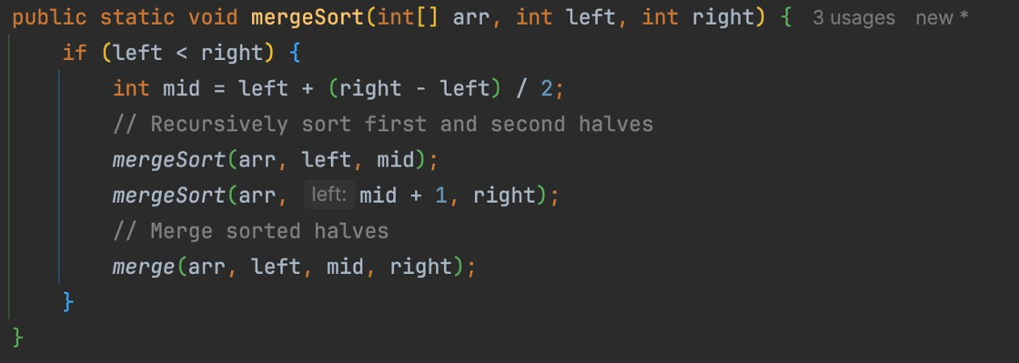
Code:

Figure 7: MergeSort function
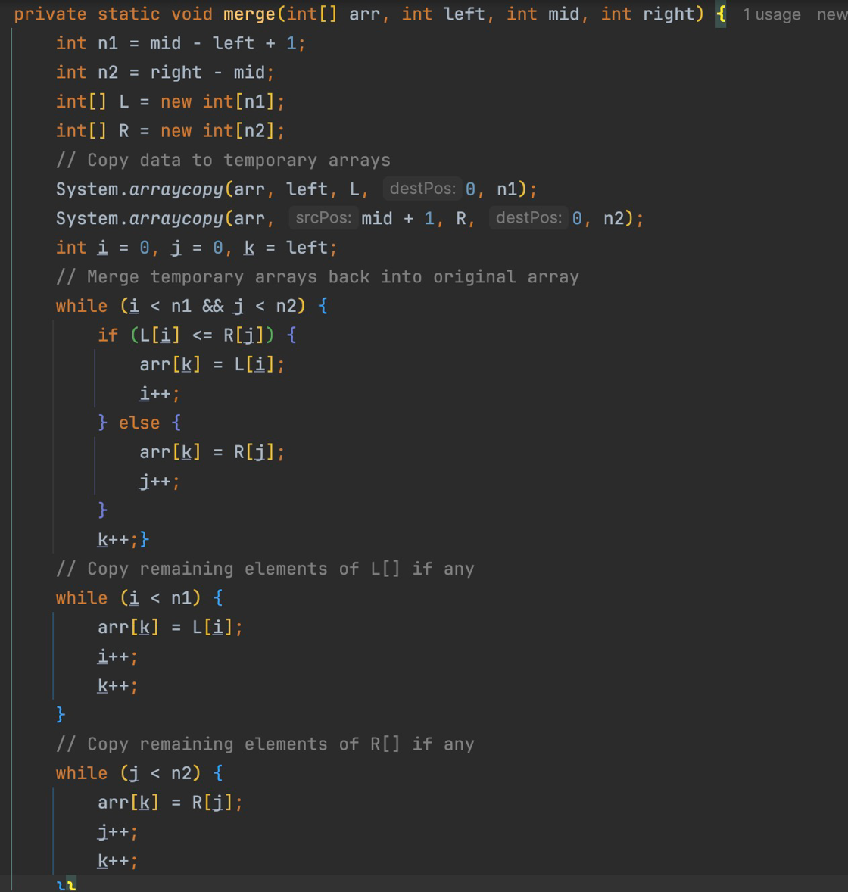

Figure 8: Merge function
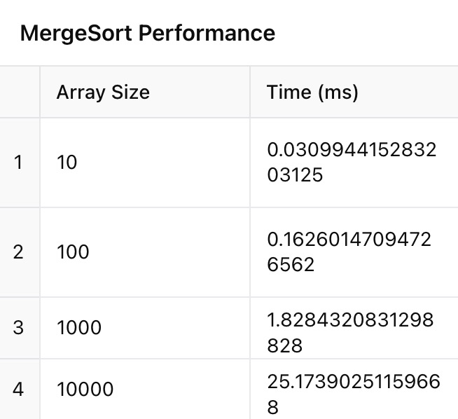
Results:

Figure 9: Merge Sort performance
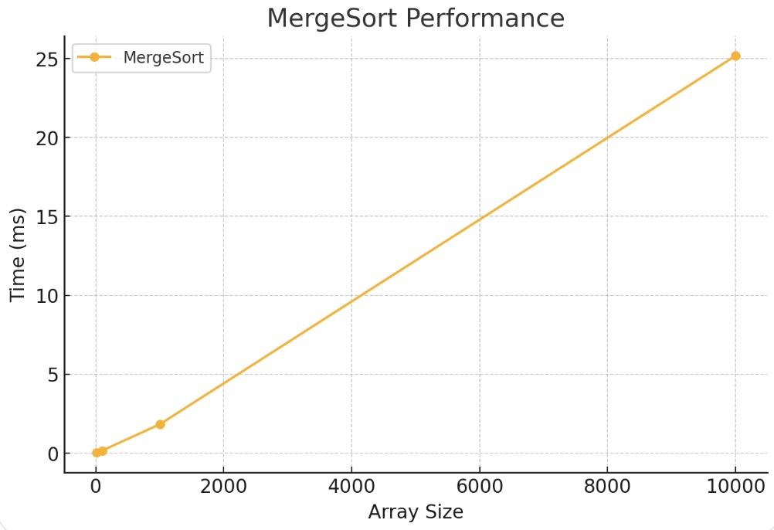

Figure 10: Merge Sort performance

The MergeSort algorithm demonstrates a steady increase in execution time as the array size grows, following its O(n log n) complexity. The measured times indicate that small arrays (10–100 elements) are sorted almost instantly, while larger arrays (1000–10,000 elements) require more time, reaching 25.17 ms for the largest dataset.
The graph shows a linear-like trend, which is expected due to MergeSort’s consistent split-and-merge process. While the time growth remains predictable, MergeSort is slower than QuickSort for small datasets because of extra memory usage for merging. However, it remains efficient for large inputs and stable sorting scenarios where preserving order matters.
Stability
Stable – Equal elements retain their original order
Efficiency Based on Data Properties:
✅ Performs consistently well regardless of input order (sorted, reversed, or random)
❌ Requires O(n) extra space, making it inefficient for memory-constrained environments
✅ Works well for large datasets and external sorting (e.g., sorting files on disk)
✅ Handles negative numbers without issues
3. HeapSort
HeapSort is a comparison-based sorting algorithm that uses a binary heap data structure to repeatedly extract the largest (or smallest) element from the heap and place it at the end of the array.
Algorithm Steps
- Build a Max Heap – Convert the input array into a binary heap (max heap ensures the largest element is at the root).
- Extract the Maximum Element – Remove the root element and place it at the end of the array.
- Reheapify – Restore heap property after removal.
- Repeat until all elements are sorted.
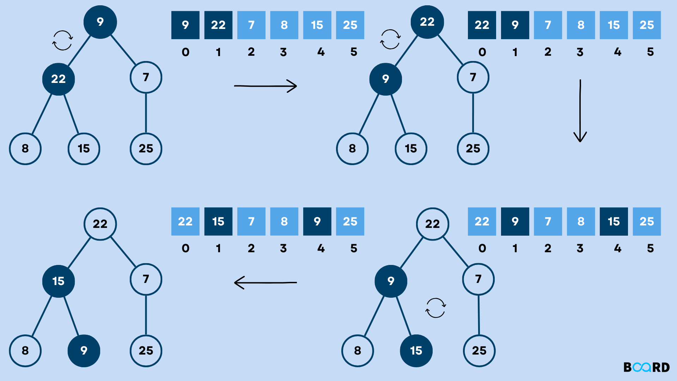

Figure 11: Heap Sort

Time Complexity Analysis
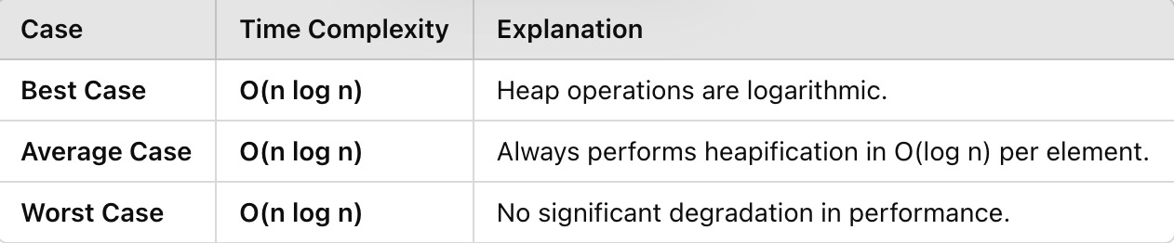

Figure 11: Heap Sort
Space Complexity Analysis
O(1) (in-place sorting)

Pceudocode:
HEAPSORT(A)
BUILD_MAX_HEAP(A)
FOR i ← length(A) - 1 TO 1 DO
SWAP(A[0], A[i]) // Move max element to the end
HEAPIFY(A, 0, i) // Restore max heap property

BUILD_MAX_HEAP(A)
FOR i ← (length(A) / 2) DOWNTO 0 DO
HEAPIFY(A, i, length(A))

HEAPIFY(A, i, heapSize)
left ← 2 * i + 1
right ← 2 * i + 2
largest ← i

IF left < heapSize AND A[left] > A[largest] THEN
largest ← left

IF right < heapSize AND A[right] > A[largest] THEN
largest ← right

IF largest ≠ i THEN
SWAP(A[i], A[largest])
HEAPIFY(A, largest, heapSize)

Code:

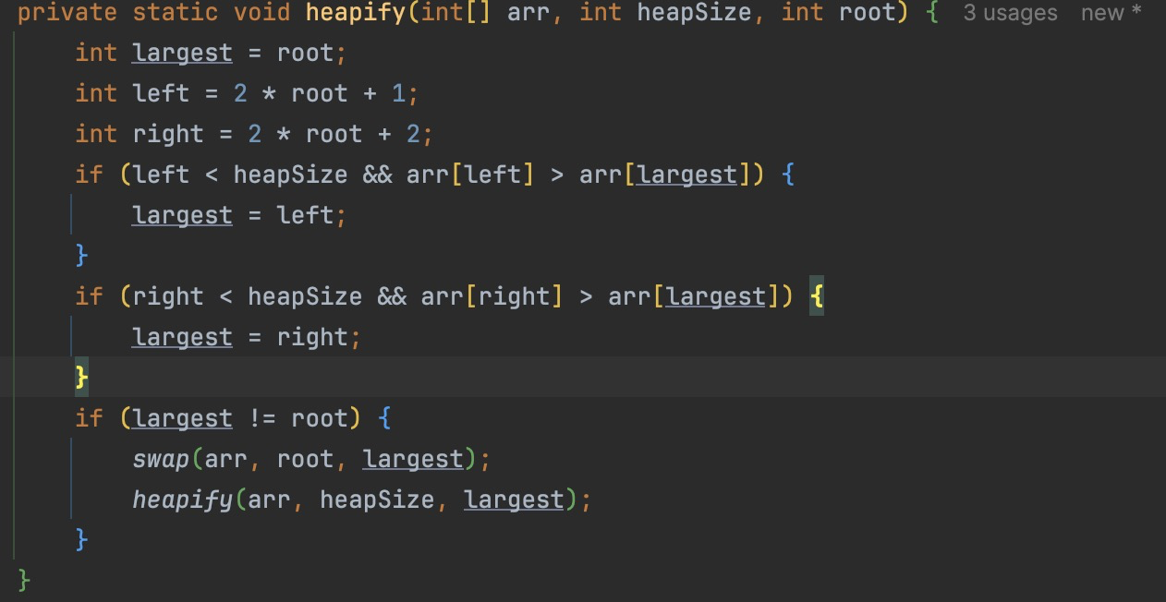

Figure 12: Heapify function
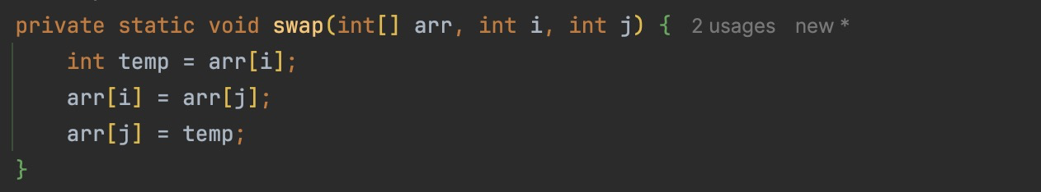

Figure 13: Swap function
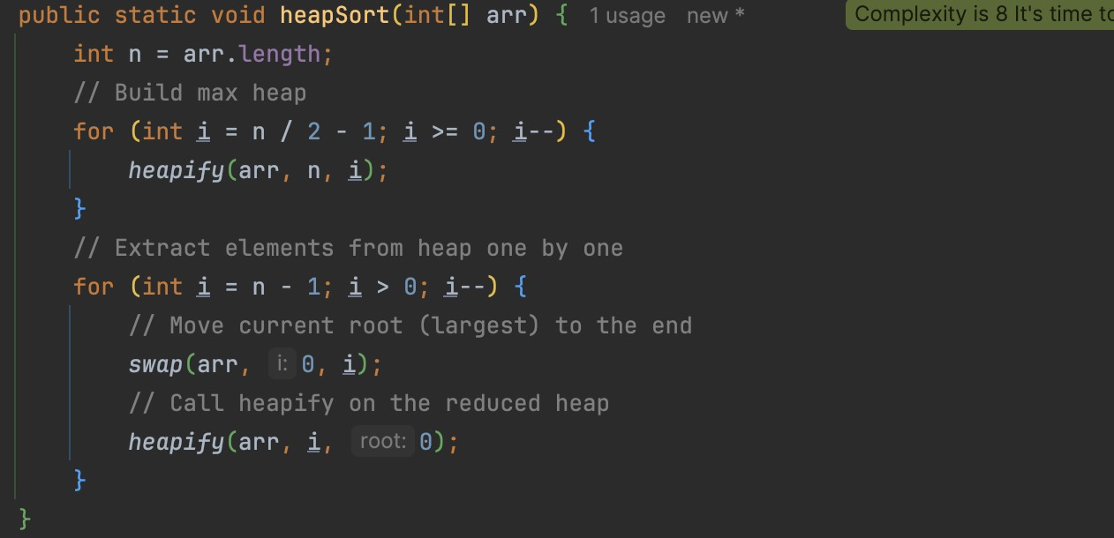

Figure 14: Heap Sort function

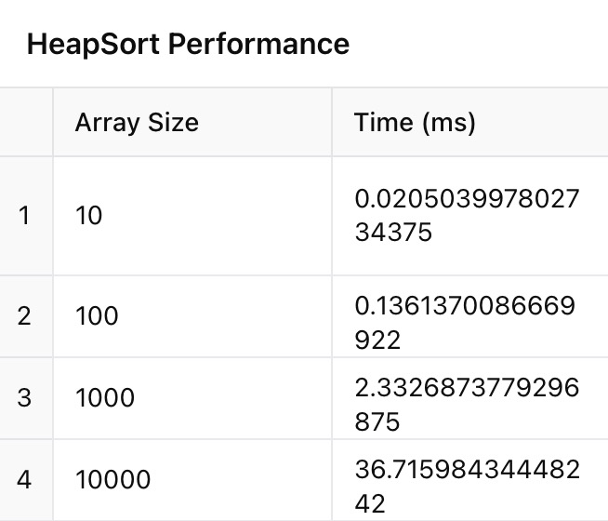
Results:

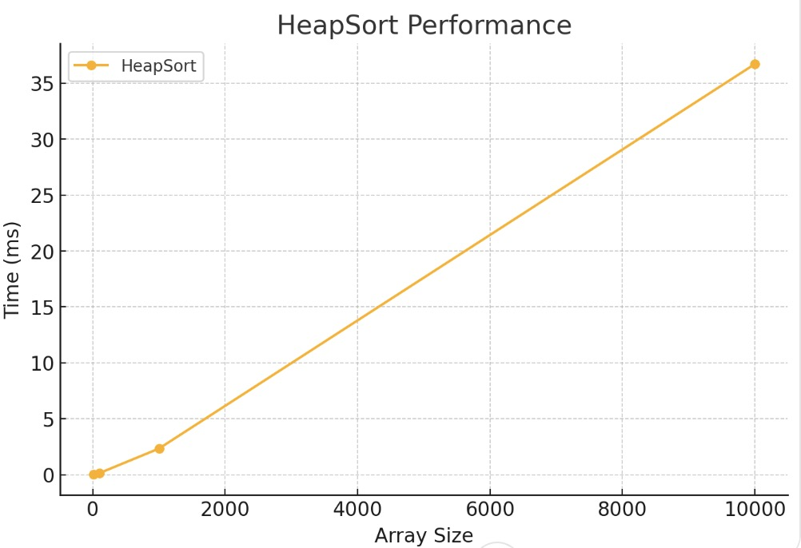
Figure 15: Heap Sort performance

Figure 16: Heap Sort performance
The results show that HeapSort follows an O(n log n) time complexity, with execution time increasing as the array size grows. For small datasets (10–100 elements), HeapSort remains very fast, completing in fractions of a millisecond. However, for larger arrays (1000–10,000 elements), the runtime increases significantly, reaching 36.71 ms for the largest dataset.
The graph confirms a linear-like growth, but HeapSort performs worse than QuickSort and MergeSort for larger inputs due to the higher number of swaps and heap maintenance operations. Although HeapSort is useful for in-place sorting without additional memory overhead, its frequent swapping makes it slower in practice compared to QuickSort. It remains a good choice for applications requiring guaranteed O(n log n) complexity, but not necessarily the fastest for real-world data sorting.
Stability
Not stable – Equal elements may change their order during heapification.
Efficiency Based on Data Properties:
✅ Performs consistently regardless of input order
✅ Uses O(1) extra space (in-place sorting)
❌ Slower than QuickSort in practice due to extra heap operations
✅ Handles negative numbers without any issues
4. BubbleSort
BubbleSort is a simple comparison-based sorting algorithm that repeatedly swaps adjacent elements if they are out of order.
Algorithm Steps
- Iterate through the array – Compare adjacent elements and swap if needed.
- Continue looping until the array is fully sorted (no more swaps are needed).
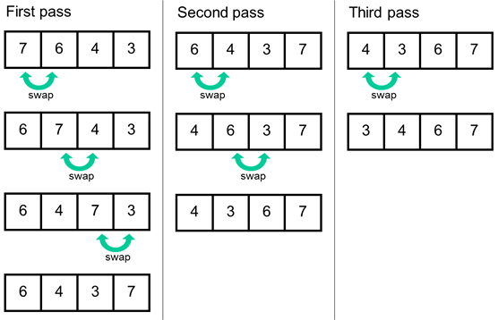

Figure 17: Bubble Sort

Time Complexity Analysis
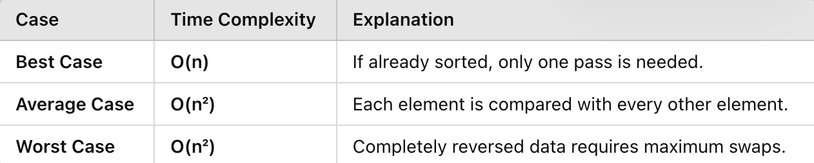

Figure 17: Bubble Sort Time Complexity Analyses
Space Complexity Analysis
O(1) (in-place sorting).
Pceudocode:
BUBBLESORT(A, n)
FOR i ← 0 TO n - 1 DO
swapped ← false
FOR j ← 0 TO n - i - 1 DO
IF A[j] > A[j + 1] THEN
SWAP(A[j], A[j + 1])
swapped ← true
IF swapped = false THEN
BREAK // Array is already sorted

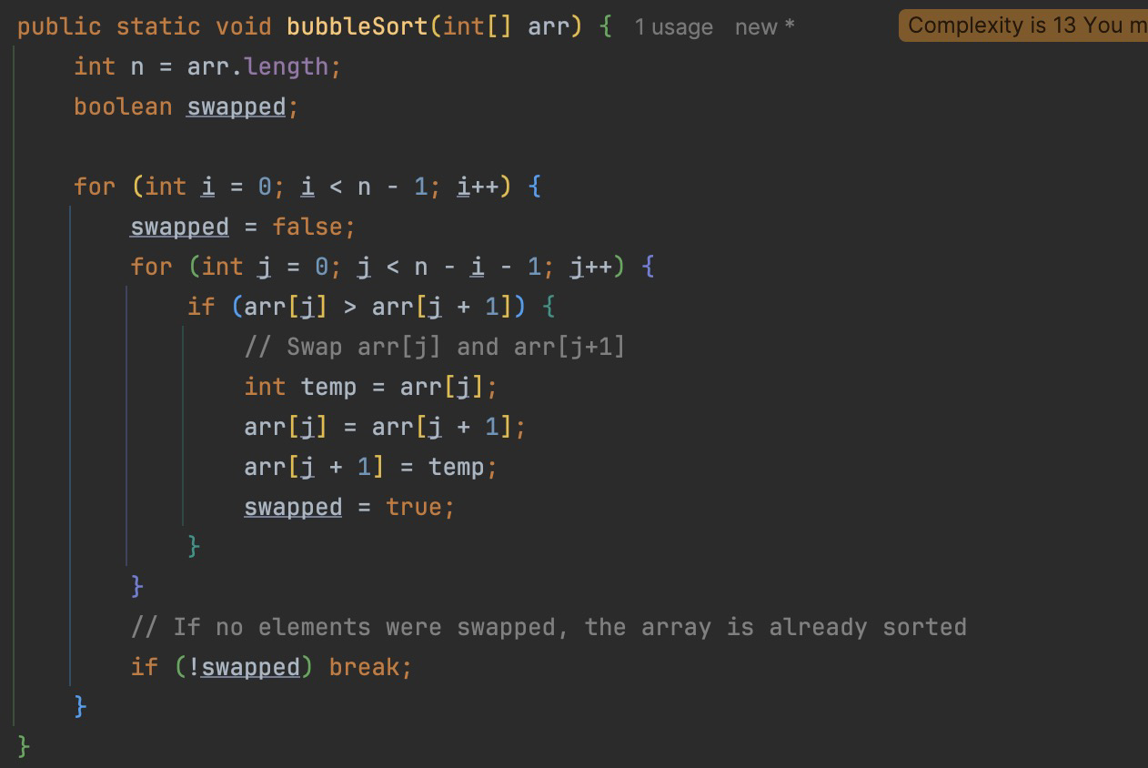
Code:

Figure 18: Bubble Sort Code in Java

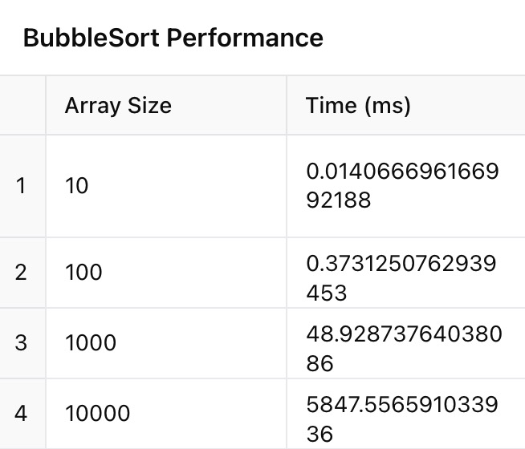
Results:

Figure 18: Bubble Sort performance
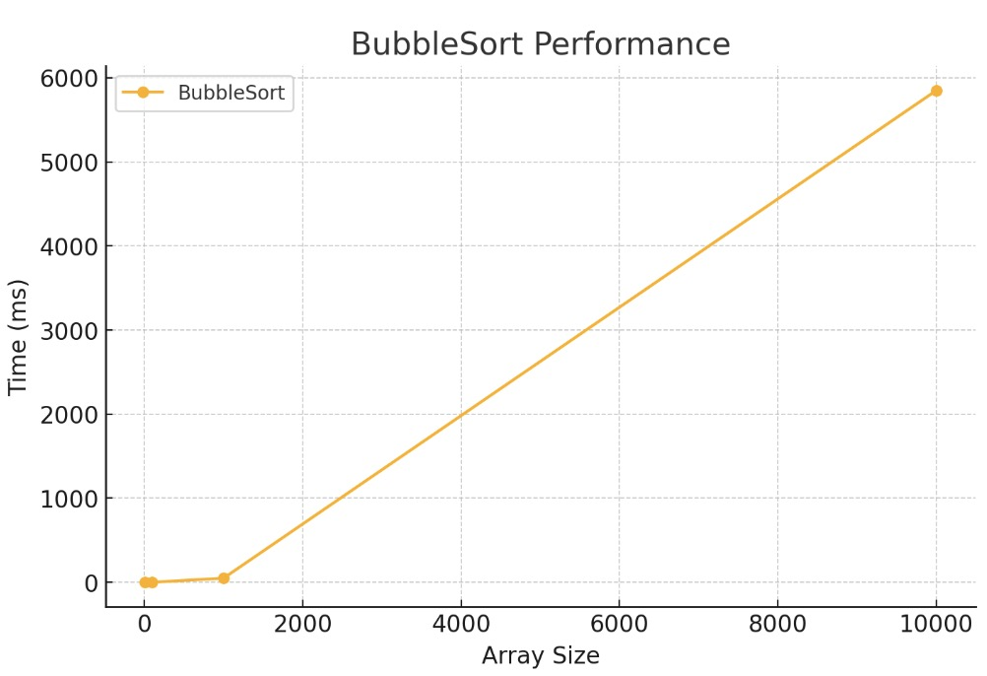

Figure 19: Bubble Sort performane

The results clearly illustrate Bubble Sort's inefficiency for large datasets. While it performs well for very small arrays (10–100 elements), its O(n²) time complexity causes execution time to grow exponentially as the array size increases.
- For 10 elements, sorting is nearly instantaneous (0.014 ms).
- For 100 elements, execution time is still reasonable (0.37 ms).
- For 1,000 elements, time jumps to 48.93 ms, indicating quadratic growth.
- For 10,000 elements, sorting takes over 5.8 seconds, making it extremely slow compared to MergeSort and QuickSort.
The graph confirms non-linear growth, demonstrating why Bubble Sort is impractical for large datasets. While it is stable and simple, it should only be used for small lists or educational purposes.
Stability
Stable – Equal elements retain their relative order.
Efficiency Based on Data Properties:
✅ Efficient only for small or nearly sorted datasets
❌ Extremely slow for large datasets (O(n²) complexity makes it impractical)
❌ Not suitable for large inputs
✅ Works with negative numbers but remains inefficient

https://github.com/vikanicologlo/AA/tree/lab2

