
MINISTRY OF EDUCATION, CULTURE AND RESEARCH
OF THE REPUBLIC OF MOLDOVA
Technical University of Moldova
Faculty of Computers, Informatics and Microelectronics
Department of Software and Automation Engineering

NICOLOGLO VICTORIA
FAF-233
Report
Laboratory Work No.1

of Cryptography and Security

Checked by:
Maia Zaica, university assistant
DISA,FCIM,UTM

Chisinau – 2025
Purpose of laboratory work:
The purpose of this laboratory work is to study and implement classical encryption methods, focusing on the Caesar cipher and its extended version with alphabet permutation. The goal is to understand how substitution ciphers function, how encryption and decryption are performed using modular arithmetic, and how to handle text transformation and key validation without relying on built-in character encoding. This work also aims to demonstrate how adding an additional key for alphabet permutation increases the cipher’s resistance to brute-force attacks, helping students develop a practical understanding of the relationship between algorithm simplicity, key space, and overall cryptographic strength.

Problem condition:
Sarcina 1.1. De implementat algoritmul Cezar pentru alfabetul limbii engleze în unul din limbajele de programare. Utilizați doar codificarea literelor cum este arătat în tabelul 1 (nu se permite de folosit codificările specificate în limbajul de programare, de ex. ASCII sau Unicode).
Valorile cheii vor fi cuprinse între 1 și 25 inclusiv și nu se permit alte valori. Valorile caracterelor textului sunt cuprinse între ‘A’ și ’Z’, ’a’ și ’z’ și nu sunt premise alte valori. În cazul în care utilizatorul introduce alte valori - i se va sugera diapazonul corect. Înainte de criptare textul va fi transformat în majuscule și vor fi eliminate spațiile. Utilizatorul va putea alege operația -
criptare sau decriptare, va putea introduce cheia, mesajul sau criptograma și va obține respective criptograma sau mesajul decriptat.

Sarcina 1.2. De implementat algoritmul Cezar cu 2 chei, cu păstrarea condițiilor exprimate în Sarcina 1.1. În plus, cheia 2 trebuie să conțină doar litere ale alfabetului latin, și să aibă o lungime nu mai mică de 7.

Code:
1.1
def caesar_cipher(text: str, key: int, mode: str) -> str:
alphabet = "ABCDEFGHIJKLMNOPQRSTUVWXYZ"
text = text.upper().replace(" ", "")
result = ""
for ch in text:
if ch in alphabet:
idx = alphabet.index(ch)
if mode == "c":
new_idx = (idx + key) % len(alphabet)
elif mode == "d":
new_idx = (idx - key) % len(alphabet)
else:
raise ValueError("Mode must be 'c' (cipher) or 'd' (decipher)")
result += alphabet[new_idx]
else:
raise ValueError("Text must contain only A–Z letters")
return result
mode = input("c = cipher, d = decipher: ").strip().lower()
key = int(input("Key (1–25): "))
message = input("(A–Z): ")
output = caesar_cipher(message, key, mode)
print("Result:", output)

Result:
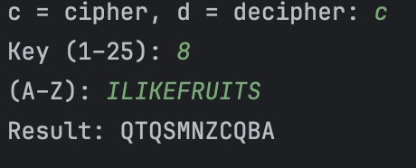
Figure 1: Result 1.1

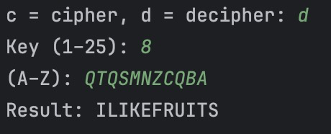
Figure 2: Result 1.1

1.2

def generate_permuted_alphabet(keyword: str) -> str:
keyword = "".join(dict.fromkeys(keyword.upper()))
alphabet = "ABCDEFGHIJKLMNOPQRSTUVWXYZ"
remaining = "".join([ch for ch in alphabet if ch not in keyword])
return keyword + remaining
def caesar_permutation_cipher(text: str, key: int, keyword: str, mode: str) -> str:
base_alphabet = "ABCDEFGHIJKLMNOPQRSTUVWXYZ"
permuted_alphabet = generate_permuted_alphabet(keyword)
text = text.upper().replace(" ", "")
result = ""
for ch in text:
if ch not in base_alphabet:
raise ValueError("Text must contain only A–Z letters")
idx = permuted_alphabet.index(ch)
if mode == "c":
new_idx = (idx + key) % len(permuted_alphabet)
elif mode == "d":
new_idx = (idx - key) % len(permuted_alphabet)
else:
raise ValueError("Mode must be 'c' (cipher) or 'd' (decipher)")
result += permuted_alphabet[new_idx]
return result
mode = input("c = cipher, d = decipher: ").strip().lower()
key = int(input("Key (1–25): "))
keyword = input("Keyword (min 7 simbols): ").strip()
message = input("A–Z: ")
output = caesar_permutation_cipher(message, key, keyword, mode)
print("Updated alphabet:", generate_permuted_alphabet(keyword))
print("Result:", output)
Result:
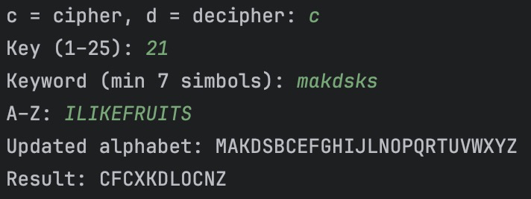
Figure 3: Result 1.2

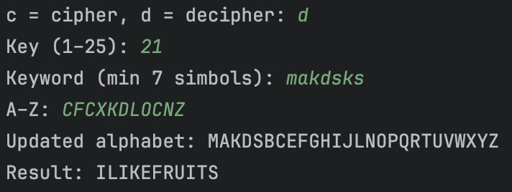
Figure 4: Result 1.2

Conclusion:
In this lab work, the Caesar cipher and its extended version with alphabet permutation were implemented and tested.The experiments showed that while the classical Caesar cipher is easy to implement, it provides very low security since it can be broken by trying all 25 possible keys.The addition of a second key that permutes the alphabet significantly increases the number of possible keys, making brute-force attacks much harder, although frequency analysis can still reveal the plaintext.
The work provided hands-on experience with encryption and decryption processes, modular arithmetic operations, and the importance of key management. It also demonstrated how the complexity of a cryptographic algorithm can be increased by expanding the key space and combining simple transformations

