Name: Vikas Chaurasiya

Rollno.: 21102B0024

Class : BE CMPN B

Experiment 1 : Predict Housing Prices using Linear Regression

Github : https://github.com/vikas-a-chaurasiya/ML_exp

Dataset: <https://www.kaggle.com/datasets/camnugent/california-housing-prices>

|  |
| --- |
| import pandas as pd  import numpy as np  import matplotlib.pyplot as plt  import seaborn as sns  from sklearn.model_selection import train_test_split  from sklearn.linear_model import LinearRegression  from sklearn.metrics import mean_squared_error, r2_score  from sklearn.preprocessing import StandardScaler  # Load the dataset  df = pd.read_csv('housing.csv')  print(df.head()) |

longitude latitude housing_median_age total_rooms total_bedrooms \

0 -122.23 37.88 41.0 880.0 129.0

1 -122.22 37.86 21.0 7099.0 1106.0

2 -122.24 37.85 52.0 1467.0 190.0

3 -122.25 37.85 52.0 1274.0 235.0

4 -122.25 37.85 52.0 1627.0 280.0

population households median_income median_house_value ocean_proximity

0 322.0 126.0 8.3252 452600.0 NEAR BAY

1 2401.0 1138.0 8.3014 358500.0 NEAR BAY

2 496.0 177.0 7.2574 352100.0 NEAR BAY

3 558.0 219.0 5.6431 341300.0 NEAR BAY

print(df.isnull().sum())

df['total_bedrooms'].fillna(df['total_bedrooms'].median(), inplace=True)

print(df.isnull().sum())

longitude 0

latitude 0

housing_median_age 0

total_rooms 0

total_bedrooms 207

population 0

households 0

median_income 0

median_house_value 0

ocean_proximity 0

dtype: int64

longitude 0

latitude 0

housing_median_age 0

total_rooms 0

total_bedrooms 0

population 0

households 0

median_income 0

median_house_value 0

ocean_proximity 0

dtype: int64

features = ['longitude', 'latitude', 'housing_median_age', 'total_rooms', 'total_bedrooms', 'population', 'households', 'median_income']

scaler = StandardScaler()

df[features] = scaler.fit_transform(df[features])

# Display the first few rows of the scaled dataset

print(df.head())

longitude latitude housing_median_age total_rooms total_bedrooms \

0 -1.327835 1.052548 0.982143 -0.804819 -0.972476

1 -1.322844 1.043185 -0.607019 2.045890 1.357143

2 -1.332827 1.038503 1.856182 -0.535746 -0.827024

3 -1.337818 1.038503 1.856182 -0.624215 -0.719723

4 -1.337818 1.038503 1.856182 -0.462404 -0.612423

population households median_income median_house_value ocean_proximity

0 -0.974429 -0.977033 2.344766 452600.0 NEAR BAY

1 0.861439 1.669961 2.332238 358500.0 NEAR BAY

2 -0.820777 -0.843637 1.782699 352100.0 NEAR BAY

3 -0.766028 -0.733781 0.932968 341300.0 NEAR BAY

4 -0.759847 -0.629157 -0.012881 342200.0 NEAR BAY

plt.figure(figsize=(10, 6))

sns.histplot(df['median_house_value'], bins=30, kde=True)

plt.title('Distribution of Median House Value')

plt.xlabel('Median House Value')

plt.ylabel('Frequency')

plt.show()

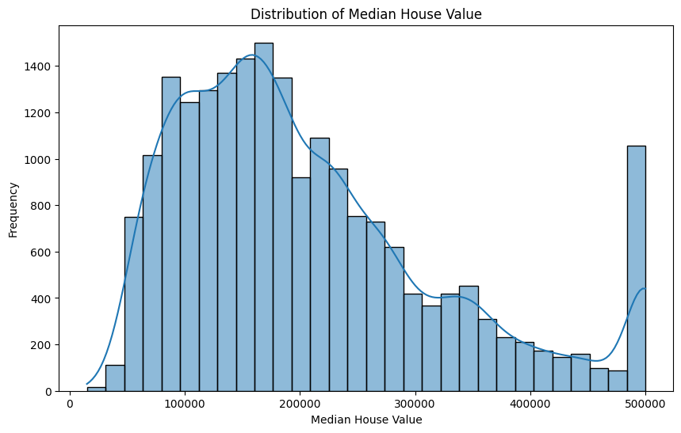

sns.pairplot(df, x_vars=features, y_vars='median_house_value', kind='reg', height=5)

plt.show()

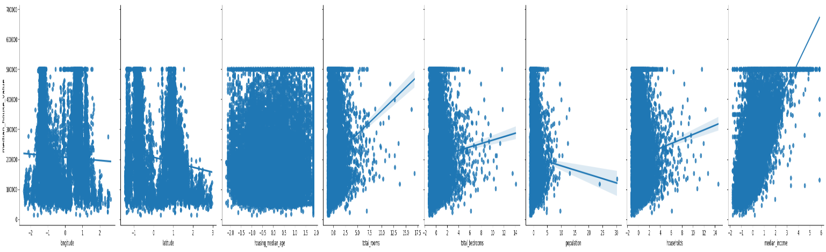

corr_matrix = df.corr()

plt.figure(figsize=(12, 8))

sns.heatmap(corr_matrix, annot=True, cmap='coolwarm', fmt='.2f', linewidths=0.5)

plt.title('Correlation Matrix')

plt.show()

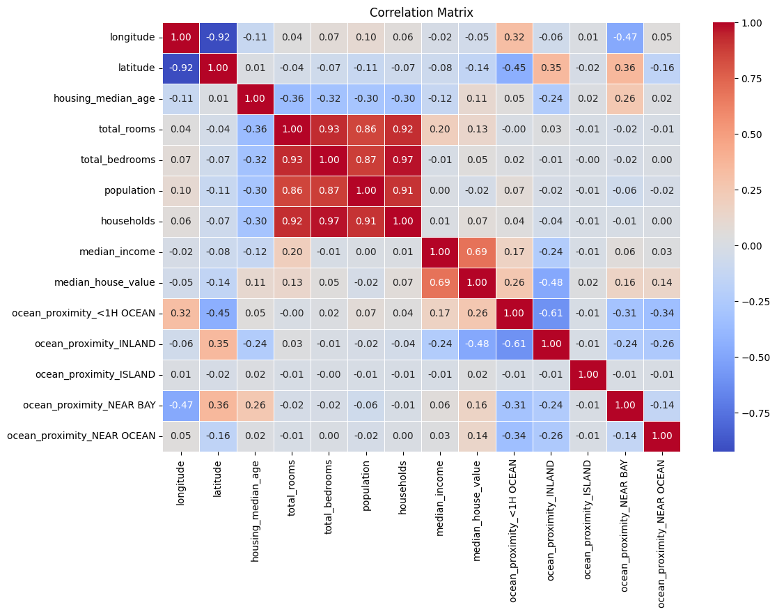

# Boxplot to identify outliers

plt.figure(figsize=(10, 6))

sns.boxplot(data=df, x='median_house_value')

plt.title('Boxplot of Median House Value')

plt.show()

# Option to handle outliers: Remove outliers using the IQR method

Q1 = df['median_house_value'].quantile(0.25)

Q3 = df['median_house_value'].quantile(0.75)

IQR = Q3 - Q1

df = df[~((df['median_house_value'] < (Q1 - 1.5 * IQR)) | (df['median_house_value'] > (Q3 + 1.5 * IQR)))]

# Verify the removal of outliers

plt.figure(figsize=(10, 6))

sns.boxplot(data=df, x='median_house_value')

plt.title('Boxplot of Median House Value After Removing Outliers')

plt.show()

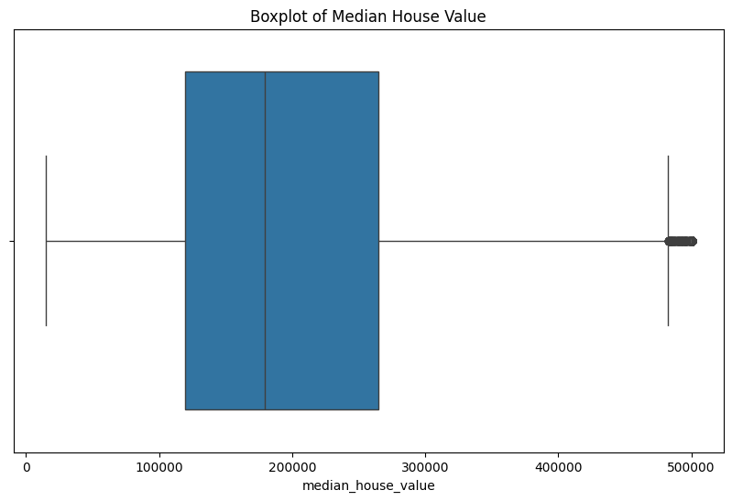

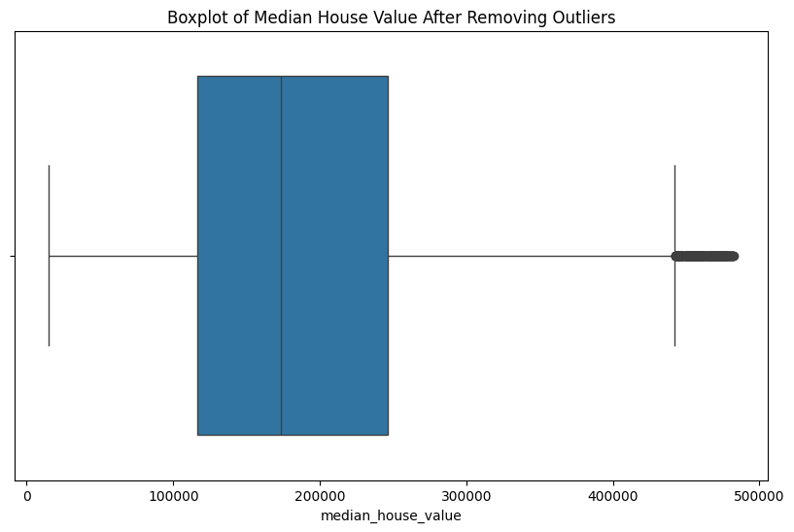

# Initialize the Linear Regression model

lr = LinearRegression()

# Fit the model to the training data

lr.fit(X_train, y_train)

# Predict on the test data

y_pred = lr.predict(X_test)

# Calculate the Mean Squared Error and R-squared value

mse = mean_squared_error(y_test, y_pred)

r2 = r2_score(y_test, y_pred)

print(f'Mean Squared Error: {mse}')

print(f'R-squared Value: {r2}')

# Visualize the predicted vs actual values

plt.figure(figsize=(10, 6))

plt.scatter(y_test, y_pred, alpha=0.5)

plt.xlabel('Actual Median House Value')

plt.ylabel('Predicted Median House Value')

plt.title('Actual vs Predicted Median House Value')

plt.show()

Mean Squared Error: 3587617293.3291674

R-squared Value: 0.6120740998708538

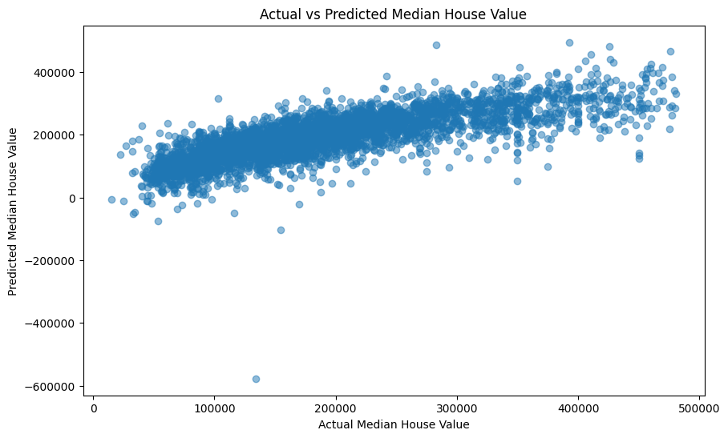

from sklearn.model_selection import cross_val_score

# Perform 5-fold cross-validation

cv_scores = cross_val_score(lr, X, y, cv=5, scoring='neg_mean_squared_error')

cv_mse = -cv_scores

cv_mse_mean = cv_mse.mean()

print(f'Cross-Validated Mean Squared Error: {cv_mse_mean}')

Cross-Validated Mean Squared Error: 3904461854.3761964

ridge = Ridge()

# Define the hyperparameter grid

param_grid = {'alpha': [0.1, 1, 10, 100, 1000]}

# Initialize the GridSearchCV object

grid_search = GridSearchCV(ridge, param_grid, cv=5, scoring='neg_mean_squared_error')

grid_search.fit(X_train, y_train)

# Get the best hyperparameters

best_params = grid_search.best_params_

ridge_best = Ridge(alpha=best_params['alpha'])

ridge_best.fit(X_train, y_train)

y_pred_ridge = ridge_best.predict(X_test)

mae_ridge = mean_absolute_error(y_test, y_pred_ridge)

mse_ridge = mean_squared_error(y_test, y_pred_ridge)

r2_ridge = r2_score(y_test, y_pred_ridge)

print(f'Best Ridge Alpha: {best_params["alpha"]}')

print(f'Mean Absolute Error (Ridge): {mae_ridge}')

print(f'Mean Squared Error (Ridge): {mse_ridge}')

print(f'R-squared Value (Ridge): {r2_ridge}')

Mean Absolute Error: 44610.13010189545

Mean Squared Error: 3587617293.3291674

R-squared Value: 0.6120740998708538

Cross-Validated Mean Squared Error: 3904461854.3761964

Best Ridge Alpha: 1

Mean Absolute Error (Ridge): 44611.1815161389

Mean Squared Error (Ridge): 3587476327.8117924

R-squared Value (Ridge): 0.6120893423481706