**Abstract**

A language translator or text translator is a tool to translate text, words, phrases from one language to any other language. It is like a dictionary where we can translate the text.

**Language Translator using Google Translate APIs in Python**– Instantly Translate texts, words, phrases from one language to another.

Translation enables communication between people from different regions. It provides meaningful communication from one language to another language.

In this project, the user enters text in any language and get it translated in any other language by selecting the output language.

**Table of Content**

1. Introduction
2. Existing Method
3. Proposed method with Architecture
4. Methodology
5. Implementation
6. Conclusion

**Introduction**

The objective of this project is to translate text from one language to any other language in real-time with a button click. This project will be built using the Tkinter, googletrans libraries.

In this Language Translator python project. We will use the popular tkinter library for rendering graphics on a display window, googletrans library to translate text from one language to another.

We will see how to translate text, how to create Combobox, buttons widget, and pass the function to the button. In this way, we build a Language Translator.

**Existing Method**

To implement this project, we will use the basic concepts of Python, Tkinter and googletrans libraries.

Tkinter is a standard GUI Python library. *ttk module* gives access to the Tk themed widget set.

googletrans is a module to translate text. We import the Translator from googletrans, which is used to do translations. We also import LANGUAGES from googletrans which lists all supported languages in a Python dictionary.

Note: Please install the following using pip command

pip install tkinter

pip install googletrans

Following versions are used in this project:

* googletrans googletrans==3.1.0a0
* python 3.8

**Proposed Method with Architecture**

We use tkinter library to create a window where we’ll enter the text which we want to convert into voice.

* **Tk()** initialized tkinter which means window created
* **geometry()** set the width and height of the window
* **resizable(0,0)** set the fixed size of the window
* **bg** = ‘’ use to set the background color
* **title()** used to set the title of the window
* **Label()** widget use to display one or more than one line of text that users aren’t able to modify.
  + **root** is the name which we refer to our window
  + **text** which we display on the label
  + **font** in which the text is written
  + **pack** organized widget in block
* **Text()** widget is used for multiple text lines.
* **wrap = WORD** will stop the line after the last word that will fit.
* **padx** puts an extra bit of space to the left and right of the widget.
* **pady** adds an extra bit of space to the top and bottom.
* **language** gets all the values from the ‘LANGUAGES’ dictionary in the form of a list.
* **ttk.Combobox()** widget is a class of ttk modules. It is a drop-down list, which can hold multi-value and show one item at a time. Combobox is useful to select one option from many option.

The Translate function will translate the message and give the output.

* **src** gets the language selected as input text language
* **dest** gets the language select to translate
* **text** gets the input text entered by the user.”1.0″ means that the input should be read from zero characters to line one
* The **END** part **means** to read the text until the end is reached
* translator = Translator() used to create a Translator class object
* **Output_text.delete(1.0, END)** delete all the text from line one to end
* **Output_text.insert (END, translated.text)** will insert the translated text in Output_text

**Button()** widget used to display button on our window

* **command** is called when we click the button
* **activebackground** sets the background color to use when the button is active

**root.mainloop()** is a method that executes when we want to run our program.

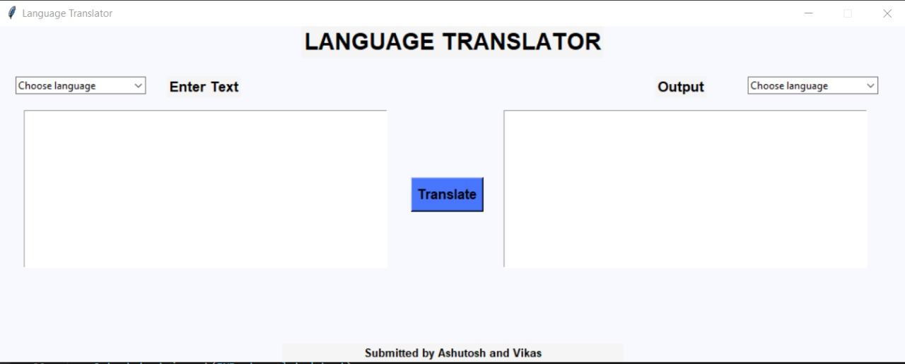

**Implementation**

Here’s the implementation of the Language Translator Project:

Step 1: Import the required modules

from tkinter import *

from tkinter import ttk

from googletrans import Translator, LANGUAGES

Step 2: Create A Display Window

root = Tk()

root.geometry('1080x400')

root.resizable(0,0)

root.config(bg = 'ghost white')

Step 3: Create an Input-Output Text Widget

label(root,text ="Enter Text", font = 'arial 13 bold', bg ='white smoke').place(x=200,y=60)

input_text = Text(root,font = 'arial 10', height = 11, wrap = WORD, padx=5, pady=5, width = 60)

input_text.place(x=30,y = 100)

label(root,text ="Output", font = 'arial 13 bold', bg ='white smoke').place(x=780,y=60)

output_text = Text(root,font = 'arial 10', height = 11, wrap = WORD, padx=5, pady= 5, width =60)

output_text.place(x = 600 , y = 100)

Step 4: Define Combobox to Select the preferred Language

language = list(LANGUAGES.values())

src_lang = ttk.Combobox(root, values= language, width =22)

src_lang.place(x=20,y=60)

src_lang.set('Choose input language')

dest_lang = ttk.Combobox(root, values= language, width =22)

dest_lang.place(x=890,y=60)

dest_lang.set('Choose output language')

Step 5: Define the function which will translate the text

def Translate():

translator = Translator()

translated=translator.translate(text= input_text.get(1.0, END) , src = src_lang.get(), dest = dest_lang.get())

output_text.delete(1.0, END)

output_text.insert(END, translated.text)

Step 6: Create a Translate Button

trans_btn = Button(root, text = 'Translate',font = 'arial 12 bold',pady = 5,command = Translate , bg = 'royal blue1', activebackground = 'sky blue')

trans_btn.place(x = 490, y= 180 )

root.mainloop()

**Conclusion**

We have provided a button so that it will be easy to translate any language to the desired language with input text section and output text section

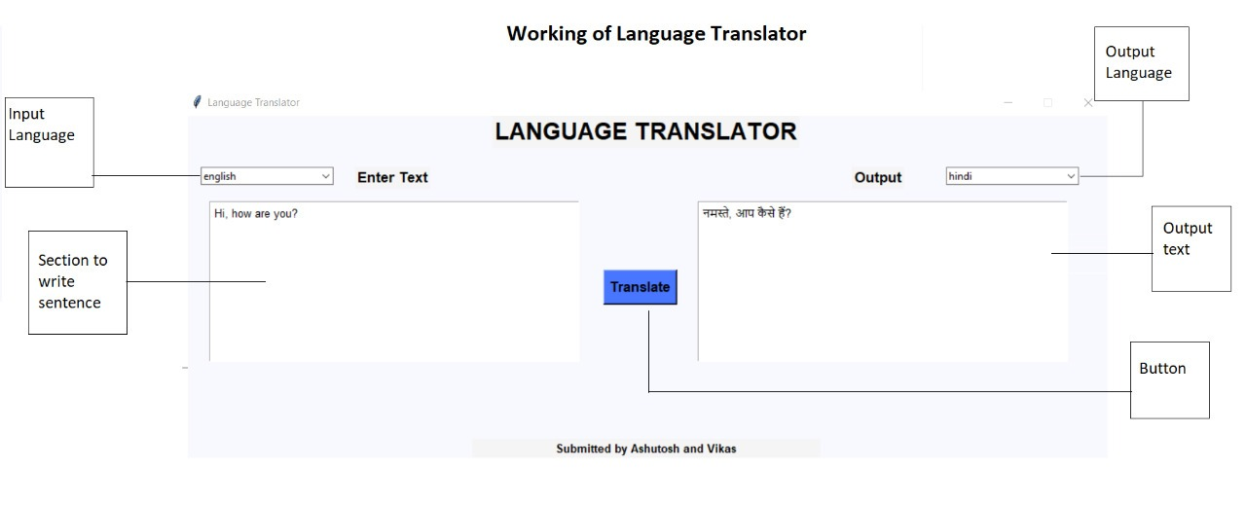

Final Product

Please install googletrans 3.1 (pip install googletrans==3.1.0a0) and for using this software, make sure you are connected to the internet.