# Configure the XBee Coordinator AT

## Step 1

Click on ‘Discover Radio Modules’ to discover the newly connected XBee. After selecting the serial port to scan, click next and select 57600 Baud Rate as well.

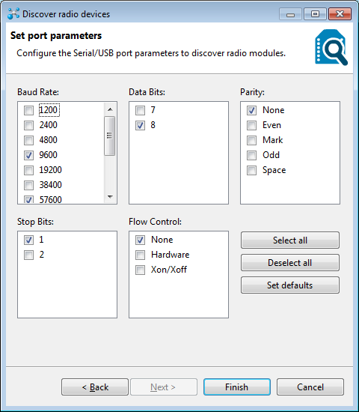

## Step 2

Click on ‘Add Selected Devices’

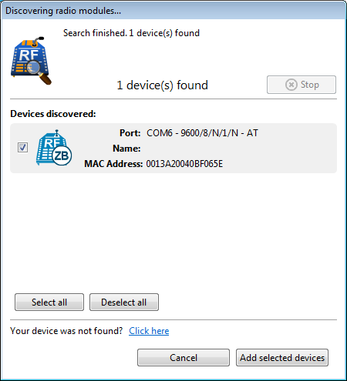

## Step 3

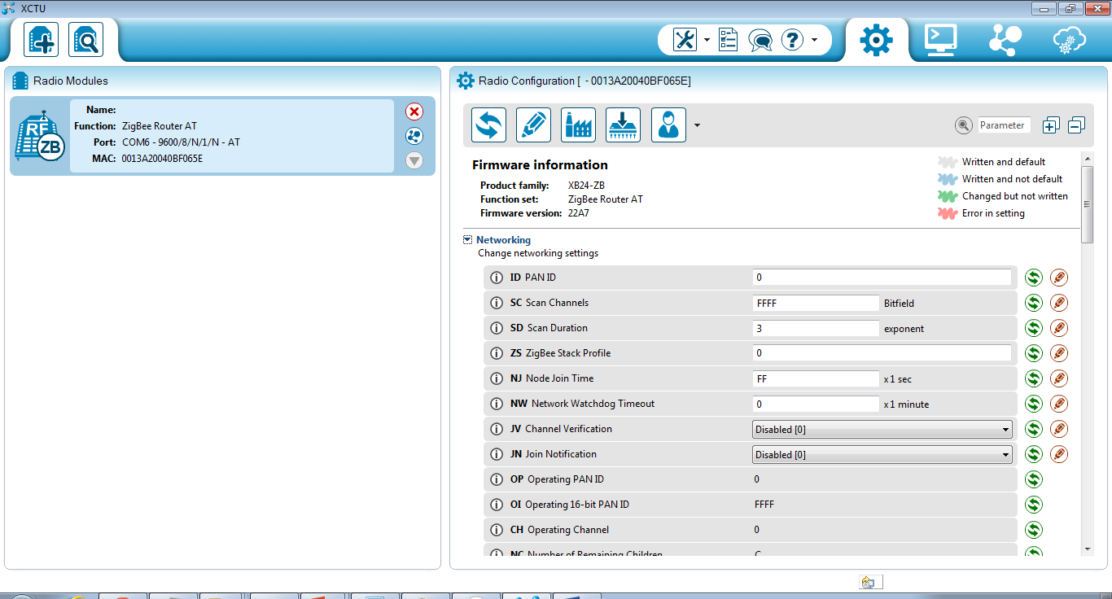

## Step 4

Click on Tools🡪Firmware Explorer. Select ‘XB24-ZB’ as the product family and ‘ZigBee Coordinator AT’ as the Function Set. Also chose the latest firmware version. Also set ‘2222’ as the PAN ID. Save this profile into the file system as coordinator.xml

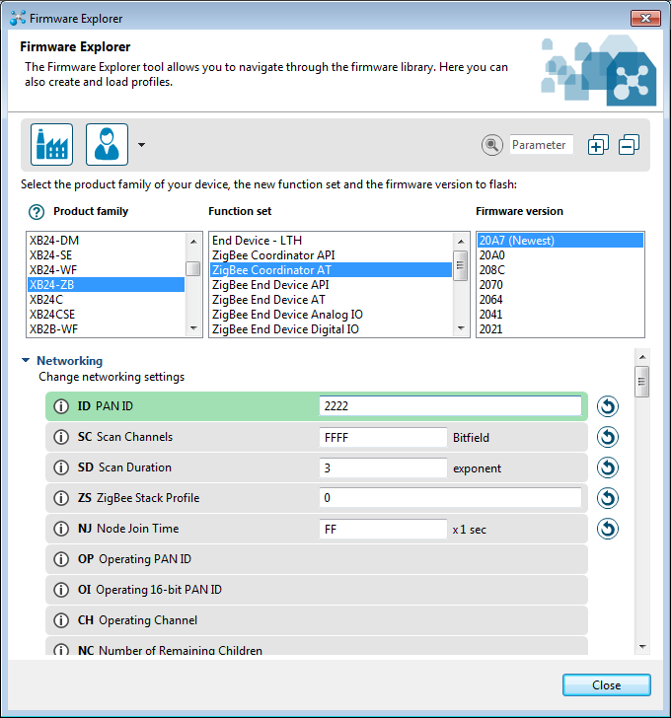

## Step 5

Update the latest Firmware to the XBee as shown below by loading the profile saved above

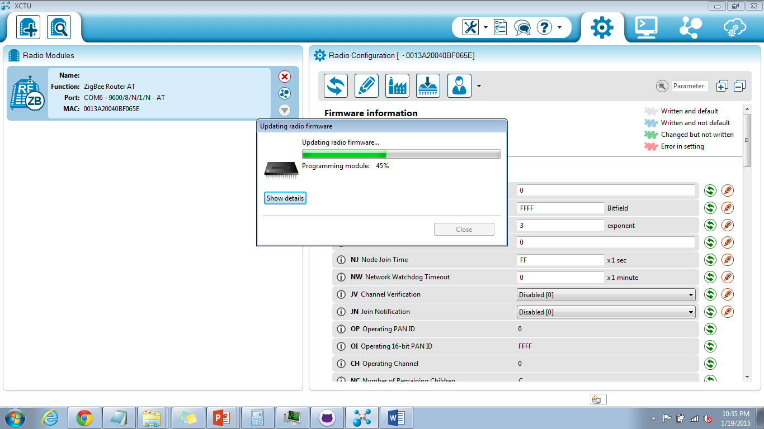

## Step 6

Once done, discover and add the XBee again. It is now discovered as a coordinator

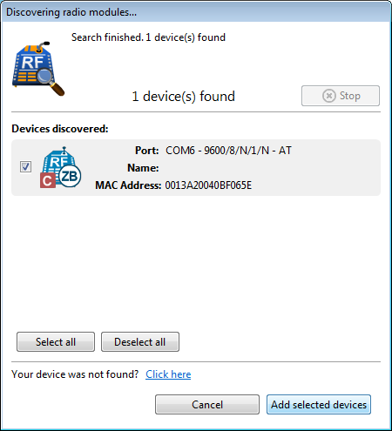

## Step 7

Update the ID and ‘Write’ the radio settings into the XBee.

-----------------------------------------------------------------------------------------------------------------------------------------------

# Configure the XBee Router AT

## Step1

Click on ‘Discover Radio Modules’ to discover the newly connected XBee. After selecting the serial port to scan, click next and select 57600 Baud Rate as well.



## Step2

Click on ‘Add Selected Devices’

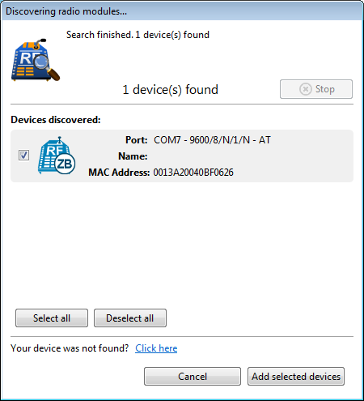

## Step3

Click on Tools🡪Firmware Explorer. Select ‘XB24-ZB’ as the product family and ‘ZigBee Router AT’ as the Function Set. Also chose the latest firmware version. Also set ‘2222’ as the PAN ID. Save this profile into the file system as Router.xml

Perform this step even if the XBee is pre-configured as a router so as to upgrade the firmware.

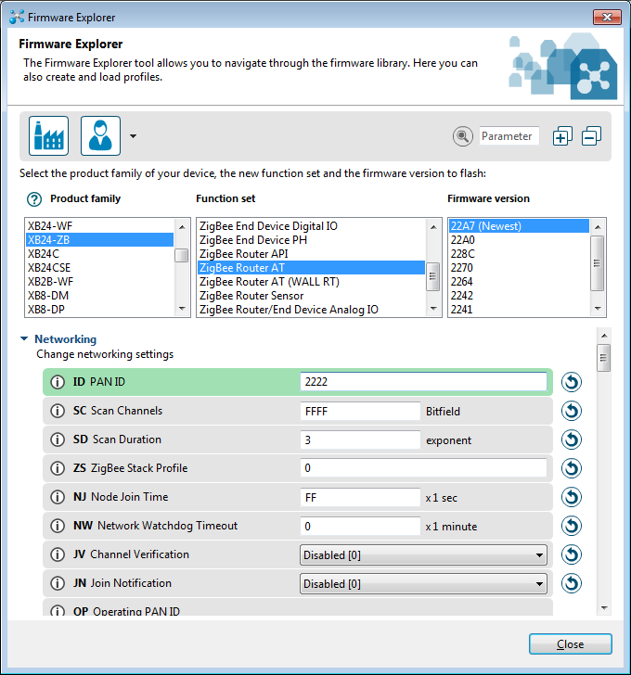

## Step 4

Update the latest Firmware to the XBee as shown below by loading the profile saved above. Set the PAN ID to ‘2222’. Set the Destination Address High and Low to the first 6 digits (13A200) of the Coordinator ZigBee and the remaining digits (40BF065E) respectively. Save this profile into the file system as Router.xml

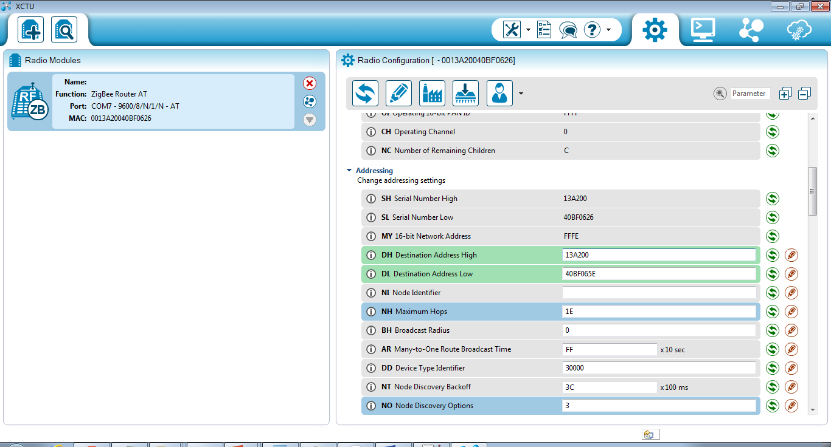

## Step 5

‘Write’ the radio settings into the XBee

# Additional configurations for the XBee Coordinator AT

## Step1

Connect the Coordinator AT XBee and click to configure it. Set the Destination Address High and Low to the first 6 digits (13A200) of the Router ZigBee and the remaining digits (40BF0626) respectively. Overwrite the saved profile in the file system for coordinator.xml

