2014

Vikas Kollur Vijayakumar

12/12/2014

Design for Autonomous Vehicle

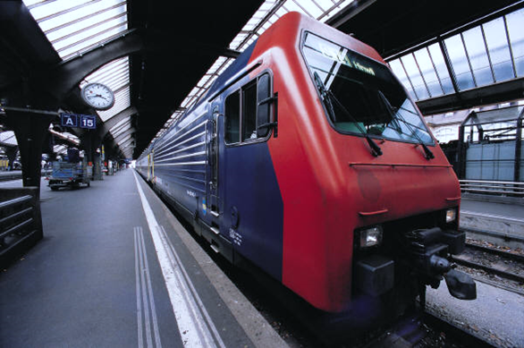

Contents

1. Introduction 3

2. Architecture 4

System Roles 4

Technical Components 4

**No table of figures entries found.**

# Introduction

This project will attempt to create an autonomous vehicle which would be able to navigate by sensing its environment and without the need of any human input.

# System Architecture

## 2.1 Roles

The below diagram displays the various technical roles expected to be performed by the system in order to make this project a success



|  |  |
| --- | --- |
| Role | Description |
| Video Camera | Would record the movements at the front end of the vehicle and transmit it back to the learning algorithm at real-time |
| AI | Machine learning algorithm which has been trained and hence would generate the appropriate command for the steering controller based on the inputs received from the Video Camera |
| Steering Controller | Controls the vehicle movement by providing an ability to–   * Steering front * Steering back * Steering to right * Steering to left |

## 2.2 Role to Component Map