## Data Ingestion from the RDS to HDFS using Sqoop

Below are the steps performed to ingest the data from RDS table into Hive table using the sqoop command:

1. Log in into EMR instance and complete the initial setup by running the below commands. This is to download the MySQL connector, which will be used by sqoop to set up jdbc connection with table in MySQL RDS:

wget https://de-mysql-connector.s3.amazonaws.com/mysql-connector-java-8.0.25.tar.gz

tar -xvf mysql-connector-java-8.0.25.tar.gz

cd mysql-connector-java-8.0.25/

sudo cp mysql-connector-java-8.0.25.jar /usr/lib/sqoop/lib/

**Sqoop command used for importing table from RDS to HDFS**

1. **Sqoop command to import card_member table from RDS to Hive**

sqoop import \

--connect jdbc:mysql://upgradawsrds1.cyaielc9bmnf.us-east-1.rds.amazonaws.com/cred_financials_data \

--table card_member \

--username upgraduser --password upgraduser \

--hive-import \

--hive-table card_member \

--create-hive-table \

--fields-terminated-by ',' \

-m 1

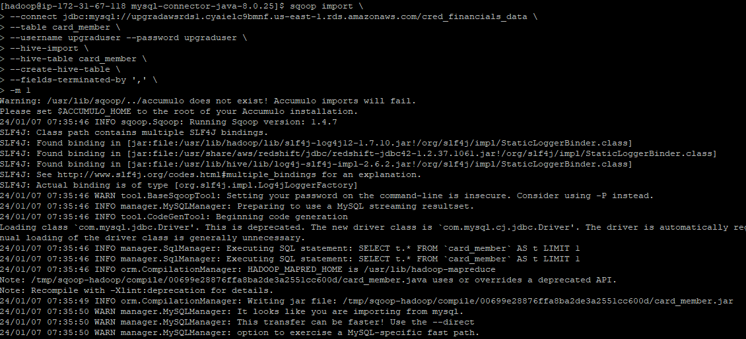

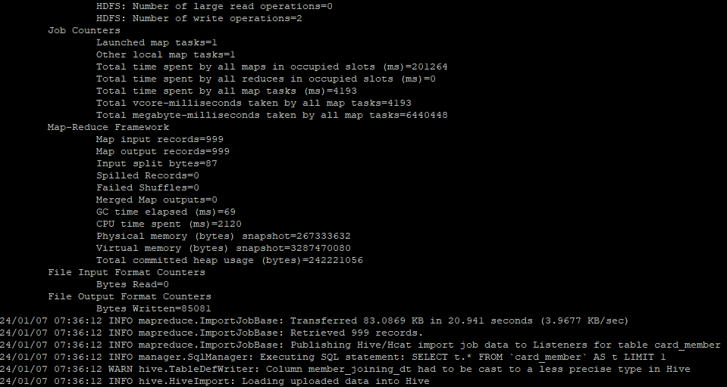

1. **Sqoop command to import member_score table from RDS to Hive**

sqoop import \

--connect jdbc:mysql://upgradawsrds1.cyaielc9bmnf.us-east-1.rds.amazonaws.com/cred_financials_data \

--table member_score \

--username upgraduser --password upgraduser \

--hive-import \

--hive-table member_score \

--create-hive-table \

--fields-terminated-by ',' \

-m 1

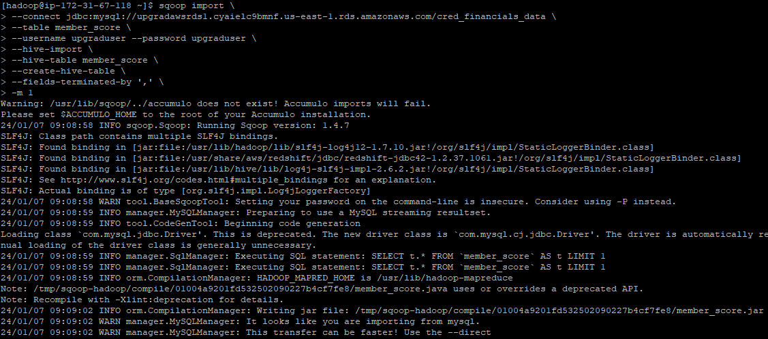

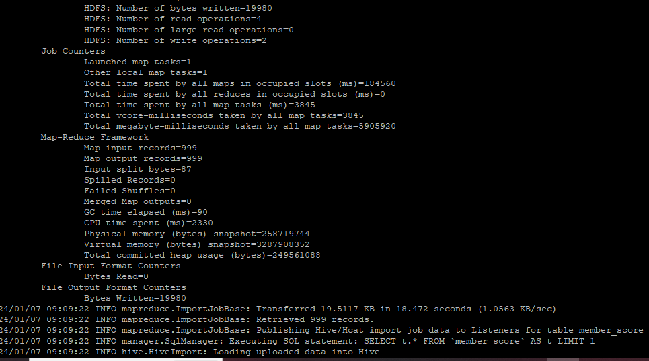

**<Command to see the list of imported data in HDFS>**

hadoop fs -ls /user/hive/warehouse/

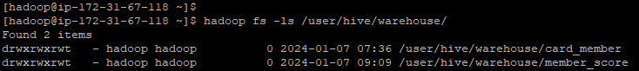

**Screenshot of the imported data**

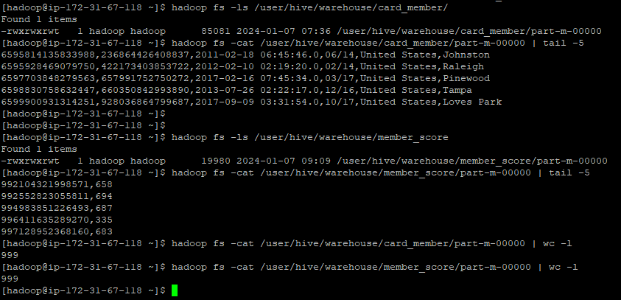

**Screenshot of the imported data in Hive:**

1. select count(*) from card_member;

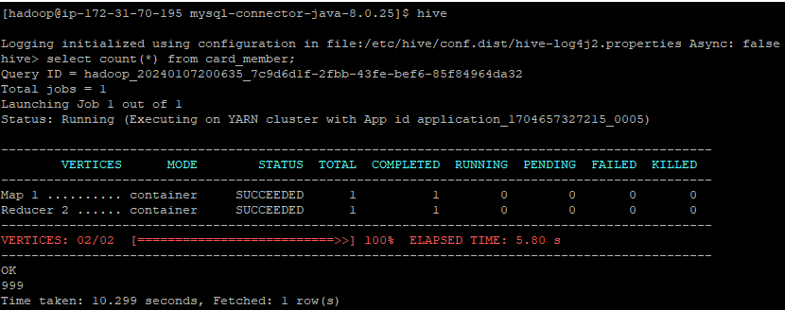

1. select count(*) from member_score;

