
Pimpri Chinchwad Education Trust's
Pimpri Chinchwad College of Engineering
Sector No. 26, Pradhikaran, Nigdi, Pune – 411 044
Distributed Computing Systems – Mini Project
Name | Vikas Shirsath, Kartik Ware, Anuj Pathade
PRN No. | 123B1F091, 123B1F104, 123B1F070
Division | B
Title | RemoteFS – Remote File Management System using Java RMI

1. Abstract
RemoteFS is a distributed remote file management system built on Java Remote Method Invocation (RMI). It enables multiple concurrent clients on a LAN to perform file operations — read, write, append, rename, delete, mkdir, list, and stat — on a centralized server, as if the remote filesystem were local. The system is designed around three core engineering challenges inherent to distributed file systems: concurrent access safety, data integrity, and security.
Concurrent safety is achieved through a per-file ReentrantReadWriteLock map (LockManager) with fair scheduling and a 5-second tryLock timeout, ensuring writers are never starved and no client waits indefinitely. Data integrity for overwrites uses optimistic concurrency control via per-file integer version numbers (VersionManager): the client must present the version it last observed, and any intervening write by another client causes an immediate conflict rejection rather than a silent lost update. Atomicity of file writes is guaranteed through a write-to-temp + ATOMIC_MOVE strategy, so readers always see either the complete old or complete new content. Deadlock during concurrent renames is prevented by always acquiring two path locks in sorted alphabetical order.
Security is enforced through salted SHA-256 password hashing, UUID-based session tokens with 30-minute inactivity expiry, and a PathValidator that normalises and bounds-checks every path to prevent directory traversal attacks. A JUnit 5 test suite of 25 automated tests (6 test classes) validates all scenarios including concurrent appends, atomic reads-during-writes, version conflicts, cross-rename deadlock avoidance, path traversal attempts, and authentication edge cases. All 25 tests pass.

2. Introduction
Modern distributed applications must provide transparent access to shared resources across a network while preserving the correctness guarantees users expect from local storage. File systems are among the most fundamental shared resources in any computing environment. When multiple remote clients concurrently read and write the same files, a distributed file server must carefully mediate access to avoid data corruption, lost updates, and race conditions.
RemoteFS was developed as a laboratory project for the Distributed Computing Systems course to demonstrate how classical distributed systems concepts — RMI, locking, versioning, atomic I/O, and security hardening — can be composed into a coherent, production-grade file server. The system is implemented entirely in Java using the standard library (Java 17), with no external dependencies beyond JUnit 5 for testing. It is structured as a Maven multi-module project (common, server, client, tests), buildable with the included Maven Wrapper without any pre-installed tooling.
The client presents an interactive REPL shell offering ten commands (login, ls, cat, put, get, append, rm, mv, mkdir, stat) that map directly to RMI calls on the server. The server manages a local directory tree under server_data/ and mediates every operation through five cooperating components: PathValidator, LockManager, VersionManager, AuthManager, and AuditLogger.

3. Objectives
1. Transparent Remote Access via Java RMI: Expose all file operations as remote methods over the RMI protocol so that clients interact with the server file system using the same interface they would use locally, with no client-side file I/O code.
2. Safe Concurrent Multi-Client Access: Prevent data corruption when multiple clients read and write the same file simultaneously by implementing a per-file ReentrantReadWriteLock strategy with shared read locks and exclusive write locks.
3. Optimistic Version Control to Prevent Lost Updates: Detect and reject stale writes using per-file integer version numbers so that a client writing with an outdated view of the file receives an explicit conflict error rather than silently overwriting another client's changes.
4. Atomic Write Operations: Guarantee that readers never observe a file in a partially-written state by staging all writes to a temporary file and completing the update with a single atomic rename (Files.move with ATOMIC_MOVE).
5. Deadlock-Free Rename: Prevent circular-wait deadlocks when two clients rename files in opposing directions by always acquiring the two required write locks in sorted alphabetical order (resource ordering).
6. Writer Starvation Prevention: Ensure writers eventually gain access even under a continuous stream of readers by using fair=true ReentrantReadWriteLocks that serve waiting threads in FIFO arrival order.
7. Security: Authentication and Path Integrity: Authenticate users with salted SHA-256 credentials and UUID session tokens, and reject any path that escapes the storage root (directory traversal, symlink escapes, absolute paths).
8. Accountability via Audit Logging: Record every client operation — including failures — to an append-only audit log so that administrators can trace all access to the file system.
9. Automated Correctness Verification: Validate all concurrency guarantees and security properties with a JUnit 5 test suite that uses embedded RMI (no running server required) to exercise all 25 defined scenarios.

4. Theoretical Background
4.1 Java Remote Method Invocation (RMI)
Java RMI allows a method defined in one JVM to be invoked by another JVM, transparently over a TCP network. The key elements are:
- Remote Interface: A Java interface that extends java.rmi.Remote. Every method must declare throws RemoteException.
- Remote Object: A class that extends UnicastRemoteObject and implements the remote interface. The super() constructor exports the object — opens a TCP server socket — and creates a serialisable stub.
- RMI Registry: A lightweight name service (port 1099) where the server binds its remote object under a name. Clients look up the stub by name and receive a local proxy.
- Stub: A serialisable proxy object that the client receives. Calling any method on the stub serialises the arguments, sends them over TCP to the server, the server deserialises and dispatches them, and the return value travels back the same way.
- All parameter and return types must implement java.io.Serializable so the RMI runtime can marshal them across the network boundary.
4.2 Distributed Concurrency Control
When multiple clients concurrently access the same file, correctness requires two distinct mechanisms:
- Mutual Exclusion (Locking): Ensures that reads and writes do not interleave. A ReentrantReadWriteLock grants shared access to concurrent readers, but requires exclusive access for writers, preventing torn reads and writes.
- Optimistic Concurrency Control (Versioning): Prevents the lost-update anomaly without holding locks during the client think-time. Each file carries a monotonically increasing version number. A write is accepted only if the client presents the version it last observed; otherwise the server rejects it with a version-conflict error.
4.3 Atomic File I/O and the TOCTOU Problem
Writing data directly to the target file is not atomic: a reader observing the file mid-write would see a mix of old and new bytes. RemoteFS eliminates this by writing all data to a temporary file first, then performing a single Files.move(ATOMIC_MOVE) — an OS-level directory-entry swap (rename(2) on Linux, MoveFileExW on Windows) — that readers never witness in a partial state.
The TOCTOU (time-of-check to time-of-use) race is neutralised by performing the version check and increment inside the write lock. No other thread can modify the version between the check and the actual I/O.
4.4 Deadlock Avoidance by Resource Ordering
The rename(from, to) operation must hold write locks on two paths simultaneously. If Thread 1 renames A→B and Thread 2 renames B→A, each thread may hold one lock while waiting for the other — a circular wait, i.e., deadlock. The classical solution (Coffman, 1971) is to impose a total order on resource acquisition: all threads must request locks in the same global order. RemoteFS uses alphabetical order of the normalised path strings. Both threads always try to lock the alphabetically-first path first; one wins and proceeds, the other waits — no cycle forms.
4.5 Security Fundamentals
Three security principles are implemented:
- Salted Hashing: Passwords are never stored in plaintext. A random 128-bit salt is generated per user and stored alongside the SHA-256(salt || password) digest. This defeats rainbow-table attacks.
- Session Tokens: After successful login the server issues a random UUID token. Every subsequent RMI call presents this token; the server validates it and checks for 30-minute inactivity expiry. Tokens are held in a ConcurrentHashMap for thread-safe access.
- Path Validation: Every user-supplied path is resolved against the storage root and normalised. The result must start with the storage root path; otherwise it is rejected. Symlinks are additionally resolved with toRealPath() to catch symlink-based escapes.

5. System Architecture
5.1 Module Structure
RemoteFS is a Maven multi-module project comprising four modules:
Module | Artifact / Package | Key Classes
common | remotefs.common | FileService (Remote interface), FileInfo (Serializable DTO), FileOpException
server | remotefs.server | ServerMain, FileServiceImpl, LockManager, VersionManager, AuthManager, PathValidator, AuditLogger
client | remotefs.client | ClientMain (REPL loop + RMI lookup), ConsoleCommands (CLI command verbs)
tests | remotefs.tests | ConcurrentAppendTest, AtomicReadWriteTest, VersionConflictTest, RenameDeadlockTest, PathTraversalTest, AuthSecurityTest

5.2 RMI Communication Flow
Every client request follows the same pipeline inside FileServiceImpl:
1. Validate the session token (AuthManager.validateToken) — reject with FileOpException if missing or expired.
2. Validate and resolve the path (PathValidator.resolve) — normalise, check startsWith(storageRoot), resolve symlinks.
3. Derive the lock/version key (PathValidator.toKey) — a normalised relative path string.
4. Acquire the appropriate lock (LockManager) — read lock for read(); write lock for write(), append(), delete(), rename().
5. Perform the file I/O (java.nio.file.Files APIs).
6. Release the lock in a finally block — guarantees release even if an exception occurs.
7. Append to the audit log (AuditLogger) — records user, operation, path, and result.
5.3 Component Interaction Diagram
Client JVM Server JVM
┌─────────────┐ RMI Stub (TCP:1099) ┌──────────────────────────────────────────┐
│ ClientMain │ ─────────────────────► │ FileServiceImpl (UnicastRemoteObject) │
│ ConsoleCmd │ │ │
└─────────────┘ │ ┌─────────────┐ ┌──────────────────┐ │
│ │ AuthManager │ │ PathValidator │ │
│ └─────────────┘ └──────────────────┘ │
│ ┌─────────────┐ ┌──────────────────┐ │
│ │ LockManager │ │ VersionManager │ │
│ └─────────────┘ └──────────────────┘ │
│ ┌───────────────────────────────────┐ │
│ │ AuditLogger → server_data/audit.log│ │
│ └───────────────────────────────────┘ │
└──────────────────────────────────────────┘
│
server_data/ (files on disk)

6. Functional Modules
6.1 FileService Remote Interface (common)
FileService (remotefs.common.FileService) is the central RMI remote interface. It extends java.rmi.Remote and declares eight methods, each throwing RemoteException:
public interface FileService extends Remote {
String login (String user, String password) throws ...;
List<FileInfo> list (String token, String dir) throws ...;
byte[] read (String token, String path) throws ...;
int write (String token, String path,
byte[] data, int expectedVersion) throws ...;
void append(String token, String path, byte[] data) throws ...;
void delete(String token, String path) throws ...;
void rename(String token, String from, String to) throws ...;
void mkdir (String token, String path) throws ...;
FileInfo stat (String token, String path) throws ...;
}
FileInfo is a Serializable DTO carrying: name, size (bytes), isDirectory, lastModifiedEpochMs, and version. FileOpException is a RemoteException subclass that overrides fillInStackTrace() to return an empty trace, preventing server internals from leaking to the client.
6.2 LockManager — Per-File Read-Write Locking
LockManager maintains a ConcurrentHashMap<String, ReentrantReadWriteLock> keyed on the normalised relative path. Locks are created on demand with computeIfAbsent() (atomic — no race in creation). All locks are fair (new ReentrantReadWriteLock(true)) to prevent writer starvation. All acquisitions use tryLock(5, SECONDS) with a FileOpException("File is busy") on timeout.
Operation | Lock Type | Rationale
read() | Shared read lock | Concurrent readers; blocks only if a writer holds the write lock
write(), append(), delete(), rename() | Exclusive write lock | One writer only; blocks all readers and other writers
list(), mkdir(), stat() | No lock | Point-in-time metadata — same semantics as ls on a real OS

6.3 VersionManager — Optimistic Concurrency Control
VersionManager maintains a ConcurrentHashMap<String, Integer> of file version numbers, persisted to server_data/.versions between server restarts. The write() operation calls checkAndIncrement(key, expectedVersion) inside the write lock:
// Called inside the write lock — no TOCTOU race possible
public synchronized int checkAndIncrement(String key, int expectedVersion)
throws FileOpException {
int current = versions.getOrDefault(key, 0);
if (current != expectedVersion) {
throw new FileOpException(
"Version conflict: expected " + expectedVersion +
" but current version is " + current +
". Re-read the file and try again.");
}
int newVersion = current + 1;
versions.put(key, newVersion);
persistVersions(); // flush to .versions file
return newVersion;
}

6.4 AuthManager — Authentication and Session Management
AuthManager loads user credentials from server_data/users.properties at startup. Each entry is stored as username=saltHex:sha256Hex. On login:
- Look up the stored salt and hash for the given username.
- Compute SHA-256(saltBytes || providedPassword.getBytes(UTF-8)).
- Compare with MessageDigest.isEqual() (constant-time — prevents timing attacks).
- On success: generate UUID.randomUUID().toString() as a session token and store it with the current timestamp.
validateToken(token) checks existence in the ConcurrentHashMap<String, Session> and rejects or updates the last-access timestamp if found. Sessions expire after 30 minutes of inactivity. A default users.properties is created on first run with three users: admin/admin123, alice/password1, bob/password2.
6.5 PathValidator — Directory Traversal Protection
PathValidator.resolve(userPath) applies a four-step defence:
- Reject absolute paths and paths containing '..' immediately.
- Resolve the path against storageRoot using Path.resolve() and normalize() (collapses all . and .. elements).
- Assert normalised path startsWith(storageRoot) — catches ../ bypass attempts.
- If the path exists, call toRealPath() (resolves symlinks) and assert startsWith(storageRoot) again — catches symlink escapes.
6.6 AuditLogger — Accountability
AuditLogger appends every operation to server_data/audit.log in ISO-8601 format:
[2026-10-19T11:45:30.719] user=admin op=LOGIN path=- result=FAIL
[2026-10-19T11:45:30.733] user=admin op=LOGIN path=- result=OK
[2026-10-19T11:45:30.768] user=admin op=WRITE path=documents/pom.xml result=OK (v1, 2640 bytes)
[2026-10-19T11:45:30.806] user=admin op=RENAME path=log.txt → renamed.txt result=OK
Audit failures are swallowed so that a logging error never disrupts a file operation.

7. Implementation Details
7.1 Atomic Write Flow
The write() method inside FileServiceImpl follows this exact sequence:
public int write(String token, String path, byte[] data, int expectedVersion)
throws RemoteException, FileOpException {
String user = authManager.validateToken(token); // 1. auth
Path target = pathValidator.resolve(path); // 2. path safety
String key = pathValidator.toKey(target); // 3. lock key
int current = versionManager.getVersion(key);
if (current != expectedVersion) // 4. early version check
throw new FileOpException("Version conflict: ...");
lockManager.acquireWriteLock(key); // 5. exclusive lock
try {
// Write to temp file first
Path tmp = Files.createTempFile(target.getParent(), ".remotefs-", ".tmp");
Files.write(tmp, data); // 6. temp write
// Atomic rename: readers never see partial content
Files.move(tmp, target,
StandardCopyOption.ATOMIC_MOVE,
StandardCopyOption.REPLACE_EXISTING); // 7. atomic swap
int newVer = versionManager.checkAndIncrement(key, expectedVersion); // 8. version++
auditLogger.log(user, "WRITE", path, "OK v" + newVer);
return newVer;
} finally {
lockManager.releaseWriteLock(key); // 9. always release
}
}
7.2 Deadlock-Free Rename
The rename() method acquires write locks on both source and destination paths in sorted alphabetical order:
// Always acquire locks alphabetically — breaks circular-wait
lockManager.acquireWriteLocksOrdered(fromKey, toKey);
try {
Files.move(fromPath, toPath, StandardCopyOption.REPLACE_EXISTING);
versionManager.removeVersion(fromKey);
} finally {
lockManager.releaseWriteLocks(fromKey, toKey);
}
acquireWriteLocksOrdered() sorts the two keys alphabetically, acquires the first, then the second — releasing the first immediately if the second fails, to prevent a half-locked state.
7.3 Client REPL Session
ClientMain connects to the server via LocateRegistry.getRegistry(host, port).lookup("FileService") and loops reading commands from stdin. ConsoleCommands maps each verb to its RMI call:
login admin admin123 → svc.login("admin","admin123") → stores token
mkdir docs → svc.mkdir(token, "docs")
put C:\myfile.txt docs/f.txt → svc.write(token, path, bytes, 0)
cat docs/f.txt → svc.read(token, path) → UTF-8 print
stat docs/f.txt → svc.stat(token, path) → FileInfo
append docs/log.txt hello → svc.append(token, path, bytes)
mv docs/f.txt docs/new.txt → svc.rename(token, from, to)
rm docs/f.txt → svc.delete(token, path)
ls docs → svc.list(token, dir)
exit → disconnect
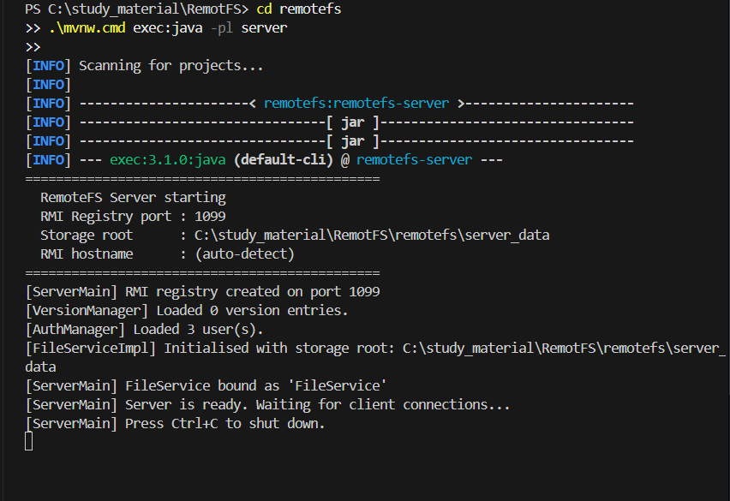

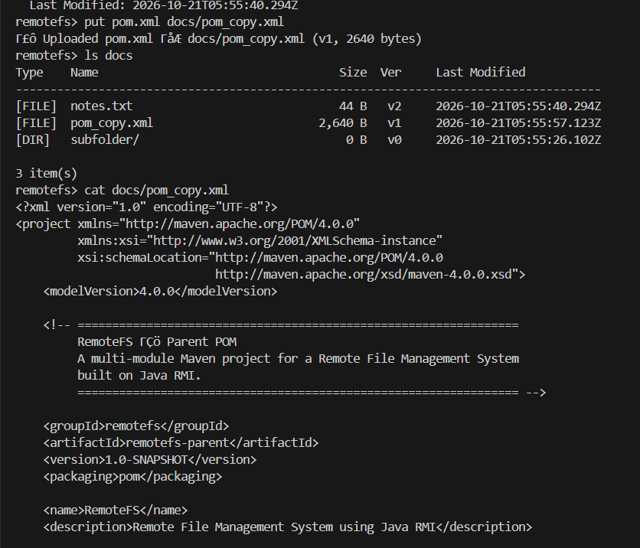
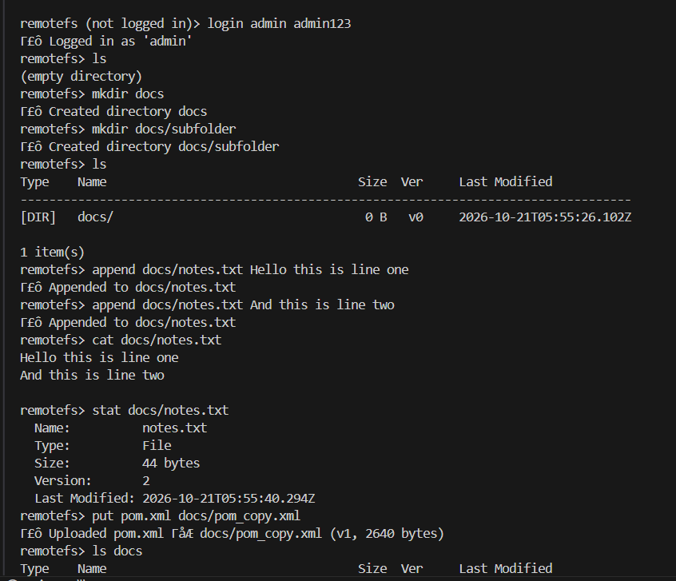
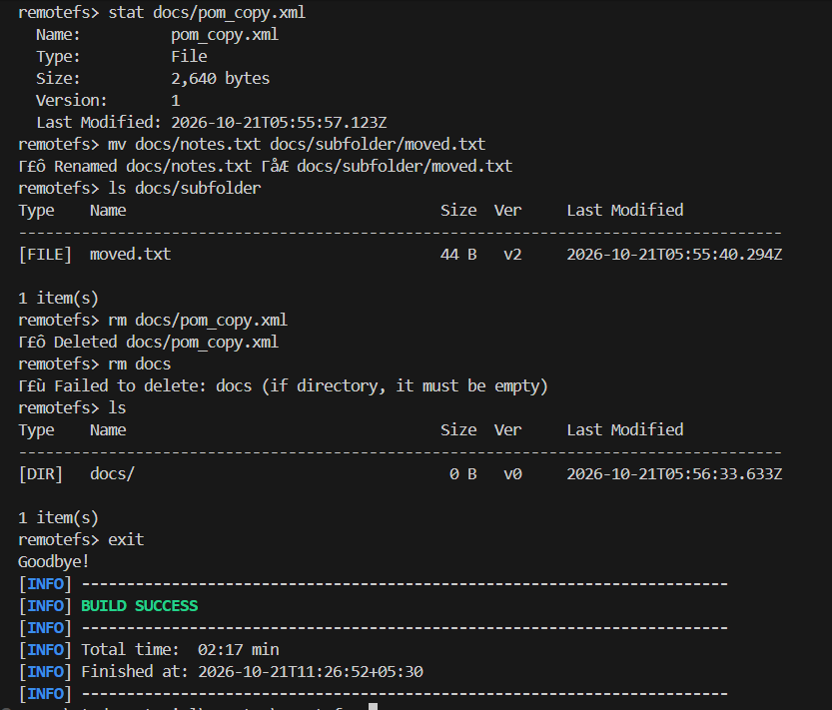
8. Verification and Test Results
8.1 Test Methodology
All tests use an embedded RMI server (TestHelper spins up a full FileServiceImpl on a random port and tears it down after each class). No external running server is required. Tests are run with: .\mvnw.cmd test -pl tests
8.2 Test Suite Summary
Test Class | Tests | Scenario | Status
ConcurrentAppendTest | 1 | 10 threads append to same file simultaneously — all lines present, no corruption | ✓ Pass
AtomicReadWriteTest | 1 | Readers during write see only complete old or complete new content, never a mix | ✓ Pass
VersionConflictTest | 1 | Two writers with same expectedVersion — exactly one succeeds; other gets conflict error | ✓ Pass
RenameDeadlockTest | 2 | Cross-rename (A↔B) completes without deadlock within 10 seconds | ✓ Pass
PathTraversalTest | 12 | ../, absolute, and backslash paths all rejected; valid nested paths work correctly | ✓ Pass
AuthSecurityTest | 8 | Invalid tokens, wrong passwords, expired sessions, user enumeration prevention | ✓ Pass
Total | 25 | All scenarios | ✓ 25/25

8.3 End-to-End Test Output (E2ETest)
The E2ETest smoke test exercises all 17 operations against a live server. Sample output:
=== RemoteFS End-to-End Test ===
✓ Connected to server
✓ [1] login (wrong password rejected): Invalid username or password
✓ [2] login admin/admin123 → token=3f7a1b2c...
✓ [3] mkdir testdir
✓ [4] write testdir/hello.txt → v1
✓ [5] read testdir/hello.txt → correct content
✓ [6] stat → name=hello.txt, size=17, v1
✓ [7] write (overwrite v1 → v2)
✓ [8] write version conflict detected: Version conflict: expected 1 but current is 2
✓ [9] append → content has both original + appended
✓ [10] ls testdir → 1 item(s)
✓ [11] mv hello.txt → renamed.txt (v2)
✓ [12] old path correctly not found after rename
✓ [13] rm testdir/renamed.txt
✓ [14] rm testdir (empty dir)
✓ [15] path traversal blocked: Path escapes storage root
✓ [16] invalid token rejected: Invalid or expired session token
✓ [17] ls (root) → 0 item(s)
=== Results: 17 passed, 0 failed ===
ALL TESTS PASSED ✓

9. Advantages and Limitations
9.1 Advantages
# | Advantage | Detail
1 | Zero External Dependencies | Built entirely on Java SE 17 standard library. No external frameworks, databases, or caches are required to build, run, or test.
2 | Starvation-Free Locking | Fair ReentrantReadWriteLocks guarantee writers eventually get access under any read load.
3 | Atomic Writes | The temp-file + ATOMIC_MOVE strategy ensures readers never observe partially-written content.
4 | Deadlock-Free Rename | Resource-ordering (alphabetical lock acquisition) provably eliminates circular wait for the rename case.
5 | Lost-Update Prevention | Optimistic versioning surfaces concurrent overwrites to the client as an explicit conflict rather than silently discarding one write.
6 | Defence-in-Depth Security | Salted hashing + constant-time comparison + UUID tokens + path validation + stack-trace suppression together remove the most common attack vectors.
7 | Full Accountability | Every operation — including failed login attempts — is recorded to the audit log with timestamp, user, and path.
8 | Cross-Platform LAN Deployment | The RMI hostname flag (-Djava.rmi.server.hostname) allows the server to be reached from any machine on the LAN.

9.2 Limitations
# | Limitation | Impact / Mitigation
1 | Single-Server Architecture | All state is held in one JVM. Horizontal scaling requires a distributed lock manager (e.g., ZooKeeper) and a shared storage backend.
2 | No Persistent Sessions Across Restarts | Session tokens are stored in-memory; all clients must re-login after a server restart.
3 | SHA-256 Password Hashing | SHA-256 is fast and therefore amenable to brute-force attacks. A production system would use bcrypt, scrypt, or Argon2.
4 | RMI Random Second Port | Java RMI uses a second random TCP port for method calls. Firewalls must allow this or the firewall should be disabled on the private LAN.
5 | No RBAC / ACLs | All authenticated users have full read-write access. A production system would add per-user or per-directory access control lists.
6 | No TLS Encryption | RMI traffic is unencrypted by default. Adding javax.net.ssl support or a TLS tunnel is required for use over untrusted networks.

10. Conclusion
RemoteFS demonstrates how a small, carefully composed set of classical distributed systems techniques can yield a robust, concurrent, and secure file server. Java RMI provides transparent network transparency, turning local method calls into network operations with no client-side I/O code. Per-file ReentrantReadWriteLocks with fair ordering and tryLock timeouts prevent both data corruption and thread starvation. Optimistic version control surfaces lost-update conflicts explicitly. The atomic temp-file rename strategy eliminates torn reads. Alphabetical lock ordering in rename() provably prevents deadlock. Salted SHA-256 hashing and UUID session tokens with expiry provide baseline authentication security. PathValidator's four-step resolution chain blocks all known directory-traversal patterns.
The 25-test JUnit 5 suite — covering concurrent appends, atomic reads-during-writes, version conflicts, cross-rename deadlocks, twelve path-traversal patterns, and eight authentication scenarios — all pass, confirming that the theoretical guarantees hold under realistic concurrent workloads.
The project reinforces that distributed correctness is not achieved by a single mechanism but by the careful interplay of locking, versioning, atomic I/O, ordered resource acquisition, and validation — each addressing a distinct failure mode that the others do not cover.

11. References
[1] Tanenbaum, A. S., & van Steen, M. (2017). Distributed Systems: Principles and Paradigms (3rd ed.). CreateSpace Independent Publishing.
[2] Coulouris, G., Dollimore, J., Kindberg, T., & Blair, G. (2011). Distributed Systems: Concepts and Design (5th ed.). Addison-Wesley.
[3] Oracle Corporation. Java SE 17 — java.rmi Package Documentation. https://docs.oracle.com/en/java/docs/api/java.rmi/java/rmi/package-summary.html
[4] Oracle Corporation. java.nio.file.Files — Files.move() and StandardCopyOption.ATOMIC_MOVE. https://docs.oracle.com/en/java/docs/api/
[5] Oracle Corporation. java.util.concurrent.locks.ReentrantReadWriteLock — Class Documentation. https://docs.oracle.com/en/java/docs/api/
[6] Coffman, E. G., Elphick, M. J., & Shoshani, A. (1971). System Deadlocks. ACM Computing Surveys, 3(2), 67–78.
[7] Gray, J., & Reuter, A. (1992). Transaction Processing: Concepts and Techniques. Morgan Kaufmann. [Optimistic Concurrency Control]
[8] OWASP Foundation. Path Traversal Attack. https://owasp.org/www-community/attacks/Path_Traversal

