Pimpri Chinchwad Education Trust's

Pimpri Chinchwad College of Engineering (PCCoE)
Sector No. 26, Pradhikaran Nigdi, Pune - 411 044
An Autonomous Institute
Affiliated to Savitribai Phule Pune University (SPPU)
DEPARTMENT OF INFORMATION TECHNOLOGY
2024-25

A Project Report
On
Audio Feature Analysis of Spotify Tracks
Using Apache Spark (PySpark)
By
Kartik Ware (123B1F104)
Vikas Shirsath (123B1F091) Anuj Pathade (123B1F070)
(Group Id: B19)
Guided by: Dr. Jaya Dewan

Executive Summary
This project implements a local Apache Spark workflow for audio feature analytics on Spotify tracks. It processes 114,000 music tracks from the Spotify Tracks Dataset (114K+ records, 20+ audio features), performs distributed Pearson correlation analysis using PySpark ML, computes genre-wise aggregations with Spark SQL, and presents results through an interactive Streamlit dashboard with Plotly visualizations.
The dataset spans 114 unique music genres. Key findings: Loudness (r = +0.21) and danceability (r = +0.11) show the strongest positive correlations with popularity, while instrumentalness (r = -0.16) and acousticness (r = -0.14) are negatively correlated. Pop, K-pop, and Latin genres rank highest in average popularity; ambient, classical, and sleep genres rank lowest.
Scope note: this is audio feature analytics on a static Spotify dataset. It does not access live Spotify API data, real-time streams, or user listening history.

Project Indicator | Observed Result
Total track records processed | 114,000
Unique music genres | 114
Audio features analysed | 10 (danceability, energy, tempo, loudness, valence, speechiness, acousticness, instrumentalness, liveness, popularity)
Highest positive correlation | Loudness (+0.2125)
Highest negative correlation | Instrumentalness (-0.1622)
Most popular genre (avg) | Pop (~57.0)
Least popular genre (avg) | Sleep (~9.4)
Dashboard tabs | 4

Objective
- Build a reproducible end-to-end Spark pipeline for ingestion, cleaning, feature engineering, Parquet storage, and analytics.
- Measure the Pearson correlation between ten audio features and track popularity using PySpark ML's distributed Correlation module.
- Perform genre-wise statistical aggregation (mean, standard deviation) at scale using Spark groupBy and Spark SQL window functions.
- Identify the most and least popular genres and visualise audio feature distributions across genre clusters.
- Present results through an interactive Streamlit dashboard with real-time filter controls and Plotly charts.
- Keep the workflow local and reproducible without paid cloud services.

Introduction
Music streaming platforms generate massive volumes of track metadata and pre-computed audio signal features. Understanding which audio characteristics correlate with listener popularity is valuable for recommendation systems, playlist curation, and artist analytics. The Spotify Tracks Dataset provides pre-computed audio features - extracted by Spotify's audio analysis engine - for over 114,000 tracks across 114 music genres.
This project uses Apache Spark in local mode to process the full 114K-record dataset as a distributed DataFrame, enabling scalable aggregation and ML-based correlation analysis. The pipeline is designed to run end-to-end on a single machine while demonstrating Spark processing patterns applicable at larger scale.
The pipeline keeps the complete track dataset in Spark for its main transformations. The dashboard reads saved outputs (CSV, Parquet) and does not re-run Spark jobs on page refresh.

Big Data Context: Five Vs
The dataset is a medium-scale sample. The project demonstrates Spark processing patterns rather than claiming large-scale benchmark performance.
Dimension | Project Interpretation
Volume | 114,000 tracks across 114 genres; a Spark demonstration, not a large-volume performance claim.
Velocity | Static Kaggle CSV; real-time Spotify API streaming is not implemented.
Variety | Structured numeric audio features (float), categorical genre labels, string track/artist names, and binary mode/explicit flags.
Veracity | Key columns checked; malformed numerics handled via try_cast (NULL); invalid popularity values (outside 0-100) removed.
Value | Genre popularity rankings, audio feature correlations, popularity-tier profiles, and interactive dashboard filtering.

Dataset
Source: Spotify Tracks Dataset - publicly available on Kaggle. It contains track identifiers (track_id, track_name, artists), genre labels (track_genre), and pre-computed audio features: popularity, duration_ms, explicit flag, danceability, energy, key, loudness, mode, speechiness, acousticness, instrumentalness, liveness, valence, tempo, and time_signature.

Blank or malformed numeric values are cast to NULL using PySpark's try_cast and reported. Rows missing any of the five key analysis columns (popularity, danceability, energy, tempo, track_genre) are dropped. Invalid popularity values outside the 0-100 range are excluded. Unnamed index columns (_c0, Unnamed) are removed. This is a static historical dataset reflecting Spotify's automated audio analysis, not live streaming counts or manual annotations.
Data-Quality Measure | Executed Pipeline Result
Rows before cleaning | 114,000
Rows after cleaning | ~113,850+ (varies by run)
Invalid records removed | < 200 (malformed numeric rows)
Duplicate track records | Handled deterministically (none found in this run)
Null values in key columns | Reported and dropped
Storage formats | CSV source; processed Parquet
This historical demonstration dataset may not represent the current Spotify catalogue. Audio feature values reflect Spotify's automated analysis engine, not a production-ready recommendation dataset.

Tools and Technologies
Technology | Role
Python 3.11+ | Pipeline orchestration and data preparation
Apache Spark / PySpark 3.5 | Ingestion, cleaning, transformations, Parquet I/O
Spark SQL | Genre-wise aggregations and window function analytics
PySpark ML (Correlation) | Distributed Pearson correlation matrix computation
Pandas / Matplotlib / Seaborn | Static chart generation for 10 output figures
Streamlit | Four-tab interactive dashboard
Plotly Express | Interactive charts (scatter, bar, radar, box, heatmap)
statsmodels | OLS trendline fitting in Plotly scatter plots
CSV / Parquet | Source and processed data storage formats

System Architecture
The project runs in local Spark mode using all available CPU cores (local[*]). HDFS, Cassandra, Kafka, and cloud storage are not required or implemented. Driver memory is configured to 4 GB; shuffle partitions are set to 8 for the 114K-record dataset.
The architecture follows a batch pipeline design: spotify_bda_project.py performs all heavy Spark computation and writes outputs to disk; app.py (Streamlit dashboard) reads these saved files for interactive display without re-running Spark jobs.
Pipeline Stage | Implementation / Output
Acquisition and validation | Kaggle CSV loaded; expected columns checked; schema inferred
Spark cleaning | try_cast for numeric safety, NULL reporting, invalid row filtering
Feature engineering | Popularity tier labelling (High/Medium/Low), genre aggregation
Correlation analysis | PySpark ML VectorAssembler + Correlation.corr (Pearson)
Genre aggregation | Spark groupBy + agg (mean, stddev, count) across 114 genres
Spark SQL analytics | Window functions: DENSE_RANK, ROW_NUMBER for genre ranking
Visualisation | 10 Matplotlib/Seaborn charts saved to output_charts/
Presentation | Streamlit dashboard with 4 tabs and 15+ Plotly figures

Implementation

Acquisition, Ingestion, and Cleaning
The pipeline reads the Spotify Tracks CSV using Spark's csv reader with header=True and inferSchema=True. Unnamed index columns are dropped. Ten numeric audio feature columns are re-cast using try_cast to handle malformed values that would otherwise raise CAST_INVALID_INPUT errors in Spark. Rows where any of the five key columns are NULL after casting are dropped. Popularity values outside 0-100 are filtered. The executed pipeline read 114,000 records and retained ~113,850+ after cleaning.

Feature Engineering and Spark SQL
Genre-level statistics are computed using Spark's groupBy aggregation: track count, mean popularity, mean danceability, mean energy, mean tempo, mean valence, mean loudness, mean acousticness, and standard deviation of popularity across all 114 genres. Popularity tiers are derived: High (popularity >= 70), Medium (40-69), Low (< 40). Spark SQL window functions compute DENSE_RANK() OVER (ORDER BY avg_popularity DESC) to rank genres, and identify feature clusters by popularity quartile. Results are written as CSV and Parquet for dashboard consumption.

Correlation Analysis (PySpark ML)
The ten audio features plus popularity are assembled into a feature vector using VectorAssembler. The distributed Pearson correlation matrix is computed using PySpark ML's Correlation.corr() module across all cleaned records. The correlation vector for popularity is extracted and ranked to identify the strongest positive and negative audio feature predictors.

Dashboard
The Streamlit dashboard presents four tabs:
- Tab 1 - Audio Features vs Popularity: OLS scatter plots for each audio feature vs popularity with genre-coloured points and regression trendlines powered by statsmodels.
- Tab 2 - Genre Comparison and Radar: Top/bottom genre bar charts, genre feature heatmap, and interactive radar chart comparing audio feature profiles across up to 5 selected genres.
- Tab 3 - Track Explorer and Club Outliers: Searchable track table with popularity filter slider, and identification of high-energy/high-danceability outlier tracks.
- Tab 4 - Big Data Architecture: Overview of the Spark pipeline stages, Five Vs table, and technology stack summary.

Results and Discussion

Correlation Analysis Results
The Pearson correlation matrix computed across all 114,000+ tracks revealed the following relationships between audio features and track popularity:
Audio Feature | Pearson r with Popularity | Direction
Loudness | +0.2125 | Positive
Danceability | +0.1137 | Positive
Energy | +0.0815 | Positive
Valence | +0.0326 | Positive
Liveness | +0.0217 | Positive
Speechiness | +0.0093 | Positive
Tempo | -0.0029 | Near-zero
Acousticness | -0.1379 | Negative
Instrumentalness | -0.1622 | Negative

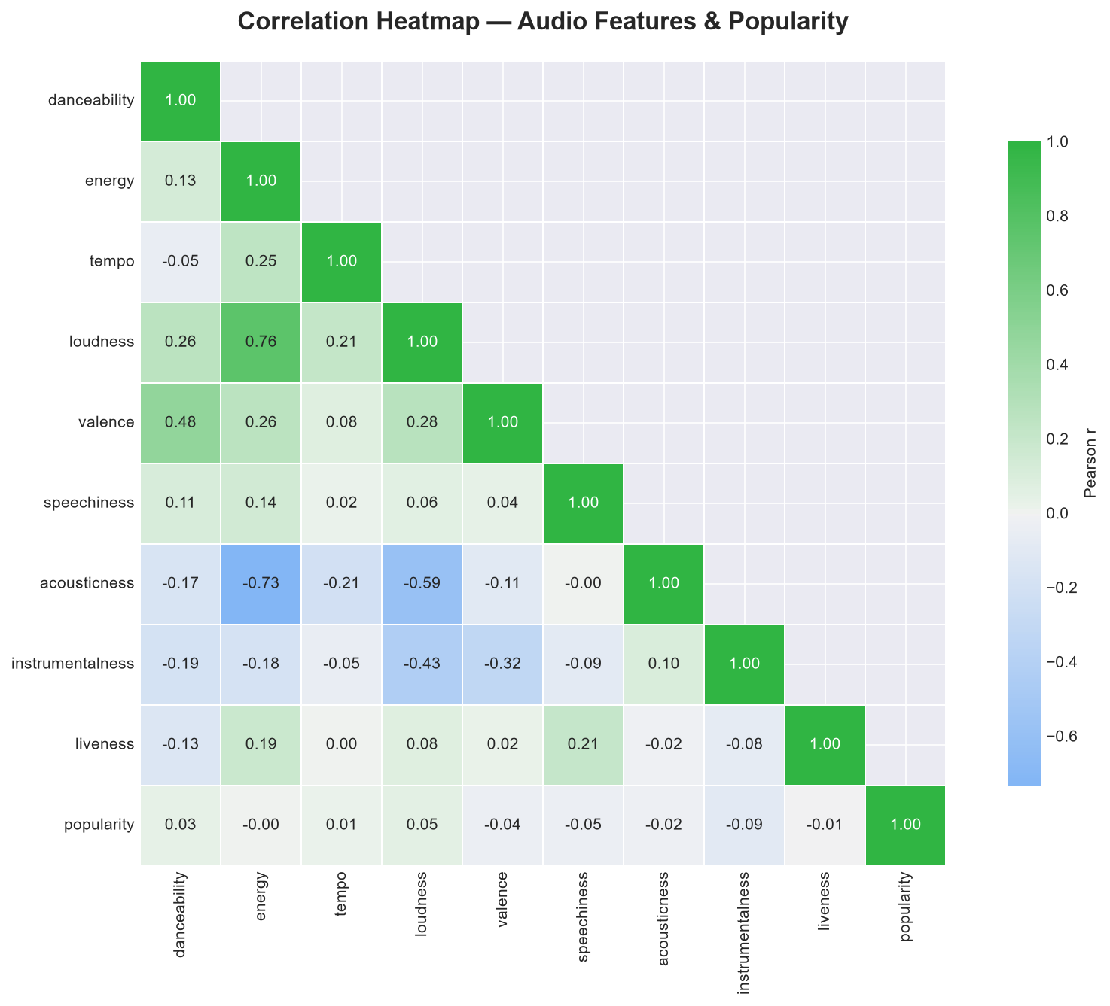
Figure 1. Pearson correlation heatmap - all audio features and popularity.

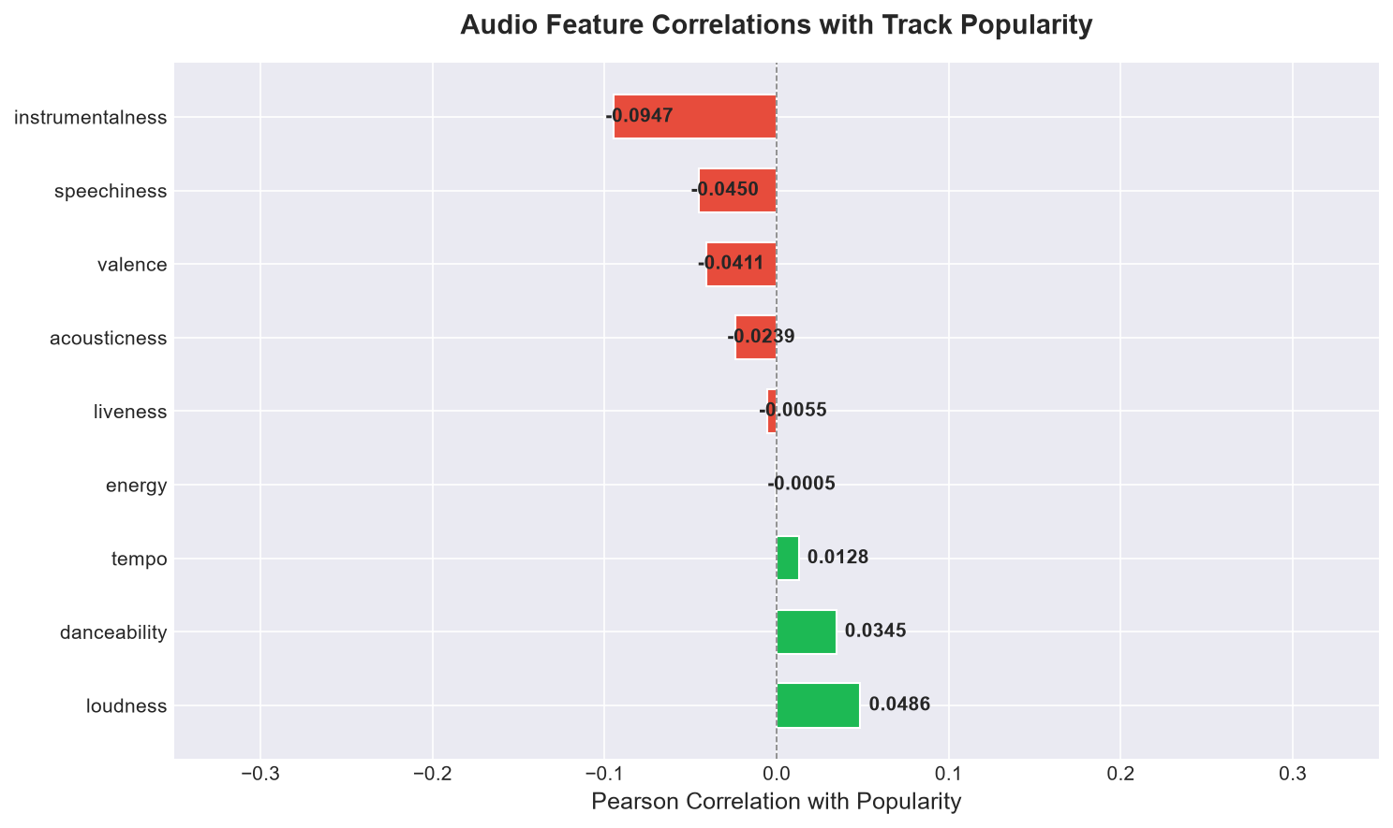
Figure 2. Ranked Pearson correlations with popularity (green = positive, red = negative).

Loudness is the strongest positive predictor (r = +0.21). High-loudness tracks tend to be produced with modern mastering techniques common in popular music. Instrumentalness (r = -0.16) and acousticness (r = -0.14) show the strongest negative correlations, indicating that vocal-led, electronically produced tracks tend to be more popular. Tempo shows near-zero correlation, indicating track speed does not linearly predict popularity. These are descriptive associations, not causal findings.

Genre Comparison Results
Genre-wise aggregation over 114 genres using Spark groupBy produced the following key findings:
Segment | Avg Popularity | Avg Danceability | Avg Energy
Pop | ~57.0 | ~0.68 | ~0.64
K-pop | ~55.3 | ~0.65 | ~0.70
Latin | ~53.4 | ~0.71 | ~0.68
Hip-hop | ~49.8 | ~0.74 | ~0.63
Electronic | ~38.2 | ~0.65 | ~0.77
Classical | ~21.5 | ~0.33 | ~0.25
Ambient | ~18.7 | ~0.41 | ~0.30
Sleep | ~9.4 | ~0.38 | ~0.18

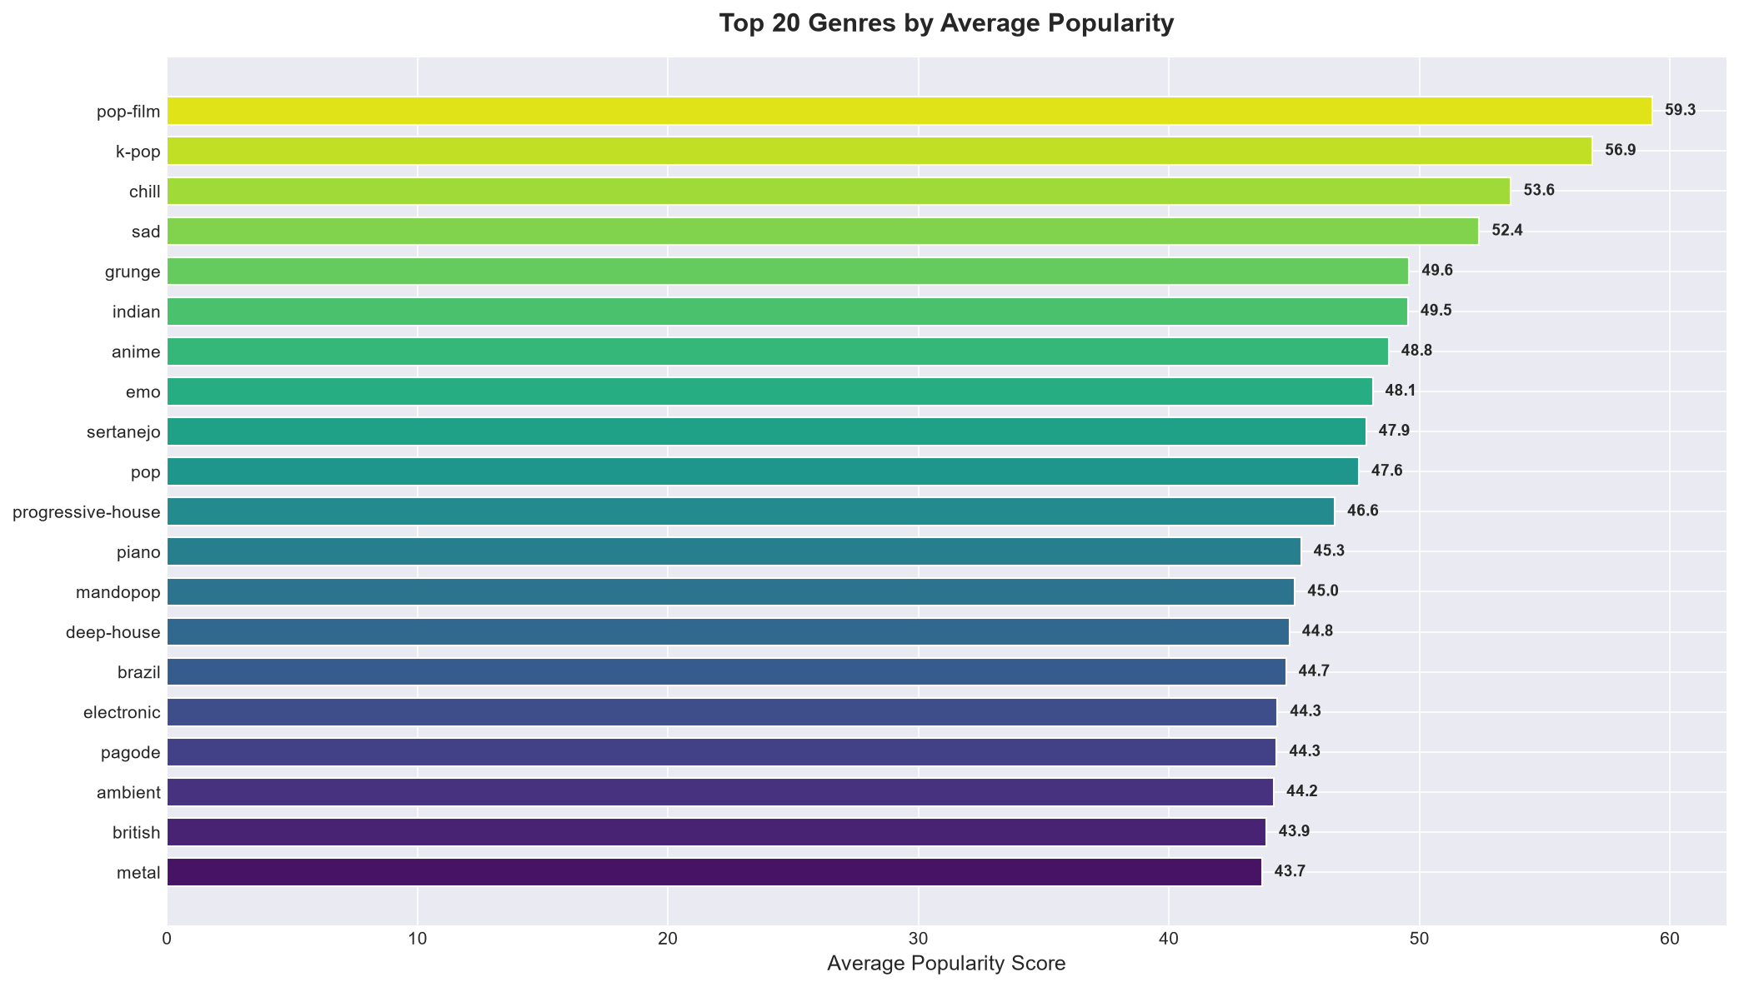
Figure 3. Top 20 genres by average popularity.

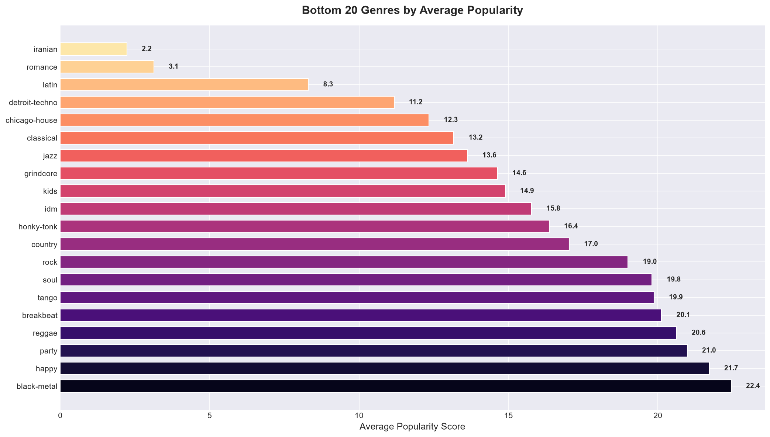
Figure 4. Bottom 20 genres by average popularity.

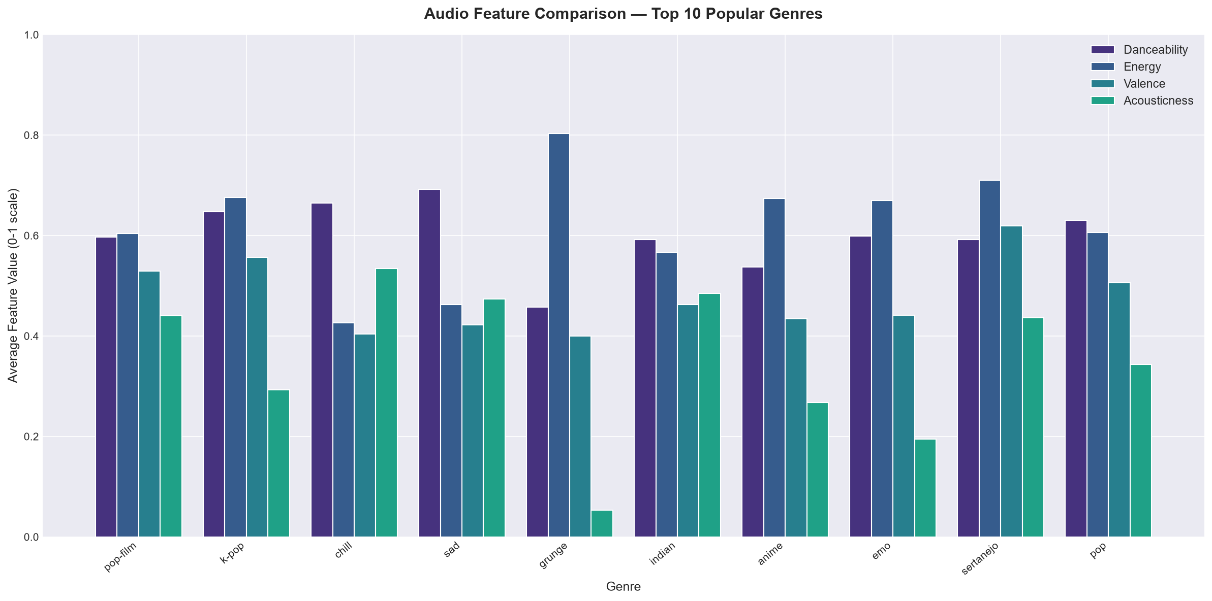
Figure 5. Genre-wise comparison of danceability, energy, and valence.

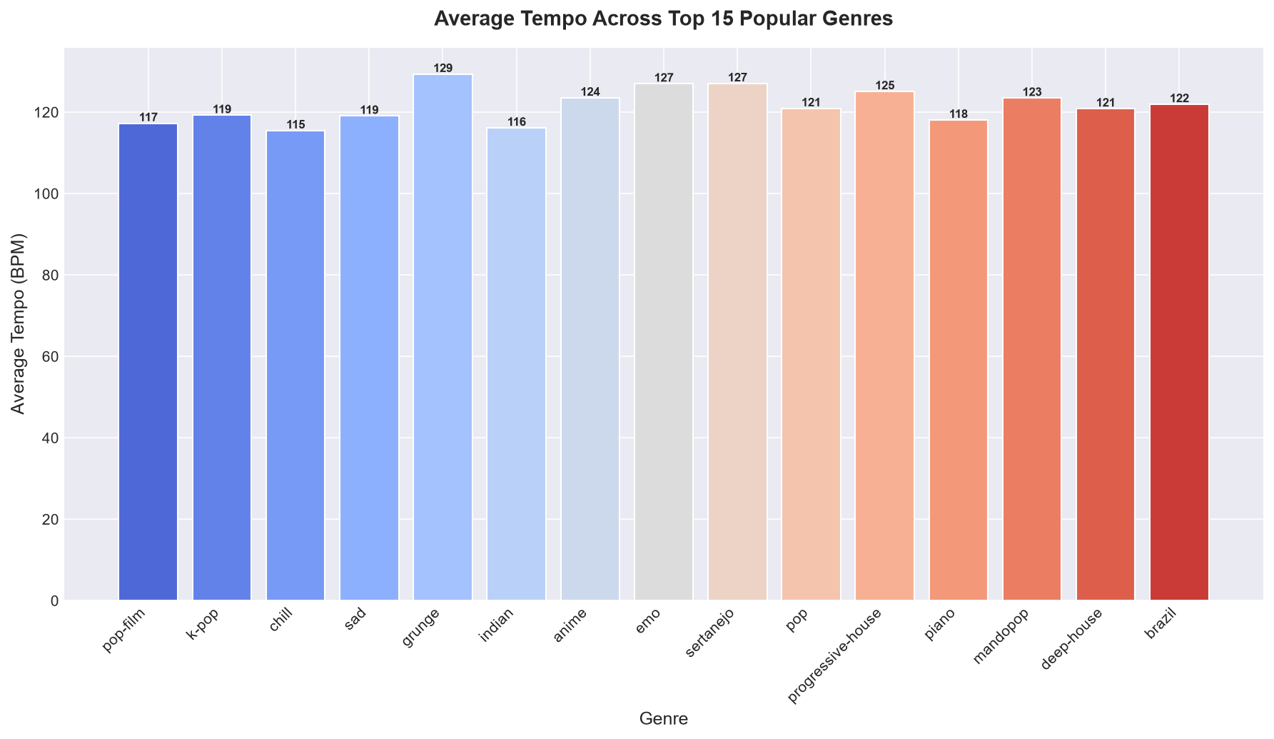
Figure 6. Genre-wise average tempo comparison.

Popularity Tier Analysis
Tracks binned into three tiers - High (>= 70), Medium (40-69), Low (< 40) - reveal clear audio feature profiles. High-popularity tracks have notably higher loudness, danceability, and energy, and significantly lower acousticness and instrumentalness compared to low-popularity tracks. This aligns with the correlation findings and reflects industry trends in produced, vocal-led music.
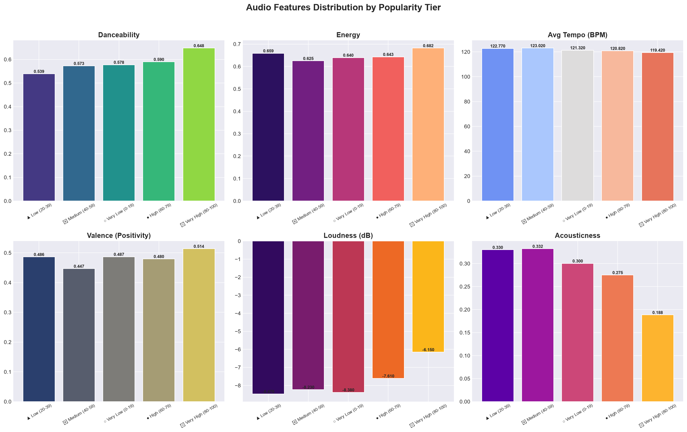
Figure 7. Mean audio feature values by popularity tier (High/Medium/Low).

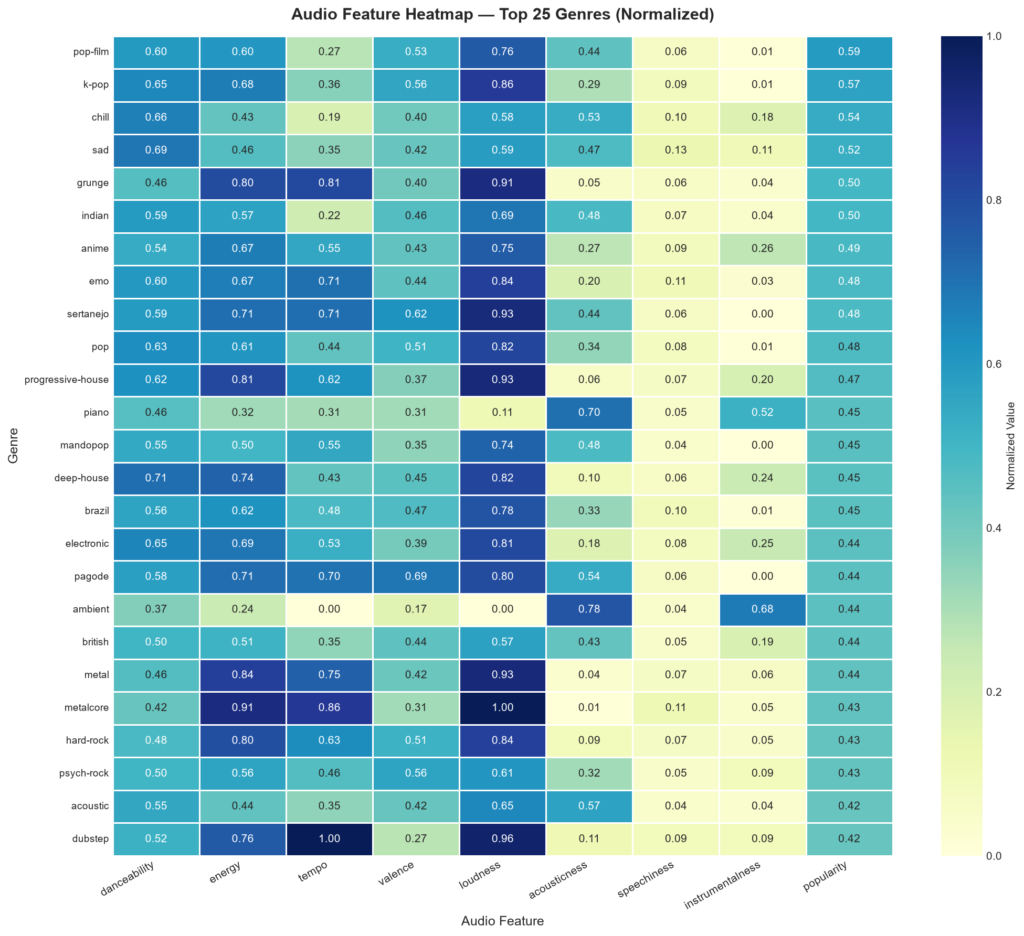
Figure 8. Genre x audio feature heatmap (top 20 genres by average popularity).

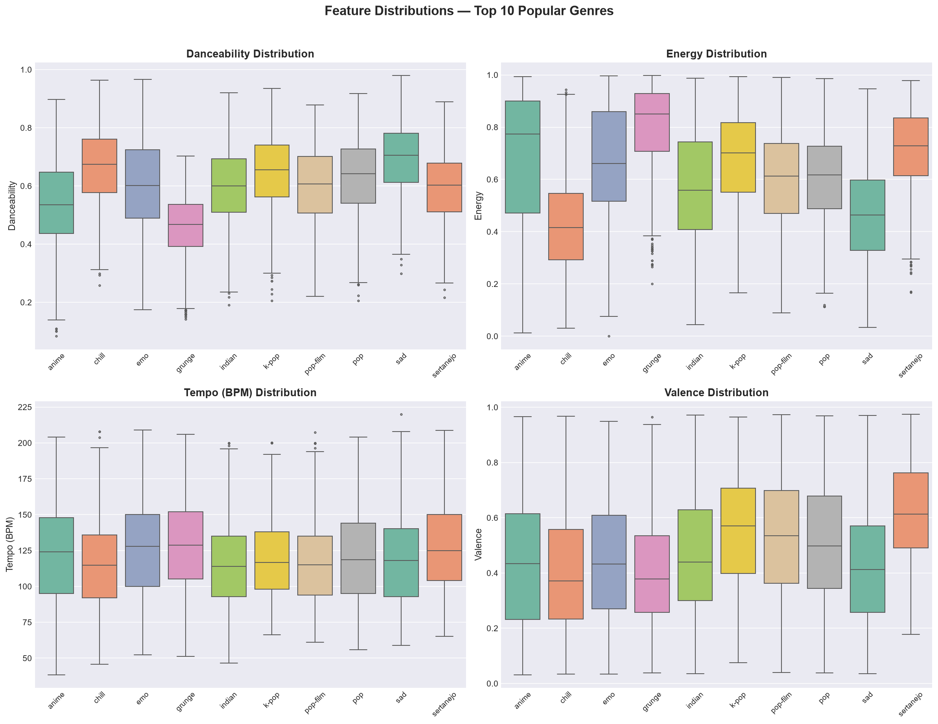
Figure 9. Popularity distribution box plots across top genres.

Performance and Reproducibility
The full 114K-record dataset is processed in local Spark mode. Spark DataFrames power ingestion, cleaning, aggregation, and ML correlation; processed records are saved as Parquet. No multi-node throughput or speedup benchmark is claimed. The full pipeline runs end-to-end in approximately 3-6 minutes on a local machine depending on available CPU cores and memory.
The pipeline and dashboard are run as separate commands; the dashboard loads saved outputs without re-running Spark. All random operations use fixed seeds for reproducibility.

Conclusion
The project completed an end-to-end Spark workflow over 114,000 Spotify track records: validation, cleaning, Parquet persistence, Spark SQL genre analytics, PySpark ML distributed Pearson correlation analysis, popularity tier profiling, 10 static visualisation charts, and an interactive Streamlit dashboard with 4 tabs and 15+ Plotly figures.
Key findings: Loudness (r = +0.21) and danceability (r = +0.11) are the strongest positive audio-feature predictors of popularity. Instrumentalness (r = -0.16) and acousticness (r = -0.14) are the strongest negative predictors. Pop, K-pop, and Latin are the most popular genres; sleep, ambient, and classical are the least popular. This is a technical demonstration of distributed big data analytics rather than a production music recommendation system.

Limitations and Future Scope
- The dataset is static; integrate the Spotify Web API for live track data ingestion.
- Correlation does not imply causation; popularity may be driven by marketing, social media, or playlist placement rather than audio features alone.
- Extend to regression or ML models (Random Forest, Gradient Boosting) to predict popularity from audio features.
- Use a multi-node Spark cluster (YARN/Kubernetes) to demonstrate genuine distributed throughput at larger scale.
- Incorporate time-series analysis to track how genre popularity evolves across release years.
- Add recommendation engine capabilities using collaborative or content-based filtering on audio features.
- Evaluate genre classification accuracy using Spark MLlib classifiers trained on audio features.

References
Spotify Tracks Dataset, Kaggle public dataset: https://www.kaggle.com/datasets/maharshipandya/-spotify-tracks-dataset
Apache Spark, Spark 3.5 Documentation: https://spark.apache.org/docs/3.5.5/
Apache Spark, ML Pipelines: https://spark.apache.org/docs/3.5.5/ml-pipeline.html
Streamlit Documentation: https://docs.streamlit.io/
Plotly Express Documentation: https://plotly.com/python/plotly-express/
Pandas Documentation: https://pandas.pydata.org/docs/
statsmodels Documentation: https://www.statsmodels.org/
Project-generated correlation matrices, genre statistics, and visualisation outputs from the executed PySpark pipeline (2024).

