Pimpri Chinchwad Education Trust’s

Pimpri Chinchwad College of Engineering (PCCoE)
Sector No. 26, Pradhikaran Nigdi, Pune – 411 044
An Autonomous Institute
Affiliated to Savitribai Phule Pune University (SPPU)
DEPARTMENT OF INFORMATION TECHNOLOGY
2026-27

A Project Report
On
Telecom Network Usage and Customer Churn Analytics
Using Apache Spark
By
Kartik Ware(123B1F104)
Vikas Shirsath(123B1F091) Anuj Pathade(123B1F070)
(Group Id: B19)
Guided by: Dr. Jaya Dewan

Executive Summary
This project implements a local Apache Spark workflow for customer churn analytics and churn-risk prediction using IBM's public Telco Customer Churn demonstration dataset. It processes 7,043 customer records, writes cleaned Parquet data, computes Spark SQL analytics, compares two Spark MLlib classifiers on held-out data, and presents saved outputs through a Streamlit dashboard.
The data contains 1,869 churned and 5,174 retained customers: an observed churn rate of 26.5%. Logistic Regression was selected by held-out F1. Its test F1 was 0.578, ROC-AUC 0.837, and accuracy
0.798. Results are sample-specific estimates, not guarantees.
Project indicator | Observed result
Customer records | 7,043
Historical churn rate | 26.5%
Selected model | Logistic Regression
Held-out test records | 1,375
Selected model F1 / ROC-AUC | 0.578 / 0.837
Monthly charges attached to churned accounts | $139,130.85

Scope note: this is customer account and service analytics. It does not monitor live network traffic, packet captures, or real-time telemetry.

Objective
Build a reproducible end-to-end customer analytics application using Spark for ingestion, cleaning, feature engineering, Parquet storage, and primary analytics; Spark SQL for segment summaries; Spark MLlib for churn prediction; and Streamlit for interactive presentation.
- Measure customer retention and churn across contract, tenure, service, and payment segments.
- Train Logistic Regression and Random Forest classifiers and evaluate both on held-out records.
- Generate customer-level probability estimates and configurable risk categories without using customer ID or the known churn outcome as predictors.
- Keep the initial workflow local and reproducible without paid cloud services.

Introduction
Customer churn is represented by the historical Churn field in the dataset. Comparing observed churn rates across customer segments describes where churn is more frequent in this sample. A classifier estimates risk from available account attributes; it does not establish why a customer churned or prove that any attribute causes churn.
The pipeline keeps the complete customer dataset in Spark for its main transformations. The dashboard reads saved outputs and does not retrain models on page refresh.

Big Data Context: Five Vs
The public sample is small; the project demonstrates Spark processing patterns rather than claiming large-scale benchmark performance.
Dimension | Project interpretation
Volume | 7,043 records: a Spark demonstration, not a large-volume performance claim.
Velocity | Static historical CSV; streaming and real-time ingestion are not implemented.
Variety | Structured numeric charge/tenure fields and categorical account/service fields.
Veracity | Required columns checked; blank or malformed TotalCharges retained as null and reported.
Value | Retention summaries and held-out risk estimates; no causal claims.

Dataset
Source: IBM Telco Customer Churn public demonstration dataset. It contains customer identifiers, demographic attributes, tenure, subscribed services, contract and payment information, MonthlyCharges, TotalCharges, and a historical Churn label.
Data-quality measure | Executed pipeline result
Rows before cleaning | 7,043
Rows after cleaning | 7,043
Invalid records removed | 0
Duplicate customer records removed | 0
Null TotalCharges after cleaning | 11
Storage formats | CSV source; processed Parquet

Blank or malformed TotalCharges values become null and are retained, including zero-tenure customers. Invalid identifiers, labels, tenure, and negative monetary values are excluded. Duplicate IDs are resolved deterministically by retaining the lexicographically first complete source row; none were found in this execution.
This historical demonstration dataset may not represent current customers or services. It is account/service data, not live network telemetry, and is not a production-ready decision dataset.

Tools and Technologies
Technology | Role
Python 3.11 | Pipeline orchestration and data preparation
Apache Spark / PySpark 3.5 | Ingestion, transformations, Parquet
Spark SQL | Segment churn and charge summaries
Spark MLlib | Feature pipeline, classifiers, evaluation
Pandas / Matplotlib | Small dashboard result tables and report figures
Streamlit | Four-page results dashboard
Pytest | Behavioral tests using small synthetic fixtures
CSV / Parquet / JSON | Source, processed data, analytics, metrics, and predictions

System Architecture
Pipeline stage | Implementation / output
Acquisition and validation | IBM CSV loaded/downloaded; expected columns checked
Spark cleaning | Type casts, duplicate handling, null and invalidrow report
Feature engineering | Tenure groups, service count, support/security indicators
Persistence and analytics | Parquet data and Spark SQL CSV/JSON summaries
Model preparation | Training-only categorical indexing/encoding and numeric imputation
Model evaluation | Stratified held-out comparison and selected pipeline artifact
Risk scoring | Separate test predictions and label-free demonstration report
Presentation | Streamlit overview, analytics, performance, and risk explorer
The project runs in local Spark mode. HDFS, Cassandra, Kafka, and cloud storage are not required or implemented.

Implementation

Acquisition, ingestion, and cleaning
The executed pipeline read 7,043 records. It retained 7,043, removed 0 invalid records and 0 duplicate customer records, and reported 11 null TotalCharges values.

Feature engineering and Spark SQL
Analytical features include tenure groups (0–11, 12–23, 24–47, and 48+ months), subscribed service count, and technical support/online security indicators. Churn rate is calculated as churned customers divided by all customers in the segment. Analytics cover contract, tenure, internet service, payment method, support, security, and charges.

MLlib model training
Churn is mapped to a binary target. Customer ID and Churn are excluded from predictors.
StringIndexer, OneHotEncoder, numeric imputation, and VectorAssembler are fitted inside each ML pipeline using training data only. A fixed-seed, class-wise train/test split separates training from evaluation.

Customer risk scoring
The pipeline scores held-out test rows and writes their observed labels separately. The historical demonstration risk report contains predicted probabilities and risk categories, not actual churn labels. Default categories are Low below 0.30, Medium from 0.30 to below 0.60, and High at or above 0.60; these example cutoffs are not business-validated.

Dashboard
The dashboard presents an executive overview, customer analytics, held-out model performance, and a churn risk explorer. It reads generated files, distinguishes historical outcomes from predicted risk, and offers filters and CSV download for the risk table.

Results and Discussion
The overall churn rate was 26.5%: 1,869 churned customers of 7,043. Retained customers numbered 5,174. The monthly charges attached to churned accounts sum to $139,130.85; this is not a verified lost-revenue estimate.
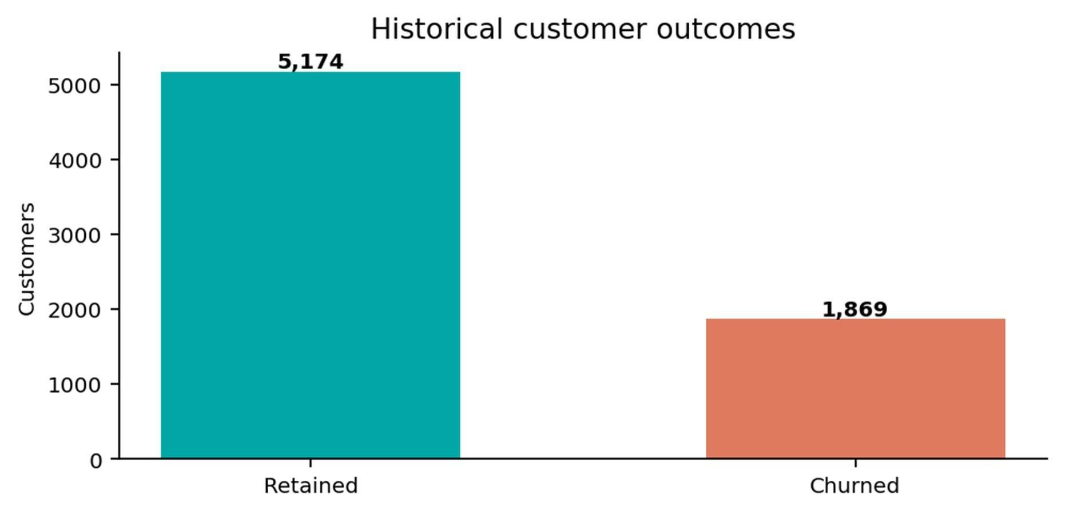
Figure 1. Customer outcomes in the historical dataset.
Observed churn was 42.7% for month-to-month customers and 2.8% for two-year customers. The 0– 11-month tenure group had 48.3% churn versus 9.6% among customers with 48+ months. Fiber optic service was 41.9%; electronic check was 45.3%. These are descriptive associations, not causal findings.
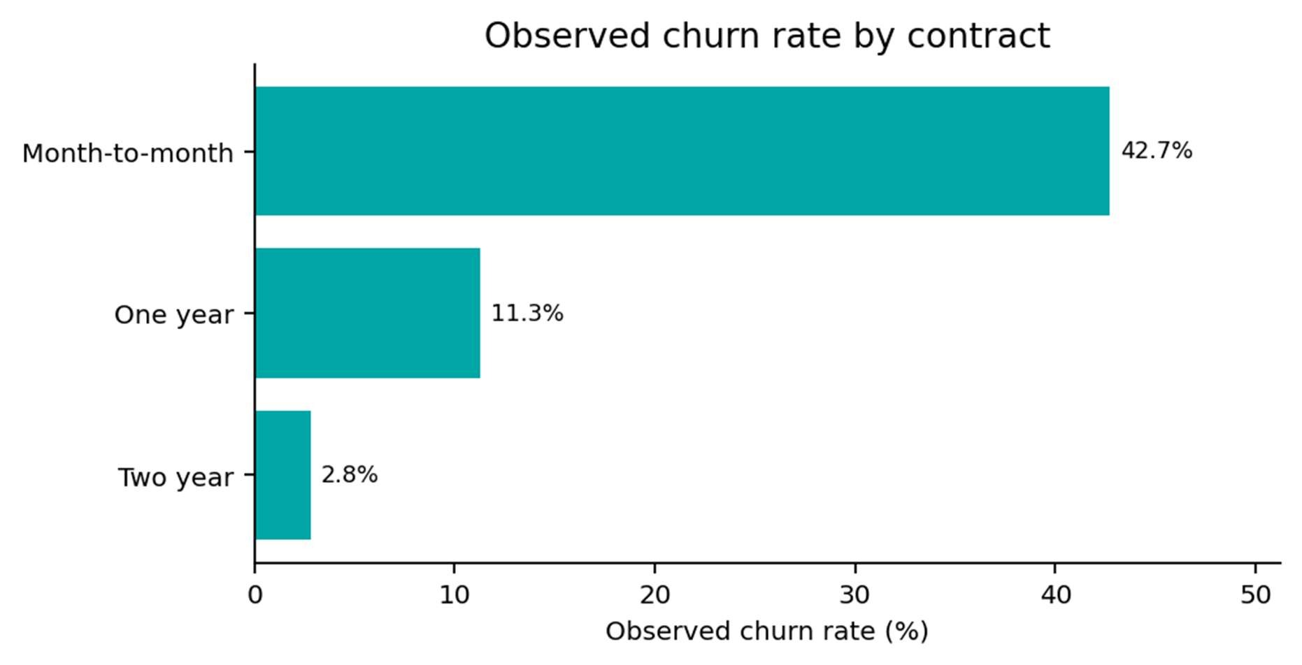
Figure 2. Churn rate by contract; denominator is all customers in each group.
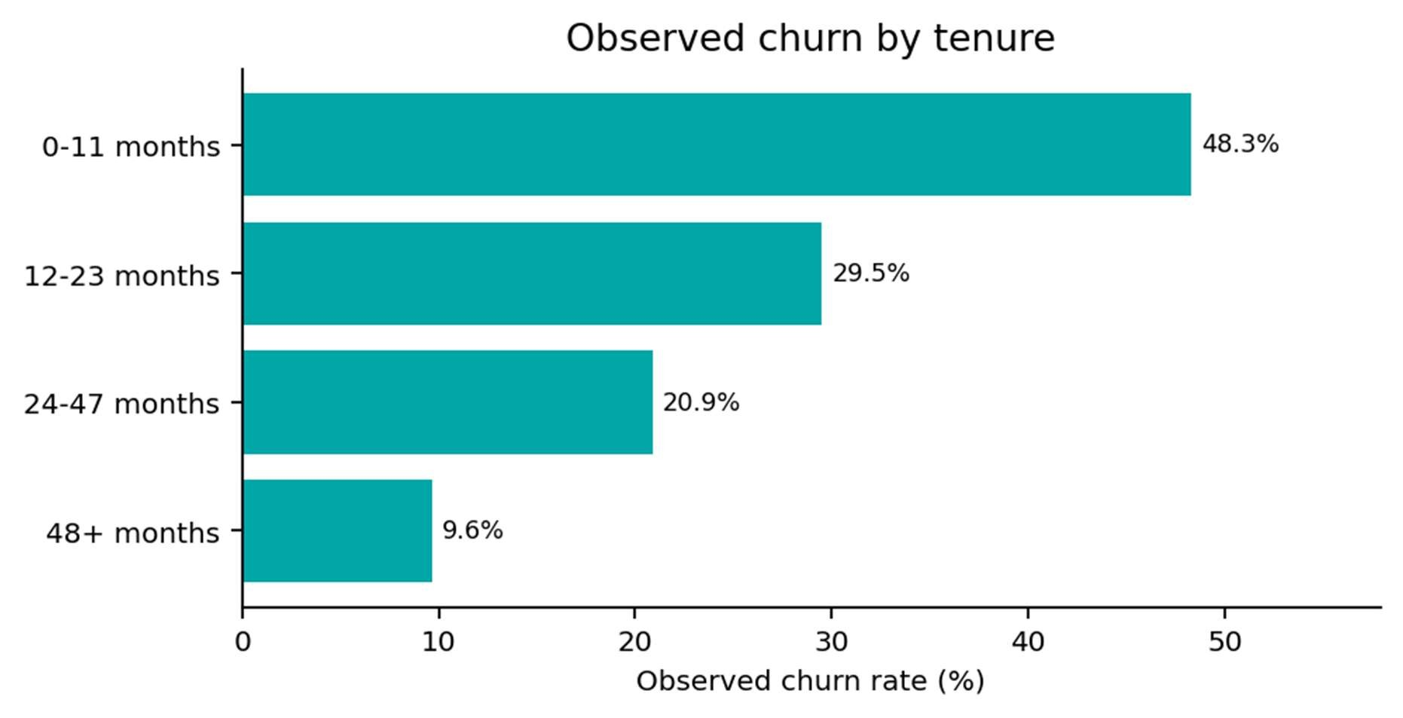
Figure 3. Churn rate by tenure group; denominator is all customers in each group.
Segment |  |  | Customers |  |  | Churned |  |  | Churn rate
Month-to-month contract |  |  | 3875 |  |  | 1655 |  |  | 42.7%
 | Two-year contract |  |  | 1695 |  |  | 48 |  |  | 2.8%
Tenure 0–11 months |  |  | 2069 |  |  | 999 |  |  | 48.3%
 | Tenure 48+ months |  |  | 2303 |  |  | 222 |  |  | 9.6%
Fiber optic internet |  |  | 3096 |  |  | 1297 |  |  | 41.9%
 | Electronic check |  |  | 2365 |  |  | 1071 |  |  | 45.3%
No technical support |  |  | 3473 |  |  | 1446 |  |  | 41.6%
 | Has technical support |  |  | 2044 |  |  | 310 |  |  | 15.2%
No online security

3498

1461
41.8
%
Has online security

2019

295
14.6
%

Mean monthly charges were $74.44 for churned customers and $61.27 for retained customers. This comparison does not isolate price from other factors.

Model Performance
Both models were evaluated on the same 1,375 held-out records. The selected model maximizes F1, with recall and ROC-AUC as tie-breakers; Random Forest was not presumed to be best.
Model | Accuracy | Precision | Recall | F1 | ROC-AUC | Test rows
Logistic  Regression | 0.798 | 0.669 | 0.508 | 0.578 | 0.837 | 1375
Random  Forest | 0.790 | 0.659 | 0.471 | 0.549 | 0.837 | 1375
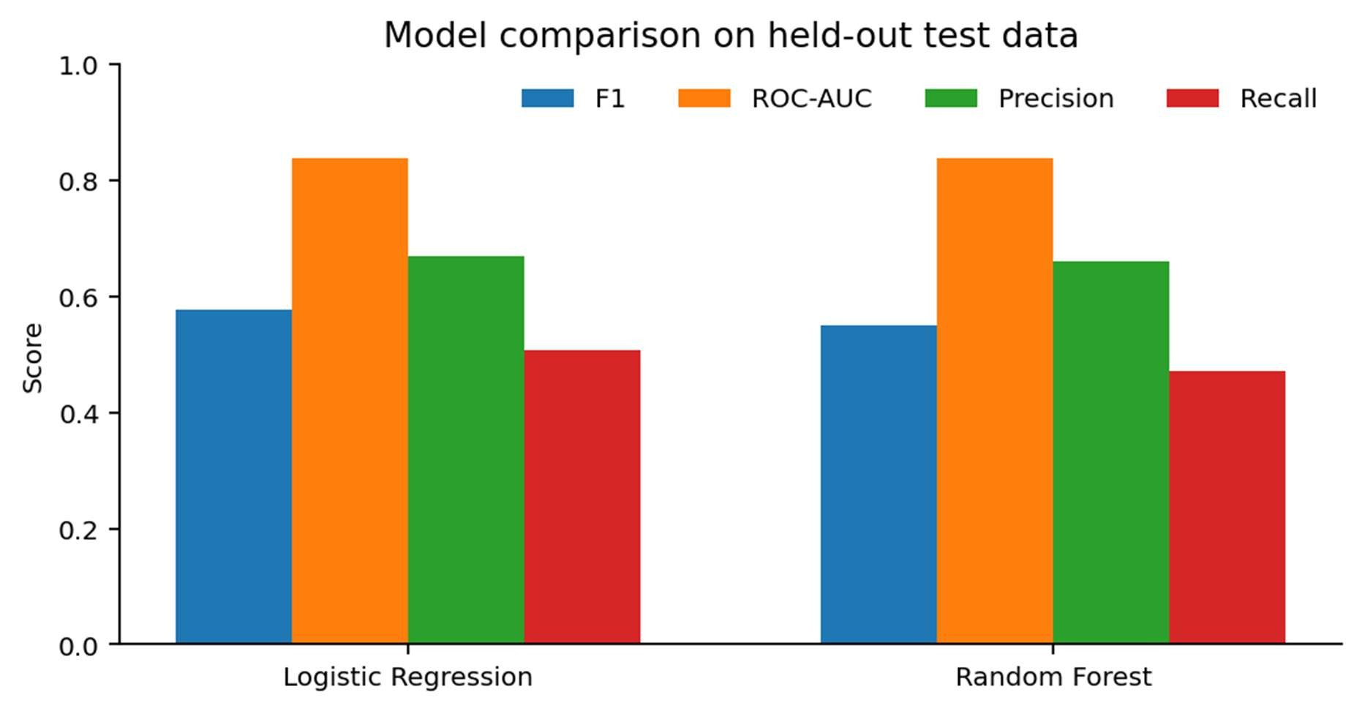
Figure 4. Held-out test-set model comparison.
Selected model confusion matrix (actual class by predicted class):
Actual class

Predicted retained (0)

Predicted churned (1)

Total

Retained (0)

907

94
,001
1
Churned (1)
184

190

374

Precision measures the share of predicted churners who churned; recall measures the share of actual churners identified; F1 balances the two; ROC-AUC measures ranking discrimination across thresholds. Accuracy alone can obscure missed churners in an imbalanced dataset. Results are specific to this sample and split.

Demonstration Risk Report
The demonstration report contains 7,043 customer estimates: 4,375 Low, 1,838 Medium, and 830 High under default example cutoffs. These are model estimates—not certainties or validated business thresholds—and the report excludes known churn labels.
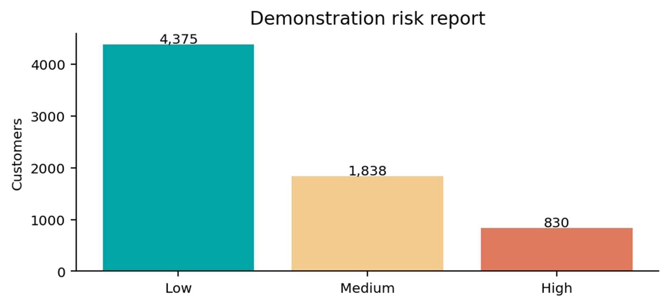
Figure 5. Predicted risk categories; default thresholds 0.30 and 0.60.

Performance and Reproducibility
The sample is processed in local Spark mode. Spark DataFrames power ingestion, cleaning, transformations, and primary analytics; processed records are saved as Parquet. No multi-node throughput or speedup benchmark is claimed. The full pipeline and dashboard are run as separate commands; the dashboard loads saved outputs.
The executed test suite reported 9 passed. Synthetic test rows verify cleaning, feature creation, churnrate denominators, prediction schema, and model artifact loading; those fixtures are not substituted for the IBM dataset in the pipeline.

Conclusion
The project completed an end-to-end Spark workflow over 7,043 customer records: validation, cleaning, Parquet persistence, Spark SQL analytics, MLlib training and held-out evaluation, risk scoring, and dashboard outputs. The observed churn rate was 26.5%. Logistic Regression was selected with held-out F1 0.578 and ROC-AUC 0.837. This is a technical demonstration rather than live network monitoring or a validated production decision system.

Limitations and Future Scope
- Use time-aware validation and repeated runs to examine model stability.
- Evaluate probability calibration, subgroup fairness, and drift before operational use.
- Validate risk cutoffs with stakeholders, intervention outcomes, and error costs.
- Use a larger governed dataset and separately measure distributed scalability.
- Treat streaming or cloud integrations as future extensions, not current features.

References
- IBM, Telco Customer Churn public demonstration dataset and accompanying dataset description.
- Apache Spark, Spark 3.5 Documentation: https://spark.apache.org/docs/3.5.5/.
- Apache Spark, ML Pipelines: https://spark.apache.org/docs/3.5.5/ml-pipeline.html.
- Streamlit Documentation: https://docs.streamlit.io/.
- Pandas Documentation: https://pandas.pydata.org/docs/.
- Project-generated analytics, evaluation metrics, confusion matrix, and prediction outputs from the executed pipeline (2026).

