1. create an VM instance with startup script

#! /bin/bash
apt-get update
apt-get install -y apache2
cat <<EOF > /var/www/html/index.html
<html><body><h1>vikas here</h1>
<p>This page was created from a simple startup script!</p>
</body></html>
EOF
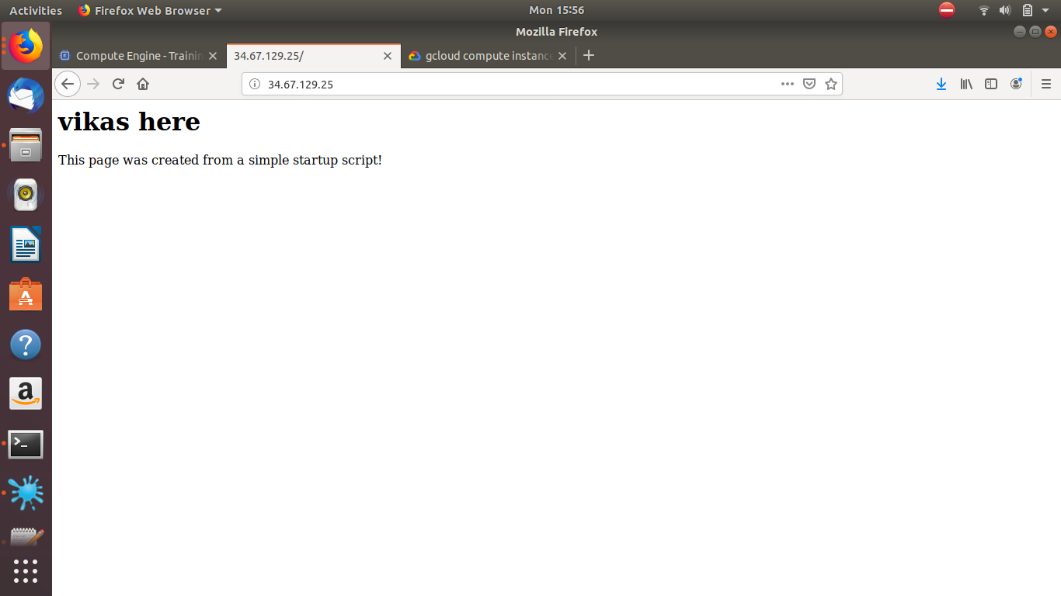

2. SSH into VM instance.

3. stop the instance
gcloud compute stop my-instance

4. resatrt the instance
gcloud compute start my-instance

5. veiw logs.

