Synopsis
on
EchoClean — Real-Time Toxic Speech Filter for Voice Chats
Submitted in the partial fulfilment of the Degree of
Bachelor of Technology
(Computer Science and Engineering)
Submitted by
OJASVI TANWAR 02896302722
VIKAS 04696302722
YASH GUPTA 35296302722
Under the supervision of
Dr.RAVI CHAUDHARY

Department of Computer Science and Engineering
Maharaja Surajmal Institute of Technology
Janakpuri, New Delhi.
2022-2026

INDEX

1. Abstract 1
2. Introduction 2
3. Literature review 2
4. Objective 5
5. Research Methodology 5
6. Gantt chart 6
7. References 6

Abstract

This project seeks to harness artificial intelligence to make online voice communication safer and more inclusive. By targeting toxic behaviors such as hate speech, harassment, and offensive language, the system provides real-time detection and intervention during live voice chats. Through an integration of speech-to-text transcription, transformer-based toxicity detection, and audio filtering, the work balances technical rigor with user-centric design. The outcome is envisioned as a deployable moderation assistant capable of muting, replacing, or alerting against toxic speech instantly, offering a practical solution for gaming, streaming, and collaborative platforms.

Introduction

Toxic and abusive speech in online voice communication has become a growing concern across gaming platforms, live streams, and virtual collaboration spaces. Exposure to hate speech, harassment, and offensive language not only degrades user experience but also fosters hostile environments that discourage healthy digital interaction. The lack of effective real-time moderation tools often results in unchecked toxicity, leading to psychological harm and reduced engagement among users.

EchoClean proposes an AI-powered moderation system designed to detect and mitigate toxic speech in live voice chats. The system captures spoken audio, transcribes it into text in real time, and applies transformer-based language models to classify toxic content with high accuracy. To ensure immediate response, EchoClean integrates lightweight audio filtering techniques that can mute, replace, or flag harmful speech segments during conversations.

Beyond detection, EchoClean emphasizes explainability and usability. A dedicated dashboard allows administrators and users to monitor flagged interactions, visualize system performance, and maintain transparency in decision-making. By combining speech processing, natural language processing, and real-time audio handling, EchoClean aims to deliver a scalable, ethical, and user-centric solution for promoting safer online communication environments.

Literature Survey

1) Toxicity datasets for model training
Early large-scale text resources such as the Jigsaw Toxic Comment datasets remain foundational for multi-label toxicity (toxic, severe toxic, obscene, threat, insult, identity hate) and benchmarking, and are widely reused for transfer learning.
HateXplain advances this by adding target annotations and human-marked rationales (explanations), enabling training and evaluation of explainable toxicity models—useful for moderation transparency.
2) Speech-to-text (ASR) for real-time pipelines
Whisper demonstrates strong multilingual robustness from 680k hours of supervision and is widely adopted for streaming transcription; however, real-world reports note occasional “hallucinations,” underscoring the need for confidence thresholds and safety fallbacks in moderation stacks. Vosk offers lightweight, offline ASR suitable for on-device or low-connectivity scenarios.
3) Toxicity classifiers and APIs
Production-oriented baselines include Perspective API (TOXICITY and related attributes) and open-source Detoxify (RoBERTa/BERT-based models trained on Jigsaw variants). These provide strong starting points and clear interfaces for rapid integration and comparison.
Research models specialized for abuse—e.g., HateBERT (BERT retrained on abusive Reddit corpora)—consistently outperform vanilla BERT on abusive language tasks, highlighting the value of domain-aligned pretraining.
4) Real-time, domain-specific moderation
Work on in-game chat shows that context (chat history, minimal metadata) substantially improves real-time detection; ToxBuster demonstrates scalable, low-latency moderation that outperforms generic toxicity models across multiple titles. This supports EchoClean’s design to incorporate conversational context rather than isolated utterances.
5) Audio-native and explainable toxic speech
Beyond transcript-only pipelines, recent studies explore audio-native toxicity and frame-level rationales (aligning toxic text to time spans), via end-to-end and cascading (ASR→NLP→audio localization) approaches—useful for precise muting/bleeping in voice streams.
6) Multi-modal and emerging directions
Newer work investigates multi-modal hate speech (text + audio/image/video), indicating benefits from combining modalities when available—relevant for future EchoClean variants that may fuse prosody, text, and user-level signals.
7) Practical considerations distilled from prior art
- Latency vs. accuracy: Domain-tuned models with short context windows and lightweight deployment (ONNX/quantization) are preferred in real-time settings. Findings in game moderation reinforce training on domain-current data to avoid drift.
- Explainability & trust: Datasets with rationales (HateXplain) and model cards (Perspective) inform transparent thresholds, appeals, and admin tooling.
Summary. The literature supports a cascaded pipeline (ASR → context-aware toxicity classifier → audio action), enhanced by domain-specific data, explainability artifacts, and strict latency budgets. EchoClean’s design aligns with state-of-the-art practices and addresses open gaps around real-time reliability, transparency, and deployment in bandwidth-constrained environments.

Objective

The primary objectives of the EchoClean project are to:

Develop an AI-powered real-time moderation tool to detect and filter toxic speech (hate speech, harassment, offensive language) in live voice chats.

Integrate speech-to-text pipelines (Whisper, Vosk) with transformer-based toxicity detection models (BERT, RoBERTa, Detoxify) for accurate classification.

Implement real-time audio interventions such as muting, replacing, or flagging toxic segments without disrupting conversation flow.

Provide explainability and transparency through a dashboard that visualizes flagged speech, model performance, and system activity.

Validate system performance with metrics such as accuracy, precision, recall, F1-score, and latency, ensuring reliability and scalability for live applications like gaming, streaming, and collaboration.

Research Methodology

The methodology is structured as follows:

Dataset Collection & Preparation — Collect toxic speech datasets by combining text corpora (Jigsaw, HateXplain) with audio datasets (AudioSet, custom recordings); preprocess and augment to handle class imbalance.

Preprocessing — Convert audio into uniform formats (WAV/PCM), segment into short clips, transcribe speech using Whisper/Vosk, and clean text for toxicity detection.

Model Selection — Experiment with transformer-based models such as BERT, RoBERTa, and DistilBERT for text classification of toxic content.

Fine-tuning & Optimization — Fine-tune pre-trained NLP models on toxicity datasets; optimize for real-time performance using ONNX/TensorFlow Lite.

Evaluation — Assess performance using precision, recall, F1-score, accuracy, and latency to ensure reliable real-time moderation.

Audio Filtering & Intervention — Apply real-time actions such as muting, replacing toxic segments with beeps, or generating user alerts.

Visualization & Transparency — Develop a dashboard to display flagged speech, system performance metrics, and maintain audit logs for transparency.

Comparative Analysis — Compare models and system setups to identify the most effective balance of accuracy, latency, and scalability for deployment.

Gantt Chart

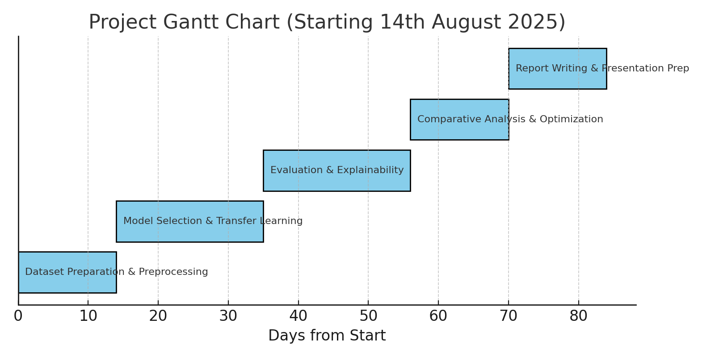

References

- Jigsaw/Conversation AI. Toxic Comment Classification Challenge. Kaggle, 2018. Available at: https://www.kaggle.com/c/jigsaw-toxic-comment-classification-challenge
- Mathew, B., Saha, P., Yimam, S. M., Biemann, C., Goyal, P., & Mukherjee, A. (2021). HateXplain: A Benchmark Dataset for Explainable Hate Speech Detection. Proceedings of the AAAI Conference on Artificial Intelligence.
- Gemmeke, J. F., Ellis, D. P. W., Freedman, D., et al. (2017). AudioSet: An ontology and human-labeled dataset for audio events. IEEE ICASSP 2017.
- OpenAI. Whisper: Robust Speech Recognition via Large-Scale Weak Supervision. 2022. Available at: https://github.com/openai/whisper
- Alphacephei. Vosk Speech Recognition Toolkit. Available at: https://alphacephei.com/vosk/
- Wolf, T., Debut, L., Sanh, V., et al. (2020). Transformers: State-of-the-Art Natural Language Processing. Proceedings of the 2020 Conference on Empirical Methods in Natural Language Processing: System Demonstrations.

