Introduction

In both biological and technological realms, cells represent the fundamental units that sustain life and power various systems. From the intricacies of living organisms to the efficiency of portable devices, the diverse types of cells serve as the building blocks of functionality and operation. While biological cells drive the processes of life, technological cells, such as those found in batteries, are instrumental in providing the energy required to power modern conveniences and innovations.

Significance of Battery Technology in Modern Life

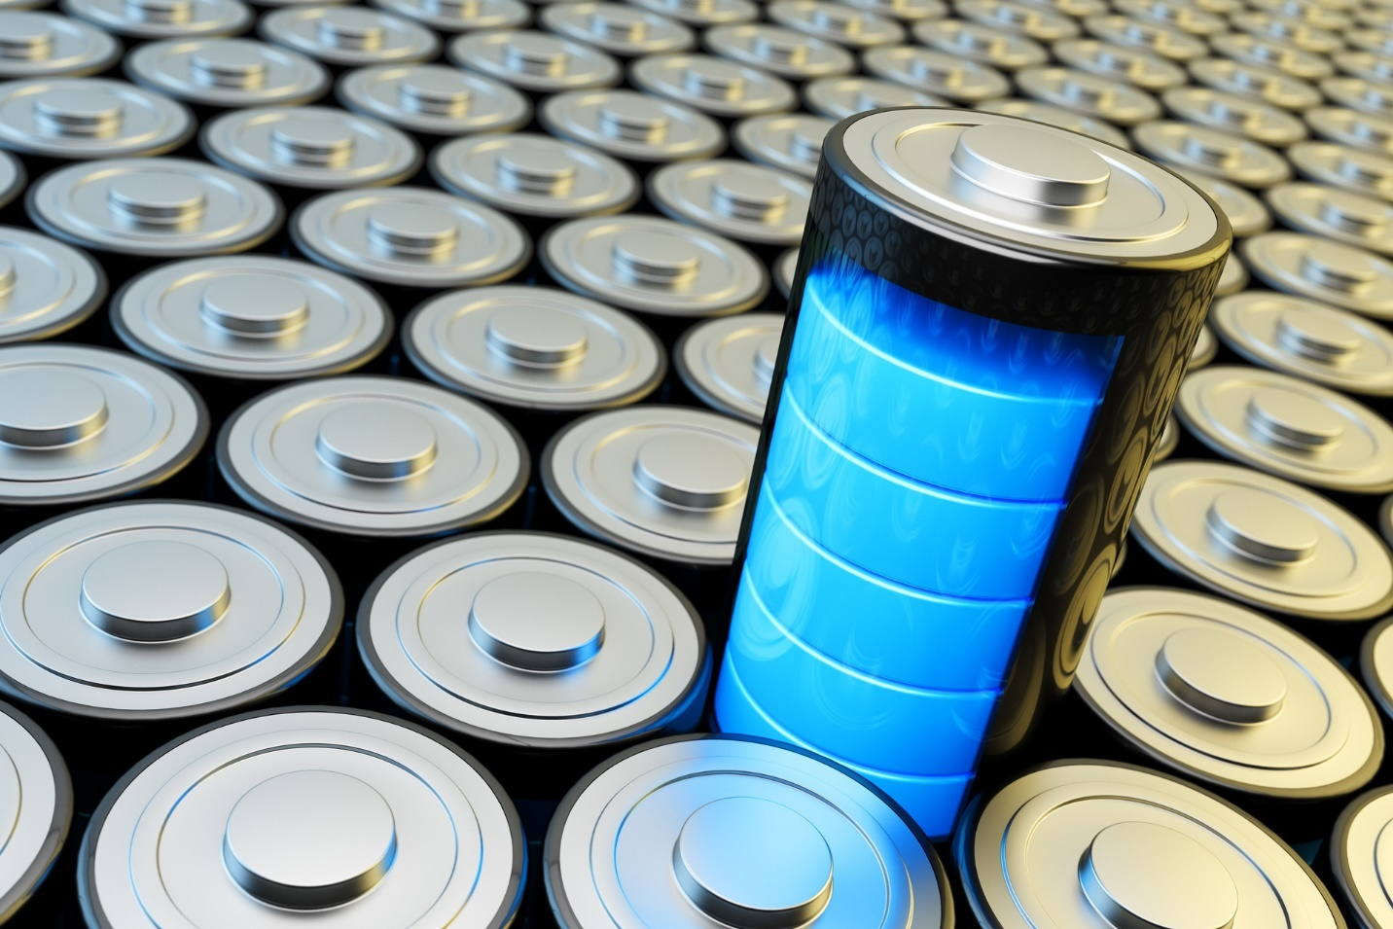

1. **Portable Power**: Battery technology enables the seamless use of portable electronic devices, such as smartphones, laptops, tablets, and wearable gadgets, allowing individuals to stay connected and productive on the go.
2. **Electric Vehicles (EVs)**: The advent of high-performance batteries has facilitated the rapid development of electric vehicles, offering a cleaner and more sustainable alternative to traditional internal combustion engines, thereby reducing greenhouse gas emissions and dependence on fossil fuels.
3. **Renewable Energy Storage**: Batteries play a crucial role in the storage of energy generated from renewable sources like solar and wind, ensuring a stable and reliable power supply even when the sun isn't shining or the wind isn't blowing. This capability is instrumental in advancing the transition toward a more sustainable and resilient energy grid.
4. **Grid Stability and Peak Load Management**: Energy storage systems based on battery technology support grid stability and enable efficient management of peak electricity demands, ensuring a smooth and uninterrupted power supply, especially during periods of high energy consumption
5. **Portable Medical Devices**: Battery-powered medical devices, such as portable diagnostic equipment and life-saving implantable devices, contribute significantly to the advancement of healthcare, enabling better patient care and improved treatment outcomes.
6. **Consumer Electronics**: The compact and lightweight nature of modern batteries has revolutionized the design and functionality of various consumer electronics, allowing for the development of sleeker, more portable, and high-performance devices that enhance the overall user experience.
7. **Uninterrupted Communication and Connectivity**: Backup power systems, often relying on advanced battery technology, ensure uninterrupted communication and connectivity during emergencies, natural disasters, or grid outages, serving as a critical lifeline for individuals and communities.
8. **Space Exploration and Aerospace Applications**: Batteries are pivotal in powering space missions and aerospace technologies, providing energy storage solutions for spacecraft, satellites, and various scientific instruments, thus enabling exploration beyond our planet
9. **Energy Independence and Security**: By enabling the widespread adoption of renewable energy sources and reducing reliance on conventional fossil fuels, battery technology contributes to enhancing energy independence, reducing geopolitical tensions, and ensuring a more secure and stable energy supply for nations worldwide.
10. **Environmental Sustainability**: The use of advanced battery technology in various applications supports the global initiative to mitigate climate change and reduce carbon emissions, fostering a more sustainable and environmentally friendly approach to energy consumption and storage.

Overview of Different Types of Cells

1. **Battery Cells**: These cells are essential components of various types of batteries, including alkaline batteries, lithium-ion batteries, lead-acid batteries, and others. They serve as energy storage units for a wide range of applications, from portable electronic devices to electric vehicles and renewable energy storage systems.
2. **Solar Cells**: Also known as photovoltaic cells, solar cells convert sunlight directly into electricity through the photovoltaic effect. They are integral to solar panels, contributing to the generation of clean and renewable energy for residential, commercial, and industrial applications.

Importance of Proper Battery Maintenance Practices



1. **Prolonged Battery Lifespan**: By following proper maintenance procedures, such as appropriate charging and discharging cycles, regular inspections, and timely cleaning, batteries can maintain their capacity and performance over an extended period, thereby maximizing their lifespan and durability.
2. **Enhanced Performance**: Regular maintenance helps to preserve the efficiency and reliability of batteries, ensuring that they deliver consistent power output and meet the energy demands of various applications, ranging from small-scale electronics to large-scale energy storage systems.
3. **Optimized Efficiency and Energy Savings**: Well-maintained batteries operate more efficiently, leading to reduced energy wastage and improved energy utilization. This not only translates into cost savings but also contributes to a more sustainable and eco-friendly approach to energy consumption.
4. **Prevention of Malfunctions and Failures**: Adequate maintenance practices, including monitoring for signs of degradation, temperature regulation, and proper handling, help in preventing common issues such as overcharging, undercharging, and thermal runaway, which can lead to malfunctions, failures, and potential safety hazards.
5. **Safety Assurance**: Battery maintenance plays a critical role in ensuring the safety of individuals and the surrounding environment. By adhering to safety protocols, such as proper storage, handling, and disposal procedures, the risk of accidents, leaks, and hazardous material exposure can be significantly reduced, promoting a secure operating environment.
6. **Optimal Functionality of Devices and Systems**: Whether in portable electronic devices or larger-scale applications like electric vehicles and renewable energy storage systems, well-maintained batteries contribute to the seamless and uninterrupted functioning of devices and systems, thereby supporting enhanced productivity and performance.
7. **Reduction of Downtime and Maintenance Costs**: Proactive maintenance practices help in minimizing unexpected downtime and the need for frequent repairs or replacements, leading to reduced operational disruptions and overall maintenance costs, both in personal and industrial settings.

Primary Cell Technologies

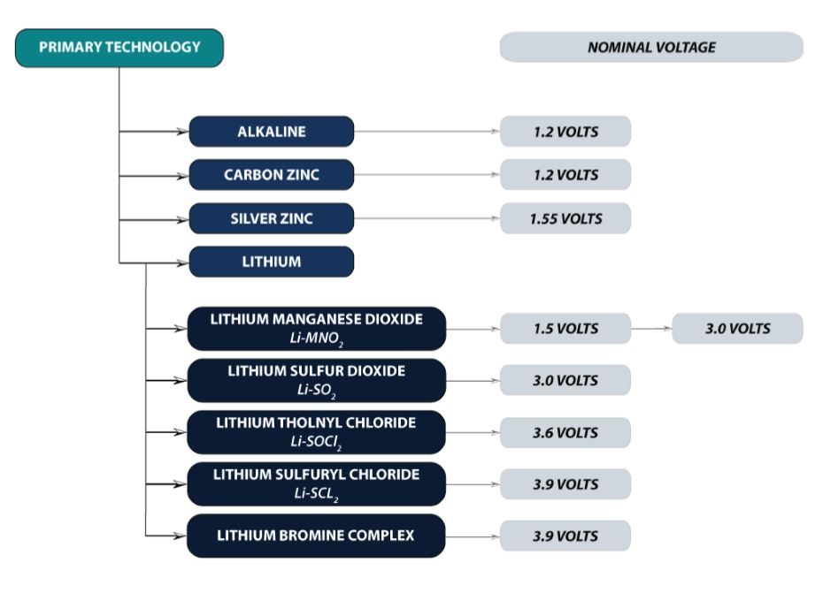

Primary cell technologies refer to non-rechargeable battery systems designed for single use, typically providing a one-time chemical reaction to generate electrical energy. These primary cells are widely used in various applications, including small-scale electronic devices, household appliances, and industrial equipment. Here are some of the primary cell technologies commonly utilized:

1. **Alkaline Batteries**: Alkaline batteries are a type of primary battery that uses an alkaline electrolyte, typically potassium hydroxide, to generate electrical energy through a chemical reaction between zinc and manganese dioxide. They are commonly used in a wide range of consumer electronics, such as remote controls, flashlights, toys, and portable radios.
2. **Zinc-Carbon Batteries**: Zinc-carbon batteries, also known as Leclanché cells, use a zinc anode and a carbon rod surrounded by a mixture of manganese dioxide and carbon powder as the cathode. They are a cost-effective option for low-drain devices like wall clocks, remote controls, and basic torches.
3. **Lithium Batteries**: Lithium primary batteries utilize lithium metal as an anode and manganese dioxide or sulfur dioxide as the cathode. These batteries offer high energy density, lightweight design, and a long shelf life, making them suitable for various applications such as medical devices, military equipment, and backup power supplies.
4. **Mercury Batteries**: Although less common due to environmental concerns, mercury batteries are known for their stable voltage output and long service life. They use mercury oxide as the cathode and zinc amalgam as the anode. These batteries were previously used in certain medical devices, cameras, and hearing aids, but their use has significantly declined due to environmental regulations.
5. **Silver Oxide Batteries**: Silver oxide batteries utilize silver oxide as the cathode and zinc as the anode, providing a stable voltage output and high energy density. They are commonly used in watches, calculators, and small medical devices, offering a reliable and long-lasting power source for precision electronic equipment.
6. **Lithium-Thionyl Chloride Batteries**: These batteries use lithium metal as the anode and thionyl chloride as the cathode. They are known for their high energy density and long shelf life, making them suitable for various applications requiring long-term, low-rate energy release, such as in remote sensors, security systems, and medical devices.

**Secondary Cell Technologies**

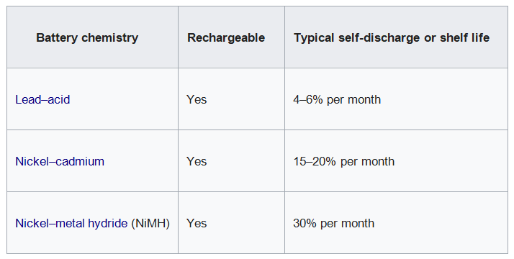

Secondary cell technologies refer to rechargeable battery systems that can be reused multiple times through the application of reverse currents, allowing the cells to regain their energy storage capacity. These secondary cells play a critical role in various applications, from portable electronic devices to electric vehicles and renewable energy storage systems. Some of the main types of secondary cell technologies include:

1. **Lead-Acid Batteries**: These batteries are among the oldest and most widely used rechargeable batteries. They consist of lead dioxide and lead electrodes immersed in a sulfuric acid solution. Lead-acid batteries are commonly used in automotive vehicles, uninterruptible power supplies (UPS), and off-grid energy storage systems.
2. **Lithium-Ion Batteries**: Known for their high energy density, low self-discharge rate, and lightweight design, lithium-ion batteries are widely used in portable electronic devices, electric vehicles, and renewable energy storage systems. They utilize lithium compounds as the electrolyte and are known for their superior performance and extended cycle life
3. **Nickel-Cadmium Batteries**: These batteries use nickel oxide hydroxide and metallic cadmium as electrodes and a potassium hydroxide solution as the electrolyte. They are known for their ability to deliver high discharge currents and perform well under extreme temperature conditions. However, their use has declined in recent years due to environmental concerns regarding cadmium.
4. **Nickel-Metal Hydride Batteries**: These batteries use a hydrogen-absorbing alloy instead of cadmium, making them more environmentally friendly than nickel-cadmium batteries. They offer a higher energy density and longer cycle life compared to nickel-cadmium batteries, and they are commonly used in portable electronic devices, hybrid electric vehicles, and other consumer electronics.
5. **Flow Batteries**: Flow batteries store energy in external tanks, using chemical components that are kept separate from the cell. They offer scalability and long cycle life, making them suitable for large-scale energy storage applications and grid-level renewable energy integration. Vanadium redox flow batteries are one example of a flow battery technology.
6. **Sodium-Sulfur Batteries**: These high-temperature batteries operate using molten sulfur as the positive electrode and molten sodium as the negative electrode. They are known for their high energy density and are commonly used in grid-level energy storage systems, helping to integrate renewable energy sources into the power grid.

**Advanced Battery Management Systems**

1. **State of Charge (SoC) and State of Health (SoH) Monitoring**: BMS accurately measures and monitors the state of charge and state of health of the battery, providing real-time data on the remaining capacity, charging status, and overall health of the battery, which is crucial for optimizing performance and extending lifespan.
2. **Cell Balancing and Equalization**: BMS ensures that all cells within a battery pack are uniformly charged and discharged, preventing overcharging or undercharging of individual cells, which can lead to capacity imbalances and reduce overall battery efficiency and lifespan.
3. **Temperature Regulation and Thermal Management**: BMS incorporates sophisticated thermal management systems to monitor and control the temperature of the battery, preventing overheating or overcooling, which can significantly impact the performance, safety, and lifespan of the battery.
4. **Overcurrent and Overvoltage Protection**: BMS safeguards the battery from potential damage caused by overcurrent or overvoltage events, employing protective measures such as disconnecting the battery from the load or the charging source to prevent irreversible damage to the cells.
5. **Safety and Fault Diagnosis**: BMS is equipped with advanced diagnostic capabilities to detect and mitigate potential faults, anomalies, or safety hazards within the battery system, ensuring the safe and reliable operation of the battery under various operating conditions.
6. **Optimized Charging and Discharging Algorithms**: BMS implements intelligent charging and discharging algorithms to optimize the energy transfer process, maximize energy efficiency, and minimize energy loss, thereby enhancing the overall performance and endurance of the battery.
7. **Data Logging and Communication Interfaces**: BMS facilitates data logging and communication interfaces, enabling the transmission of critical battery performance data to external monitoring systems, controllers, or user interfaces, allowing for remote monitoring, analysis, and real-time adjustments as needed.
8. **Predictive Maintenance and Prognostics**: Advanced BMS systems utilize predictive maintenance algorithms and prognostic capabilities to anticipate potential issues, identify degradation patterns, and recommend proactive maintenance measures, thereby extending the battery's lifespan and reducing unexpected downtime.
9. **Integration with Energy Management Systems**: BMS can integrate seamlessly with broader energy management systems, including smart grids, renewable energy systems, and electric vehicle infrastructure, contributing to the efficient and sustainable integration of battery technology within the larger energy ecosystem.
10. **Enhanced User Interface and User Experience**: BMS features user-friendly interfaces and controls that provide users with comprehensive insights into battery performance, health, and operational parameters, enabling informed decision-making and effective management of battery systems.

**Future Trends in Battery Technology**

Future trends in battery technology are driven by the increasing demand for sustainable energy solutions, advancements in electric transportation, and the need for more efficient energy storage systems. Several key developments are shaping the trajectory of battery technology:

1. **Increased Energy Density**: Research and development efforts are focused on enhancing the energy density of batteries, aiming to increase the amount of energy stored within the same physical footprint, thereby enabling longer-lasting and more powerful energy storage solutions for various applications.
2. **Fast Charging and Rapid Energy Delivery**: Innovations in battery technology are striving to reduce charging times and enable rapid energy delivery, catering to the growing demand for quick charging solutions in electric vehicles, portable electronics, and renewable energy systems.
3. **Solid-State Batteries**: Solid-state battery technology, which replaces liquid electrolytes with solid-state alternatives, is gaining traction for its potential to enhance safety, increase energy density, and enable higher operating temperatures, paving the way for safer and more efficient battery solutions.
4. **Advancements in Lithium-Sulfur Batteries**: Lithium-sulfur batteries are being developed to offer higher energy densities, lower costs, and improved safety compared to conventional lithium-ion batteries, making them a promising candidate for various applications, including electric vehicles and grid-scale energy storage.
5. **Sustainable and Environmentally Friendly Materials**: The focus on using sustainable and environmentally friendly materials in battery manufacturing is gaining momentum, with research and development efforts geared towards reducing the reliance on rare earth materials and toxic components, promoting a more sustainable and eco-friendly approach to battery production and recycling.
6. **Integration of Artificial Intelligence and Smart Features**: The integration of artificial intelligence (AI) and smart features within battery management systems is expected to enhance battery performance, predictive maintenance, and operational efficiency, enabling real-time monitoring, data analysis, and adaptive control for optimized energy management.
7. **Reduction in Costs and Improved Affordability**: Continuous efforts to reduce the production costs of batteries and improve their affordability are expected to make battery technology more accessible and viable for a broader range of applications, fostering greater adoption in consumer electronics, electric vehicles, and renewable energy systems.
8. **Hybrid and Multi-Modal Energy Storage Systems**: The development of hybrid and multi-modal energy storage systems, combining various battery technologies, supercapacitors, and other energy storage solutions, is anticipated to offer more versatile, adaptable, and efficient energy storage options for diverse applications, supporting the integration of renewable energy sources and enhancing grid stability.
9. **Recycling and Circular Economy Initiatives**: Emphasis on battery recycling technologies and circular economy initiatives is expected to increase, addressing the environmental impact of used batteries and promoting sustainable waste management practices, thereby fostering a more sustainable and responsible approach to the lifecycle of battery technology.
10. **Integration with Renewable Energy Sources**: The integration of battery technology with renewable energy sources, such as solar and wind power, is anticipated to play a pivotal role in addressing energy storage challenges, facilitating the efficient utilization of renewable energy, and supporting the transition towards a more sustainable and resilient energy infrastructure.