semester schedule with holiday and exams

forking github

reporting sheets downloads

tools

syllabus

->sts

//decompositins and minimal cover

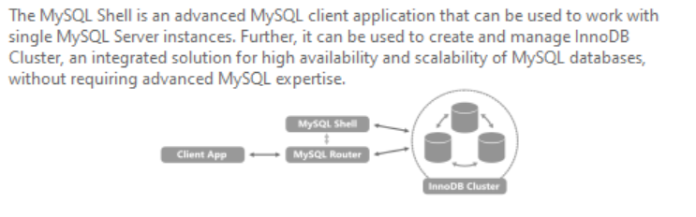

How to connect mysql shell to innerDB cluster->

$ \c root@localhost:3306

Enter your cluster password

$ \sql

How to connect mysql CLI to innerDB cluster->

Just enter password;