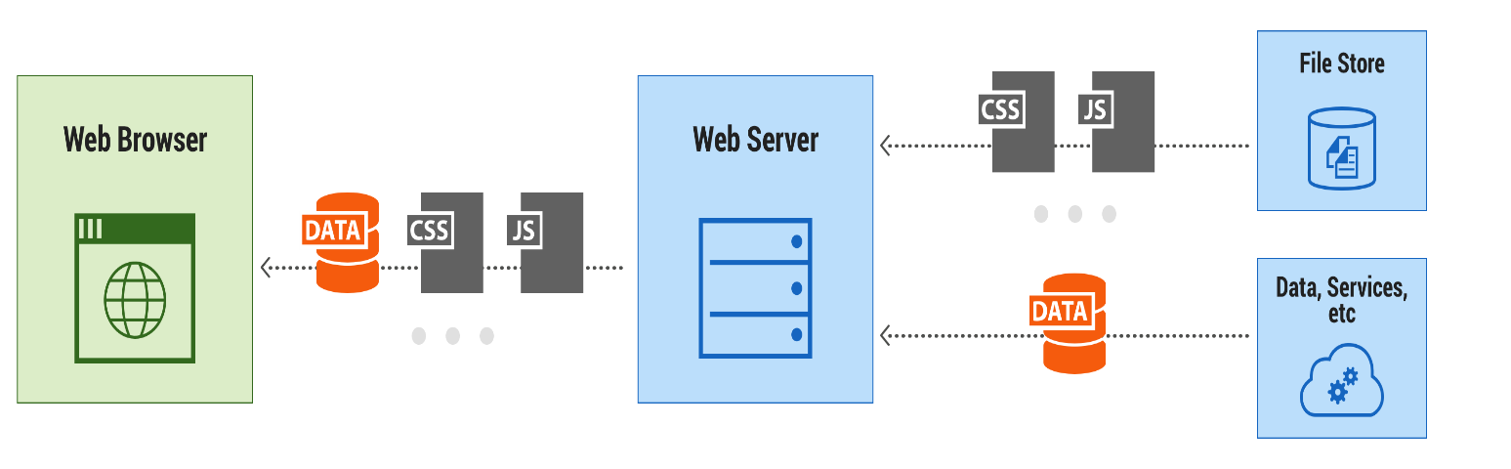

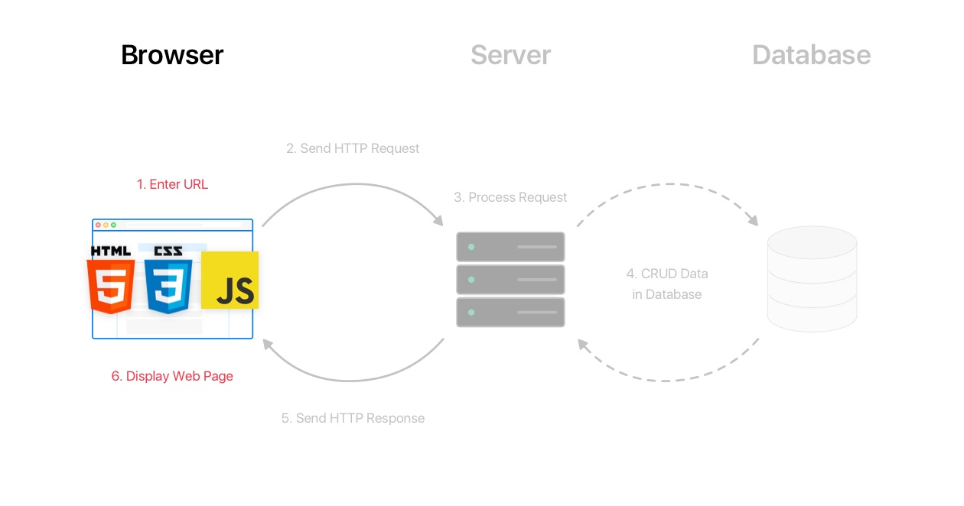

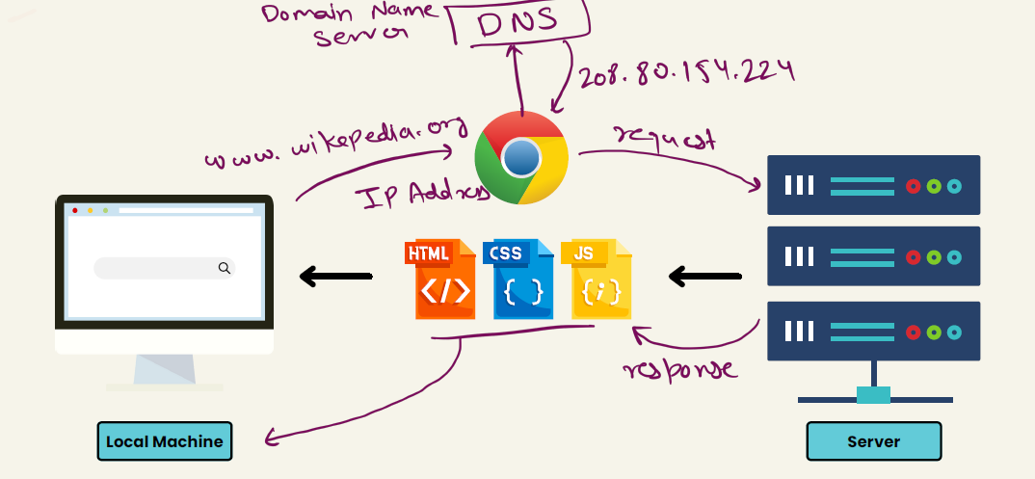

**HTML/CSS/JavaScript uses in web development->**

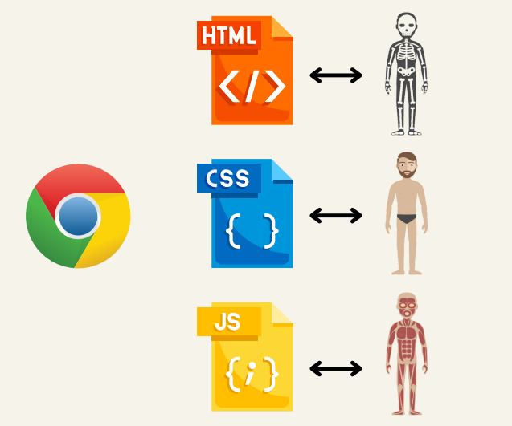

**Tools-> VS Code(auto save) , Live server, any browser for compiling HTML/CSS/JS**

**HTML**

**HTML is the standard markup language for creating Web pages.**

What is HTML?

* HTML describes the structure of a Web page
* HTML consists of a series of elements
* HTML elements tell the browser how to display the content
* HTML elements label pieces of content such as "this is a heading", "this is a paragraph", "this is a link", etc.

Understandings Term using Example with code->

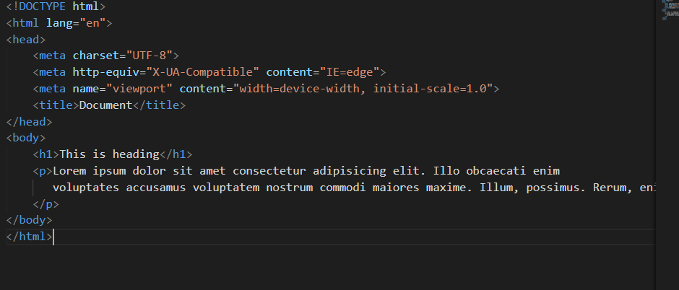

* The <!DOCTYPE html> declaration defines that this document is an HTML5 document
* The <html> element is the root element of an HTML page
* The <head> element contains meta information about the HTML page
* The <title> element specifies a title for the HTML page (which is shown in the browser's title bar or in the page's tab)
* The <body> element defines the document's body, and is a container for all the visible contents, such as headings, paragraphs, images, hyperlinks, tables, lists, etc.
* The <h1> element defines a large heading
* The <p> element defines a paragraph

## HTML Elements

The HTML **element** is everything from the start tag to the end tag:

<tagname>Content goes here...</tagname>

HTML Formatting Elements

Formatting elements were designed to display special types of text:

* <b> - Bold text
* <u> - underline text
* <strong> - Important text
* <i> - Italic text
* <em> - Emphasized text
* <mark> - Marked text
* <small> - Smaller text
* <del> - Deleted text
* <ins> - Inserted text
* <sub> - Subscript text
* <sup> - Superscript text
* <hr> - a horizontal line

## HTML Links

## <a href=<https://www.w3schools.com> target=”_blank” >This is a link</a>

## (adding self html file as a link)

<a href="index.html">head</a>

## 

## HTML Images

## <img src="w3schools.jpg" alt="W3Schools.com" width="104" height="142">

HTML Attributes

* All HTML elements can have **attributes**
* Attributes provide **additional information** about elements
* Attributes are always specified in **the start tag**
* Attributes usually come in name/value pairs like: **name="value"**

<tag att1=”xyz” att2=”xyz2” att3=”xyz3”>conten……..<\tag>

**HTML List-**

<ul>

        <li type="squre">burger</li>  <!-- disc circle -->

        <li>tea</li>

        <li>pasta</li>

    </ul>

    <ol type="1" start="5">     <!-- type="1","A","a" -->

    <li>vikas</li>

    <li>rohit</li>

    <li>saumik</li>

    </ol>

    <p>A description list, with terms and descriptions:</p>

    <dl>

        <dt>Coffee</dt>

        <dd>Black hot drink</dd>

        <dt>Milk</dt>

        <dd>White cold drink</dd>

      </dl>

HTML Table-

 <table border="6" cellspacing="15px" cellpadding="5px"  >

        <tr> <!-- tr->table row -->

            <th>name</th>    <!-- th->table head -->

            <th>dist</th>

            <th>roll</th>

        </tr>

        <tr bgcolor="blue" >

            <td bgcolor="red" colspan="2" rowspan="3">vikas</td>

 <!-- rowspan->number of rows filled, colspan->number of colom filled -->

           <!-- th->table data -->

<td>azamgarh</td>

            <td>056</td>

        </tr>

        <tr >

            <td>jitendra</td>

            <td>bikaner</td>

            <td>023</td>

        </tr>

<tr >

            <td>kisan</td>

            <td>pune</td>

            <td>093</td>

        </tr>

</table>

# HTML <input> Tag-

* <input type="button">
* <input type="checkbox">
* <input type="color">
* <input type="date">
* <input type="datetime-local">
* <input type="email">
* <input type="file">
* <input type="hidden">
* <input type="image">
* <input type="month">
* <input type="number">
* <input type="password">
* <input type="radio">
* <input type="range">
* <input type="reset">
* <input type="search">
* <input type="submit">
* <input type="tel">
* <input type="text"> (default value)
* <input type="time">
* <input type="url">
* <input type="week">
* <form action="/action_page.php">
* <label for="fname">First name:</label>
* <input type="text" id="fname" name="fname"><br><br>
* <label for="lname">Last name:</label>
* <input type="text" id="lname" name="lname"><br><br>
* <input type="submit" value="Submit">
* </form>

## Input tag -Type Attribute-

## button checkbox color date datetime-local email file hidden image month number password radio range reset search submit tel text time url week

**HTML Form tag-**

 <form action="" method="post">

        <label for="name">Name</label>

        <input type="text">

        <br><br>

        <label for="name">District</label>

        <input type="text">

        <br><br>

        <label for="email">Email</label>

        <input type="email">

        <br><br>

        <label for="date">Date</label>

        <input type="date">

        <br><br>

        <label for="date">button</label>

        <input type="button" value="click">

        <br><br>

        <label for="">please select your plan</label>

        <select name="choose" id="">

            <option value="defalt">select</option>

            <option value="personel">personel</option>

            <option value="business">business</option>

            <option value="premium">premium</option>

            <option value="">super premium</option>

        </select>

        <br> <br> <br>

        <p> which subject do you prefer in class 12th =</p>

        physics<input type="checkbox" name="" id="">

        chemistry<input type="checkbox" name="" id="">

        mathmetics<input type="checkbox" name="" id="">

        punjabi<input type="checkbox" name="" id="">

        english<input type="checkbox" name="" id="">

        <br><br>

        textarea <br>

        <textarea name="" id="" cols="30" rows="10">

         sumit your feedback

        </textarea>

        <br><br>

        <label for="">Gender</label>

        <input type="radio" name="gender" id="">Male

        <input type="radio" name="gender" id="">Female

        <input type="radio" name="gender" id="">Trans

        <br><br><br>Time

        <input type="time" name="" id="" value="23">

        <br><br>Range

        <input type="range" id="a" value="50">

    </form>

**CSS(designing web page)**

*Inline css*

*Internal css*

*External css*

*Priority inline vs external*

*Text color vs backgroup color*

**CSS selectors-** are used *to select the content you want to style*. Selectors are the part of CSS rule set. CSS selectors select HTML elements according to its id, class, type, attribute etc.

There are several different types of selectors in CSS.

1. CSS Element Selector
2. CSS Id Selector
3. CSS Class Selector
4. CSS Universal Selector
5. CSS Group Selector

Html file-

<body class="bd">

<h1>This is heading</h1>

<p class="vikas">Lorem ipsum dolor sit amet consectetur adipisicing elit. Ullam, rerum.</p>

<p class="vikas">Lorem <i>chitkara university </i> dolor sit, amet consectetur adipisicing elit. Officiis repudiandae beatae magni impedit perspiciatis quos,

  est reiciendis, dolorem sapiente totam, tempore nobis autem.

</p>

<p class="cl1" id="xyz">this is last paragraph</p><br>

<p>this is paragraph</p>

<p>this is last paragraph</p>

</body>

**Css file-**

*{

  background-color: bisque;

}

h1{

  background-color: blue;

}

p{

  background-color: chartreuse;

}

.bd{

  background-color: aquamarine;

}

 .p{

  background-color: burlywood;

}

#xyz{

  background-color: brown;

}

.vikas{

  background-color: aqua;

}

#xyz{

  background-color: red;

}

p i{

  font-family: Arial, Helvetica, sans-serif;

  font-weight: bold;

}

.cl1{

  background-color: blanchedalmond;

}

1. combinator selector in css.

2. child selector.

3. immediate sibling selector.

4. sibling selector.

5. descendant selector

6. child selector v/s descendant selector.

7. adjacent sibling selector with example put a para in between

8. general sibling

9. attribute selector achor, class attribute selector.

10. inherited v/s defined style.

11. pseudo selectors using : for special state like visited, hover.

12. active state.

13. focus pseudo class for input, button.

14. structural pseudo class first-child, last-child.

15. active v/s focus

16. substring matching ^=, $=, *=

17. specifically target specific child.

**CSS Combinators:**

There are four different combinators in CSS:

* descendant selector (space)
* child selector (>)
* adjacent sibling selector (+)
* general sibling selector (~)

**Attributes selecters: as a href ,as a class**

 <h1>

        this is heading in class 75

    </h1>

    <!-- <div>

        <h4>thi is heading starting</h4>

        <p>Lorem ipsum dolor sit amet <b>VIKAS</b> consectetur adipisicing elit. Fugiat, aperiam.</p>

        <p>Lorem ipsum dolor sit <span>Patel</span> amet consectetur adipisicing elit. Quia ipsam sed voluptates

            molestiae.</p>

        <p>Lorem ipsum dolor sit amet consectetur adipisicing elit. Rem et omnis illo fugiat maxime mollitia

            aliquam itaque, laborum, commodi blanditiis ex iure nisi!</p>

        <main>

            <p>this is paragraph </p>

        </main>

    </div>

    <p>Lorem ipsum dolor sit amet consectetur adipisicing elit. Eveniet, quo!</p>

    <p>thia is last paragraph</p> -->

    <a href="https://chitkara.com" >click me</a><br>

    <a href="https://chitkara.com" target="_blank">click me</a><br>

    <a href="https://chitkara.com" target="_blank">click me</a><br>

div{

    background-color: aquamarine;

}

/* div  p{

    background-color: brown;

} */

/* div > p{

    background-color: brown;

} */

/* div + p{

    background-color: brown;

} */

/* div ~ p{

    background-color: brown;

} */

/* a[href]{

   color: red;

}

a[target]{

    font-size: 40px;

} */

What are Pseudo-classes?

A pseudo-class is used to define a special state of an element.

For example, it can be used to:

* Style an element when a user mouses over it
* Style visited and unvisited links differently
* Style an element when it gets focus

a:link{

color: red;

}

a:focus{

    color: blanchedalmond;

}

a:visited{

    color: greenyellow;

}

a:hover{

    color: yellow;

}

a:active{

    color: teal;

}

## CSS - The :first-child Pseudo-class

In the following example, the selector matches any <p> element that is the first child of any element:

### **Example**

p:first-child {  
  color: blue;  
}

p:last-child {  
  color: blue;  
}