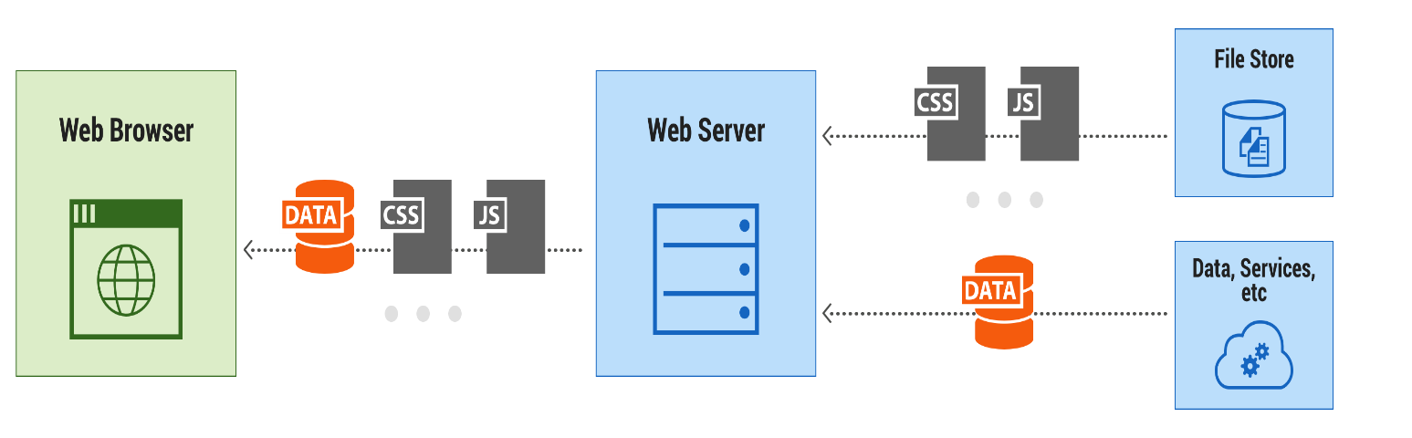

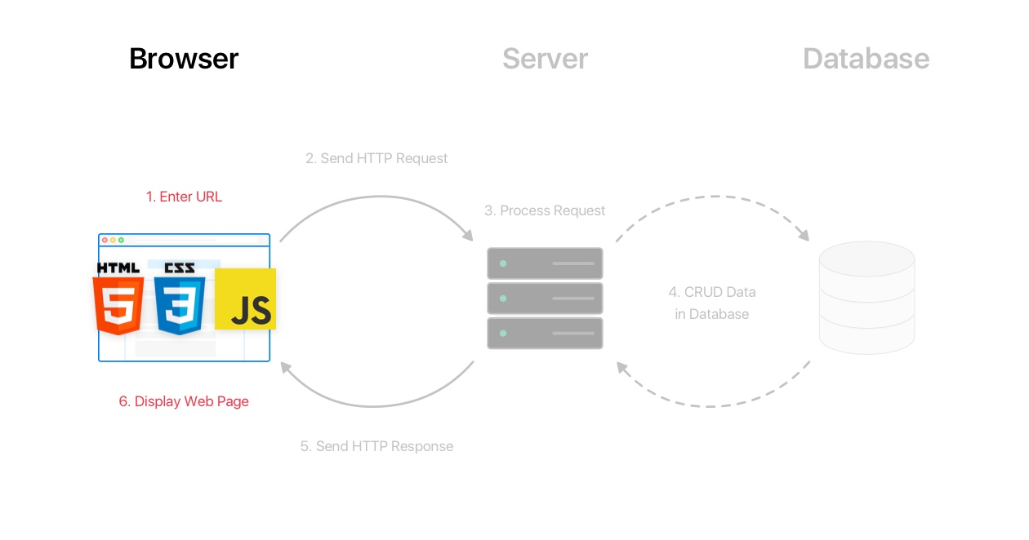

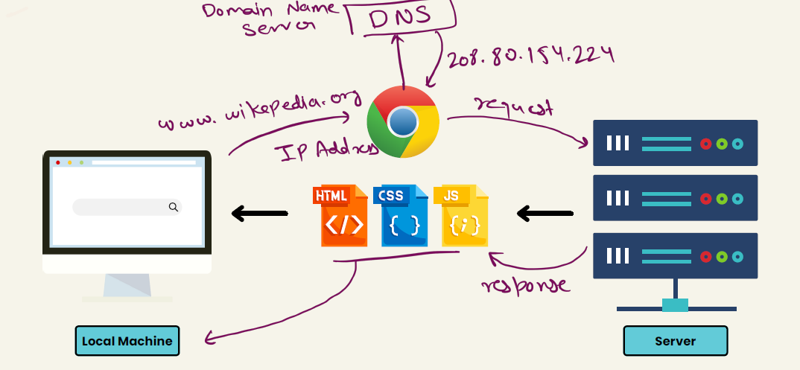

**HTML/CSS/JavaScript uses in web development->**

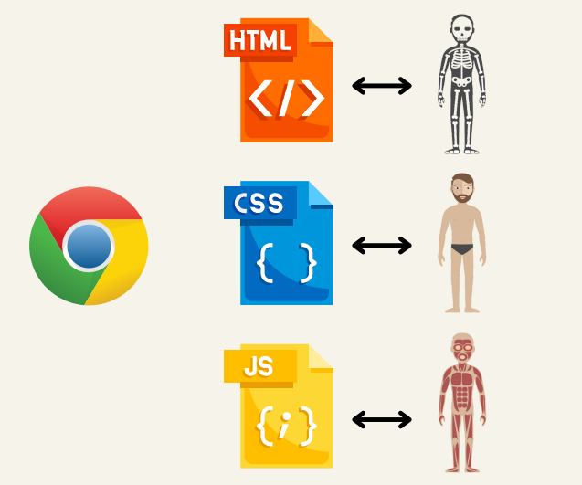

**Tools-> VS Code(auto save) , Live server, any browser for compiling HTML/CSS/JS**