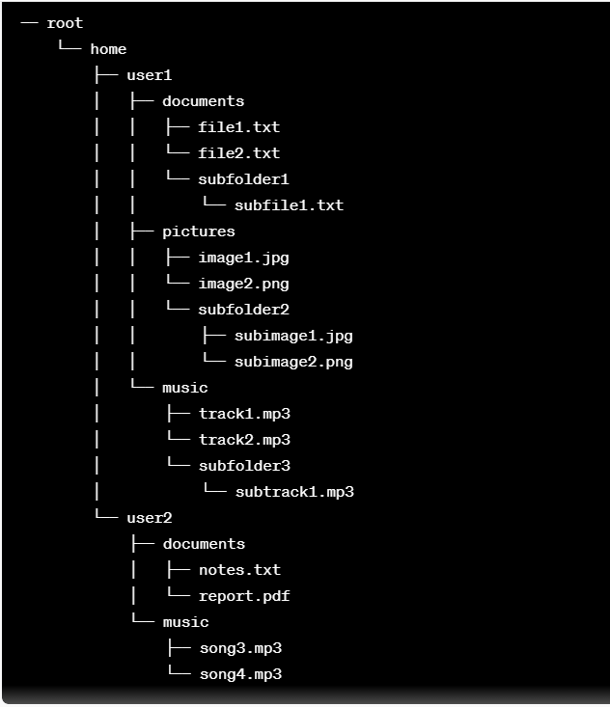

1. Given the current working directory is "/home/user2/documents," to create the file "report.txt," which command should be used?

a) touch /home/user2/documents/report.txt

b) rm report.txt

c) rm /documents/report.txt

d) delete report.txt

Correct Answer: a) touch /home/user2/documents/report.txt

2. Assuming the current directory is ""/home/user2/documents," to create a directory named "backup" within the current location, which command should be used?

a) mkdir /backup

b) mkdir backup

c) mkdir /var/log/backup

d) mk backup

Correct Answer: b) mkdir backup

3. Given the current working directory is "/home/user1/pictures," to create a directory named "vacation" within this location, which command should be used?

a) mkdir vacation

b) mkdir /vacation

c) mkdir /home/user1

d) mk vacation

Correct Answer: a) mkdir vacation

4. Assuming the current directory is "/home/user2/music," to copy the file "song3.mp3" to the "user1/music" directory, which command should be used?

a) cp song3.mp3 /home/user1/music

b) cp /home/user2/music /home/user1/music

c) cp /home/user1/music /home/user2/music

d) copy song3.mp3

Correct Answer: a) cp song3.mp3 /home/user1/music

5. Given the directory structure, assuming the current working directory is "/home/user1," to delete the file "file2.txt," which command should be used?

a) rm /home/user1/documents/file2.txt

b) rm file2.txt

c) rm /documents/file2.txt

d) delete file2.txt

Correct Answer: a) rm /home/user1/documents/file2.txt

6. Given the directory structure, assuming the current working directory is "/home/user2/music," to copy the file "song4.mp3" to the "user1/music" directory, which command should be used?

a) cp song4.mp3 /home/user1/music

b) cp /home/user2/song4.mp3 /home/user1/music

c) cp /home/user1/music/song4.mp3 /home/user2/music

d) copy song4.mp3

Correct Answer: a) cp song4.mp3 /home/user1/music

7. Assuming the current working directory is "/home/user1/documents," to move the file "file1.txt" to the "pictures" directory, which command should be used?

a) mv file1.txt /home/user1/pictures

b) mv /home/user1/documents /home/user1/pictures

c) mv file1.txt /documents

d) mv file1.txt /pictures

Correct Answer: a) mv file1.txt /home/user1/pictures

8. Assuming the current working directory is "/home/user1/documents," to create a subfolder named "projects" within this location, which command should be used?

a) mkdir projects

b) mkdir /projects

c) mkdir /home/user1/documents

d) mk projects

Correct Answer: a) mkdir projects

9. Given the directory structure, assuming the current directory is "/home/user2/documents," to move the file "report.pdf" to the user1 "documents" directory, which command should be used?

a) mv report.pdf /home/user1/documents

b) mv /home/user2/report.pdf /home/user2/documents

c) mv /home/user2/documents/report.pdf

d) mv report.pdf documents

Correct Answer: a) mv report.pdf /home/user1/documents

10. Assuming the current working directory is "/home/user1/pictures," to delete the file "subimage2.png," which command should be used?

a) rm /home/user1/pictures/subfolder2/subimage2.png

b) rm subimage2.png

c) rm pictures/subimage2.png

d) delete subimage2.png

Correct Answer: a) rm /home/user1/pictures/subfolder2/subimage2.png