**Top IT Technology :-**

Blockchain , Data Science , Machine Automation (ML), IoT, 5G ,

CyberSecurity, Cloud Computing, VR & AR, Edge Computing, AI,

Metaverse, Bioinformatics and genetics Engineering, Game

Development, Web Development, etc Software Development

**SDLC –> Software(product, solutions) Development Life Cycle :-**

The SDLC is a process by which software is developed and deployed. It’s a

process that encompasses every phase of software creation, from

conception to maintenance after the software is released.



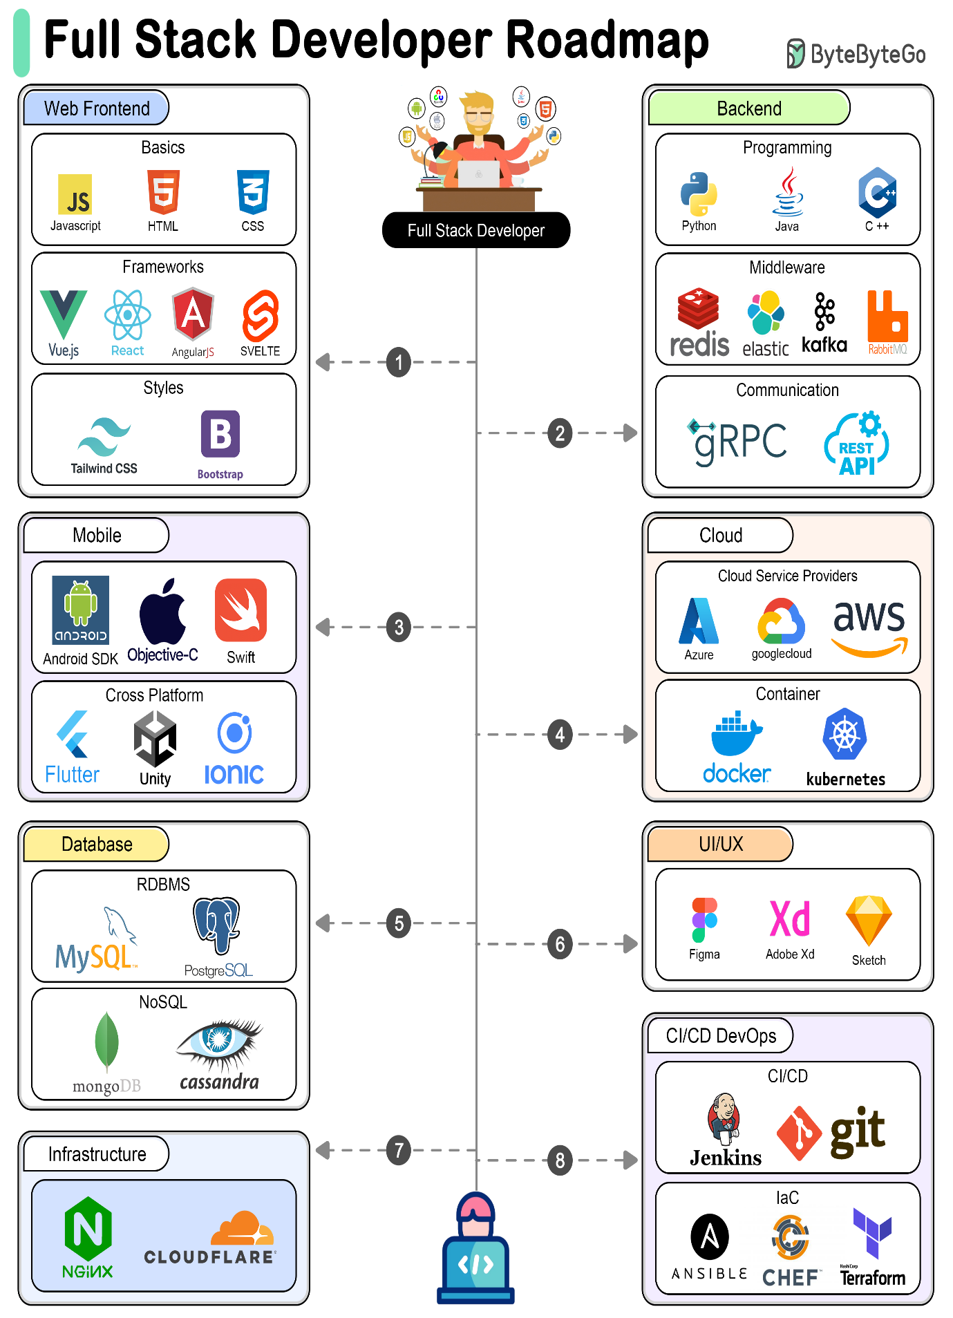

**💻 What is a Computer?**

A **computer** is an electronic device that accepts data (input), processes it according to instructions (processing), stores it, and produces useful information (output).  
It works on the principle of **Input → Process → Output → Storage**.

**🧩 Components of a Computer**

**1. Input Devices**

Used to enter data and instructions.

* Examples: **Keyboard, Mouse, Scanner, Microphone, Webcam, Touchscreen**

**2. Output Devices**

Used to display or communicate results.

* Examples: **Monitor, Printer, Speakers, Projector**

**3. Storage Devices**

Used to store data permanently or temporarily.

* **Primary Storage** (fast, temporary): **RAM, Cache**
* **Secondary Storage** (permanent): **Hard Disk, SSD, Pen Drive, CD/DVD**

**4. Central Processing Unit (CPU)**

The **brain of the computer** – executes instructions.

* **ALU (Arithmetic Logic Unit):** Performs calculations & logical operations
* **CU (Control Unit):** Directs data flow and controls components
* **Registers:** Small, high-speed storage inside CPU

**5. Memory**

* **RAM (Random Access Memory):** Temporary, volatile memory for currently running tasks
* **ROM (Read Only Memory):** Permanent memory with essential instructions (like BIOS)

**6. Motherboard**

The main circuit board that connects CPU, memory, storage, and peripherals together.

**7. Power Supply (SMPS)**

Converts electricity from AC (wall supply) to DC to power computer components.

**8. Communication Devices**

Used for networking and Internet.

* Examples: **Modem, Network Interface Card (NIC), Wi-Fi adapter**

✅ **Summary:**  
A computer = **Input + Output + CPU + Memory + Storage + Motherboard + Power + Communication**.

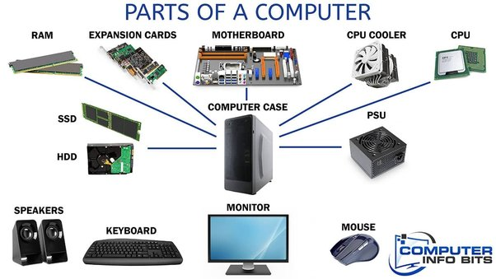

**🌐 Internet**

The **Internet** is a global network of interconnected computers and devices that communicate using a standard protocol called **TCP/IP (Transmission Control Protocol/Internet Protocol)**.  
It allows devices worldwide to exchange data, share resources, and access services like whatsapp email etc..

**Key Features:**

* **Decentralized Network** – No single authority controls the whole Internet.
* **Protocols** – Communication rules (e.g., HTTP, HTTPS, FTP, SMTP).
* **Services** – Email, Web (WWW), Cloud, IoT, Streaming, etc.
* **Identifiers** – Every device has a unique **IP address**. Domain names map to IPs via **DNS (Domain Name System)**.
* **Reference** :- <https://youtu.be/x3c1ih2NJEg>

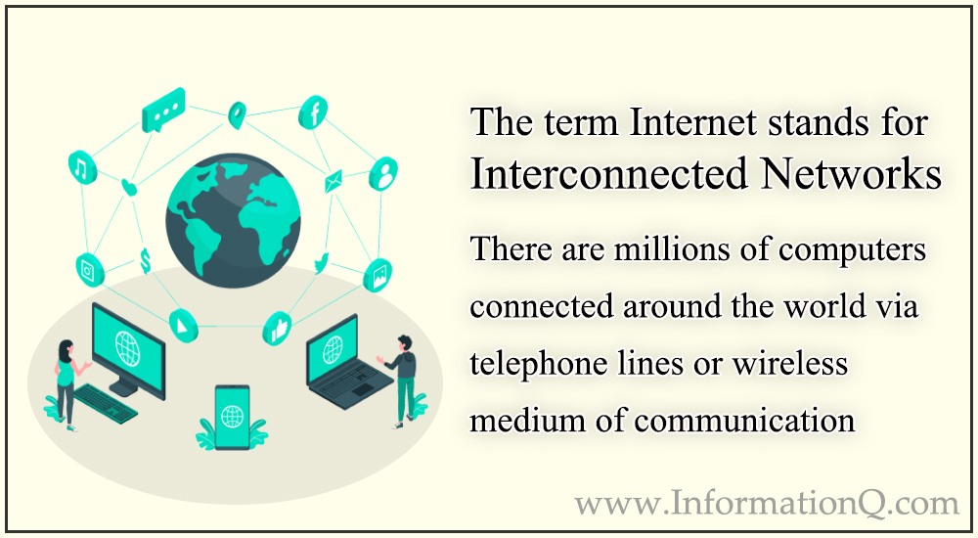

**🖥️ Client-Server Architecture**

This is a **distributed computing model** used to design applications and systems over a network.

**1. Definition**

* **Client**: A device or application that sends requests (like a web browser).
* **Server**: A powerful system or software that listens, processes requests, and sends back responses (like a web server).

Example:  
When you type www.google.com in your browser:

1. Client (your browser) → sends request → Google’s server.
2. Server processes → finds result → sends response back.
3. Client displays result to you.

**2. Working of Client-Server**

1. **Client Initiates Request** → using protocols like HTTP/HTTPS.
2. **Server Processes Request** → fetches data or performs operations.
3. **Server Responds** → sends back HTML, JSON, files, or other data.
4. **Client Displays/Uses Response**.

**3. Types of Servers**

* **Web Server** – Handles web pages (Apache, Nginx).
* **Application Server** – Executes business logic (Node.js, Express, Django).
* **Database Server** – Stores & manages data (MySQL, MongoDB, PostgreSQL).
* **File Server** – Provides file storage and access.
* **Mail Server** – Manages emails (SMTP, IMAP, POP3).

**4. Advantages**

* **Centralized control** of data and security.
* **Scalability** – Servers can be upgraded based on services
* **Data integrity** – Same updated data served to all clients.
* **Easier maintenance** – Updates applied at server side.

**5. Disadvantages**

* **Single point of failure** – If server crashes, clients can’t access services.
* **High cost** – Servers are expensive to maintain.
* **Network dependency** – Requires reliable internet/network connection.

**6. Real-Life Examples**

* **Web Browsing** – Browser (client) ↔ Web Server.
* **Banking Systems** – Mobile app (client) ↔ Bank server.
* **Online Games** – Player (client) ↔ Game server.
* **Email Services** – Outlook/Gmail client ↔ Mail server.

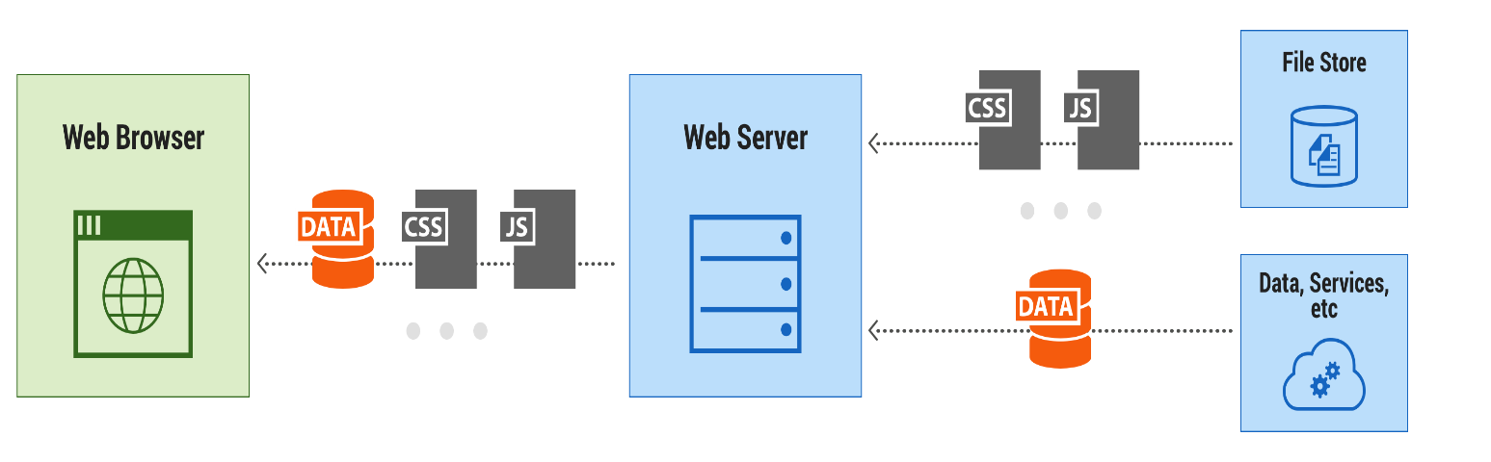

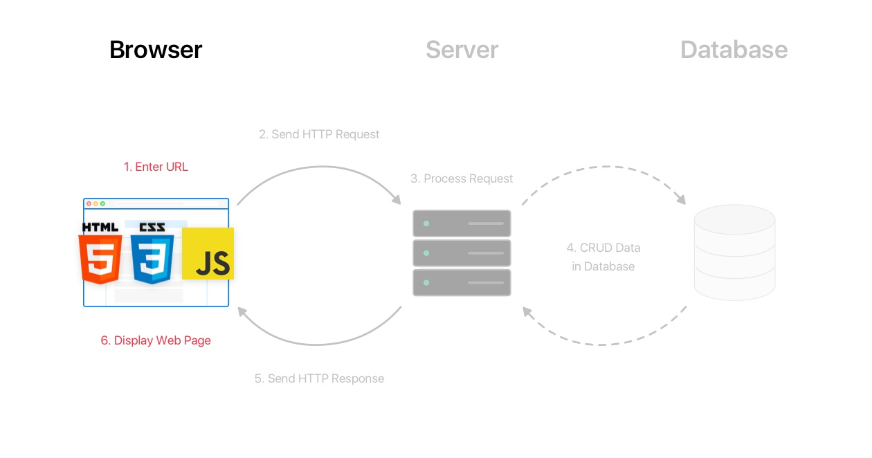

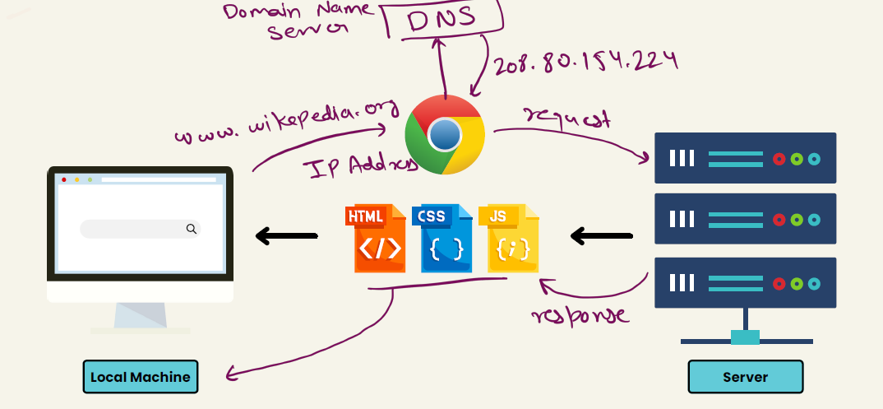

**HTML/CSS/JavaScript uses in web development->**

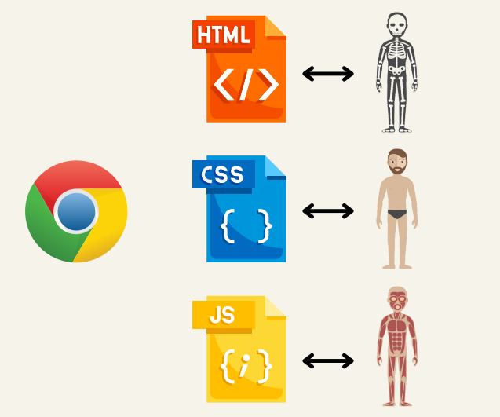

**Install Tools-> VS Code(auto save) , Live server, any browser for compiling HTML/CSS/JS**