# Angular installation steps

## Run the Angular CLI command to install Angular CLI

npm install -g @angular/cli

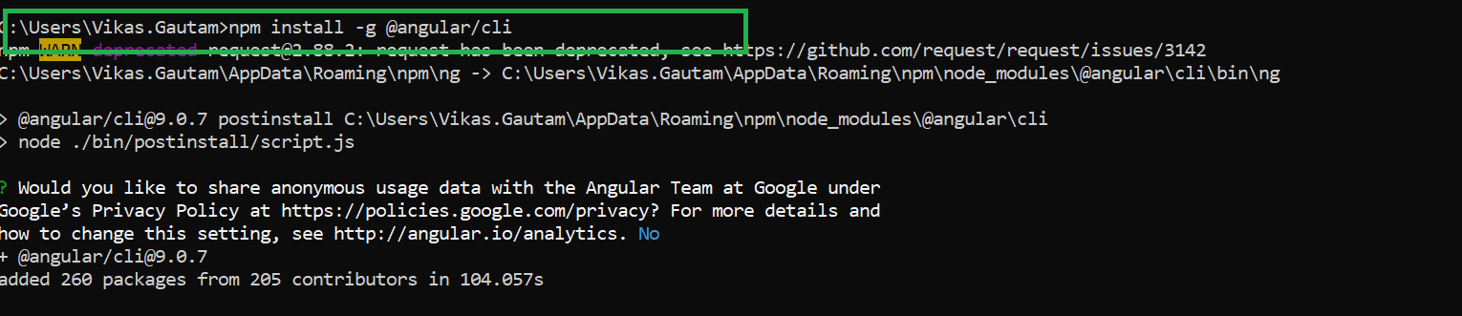

## Create the new project

ng new my-app

This will install all the necessary packages and files and create a project in the folder.

For styling and routing option we can choose no if we are beginning with learning angular.

## Switch to the project

cd my-app

## Start the server

ng serve

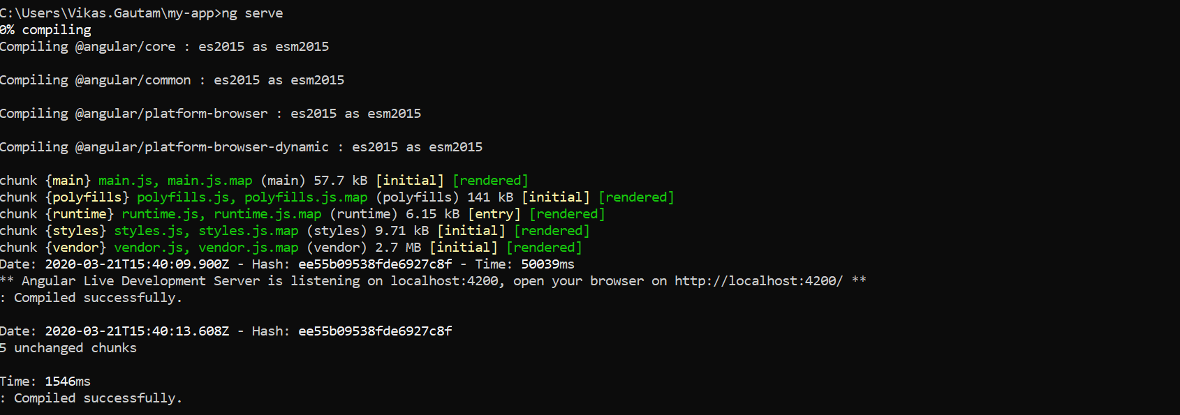

Server is running at localhost:4200

# Angular CLI commands

## Compile the typescript file

tsc filename.tsc

## Check angular version

Ng -version

## Check node version

Npm -version

## Start the server

Ng serve or npm start