**CodroidHub Summer Training**

**Title:-**

**BREAK statement in Python**

**CONTINUE statement in Python**

**FUNCTIONS in Python**

**PRE-DEFINED FUNCTIONS in Python**

**USER-DEFINED FUNCTIONS in Python**

**FUNCTION WITH PARAMETERS in Python**

**DEFAULT ARGUEMENT FUNCTION in Python**

**RECURSIVE FUNCTION in Python**

**CLASS AND OBJECT in Python**

**BREAK STATEMENT IN PYTHON**

*In Python, the break statement is used to immediately exit a loop when a certain condition is met. When working with nested loops, the break statement can be used to break out of both the inner and outer loops.*

*If a break statement is encountered in the inner loop, only the inner loop will be exited and the outer loop will continue to iterate. However, if the break statement is included in the outer loop, both the outer and inner loops will be exited and the program will continue executing after the loop.*

*EXAMPLE:*

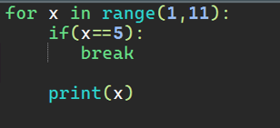

*OUTPUT:*

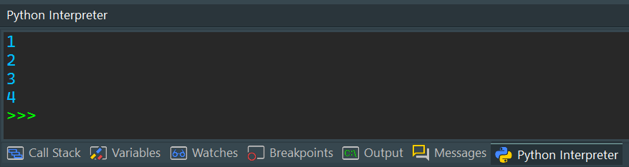

[***Key takeaways***](https://www.coursera.org/tutorials/python-break#key-takeaways)

* *Break is a loop control statement along with continue and pass.*
* *You can use break to exit for loops and while loops.*
* *Break only exits the innermost loop in a nested loop.*
* *You can’t use break to exit an if statement unless the if statement is inside of a loop.*

**Continue Statement in Python**

* *The continue statement is used to skip the remaining code inside a loop for the current iteration only.* ***For instance, let’s use continue instead of a break statement in the previous example.***

*EXAMPLE:*

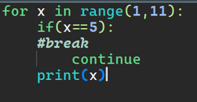

*OUTPUT:*

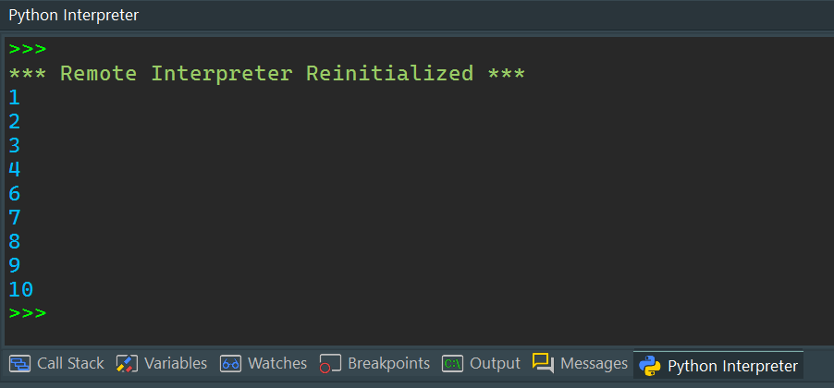

*When the condition x == 5 becomes True, the continue statement gets executed. The remaining code in the loop is skipped only for that iteration. That’s why Iteration: 5 is missing from the above output.*

*Therefore, the continue statement works opposite to the break statement. Instead of terminating the loop, it forces it to execute the next iteration of the loop.*

**FUNCTIONS IN PYTHON**

*A function is a block of code which only runs when it is called. You can pass data, known as parameters, into a function. A function can return data as a result.*

***Creating a Function***

*In Python a function is defined using the def keyword.*

***Calling a Function***

*To call a function, use the function name followed by parenthesis.*

*EXAMPLE*

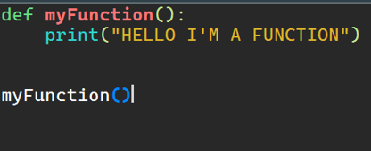

*OUTPUT:*

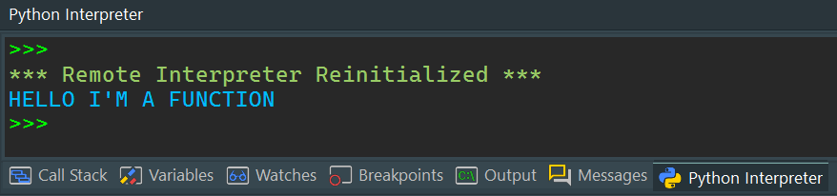

**PRE-DEFINED FUNCTIONS IN PYTHON**

*A predefined function is a function that has already been written in the programming language and can be used by the programmer. A function will return a value that can be stored in a variable or sometimes in a conditional statement*

*There are many pre-defined or built in functions in python. Total there are 68 built in functions in python programming. For example: print(), list(), abs(), ascii(),all(), any(), max(), min() & many more.*

*EXAMPLE:*

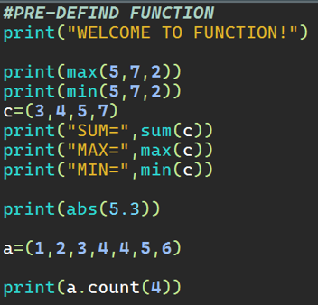

*OUTPUT:*

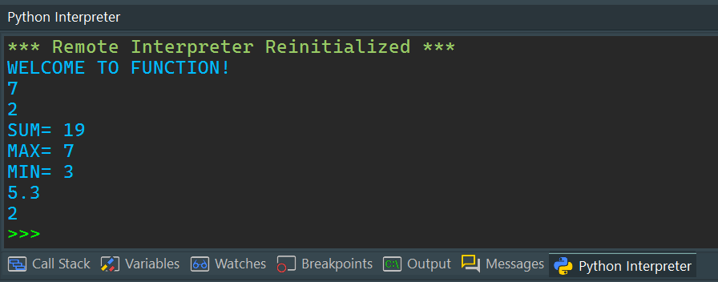

**USER-DEFINED FUNCTIONS IN PYTHON**

*All the functions that are written by any of us come under the category of user-defined functions. Below are the steps for writing user-defined functions in*[*Python*](https://www.geeksforgeeks.org/python-programming-language/)*.*

* *In Python, a*[*def keyword*](https://www.geeksforgeeks.org/python-def-keyword/)*is used to declare user-defined functions.*
* *An indented block of statements follows the function name and arguments which contains the body of the function.*

*EXAMPLE:*

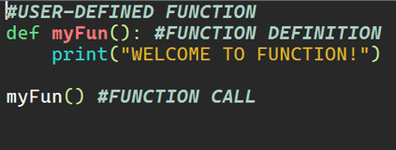

*OUTPUT:*

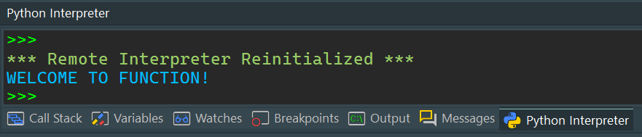

**FUNCTION WITH PARAMETERS IN PYTHON**

*If you have experience in C/C++ or Java then you must be thinking about the return type of the function and data type of arguments. That is possible in Python as well .*

*EXAMPLE:*

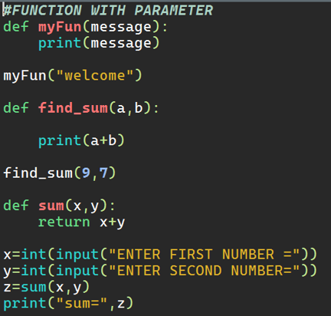

*OUTPUT:*

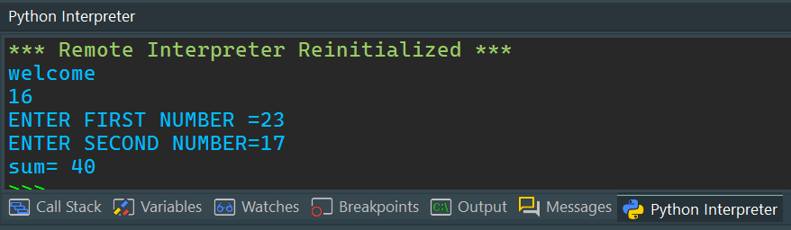

*Let us make a program to calculate simple interest using user defined function.*

*EXAMPLE:*

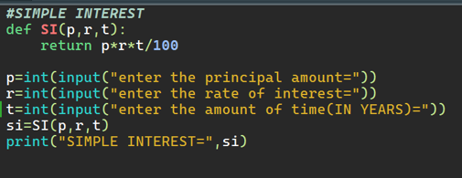

*OUTPUT:*

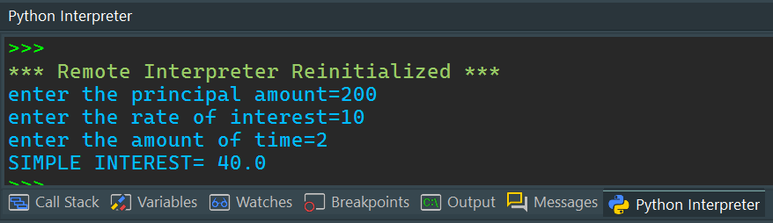

**DEFAULT ARGUMENT FUNCTION IN PYTHON**

*Python allows function arguments to have default values.*

*If the function is called without the argument, the argument gets its default value.*

*Python has a different way of representing syntax and default values for function arguments. Default values indicate that the function argument will take that value if no argument value is passed during the function call. The default value is assigned by using the assignment(=) operator of the form keyword name=value.*

*EXAMPLE:*

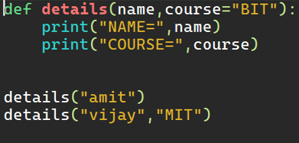

*OUTPUT:*

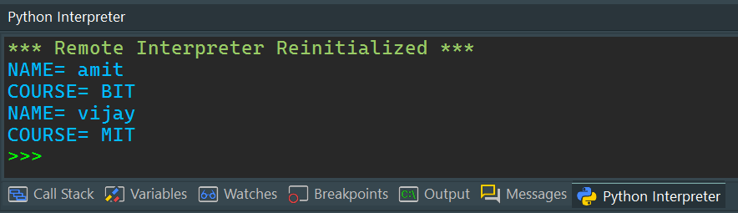

**RECURSIVE FUNCTION IN PYTHON**

*The term*[*Recursion*](https://www.geeksforgeeks.org/recursion/#:~:text=The%20process%20in%20which%20a,%20can%20be%20solved%20quite%20easily.)*can be defined as the process of defining something in terms of itself. In simple words, it is a process in which a function calls itself directly or indirectly.*

***Advantages of using recursion***

* *A complicated function can be split down into smaller sub-problems utilizing recursion.*
* *Sequence creation is simpler through recursion than utilizing any nested iteration.*
* *Recursive functions render the code look simple and effective.*

*Let us solve a problem of finding a factorial of a number using recursion.*

*EXAMPLE:*

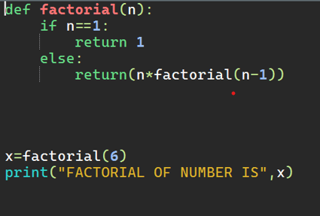

*OUTPUT:*

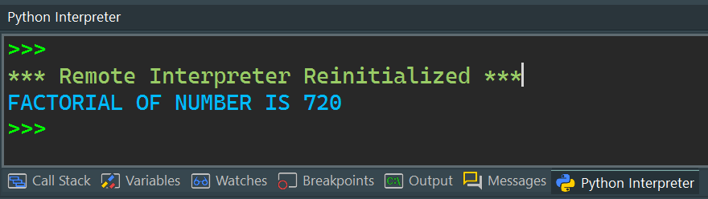

**CLASS AND OBJECT IN PYTHON**

*A* ***class*** *is a user-defined blueprint or prototype from which objects are created. Classes provide a means of bundling data and functionality together. Creating a new class creates a new type of object, allowing new instances of that type to be made. Each class instance can have attributes attached to it to maintain its state. Class instances can also have methods (defined by their class) for modifying their state.*

*EXAMPLE:* 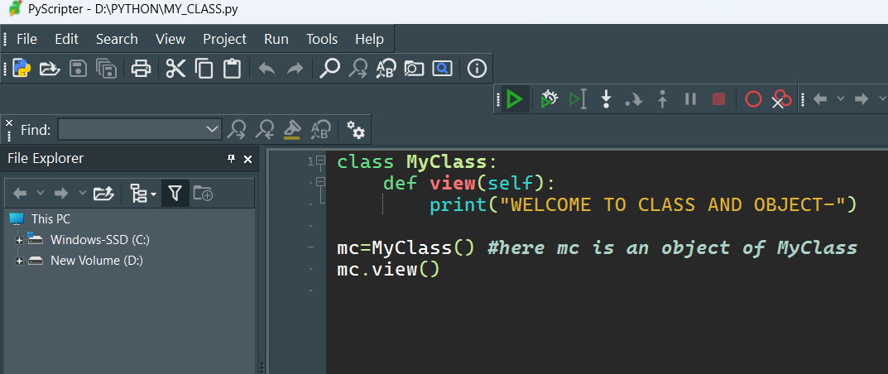

*OUTPUT:* 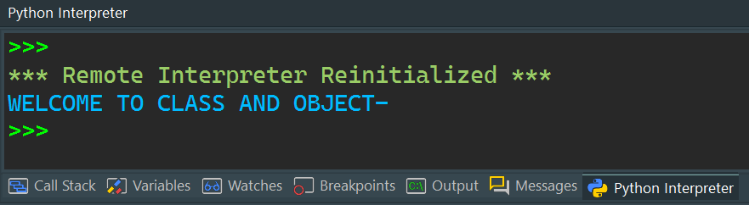

***Object of Python Class***

*In*[*Python programming*](https://www.geeksforgeeks.org/courses/search?query=python)*an Object is an instance of a Class. A class is like a blueprint while an instance is a copy of the class with actual values. It’s not an idea anymore, it’s an actual dog, like a dog of breed pug who’s seven years old. You can have many dogs to create many different instances, but without the class as a guide, you would be lost, not knowing what information is required.*

*An object consists of:*

* ***State:****It is represented by the attributes of an object. It also reflects the properties of an object.*
* ***Behaviour:****It is represented by the methods of an object. It also reflects the response of an object to other objects.*
* ***Identity:****It gives a unique name to an object and enables one object to interact with other objects.*

*EXAMPLE OF CONSTRUCTOR:*

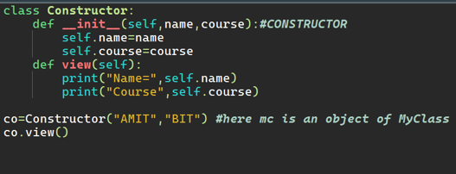

*OUTPUT:*

