**AI ASSISTED CODING**

TASK-1:

Factorial without Functions  
• Description:  
Use GitHub Copilot to generate a Python program that calculates the  
factorial of a number without defining any functions (using loops  
directly in the main code).  
• Expected Output:  
o A working program that correctly calculates the factorial for  
user-provided input.  
o Screenshots of the code generation process

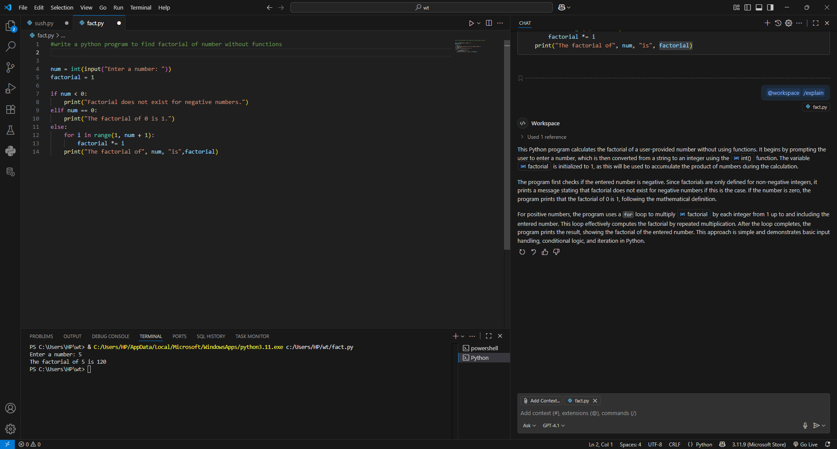

TASK-2:

Improving Efficiency  
• Description:  
Examine the Copilot-generated code from Task 1 and demonstrate  
how its efficiency can be improved (e.g., removing unnecessary  
variables, optimizing loops).  
• Expected Output:  
o Original and improved versions of the code.  
o Explanation of how the improvements enhance performance.

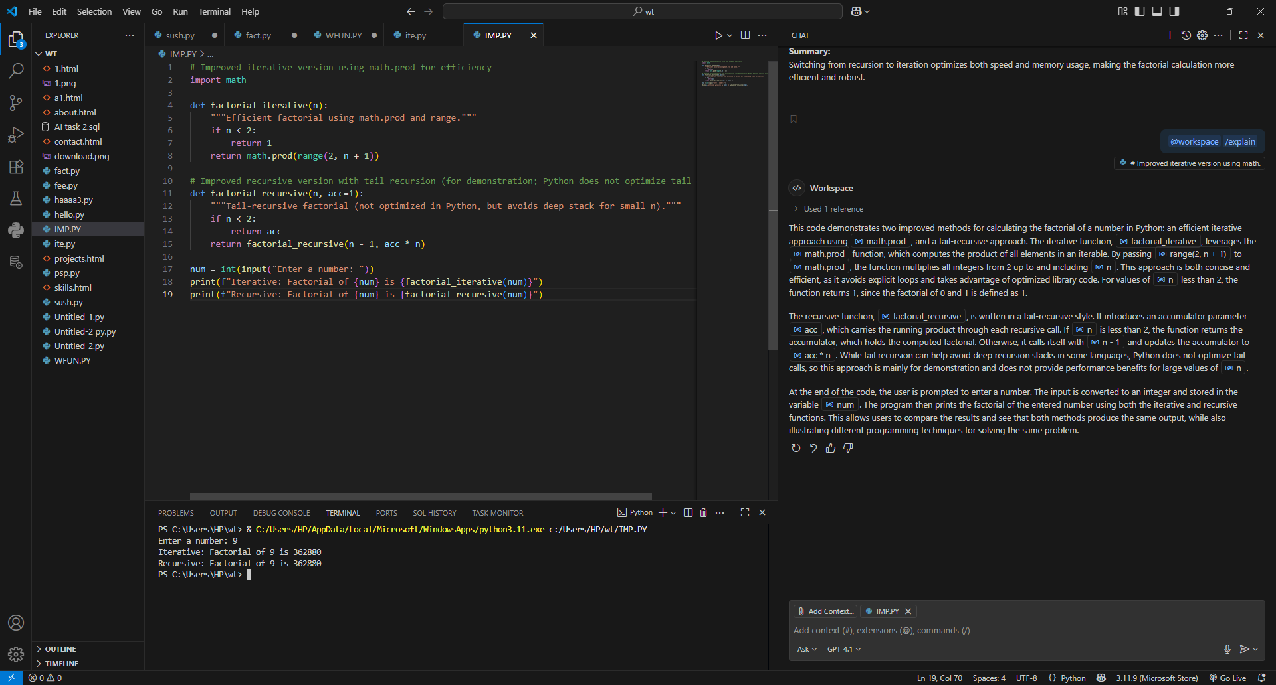

TASK-3:

Factorial with Functions  
• Description:  
Use GitHub Copilot to generate a Python program that calculates the  
factorial of a number using a user-defined function.  
• Expected Output:  
o Correctly working factorial function with sample outputs.  
o Documentation of the steps Copilot followed to generate the  
function.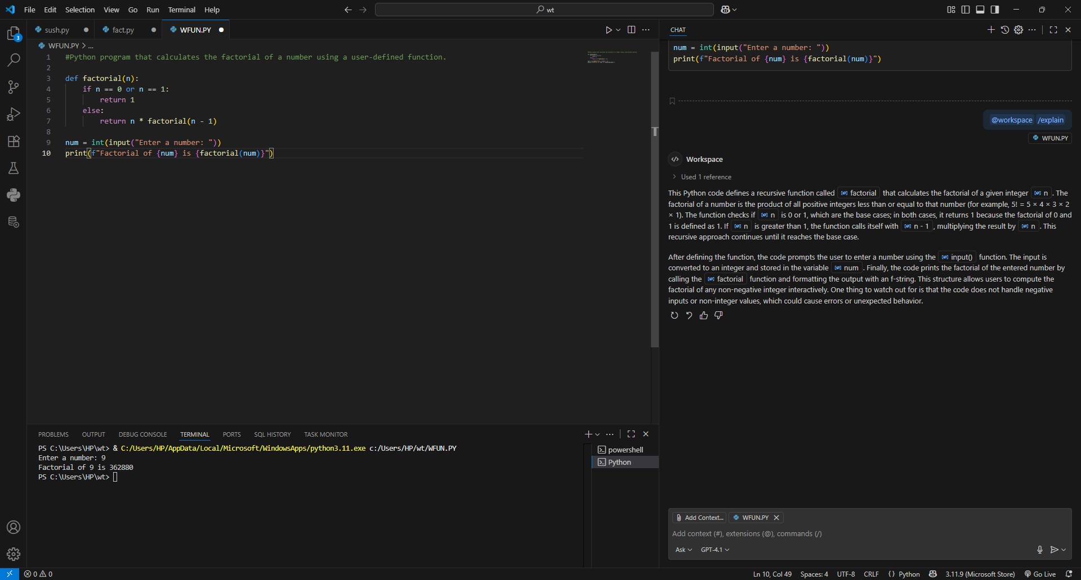

TASK-4:

Comparative Analysis – With vs Without Functions  
• Description:  
Differentiate between the Copilot-generated factorial program with  
functions and without functions in terms of logic, reusability, and  
execution.  
• Expected Output:  
o A comparison table or short report explaining the differences.

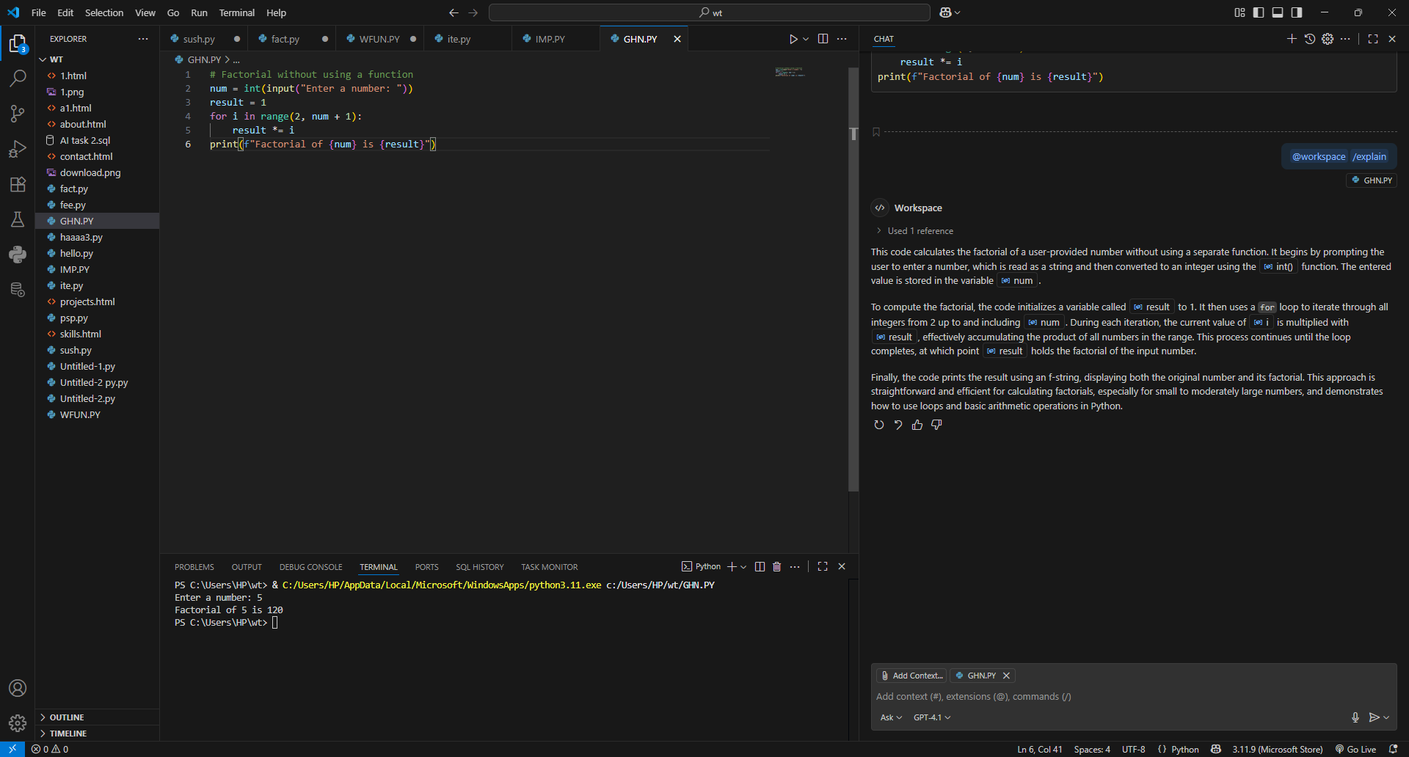

TASK-5:

Iterative vs Recursive Factorial  
• Description:  
Prompt GitHub Copilot to generate both iterative and recursive  
versions of the factorial function.  
• Expected Output:  
o Two correct implementations.  
o A documented comparison of logic, performance, and  
execution flow between iterative and recursive approaches.

