**BCA CAPSTONE PROJECT (Review I)**



**Designation, Department**

**School**

1

## TITLE OF THE PROJECT

**Submitted to the Presidency University, Bengaluru in partial fulfillment for the award of the degree of Bachelor of Computer**

**Applications(BCA)**

**Project Team No :**

|  |  |
| --- | --- |
| **Name** | **Roll Number** |
| Vikas M | 20231BCA0101 |
| Prasad Narayanappa Birasal | 20231BCA0071 |

**Under the supervision of**

Ms devi s

# Content

* Problem Statement
* Literature Survey
* Tools and Technologies to be used
* Timeline of the Project
* Github Link
* References

# Problem Statement

* + Defining the Problem.

Traditional attendance systems, such as manual roll calls, RFID cards, and fingerprint scanners, are **time-consuming, prone to errors, and susceptible to fraud** like proxy attendance. These methods lack **automation, security, and real-time tracking**, making them inefficient in modern environments.

* + Relevance & Significance.

Educational institutions and workplaces require a **secure, contactless, and accurate attendance system** to eliminate proxy attendance and improve efficiency. **NFC technology** provides **quick authentication**, while **face recognition ensures identity verification**, making the system **fraud-proof and reliable**.

* + Current Gaps in Existing Solutions.
* **Manual attendance** → Time-consuming and easy to manipulate.
* **RFID/NFC cards alone** → Cannot prevent **proxy attendance** (one person using another’s card).
  + Concise & Research-Oriented Statement

This project aims to develop an **NFC-Based Attendance System with Face Recognition**, combining **NFC for quick authentication** and **AI-powered face recognition for identity verification**. This **contactless, secure, and automated** system eliminates **fraud and inefficiencies**, making attendance tracking more **accurate and real-time**. 🚀

# Literature Review

* Scope of the Review:

This review explores the development of **automated attendance systems** focusing on **NFC technology** and **face recognition**. It covers research from the past decade, analyzing security, efficiency, and real-world applications in **educational institutions, corporate environments, and secure facilities**.

* Research and Sources:

Studies from **peer-reviewed journals, conference papers, and industry reports** have been reviewed to assess advancements in **NFC authentication, biometric verification, and attendance automation**.

* Organization of Sources:
* **Traditional Attendance Systems** → Manual, RFID, and fingerprint-based methods.
* **NFC-Based Authentication** → Fast, contactless, but vulnerable to misuse.
* **Face Recognition for Security** → Prevents proxy attendance, ensuring identity validation.
* **Integration of NFC and AI** → Hybrid models improving accuracy and efficiency.
* Key Findings and Conclusions:
* Manual and RFID-based attendance systems **lack fraud prevention mechanisms**.
* NFC offers **fast and seamless** authentication but requires additional identity verification.
* Face recognition ensures **security and accuracy** by preventing unauthorized use.
* Combining **NFC and AI-powered face recognition** results in **a robust, fraud-proof attendance system**.
* Conclusion:

Integrating **NFC and face recognition** into attendance systems addresses the **limitations of manual, RFID, and fingerprint-based systems** by providing **a secure, efficient, and contactless solution**. Future studies should focus on **enhancing AI accuracy, reducing costs, and ensuring privacy** in real-world applications.

# Module Design

* Brief overview of the project’s modular architecture

The **NFC-Based Attendance System with Face Recognition** is designed using a **modular approach** to ensure scalability, maintainability, and efficiency. The system consists of multiple interconnected modules, each responsible for a specific function:

* **User Authentication Module** – Uses **NFC** for initial identification and **face recognition** for verification.
* **Database Management Module** – Stores user data, attendance logs, and facial recognition records securely.
* **Attendance Processing Module** – Records and updates attendance status in real-time.
* **Security & Access Control Module** – Ensures data privacy and prevents unauthorized access.
* **Admin Dashboard & Reporting Module** – Provides an interface for monitoring attendance, generating reports, and managing user data.
* Purpose of dividing the project into modules
* **Scalability** → Allows for easy integration of new features, such as AI improvements or cloud storage.
* **Maintainability** → Each module operates independently, making debugging and updates more manageable.
* **Security** → Dividing tasks into separate modules prevents unauthorized access to critical system components.
* **Efficiency** → Parallel processing ensures faster attendance marking and data retrieval.

## Modular Breakdown: NFC-Based Attendance System

## with Face Recognition

* Module 1: Data Collection (User Authentication)

**Functionality:** This module is responsible for collecting user data through **NFC and face recognition**. When a user taps their **NFC-enabled ID card**, the system reads the **unique identifier (UID)** from the NFC tag. Simultaneously, the **camera captures the user’s face** for authentication. The collected data is sent for validation to ensure accuracy and prevent fraud.

* Module 2: Data Processing (Verification & Attendance Marking)

**Role:** This module **processes and verifies the collected data**. It checks the NFC UID against the database and **compares the captured facial data with stored records** using AI-based face recognition algorithms. If both credentials match, the system marks the user's attendance **along with the timestamp and location**. If authentication fails, it prompts an error or alerts the admin for manual verification.

* Module 3: Analysis & Output (Reporting & Monitoring)

**Importance:** This module **generates reports and real-time analytics** based on attendance records. It provides **attendance history, trends, and statistics** through an admin dashboard. This data can be used for **automated payroll processing, performance tracking, or security monitoring**. The system can also send notifications for irregular attendance or unauthorized access attempts.

# Tools And Technologies To Be Used

* + Development Tools:
* **Android Studio** – For developing the mobile application that interacts with NFC tags.
* **Visual Studio Code** – For backend and web-based admin dashboard development.
  + Programming Languages:
* **Python** – Used for face recognition and backend processing.
* **Java** – For Android-based NFC application development.
* **JavaScript (Node.js)** – For backend API and real-time data handling.
  + Frameworks/Libraries:
* **OpenCV** – For face recognition and image processing.
* **TensorFlow/Keras** – For AI-based facial recognition models.
* **React.js** – For building the admin dashboard.
* **Flask/Django** – For backend API development.
  + Database:
* **Firebase** – For real-time attendance data storage.
* **MySQL** – For structured storage of user data and logs.
  + Version Control:
* **Git & GitHub** – For managing source code and collaboration.
  + Additional Tools:
* **Google Cloud Vision API** – For advanced facial recognition processing.
* **Raspberry Pi (Optional)** – If implementing hardware-based NFC readers.
* **Cloud Services (AWS/GCP)** – For hosting and processing large attendance data.

# Github Link

The Github link provided should have public access permission.

## Github Link

* **GitHub Repository:**
* Create a GitHub repository for your project.
* Include the GitHub link in your presentation to showcase any initial code,

documentation, or project structure.

* Make sure your repository is well-organized and updated regularly as your project progresses.

# Timeline of the Project (Gantt Chart)

* + 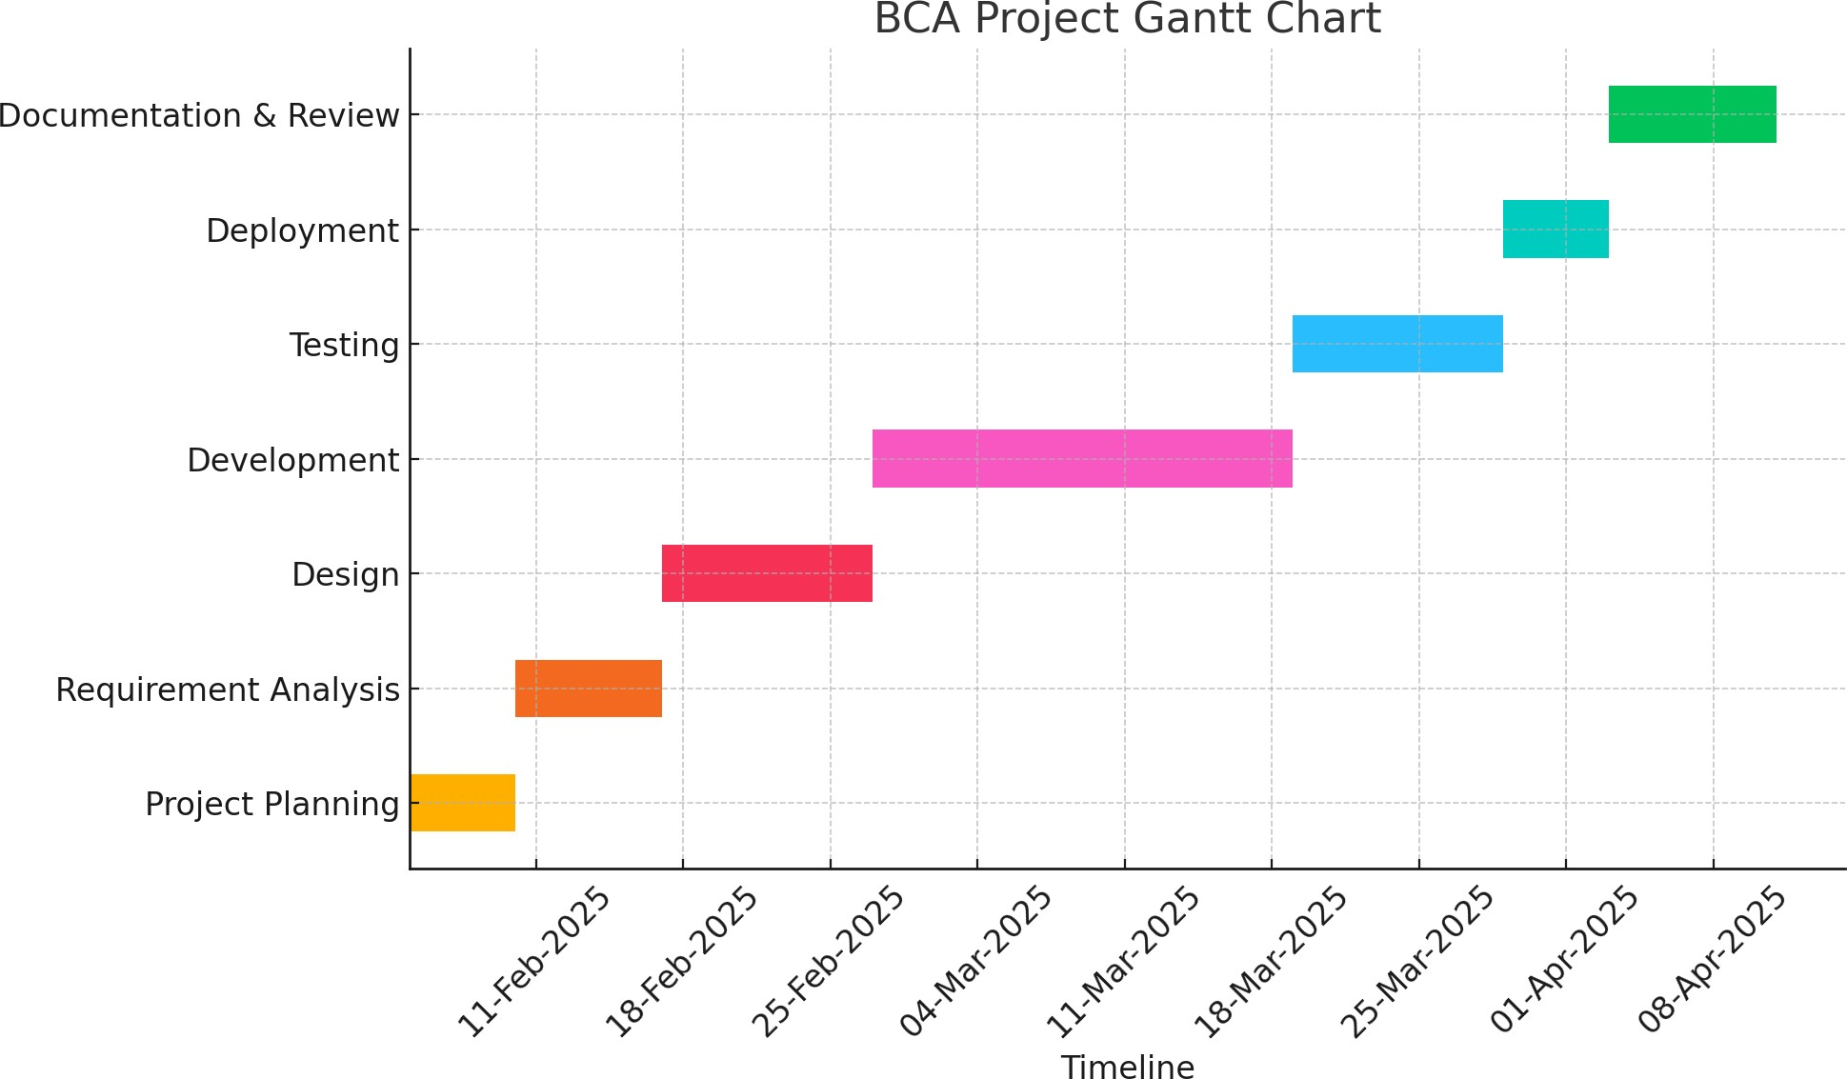Mention the dates according to the phases of your project.
  + Refer Project Review Schedule for Dates.

# References (IEEE Paper format)

* Add APA Citation for all references.
* Use the below link for various APA styles :

htt[ps://w](http://www.indeed.com/career-advice/career-development/how-)ww[.indeed.com/ca](http://www.indeed.com/career-advice/career-development/how-)r[eer](http://www.indeed.com/career-advice/career-development/how-)-[advice/ca](http://www.indeed.com/career-advice/career-development/how-)r[eer-development/how-](http://www.indeed.com/career-advice/career-development/how-) to-cite-a-research-paper

