**Kaarma - Automotive Communication Systems**

(In collaboration with CSULB)

**Project:** Authorization Message Classification

**Document Name:** User Manual

**Owners:** Animesh Pathak (Kaarma) & Birgit Penzenstadler (CSULB)

**Team**

Shashank Linganagari

Shiva Ram Madishetty

Prashanth Nandamuri

Goutam Tadi

Vikas Venkapally

Table of Contents

1. General Information
2. System Overview
3. Organization of the Manual
4. Getting Started
5. Basic Requirements

3. Running the project

1. Installing Maven and GitHub on Linux.
2. Setting up GitHub project.
3. Building project using Maven.
4. Running project.
5. Web Tool
6. Installation
7. Running the Web Tool
8. Error Messages and Recovery Procedures

1. General Information

General Information section explains in general terms the tool and the purpose for which it is intended.

1.1 System Overview

KAARMA classifier tool is an application which can be used to sort out the authorization messages from the conversation data set. The data is stored in the database. Its operational status is still under development.

1.2 Organization of the Manual

The user manual consists of five sections: General Information, Getting Started, Running the Project, Web Tool, Error Messages and Recovery Procedures.

General Information section explains in general terms the tool and the purpose for which it is intended.

Getting Started section explains the requirements and the installation steps for the prerequisites to run the tool.

Running the System section provides a detailed explanation of how the tool can be used by the user.

Web Tool section explains how the authorization messages are classified manually which can be also used as a trained data set for the tool.

Error Messages and Recovery Procedures section gives a list of error messages that can occur and how to troubleshoot them.

2. Getting Started

This section explains how to run KAARMA classifier tool.

2.1 Basic Requirements

The system must have the latest versions of java and MySql installed. The following links can provide you with these softwares

[Java download](https://www.java.com/en/download/) - https://www.java.com/en/download/

[MySql installer](https://dev.mysql.com/downloads/installer/) - https://dev.mysql.com/downloads/installer/

3. Running the Project:

Detailed instructions on setting up the KAARMA classifier tool and how to use it are described in the following sections.

3.1 Installing Maven and GitHub on Linux:

For GitHub installation just type the command: **sudo yum install -y git.**

For Maven installation follow the steps:

This is change to conflict files.

(i) sudo wget

http://repos.fedorapeople.org/repos/dchen/apache-maven/epel-apache-maven.repo-O /etc/yum.repos.d/epel-apache-maven.repo

(ii) sudo sed -i s/\$releasever/6/g /etc/yum.repos.d/epel-apache-maven.repo

(iii) sudo yum install -y apache-maven

3.2 Setting up GitHub Project

Importing the project: git clone https://github.com/mykaarma/labs-authorization.git

3.3 Building Project Using Maven

$> mvn install

3.4 Running Project:

$> cd authorization/target

$> java -jar authorization-1.0.jar <space>

com.kaarma.labs.authorization.Weka.Implementation.ConversationClassify

<space> NaiveBayes

4. Web Tool

The Web Tool is used to manually classify the authorization messages in a data set. The installation requirements and steps to run this tool can be seen in the following sections.

4.1 Installation:

For this web tool LAMP stack is used which is an open source software for running web servers and it stands for Linux, Apache, Mysql and PHP. To install apache, open terminal and type command **sudo yum apache.** For mysql installation type **sudo yum install mysql-server** on terminal and follow the instructions and set the username and password. To install PHP, type **sudo yum install php.** Once the installation is done start the apache server and mysql.

4.2 Running the Web Tool:

This tool is used to classify the authorization messages in each thread manually. To run this tool following steps should follow:

Step 1: Select a Thread id to which you have to authorize

.

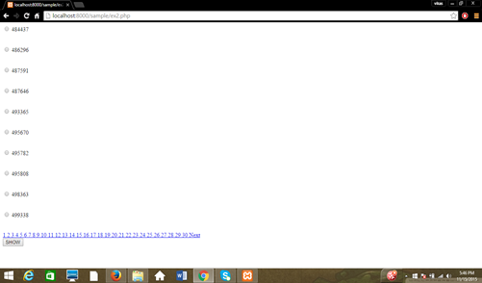

Step 2: The details of the thread id will be displayed.

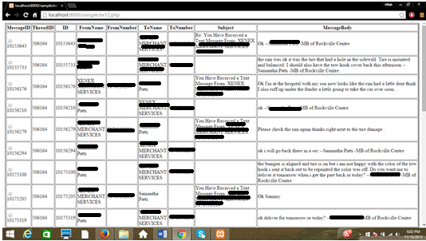

Step 3: Select the message id where the authorization has been done.

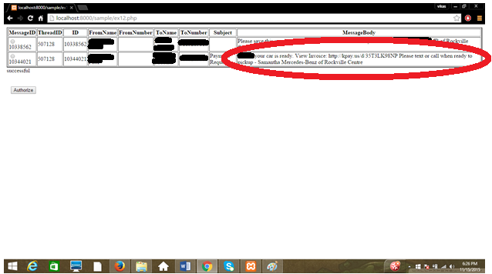

Step 4: Authorized the message by submitting the submit button. Hence, it will classify the message and update it in the database.

5. Error Messages and Recovery Procedures

|  |  |
| --- | --- |
| **Error Message** | **Recovery Procedure** |
| 1. Web page is not available. Err_connection_refused. | The skype and Lamp run on the same port number. So change the port number by changing it in the php.config file and restart it. |
| 2. mysql_connect(): No connection could be made because the target machine actively refused it. | Start mysql, or enter the password and hostname correctly or change the port number. |