Q1: How to speed up the page load (performance)? Write and describe all possible options you know.

Solution:
- Minimize the HTTP Requests
- Minify the combines files (CSS & Java Scrip)
- Use asynchronous loading for CSS And JavaScript files
- Defer JavaScript loading
- Minimize time for first byte
- Reduce Server Response time
- Choose the right hosting option for your need
- Enable compression
- Enable browser caching
- Reduce Image size
- Use a CDN
- Use external hosting platform
- Optimize CSS delivery
- Lazy loading
- Depends on Number of plugin use in the website

Q2: Why and where we need/can to use AngularJS (or any other framework)? Write and explain your opinion, show good and bad sides of the usage. Explain your position.

Solutions :

First of all AngularJs is free open source framework, provided by Google. AngularJs help to use as template language , create rich internet application and offers its developer a client side application. An open-source web application framework like AngularJS, which is written in JavaScript and maintained by Google, is famously used in the development of single page applications(SPA). These single page applications are web applications or websites that very well suit on a single web page, giving a smooth user experience.

Reason For Good Framework.

It is possible to structure the source code by following the Model View ViewModel or Model-View-Controller.
The two-way data binding greatly lessens the amount of boilerplate code which is written to keep the model and view in agreement.
Designers and web developers can work parallelly, as HTML is used for templating. While Web designers can create user interfaces, the developers tie user interface components with data models by using declarative binding syntax.
- Write less code
- DOM Manipulation where they belong
- A declarative user interface
- Flexibility with filterers
- Easily we can install any plugin
- handles dependencies
- Enable a design & Development work flow
- Support Single page Application

Cons of AngularJs

- Performance : Dynamic applications didn’t always perform that well. Complex SPAs could be laggy and inconvenient to use due to their size.

- Steep Learning Curve : After the release of Angular 2 and then the Angular 4 update, the use of the original AngularJS 1.x slowly started to decline. While the new versions still have the same features, described in the benefits section, they were completely rebuilt in the new versions.

- Compulsory JavaScript support
- Scopes
- Complications with backward compatibility
- Lacking CLI documentation details

Q3: Write a JS function what will give successful results for next sentence where input => output.

("Eva, can I see bees in a cave?") => true

Please use only pure JS, no frameworks or additional libraries.

Hint: First, find the logic, what function should do, describe it, then go with realisation

Q4: How to throw a tennis ball so that it will definitely fly back to you? Describe why do you think so…

Solutions: Throw the ball straight up in the air that way it will return because of gravitational force.

Q5: Layout. Check the image below, create a layout based on requirements:
- Max block size is 1250px
- The block with graphics should be in the middle of main block
- Each round should have own background colour: #e0b8b8, #9de397, #bbc54a
- The layout should be responsive and be ready for desktop, tablet and mobile screens
- The layout support browsers: IE8+, FF, Chrome, Opera

Required:
- Use only CSS and HTML to create the layout
- No tables, only containers
- Use one of pre-processors SASS/LESS
- Do not use any tricks for supporting different browsers, only pure CSS
- The page layout should follow HTML5 standards and should be valid based W3C standards

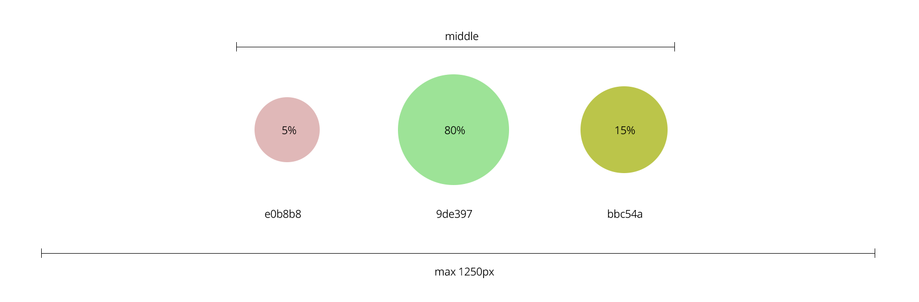

Q5.1: Create a JS function, what will randomly change the size of the circles, based on percentage. The maximum % of the circle can be 99%, the minimum circle % can be 0.5%.

Use the image example, as main layout and view of the future page.

Required:
- Add the button, what will randomly create % of each circle, the total percentage of three circles should be 100%
- Based on %, the biggest should have background colour #9de397, next #bbc54a and smallest #e0b8b8
- Do not use any JS framework in this task
- Follow ES6+ standards
- You can use JQuery library, without additional plugins

