What is Ischool? why was Ischool created? Where are Ischools heading?

Vikas Yadav
School of Information, University of Arizona

Bryan Heidorn
School of Information, University of Arizona

Abstract— The new movement and era of Ischool has titillated many students, researchers and general public to learn about Ischools and join them. Ischools are highly interdisciplinary in nature and cover vast number of domains in education. Information, direction, vision and research of Ischool is one of the recent ongoing researches by scientists and researchers in information community. Also courses and research areas covered by Ischools have gradually changed since last 5years. This paper includes literature surveys about Ischool and proposes recent transformed directions and visions of an Ischool. This paper particularly focuses on the recent advancements, momentum of Ischool in terms of research areas and courses. We also highlight the need for the change of conventional LIS institutes to Ischools. We have also made an attempt to predict future course curriculums and research domains of Ischools.
Index Terms— Ischool research areas, Course curriculums of Ischool, Future of Ischool.
1] Introduction
One of the emerging educational society named Ischool is growing across every part of the world. Being highly interdisciplinary and heterogeneous in nature, Ischools are now being considered as the center for future of innovations. Many researchers, faculties, students with completely different expertise and interests are pooling together at Ischools to innovate and develop the existing technical world. Few examples of research domains in Ischools are Digital studies, Informations Sciences, Social sciences, Data Sciences etc.
Most of the Ischools are originated from conventional Library and Information Sciences department and very few originated from other related departments. Information about Ischool society (ISchool caucus) can be gathered from http://ischools.org/ which is a consortium of information schools that aims to excel and improve member Ischools. Ischool caucus mentions about their vision, history and interdisciplinary nature of Ischools.
The goal of this paper is to help researchers and students understand vision, studies, history, domains and most importantly future of Ischools. Though there are numerous contents available on websites of each Ischool, which many times do not answer every question. For example, just by the introductory webpage of Ischool, one cannot conclude about research expertise of an Ischool. Many Ischools still promote researches in Library sciences through their webpage which confuses many students and researches who want to join Ischool for their research in Informatics, Information Technology, data sciences, social sciences etc. True potential of domains or study areas in an Ischool is depicted by their offered courses. We propose key findings from our survey report conducted over courses offered by various Ischools around United States. Analyzing Ischool domain and study area through offered courses is a novel technique which clearly shows shift in research and study focuses of Ischools.
Paper is organized as followed: Section 1 is introduction, section 2 highlights previous works in this domain and section 3 answers the question about what is Ischool and history of Ischools. Section 4 shows our key findings and proofs of our claims about direction and momentum of Ischools in the future. Section 5 states about possible future work in this domain and section 6 states conclusion. At last section 7 is the reference section.

II. Previous work

There are many research papers, blogs, webpages etc which have made an attempt to explain details of Ischools. Andrew Dillon[1] also focus on explaining readers about various attributes of Ischools like intellectual coverage, interdisciplinarity, and research commitment. Dillon also states about growth of Ischools since last 2 decades and about different universities who started this revolution of transforming conventional LIS schools to Ischools.

Wiggins et.al [2] analyzed faculty hiring trends among those involved in the iSchool community to better understand the intellectual heritage and major influences shaping the development of the individual and collective identities in iSchools. Authors have presented a classification of the intellectual domains of iSchool faculty, and have presented a brief descriptive analysis of the community’s intellectual composition. Wiggins et.al also stated development of Ischools in terms of interdisciplinary research, computational courses and inclusion of many social studies fields which were absent in the LIS schools. John Bertot[3] wrote a report on engagement events and speakers series on Re-Envisioning process of LIS. This report depicts an excellent view of how LIS has changed and now under the name of Ischool, covers broader scope of Information sciences of community and people. Authors also include conventional research domains like archiving in their report.

MYBURGH et.al [5] highlights on the problem of designing course curriculums for LIS schools. Authors studied few subjects who were master’s students in Digital Library Learning and based on their study and interviews of these subjects, they could not reach a conclusion for designing a perfect curriculum. Authors also considered recent developments in Information sciences which are mostly non-library oriented. Lisa P. Nathan et.al [6] state through their paper that Ischools are uniquely centered for designing proactive and adaptive policies for social and online media. This paper gives an example of how an Ischool’s prospective is different from that of a LIS school. Fred Mulder[7] presented a report about effective course curriculum in Informatics field. The courses mentioned in this report are quite similar to our findings of courses which Ischools have started or shifted over in recent years. One can easily understand the momentum or directions in which Ischool and Informatics schools are heading in terms of research and studies.

Gary Marchionini et.al [8] from Ischool at University of North Carolina Chapel Hill presented an excellent report about careers, educational pathways, potential and scope of Information specialists and graduates by 2050. This report covers every aspect and reason of recent transformations in Ischools. As the digital world is thriving day by day, conventional LIS schools have to transform according to the requirement of this digital world. Susan Rathbun[9] from UNCC Ischool also presented a poster tracking careers of Information graduates from ISchools. Authors state that career tracking of graduates can provide iSchools with useful data for strategic planning of programs and engagement activities. One can clearly conclude that IT jobs, financial, data sciences or data management jobs have clearly surpassed conventional core Library jobs. This poster clearly shows the need of changing course curriculums at Information Schools and particularly this change should be towards computing domain.

What is Ischool and History of Ischools

In 1980’s, several long-standing American Library Association (ALA) LIS programs closed due to lack of support and funding’s. Hildreth[10] documented some of the survival strategies by LIS schools: merger with a larger partner or expansion into IT related departments. Many ISchools originated by collaborations of 2 or more schools together like communication, education and LIS schools. Few universities started a new Ischool with researchers and faculties from various departments of the university. For example, departments like Informatics and School of Information have faculties from psychology, college of education, computer sciences, MIS etc. Ischools are always seen as institutes of high interdisciplinary nature and are considered as the first place for research about information policies.

ISchools engage in a broad range of interdisciplinary research pursuits and offer a variety of courses that integrate studies from applied computer science, design, and library science, among other disciplines. The iSchools typically focus on some combination of people, information and technology, across a wide variety of organizational and social contexts. As a result, course offerings at iSchools vary widely in accordance with the variety of degree program offerings. Also due to market change which has now exponentially increased number of IT and data science jobs, Ischools had to change their curriculums.

IV Proposed work

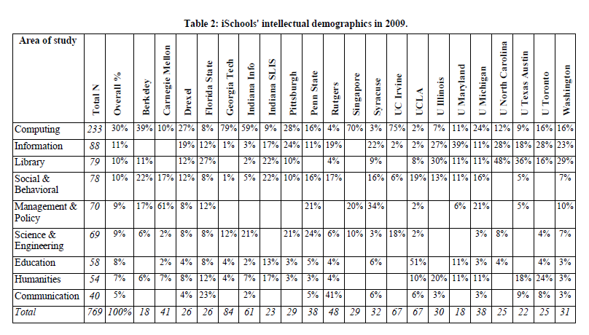
Ischools have always been in the process of evolution since their origin. These interdisciplinary institutes cover many different domains and the main reasons for these adaptions or interdisciplinary nature is immense demand of Information scientists in this digital age. In today’s digital world, almost every information can be found online, people and communities can connect to each other, advent of IOT, digital online market etc. There has been a boom of IT jobs in past 5 years and this trend is expected to grow exponentially in the coming years. With this trend, demand for information scientists has also increased exponentially. Information security, cyber security, Information policy, digital archiving, information extraction, HCI are one of the new core fields where information scientists are highly demanded. Also online social networking platforms, online education societies, data sciences, health informatics are also some important areas where Information scientists are required. Ischools are transforming according to this trend.

We have conducted a survey on courses taught at various Ischools and we have classified these courses in different domains of research or study. After calculating number of courses taught in these domains, and comparing it with previous statistics of courses by ISchools, we extracted the domains where Ischools are focusing more. In other words, Ischools are reducing conventional LIS courses and increasing number of computing courses.
We have conducted surveys on webpages of 3 Ischools of US- Ischool at UT Austin, University of Michigan School of Information, Ischool of UIUC. We have classified courses in 24 classes and each course if further classified as graduate level or undergrad level. We have also made an attempt to classify these courses further down by classifying them in advance or basic levels. We are representing only 2 classes in this paper to show readers that how far ISchools focus has changed from conventional LIS domain.

Domains | Percentage of courses
Conventional LIS (Foundation of Information, research methods for library, Studies on Human behavior, Fundamental and theory of Information etc) | 22.4
New courses (covering wide domain of Big Data, HCI, data sciences, IT, MIS, Health Informatics, digital and online information, computational social sciences etc.) | 77.6

Table 1: Summarization of proposed survey results conducted over courses offered in 3 ISchools of US- UIUC, UMSI, UT Austin.

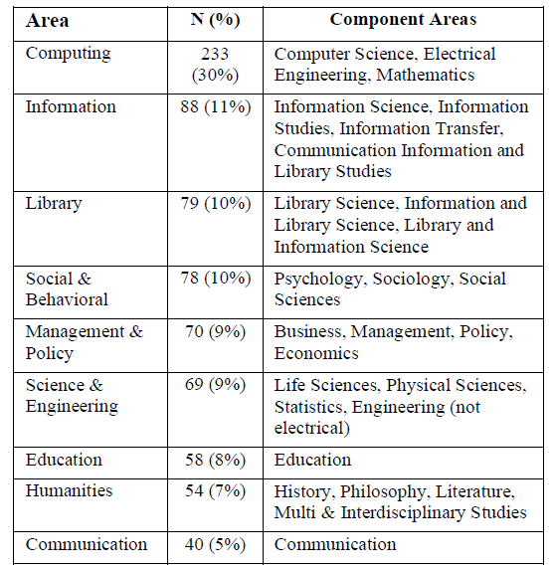

Table 3: Classification of disciplinary areas for 2009 iCaucus

Table 2 and Table 3 are from the report presented by Wiggins[2] which clearly shows that how Ischools have shifted to computing, Informatics, Science, Engineering etc. from conventional LIS courses. This report [2] was in 2009 and we have conducted our survey in start of 2017. Comparing results of our survey to this table, we could easily conclude that ISchools have doubled their efforts or focus on computing domains since last 7-8 years.

These findings are quite logical to accept if one is familiar with the rise of big data in this digital world. We found growth of Ischools in domains like HCI, computational social sciences, data sciences, Information technology, Management information systems, Information policy and securities, Digital collection etc. On the other side, we could find reduction(or no growth) in core LIS courses in our selected ISchools. There is also an interesting point which we could extract from our survey- Many top tier ISchools have introduced Health informatics both as course and educational degree (MS in health informatics). The origin of this domain seems logical as online health community and forums have grown exponentially since last 5 years. Also lot of research is done in Health informatics and Biostatistics since last 5 years. With this observation we also propose that Ischools due to its dynamic nature will keep introducing new fields in the course curriculums with the growth of the same field. Basically one can assert that Ischools are new age institutes which walk along with the development of this digital world. Being dynamic and interdisciplinary in nature, Ischools are adapting best to the existing economic market better than any other School or department.

future works

We have presented our surveys on courses of ISchools and few researchers have presented their surveys of faculty hirings[2]. Some have presented their findings based on jobs[9] of graduates of Ischools. We suggest and motivate interested researchers to carry forward our initiated research by conducting surveys on not only US schools, but also with universities outside US. This will help everyone to reach at better conclusion. Also considering many features like faculty hiring, jobs opportunities, courses etc together for conducting survey will give a better picture of the scenario.

Conclusion

We conclude from our survey and past surveys that ISchools have now doubled their focus and efforts on computing and non-conventional LIS courses. There is a drastic ongoing transformation of ISchool from convention LIS school to a dynamic interdisciplinary department. We also conclude that Ischools will keep introducing new courses based on demand of our digital world.

References

1] Andrew Dillon, What it means to be an iSchool, Journal of Education for Library and Information Science, P 267-273

2] Andrea Wiggins, Steve Sawyer, Intellectual Diversity in iSchools: Past, Present and Future, Syracuse University, School of Information Studies

3] John Carlo Bertot, Lindsay C. Sarin, Johnna Percell, Re-Envisioning the MLS: Findings, Issues, and Considerations, College of Information Studies, University of Maryland College Park

4] The reality of information systems research, John Lamp, School of Information Systems, Deakin University. Simon Milton, Department of Information Systems, University of Melbourne

5] Sue MYBURGH, Anna Maria TAMMARO Università degli studi di Parma (Italy), What is the purpose of a School of Library and Information Science in the 21st Century? Revue de l'Enssib • n° 1 • octobre 2013
6] Lisa P. Nathan,Alice MacGougan,Elizabeth Shaffer, If Not Us, Who? Social Media Policy and the iSchool Classroom, iSchool@UBC, University of British Columbia, Irving K. Barber Learning Centre, 483 470 – 1961 East Mall Vancouver BC Canada V6T 1Z1.

7] Fred Mulder & Tom van Weert, Informatics Curriculum Framework 2000 for Higher Education, International Federation for Information processing (IFIP)

8] Gary Marchionini and Barbara B. Moran, Informational Professionals 2050: Educational Possibilities and Pathways, School of Information and Library Science, University of North Carolina at Chapel Hill

9] Susan Rathbun-Grubb, What happens to iSchool graduates? Using career data to support iSchool engagement initiatives, School of Information and Library Science, UNC Chapel Hill.

10] Hildreth, C. R. and Koenig, M. 2002. Organizational realignment of LIS programs in academia: from independent standalone units to incorporated programs. J. Ed. Lib. Info. Sci. 43, 2, 126-133.

