**Edureka Case Study (User Administration)**

•You create a user Tom with short description and password and a home directory.

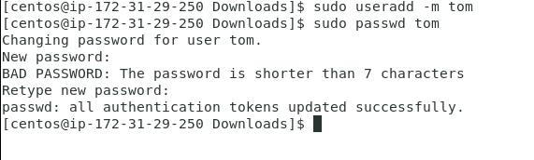

•Let Tom modify his shell and password.

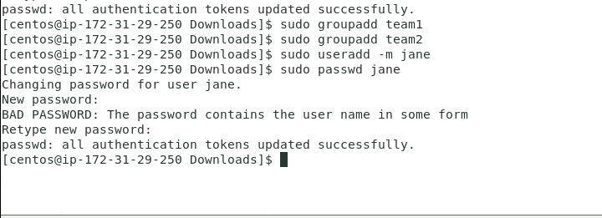

•Tom shouldn’t be able to access your home folder.

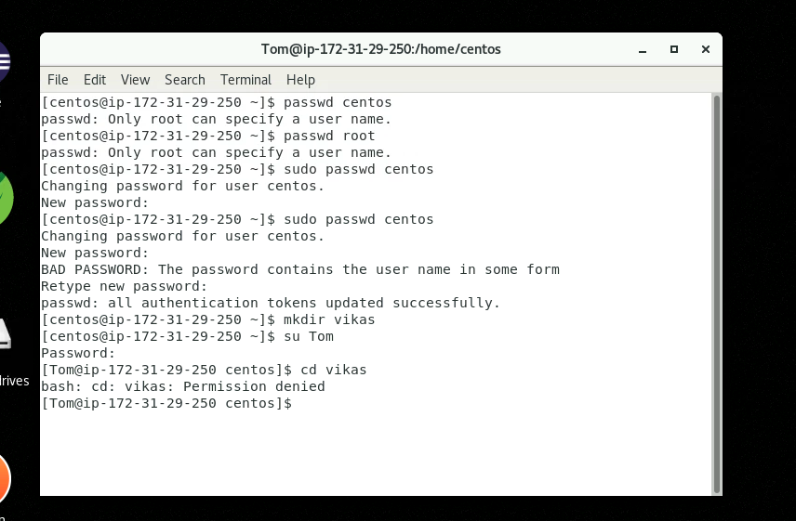

•Create another folder named ‘notes’ where you keep your study notes and Tom and may be other friends can also have same access to it. Guest shouldn’t be able to modify anything.

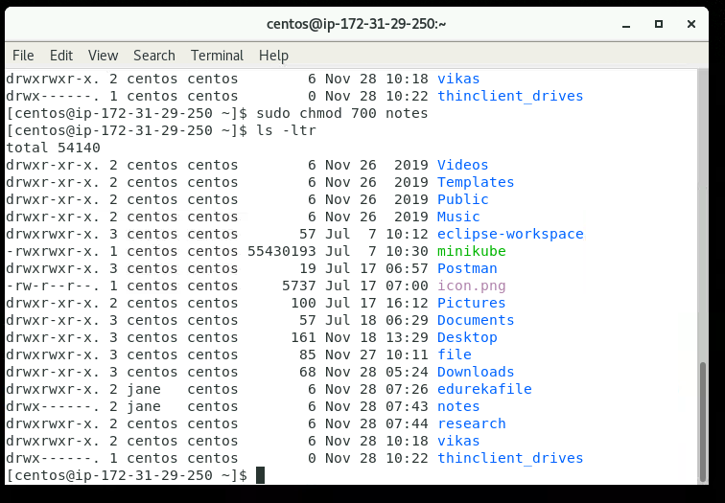

•Create another folder named ‘research’ where you keep t

he list of your researches. Others can have a look at list of researches in it but no one should be able to read, write it.

