Case Study 1

**Stage 0:**

1.You have given an empty repository having only README file.

2.If Repository is not given create one having README file which will contains some information about repository.

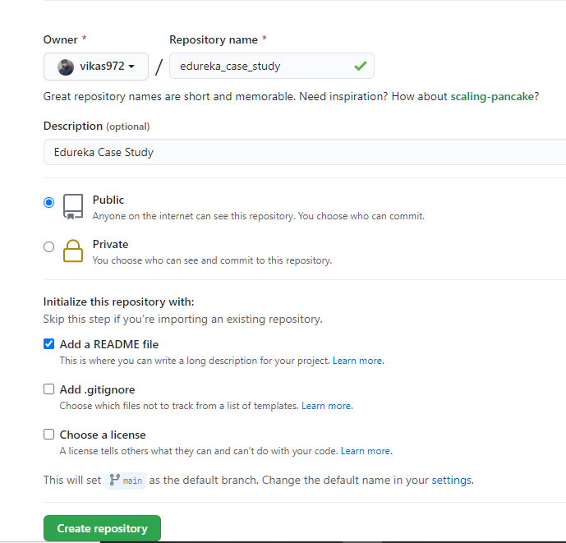

**Stage 1**

1.Pull master branch.

Command: **git pull origin main**

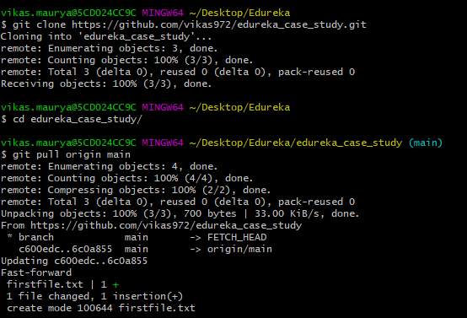

2.Create Files and add to working repository.

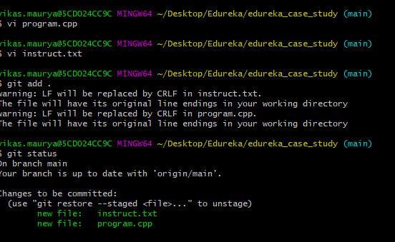

3.Create a new feature branch and push the changes.

Command: **git checkout -b feature**

**git push origin feature**

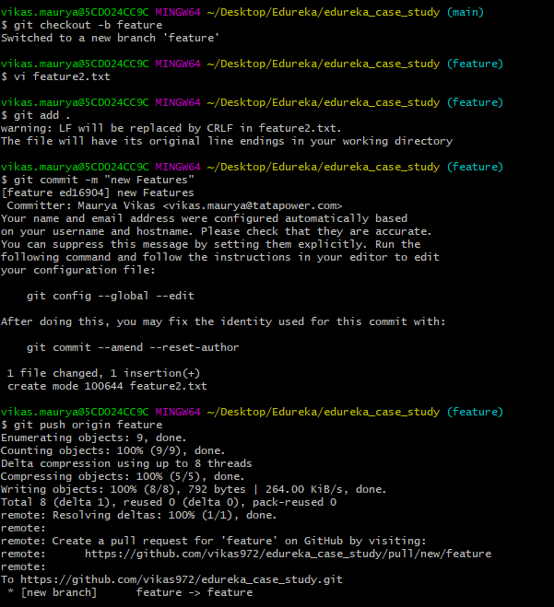

**Stage 3**

1.Create one more branch from GIT HUB UI

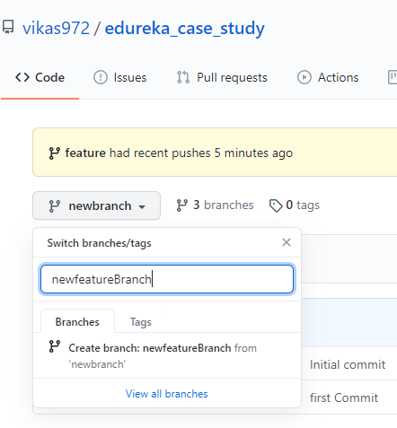

2.Check in command line if you can see new branch details

Command: **git branch**

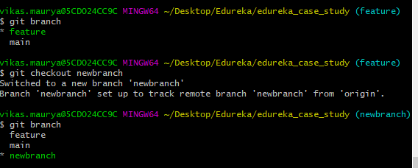

3.Use appropriate command to pull branch from remote.

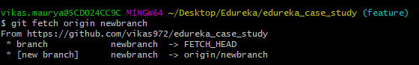

**Stage 3**

1.Create tag release 1.1 & push to remote

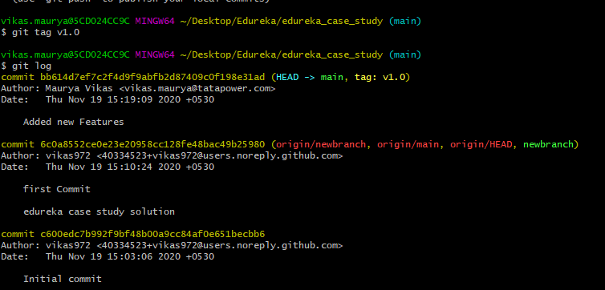

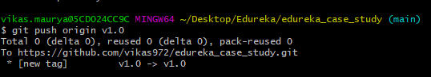

2.Change in file and create new tag release 1.2 & push to remote

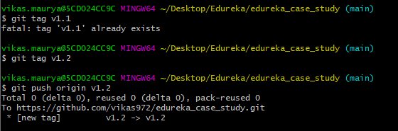

3.List all tags

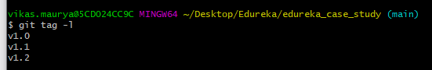

4.Delete release1.0 from remote

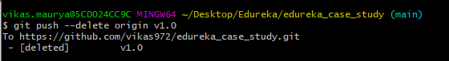

5.Delete release 1.0 from local

