Case Study 2

1.Create pull request

Command: **git request-pull <start> <url> <end>**

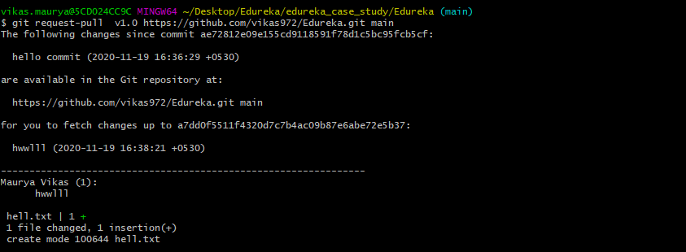

2.Merge 2 branches

Command: **git merge branch1 branch2**

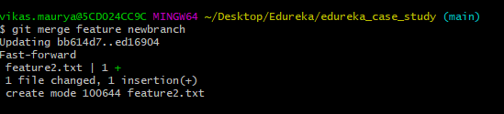

3.Check difference in 2 branches

Command: **git diff branch1 branch2**

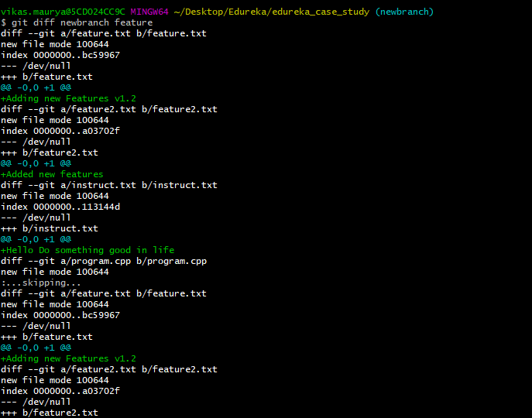

4.Delete remote repository

Command: **git remote remove origin**

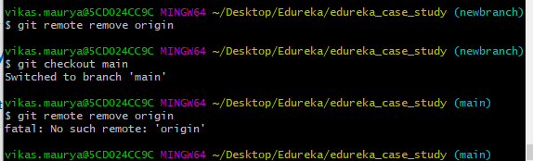

5.Generating pull request from UI

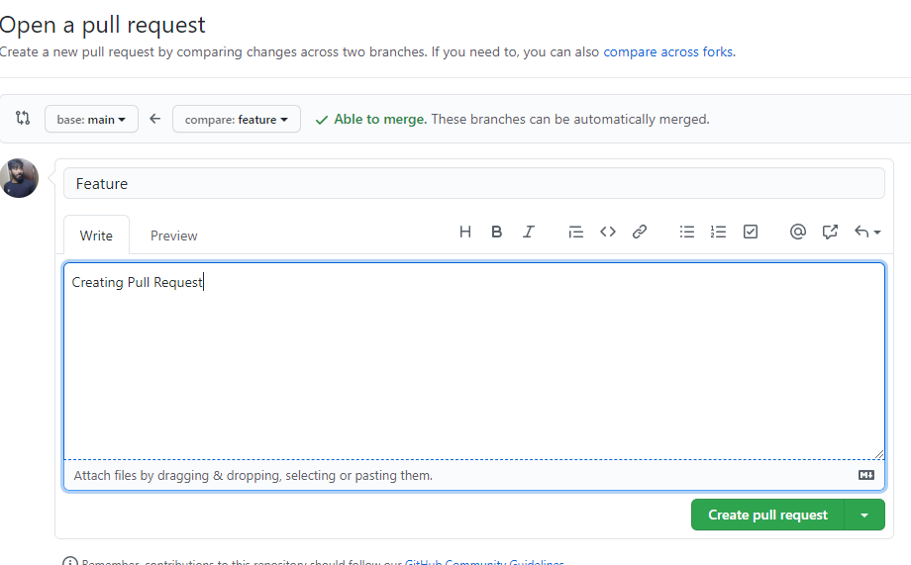

6.Resolve Conflicts and merge from UI.

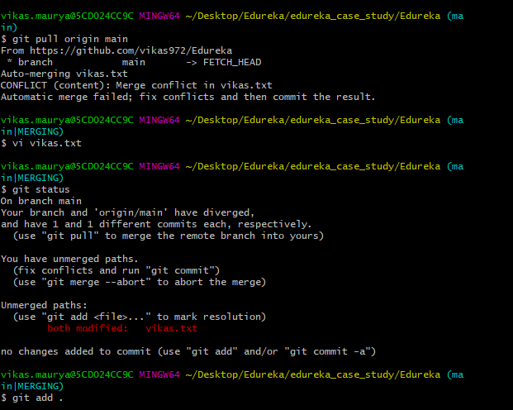

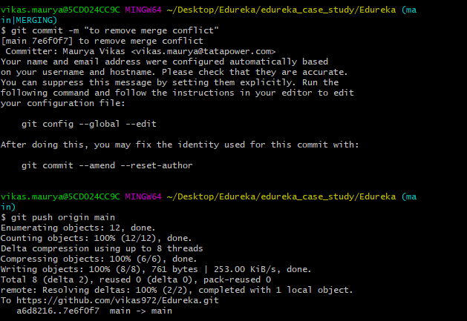

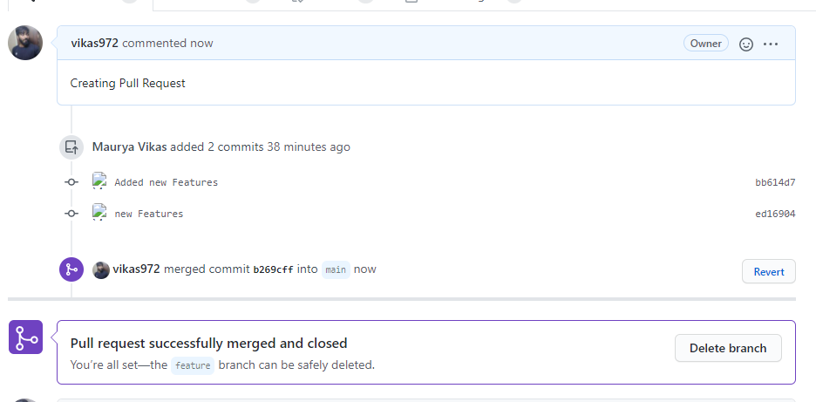

7.Merging from GIT Bash

Command: **git merge branch_name**

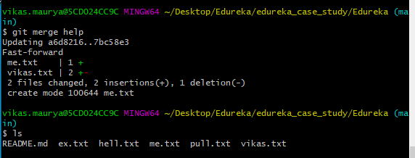

8.Use reset command to revert the changes

Command: **git reset <commit_id>**

