Edureka Case Study(Git)

**1.Create a repository called “edureka-transaction-api”.**

Created the repository remotely using Graphical User Interface.

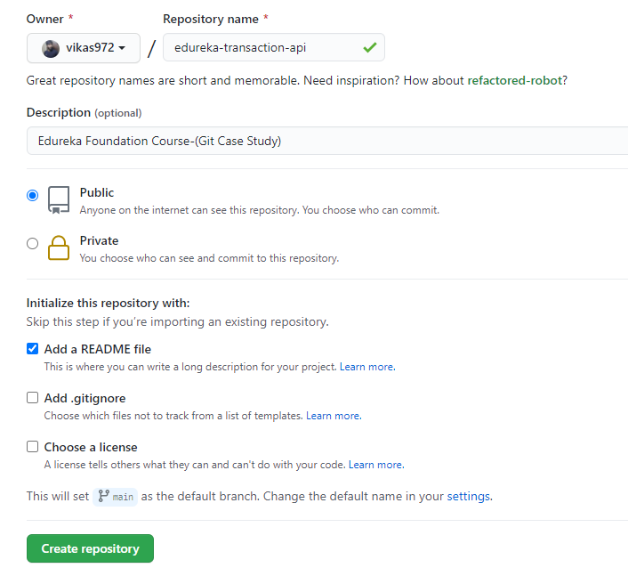

**2.Clone it**

Clone the repository using the below command.

Command:-

git clone <https://github.com/vikas972/edureka-transaction-api.git>

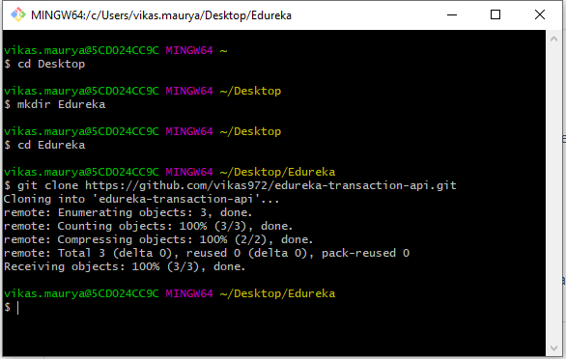

3.Check the current branch

Created the branch using the below command:

git checkout -b new_branch

Check the current branch using:

git branch --show-current

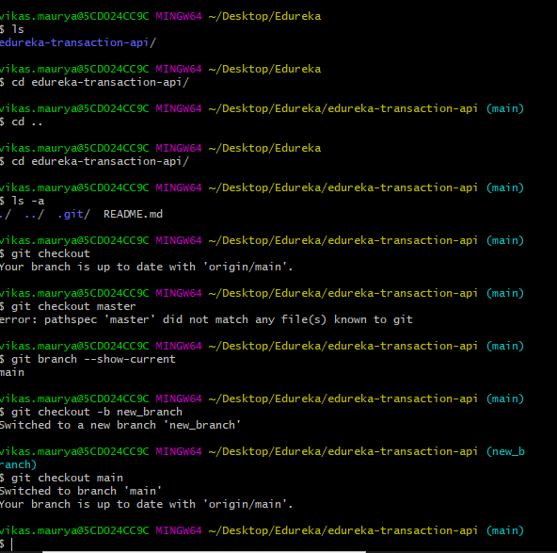

4.Add few files

Added few files using vi editor.

And added to the staging area using the following command.

git add .

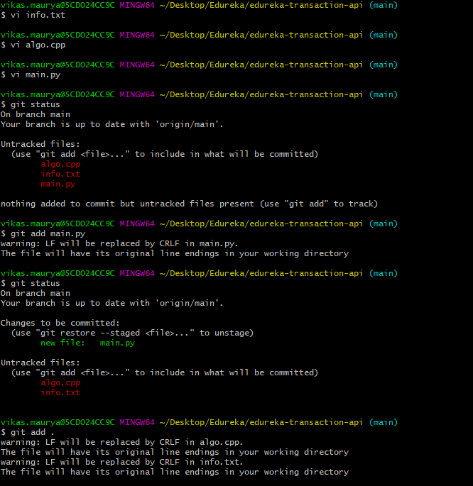

5.Commit them with message

Commit the all the files using the below command.

git commit -m "First commit to the edureka Case Study"

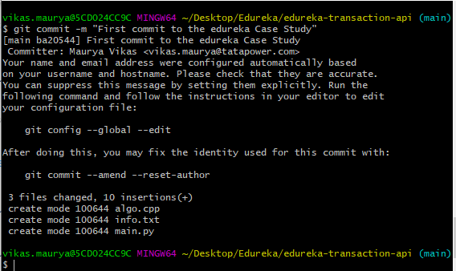

6.Push them in branch

Command:

git push origin main

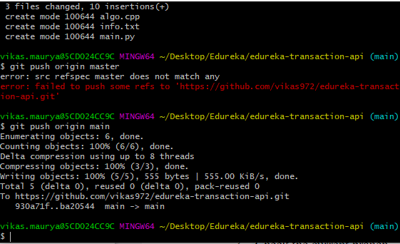

7.Check last commits

Command:

git log

