Microsoft Power Bl

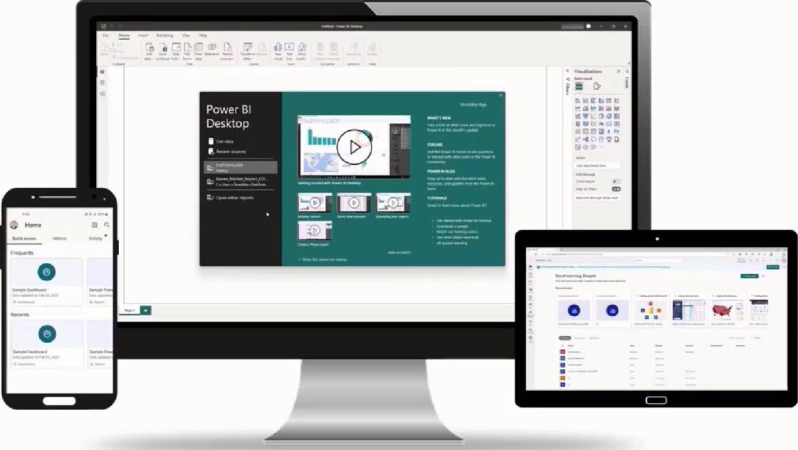

The course consists of eight sections:
Introd uction to Power Bl Data Connectivity and Transformation |  |  |  | Data Modeling and DAX |  |  | DAX Applications
Report Creation and Data  Visualization |  | Dashboard Creation, Sharing and Collaboration |  |  | Capstone Project |  |  | PL 300 Exam and Interview  Preparation

Agenda


What is Business Intelligence?
Power Bl and Its Components
Power Bl Licensing and Pricing
Power Bl Desktop and Its
Capabilities

What is Business Intelligence?

Business intelligence (Bl) is a combination of techniques and tools organizations use to analyze

and present heaps of data purposefully.

Earlier
- Use of manual processes and spreadsheets for data analysis
- Time-consuming, errorprone, and inadequate data processing

Now
- Use of business intelligence tools to collect and analyze data
- Faster data processing to generate insightsfor informed decision-making

Bl encompasses various technologies and methods, such as:

Data Warehousing Data Mining Predictive Analytics
There are various Bl tools available in the market, such as:


 4-+4- 
Power Bl Tableau ZOHO Analytics
Power Bl

Power BI is a cloud-based business intelligence platform that enables organizations to gather, transform, analyze, and present data in a meaningful way.


Power BI is a cloud-based business intelligence platform that enables organizations to gather, transform, analyze, and present data in a meaningful way.
Ability to connect with a wide range of data sources (on-premise and cloud)
Salient features Accessibility to multiple data sources through a single view
Simple and intuitive interface to create and share reports


Components of Power Bl


Power Bl | Power Bl | Power BI
Desktop | Service | Mobile

Power BI Power Bl
Report Builder Report Server

Power B I Integration

Power Bl integrates with multiple sources to aggregate data.
External Data Sources

Office 365 |  | Azure

Power BI
Power BI Licensing Types

The four license types available for Power Bl are:
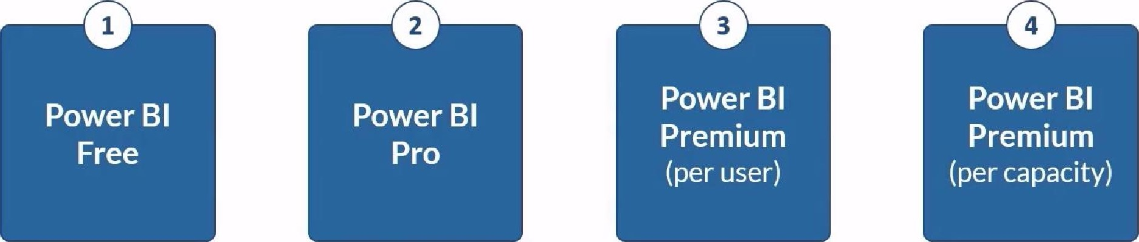

The pricing for each license type of Power BI are:
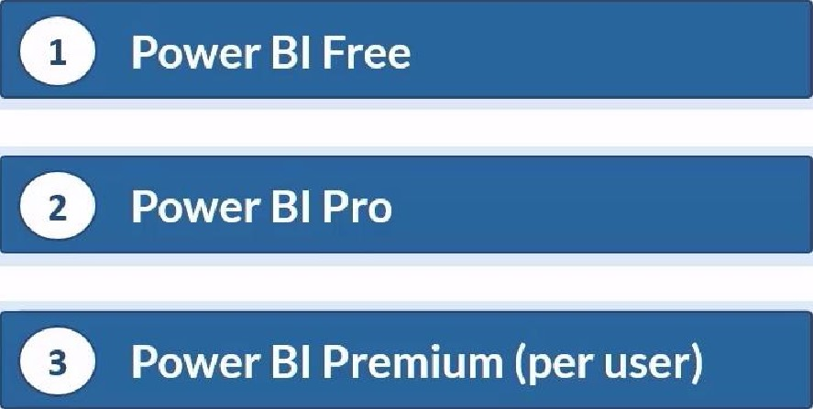
$0
$9.99/user/month
$20/user/month
 $4,995/capacity/month

in Key Feature Differences

The key feature differences between the license types are:
Power Bl Desktop Access Available Available Available Available
Collaboration and Sharing Available Available

Data Storage | 10 GB | 10 GB | 100 TB | 100 TB
Model Size Limit | IGB | IGB | 100 GB | 400 GB
Data Refresh Rate | 1/Day | 8/Day | 48/Day | 48/Day
App Integration  On-premises Reporting  Auto-scale |  | Available | Available | Available  Available  Available
Power Bl Desktop

Power Bl Desktop is a tool that has a simple and intuitive interface that makes it easy for users to connect to data sources, transform and visualize data, and create reports and dashboards.
 Visualizations fields
visual
sc; Seuch
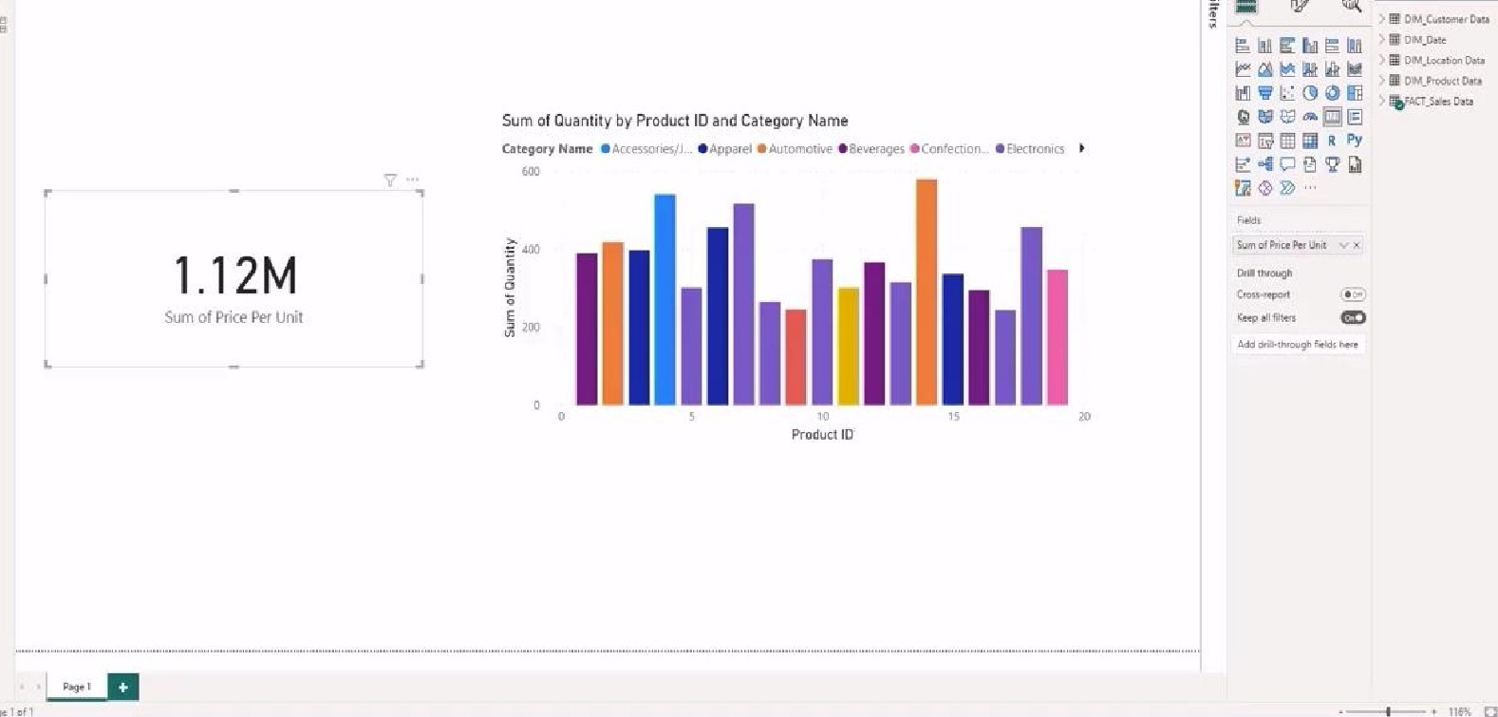
TM

Capabilities of Power Bl Desktop

Affy informatics
The capabilities of Power Bl Desktop are:

