
Kondamuri Kameswara Rao

Cloud Engineer

kameswararaok77@gmail.com | Ph. 8919333567

Career Objective

Seeking a position of Cloud Engineer in an IT environment where I can use my excellent cloud

Computing abilities in developing and managing virtual environments and be beneficial for the company.

Skills

Implemented AWS Cloud platform and its features which includes EC2, VPC, EBS, AMI, SNS, RDS, EBS, Cloud Watch, Cloud Trail, Autos calling, Cloud Front, IAM, S3, Route53.
Knowledge of databases like MySQL and Aurora DB.

Experience in Amazon Cloud (EC2) Hosting and AWS Administration.

Maintained DNS records using Route53. Used Amazon Route53 to manage DNS zones and also give public DNS names to elastic load balancers IP's.
Used Amazon RDS Multi-AZ for automatic failover and high availability at the database tier for MySQL workloads.

Creating an AWS RDS MySQL DB cluster and connected to the database through an Amazon RDS MySQL DB Instance using the Amazon RDS Console.
Used Amazon IAM to grant fine-grained access to AWS resources to users. Also managed roles and permissions of users to AWS account through IAM.
Used Cloud Front to deliver content from AWS edge locations to users, allowing for further reduction of load on front-end servers.

Experience in architecting and configuring secure VPC through private and public networks in AWS.

Created monitors, alarms and notifications for EC2 hosts using CloudWatch.

Technical Skills:
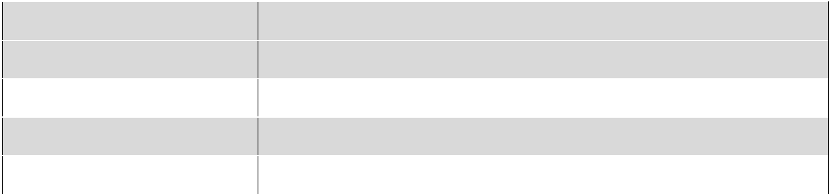

Platforms | Linux
Networking | HTTP/HTTPS, FTP, SMTP
Source Code Management | GIT
Continuous Integration | AWS Code Pipeline
Cloud | AWS

Educational Details:


Degree | Institute |  | Percentage/CGPA |  | Passing Year
 | Name/University
 | Name
B.Tech | Kakinada Institute of | 61% |  | 2020
(Mechanical | Engineering College,
Engineering) | Kakinada
Diploma in | Chaitanya Institute of | 71% |  | 2016
Mechanical | Science and
Engineering | Technology,
 | Madhavapatnam
SSC | Zilla Parishad High | 8.8 |  | 2013
 | School, Vella

Personal Details:

Name : Kondamuri Kameswara rao

DOB : 08-01-1998

Father Name : Kondamuri Vishnu

Languages Known : English, Telugu

Interest : Learning New things

Permanent Address : 2-73,Mainroad,Kapavaram,Ramachandrapuram Mandal, East

Godavari, 533262

Declaration:

I do here by confirm that the information given in this document is true to the best my knowledge and belief.

Place: Kapavaram

Date: 08-03-2021

K.Kameswara Rao

.

