Exercise 1: Inventory Management System
Code:
=> Product.java
package exno_1;
public class Product {
private int productId;
private String productName;
private int quantity;
private double price; // price per unit
public Product(int productId, String productName, int quantity, double price) {
this.productId = productId;
this.productName = productName;
this.quantity = quantity;
this.price = price;
}
// Getters and setters
public int getProductId() {
return productId;
}
public String getProductName() {
return productName;
}
public int getQuantity() {
return quantity;
}
public double getPrice() {
return price;
}
public void setQuantity(int quantity) {
this.quantity = quantity;
}
public void setPrice(double price) {
this.price = price;
}
public double getTotalCost() {
return this.quantity * this.price;
}
@Override
public String toString() {
return "[" + productId + "] " + productName + " - Qty: " + quantity +
" - ₹" + price + " per unit - Total: ₹" + String.format("%.2f", getTotalCost());
}
}
=> Inventory.java
package exno_1;
import java.util.HashMap;
public class Inventory {
private HashMap<Integer, Product> products;
private static Inventory instance;
private Inventory() {
products = new HashMap<>();
}
public static Inventory getInstance() {
if (instance == null) {
instance = new Inventory();
}
return instance;
}
public void addProduct(Product product) {
products.put(product.getProductId(), product);
}
public void updateProduct(int id, int newQty, double newPrice) {
Product product = products.get(id);
if (product != null) {
product.setQuantity(newQty);
product.setPrice(newPrice);
}
}
public void deleteProduct(int id) {
products.remove(id);
}
public void displayInventory() {
if (products.isEmpty()) {
System.out.println("Inventory is empty.");
return;
}
for (Product p : products.values()) {
System.out.println(p);
}
}
}

=> ProductFactory.java
package exno_1;
public class ProductFactory {
public static Product createProduct(int id, String name, int quantity, double price) {
return new Product(id, name, quantity, price);
}
}

=> Main.java
package exno_1;
import java.util.Scanner;
public class Main {
public static void main(String[] args) {
Scanner sc = new Scanner(System.in);
Inventory inventory = Inventory.getInstance();
int choice;
System.out.println("\n=== Inventory Management System ===");
System.out.println("1. Add Product");
System.out.println("2. Display Inventory");
System.out.println("3. Update Product");
System.out.println("4. Delete Product");
System.out.println("5. Exit");

do {

System.out.print("\nEnter your choice: ");
choice = sc.nextInt();
switch (choice) {
case 1:
System.out.print("Enter Product ID: ");
int id = sc.nextInt();
sc.nextLine(); // Consume newline
System.out.print("Enter Product Name: ");
String name = sc.nextLine();
System.out.print("Enter Quantity: ");
int quantity = sc.nextInt();
System.out.print("Enter Price: ");
double price = sc.nextDouble();
Product p = ProductFactory.createProduct(id, name, quantity, price);
inventory.addProduct(p);
System.out.println("Product added successfully!");
break;
case 2:
inventory.displayInventory();
break;
case 3:
System.out.print("Enter Product ID to update: ");
int updateId = sc.nextInt();
System.out.print("Enter New Quantity: ");
int newQty = sc.nextInt();
System.out.print("Enter New Price: ");
double newPrice = sc.nextDouble();
inventory.updateProduct(updateId, newQty, newPrice);
break;
case 4:
System.out.print("Enter Product ID to delete: ");
int deleteId = sc.nextInt();
inventory.deleteProduct(deleteId);
break;
case 5:
System.out.println("Exiting... Thank you!");
break;
default:
System.out.println("Invalid choice! Please try again.");
}
} while (choice != 5);
sc.close();
}
}

Output:
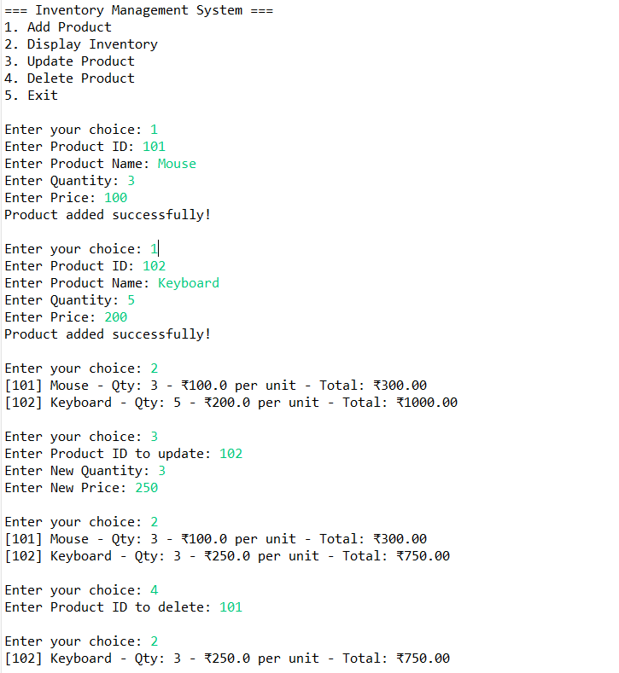
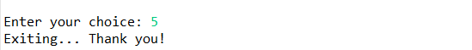

Exercise 2: E-commerce Platform Search Function
Code:
=> Product.java
package exno_2;
public class Product implements Comparable<Product> {
private int productId;
private String productName;
private String category;
public Product(int productId, String productName, String category) {
this.productId = productId;
this.productName = productName;
this.category = category;
}
public int getProductId() {
return productId;
}
public String getProductName() {
return productName;
}
public String getCategory() {
return category;
}
@Override
public int compareTo(Product other) {
return this.productId - other.productId;
}
@Override
public String toString() {
return "[" + productId + "] " + productName + " - " + category;
}
}

=> SearchEngine.java
package exno_2;
public class SearchEngine {
// Linear Search
public static Product linearSearch(Product[] products, int id) {
for (Product product : products) {
if (product.getProductId() == id) {
return product;
}
}
return null;
}
// Binary Search (products must be sorted by productId)
public static Product binarySearch(Product[] products, int id) {
int left = 0;
int right = products.length - 1;
while (left <= right) {
int mid = left + (right - left) / 2;
int midId = products[mid].getProductId();
if (midId == id) return products[mid];
else if (id < midId) right = mid - 1;
else left = mid + 1;
}
return null;
}
}

=> Main.java
package exno_2;
import java.util.Arrays;
public class Main {
public static void main(String[] args) {
Product[] products = {
new Product(102, "Phone", "Electronics"),
new Product(101, "Shirt", "Clothing"),
new Product(103, "Laptop", "Electronics"),
new Product(104, "Book", "Stationery")
};
System.out.println("Linear Search:");
Product result1 = SearchEngine.linearSearch(products, 103);
System.out.println(result1 != null ? result1 : "Product not found");
// Sort for binary search
Arrays.sort(products);
System.out.println("\nBinary Search:");
Product result2 = SearchEngine.binarySearch(products, 103);
System.out.println(result2 != null ? result2 : "Product not found");
}
}
Output:
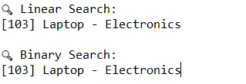
Exercise 3: Sorting Customer Orders
Code:
=> Order.java
package exno_3;
public class Order {
private int orderId;
private String customerName;
private double totalPrice;
public Order(int orderId, String customerName, double totalPrice) {
this.orderId = orderId;
this.customerName = customerName;
this.totalPrice = totalPrice;
}
public double getTotalPrice() {
return totalPrice;
}
public int getOrderId() {
return orderId;
}
public String getCustomerName() {
return customerName;
}
@Override
public String toString() {
return "[" + orderId + "] " + customerName + " - ₹" + totalPrice;
}
}

=> OrderSorter.java
package exno_3;
public class OrderSorter {
// Bubble Sort
public static void bubbleSort(Order[] orders) {
int n = orders.length;
for (int i = 0; i < n - 1; i++) {
boolean swapped = false;
for (int j = 0; j < n - i - 1; j++) {
if (orders[j].getTotalPrice() > orders[j + 1].getTotalPrice()) {
Order temp = orders[j];
orders[j] = orders[j + 1];
orders[j + 1] = temp;
swapped = true;
}
}
if (!swapped) break; // optimization
}
}
// Quick Sort
public static void quickSort(Order[] orders, int low, int high) {
if (low < high) {
int pivotIndex = partition(orders, low, high);
quickSort(orders, low, pivotIndex - 1);
quickSort(orders, pivotIndex + 1, high);
}
}
private static int partition(Order[] orders, int low, int high) {
double pivot = orders[high].getTotalPrice();
int i = low - 1;
for (int j = low; j < high; j++) {
if (orders[j].getTotalPrice() <= pivot) {
i++;
Order temp = orders[i];
orders[i] = orders[j];
orders[j] = temp;
}
}
Order temp = orders[i + 1];
orders[i + 1] = orders[high];
orders[high] = temp;
return i + 1;
}
}

=> Main.java
package exno_3;
public class Main {
public static void main(String[] args) {
Order[] orders = {
new Order(101, "Alice", 2499.99),
new Order(102, "Bob", 999.50),
new Order(103, "Charlie", 4999.00),
new Order(104, "Daisy", 1499.00)
};
System.out.println("Original Orders:");
printOrders(orders);
// Bubble Sort
Order[] bubbleSorted = orders.clone();
OrderSorter.bubbleSort(bubbleSorted);
System.out.println("\nBubble Sorted Orders:");
printOrders(bubbleSorted);
// Quick Sort
Order[] quickSorted = orders.clone();
OrderSorter.quickSort(quickSorted, 0, quickSorted.length - 1);
System.out.println("\nQuick Sorted Orders:");
printOrders(quickSorted);
}
private static void printOrders(Order[] orders) {
for (Order o : orders) {
System.out.println(o);
}
}
}

Output:
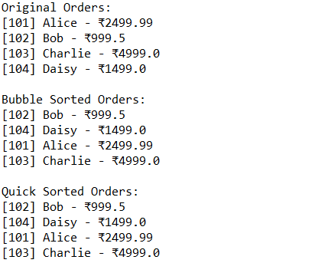

Exercise 4: Employee Management System
Code:
=> Employee.java
package exno_4;
public class Employee {
private int employeeId;
private String name;
private String position;
private double salary;
public Employee(int employeeId, String name, String position, double salary) {
this.employeeId = employeeId;
this.name = name;
this.position = position;
this.salary = salary;
}
public int getEmployeeId() {
return employeeId;
}
@Override
public String toString() {
return "[" + employeeId + "] " + name + " - " + position + " - ₹" + salary;
}
}

=> EmployeeManager.java
package exno_4;
public class EmployeeManager {
private Employee[] employees;
private int count;
public EmployeeManager(int capacity) {
employees = new Employee[capacity];
count = 0;
}
// Add employee
public void addEmployee(Employee e) {
if (count < employees.length) {
employees[count++] = e;
} else {
System.out.println("Employee list is full.");
}
}
// Search by employeeId
public Employee searchEmployee(int id) {
for (int i = 0; i < count; i++) {
if (employees[i].getEmployeeId() == id) {
return employees[i];
}
}
return null;
}
// Traverse (list all employees)
public void displayEmployees() {
if (count == 0) {
System.out.println("No employees found.");
} else {
for (int i = 0; i < count; i++) {
System.out.println(employees[i]);
}
}
}
// Delete by employeeId
public void deleteEmployee(int id) {
int index = -1;
for (int i = 0; i < count; i++) {
if (employees[i].getEmployeeId() == id) {
index = i;
break;
}
}
if (index != -1) {
for (int i = index; i < count - 1; i++) {
employees[i] = employees[i + 1];
}
employees[--count] = null;
System.out.println("Employee with ID " + id + " deleted.");
} else {
System.out.println("Employee not found.");
}
}
}

=> Main.java
package exno_4;
public class Main {
public static void main(String[] args) {
EmployeeManager manager = new EmployeeManager(5);
manager.addEmployee(new Employee(1, "Alice", "Manager", 70000));
manager.addEmployee(new Employee(2, "Bob", "Developer", 50000));
manager.addEmployee(new Employee(3, "Charlie", "Tester", 45000));
System.out.println("All Employees:");
manager.displayEmployees();
System.out.println("\nSearching for Employee with ID 2:");
Employee e = manager.searchEmployee(2);
System.out.println(e != null ? e : "Not found");
System.out.println("\nDeleting Employee with ID 1:");
manager.deleteEmployee(1);
System.out.println("\nUpdated Employee List:");
manager.displayEmployees();
}
}

Output:
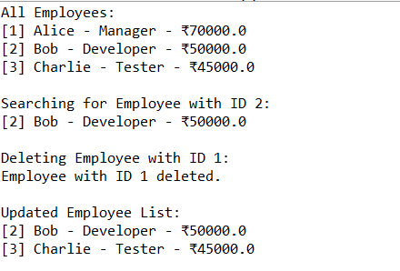

Exercise 5: Task Management System using Linked List
Code:
=> Task.java
package exno_5;
public class Task {
private int taskId;
private String taskName;
private String status; // e.g., Pending, Completed
public Task(int taskId, String taskName, String status) {
this.taskId = taskId;
this.taskName = taskName;
this.status = status;
}
public int getTaskId() {
return taskId;
}
@Override
public String toString() {
return "[" + taskId + "] " + taskName + " - " + status;
}
}
=> TaskNode.java
package exno_5;
public class TaskNode {
Task task;
TaskNode next;
public TaskNode(Task task) {
this.task = task;
this.next = null;
}
}

=> TaskManager.java
package exno_5;
public class TaskManager {
private TaskNode head;
// Add task to end
public void addTask(Task task) {
TaskNode newNode = new TaskNode(task);
if (head == null) {
head = newNode;
} else {
TaskNode temp = head;
while (temp.next != null) {
temp = temp.next;
}
temp.next = newNode;
}
}
// Search task by taskId
public Task searchTask(int id) {
TaskNode temp = head;
while (temp != null) {
if (temp.task.getTaskId() == id) {
return temp.task;
}
temp = temp.next;
}
return null;
}
// Traverse tasks
public void displayTasks() {
if (head == null) {
System.out.println("No tasks available.");
return;
}
TaskNode temp = head;
while (temp != null) {
System.out.println(temp.task);
temp = temp.next;
}
}
// Delete task by taskId
public void deleteTask(int id) {
if (head == null) return;
if (head.task.getTaskId() == id) {
head = head.next;
System.out.println("Task with ID " + id + " deleted.");
return;
}
TaskNode prev = null, curr = head;
while (curr != null && curr.task.getTaskId() != id) {
prev = curr;
curr = curr.next;
}
if (curr == null) {
System.out.println("Task not found.");
return;
}
prev.next = curr.next;
System.out.println("Task with ID " + id + " deleted.");
}
}

=> Main.java
package exno_5;
public class Main {
public static void main(String[] args) {
TaskManager manager = new TaskManager();
manager.addTask(new Task(1, "Write proposal", "Pending"));
manager.addTask(new Task(2, "Develop module", "In Progress"));
manager.addTask(new Task(3, "Test features", "Pending"));
System.out.println("Task List:");
manager.displayTasks();
System.out.println("\nSearching for Task with ID 2:");
Task found = manager.searchTask(2);
System.out.println(found != null ? found : "Not found");
System.out.println("\nDeleting Task with ID 1:");
manager.deleteTask(1);
System.out.println("\nUpdated Task List:");
manager.displayTasks();
}
}

Output:
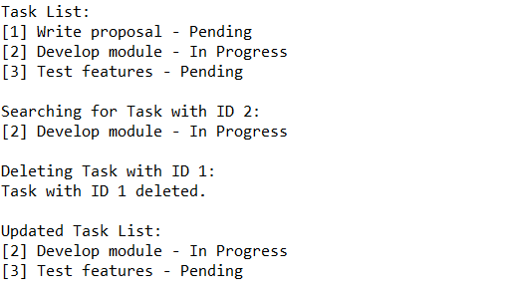

Exercise 6: Library Management System
Code:
=> Book.java
package exno_6;
public class Book implements Comparable<Book> {
private int bookId;
private String title;
private String author;
public Book(int bookId, String title, String author) {
this.bookId = bookId;
this.title = title;
this.author = author;
}
public String getTitle() {
return title.toLowerCase(); // for case-insensitive search
}
public String getOriginalTitle() {
return title;
}
@Override
public int compareTo(Book other) {
return this.getTitle().compareTo(other.getTitle());
}
@Override
public String toString() {
return "[" + bookId + "] " + title + " by " + author;
}
}

=> LibrarySearch.java
package exno_6;
public class LibrarySearch {
// Linear Search by title
public static Book linearSearch(Book[] books, String title) {
for (Book book : books) {
if (book.getTitle().equals(title.toLowerCase())) {
return book;
}
}
return null;
}
// Binary Search by title (requires sorted array)
public static Book binarySearch(Book[] books, String title) {
int left = 0;
int right = books.length - 1;
String searchTitle = title.toLowerCase();
while (left <= right) {
int mid = left + (right - left) / 2;
int cmp = books[mid].getTitle().compareTo(searchTitle);
if (cmp == 0) return books[mid];
else if (cmp < 0) left = mid + 1;
else right = mid - 1;
}
return null;
}
}

=> Main.java
package exno_6;
import java.util.Arrays;
public class Main {
public static void main(String[] args) {
Book[] books = {
new Book(1, "The Alchemist", "Paulo Coelho"),
new Book(2, "Atomic Habits", "James Clear"),
new Book(3, "Rich Dad Poor Dad", "Robert Kiyosaki"),
new Book(4, "The 5 AM Club", "Robin Sharma")
};
// Linear Search
System.out.println("Linear Search: Find 'Atomic Habits'");
Book linearResult = LibrarySearch.linearSearch(books, "Atomic Habits");
System.out.println(linearResult != null ? linearResult : "Book not found");
// Sort books for binary search
Arrays.sort(books);
// Binary Search
System.out.println("\nBinary Search: Find 'Atomic Habits'");
Book binaryResult = LibrarySearch.binarySearch(books, "Atomic Habits");
System.out.println(binaryResult != null ? binaryResult : "Book not found");
}
}

Output:
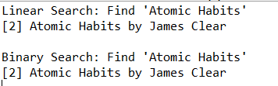

Exercise 7: Financial Forecasting
Code:
=>FinancialForecast.java
package exno_7;
public class FinancialForecast {
// Recursive method to calculate future value
public static double futureValueRecursive(double initialValue, double growthRate, int years) {
if (years == 0) {
return initialValue;
}
return (1 + growthRate) * futureValueRecursive(initialValue, growthRate, years - 1);
}
// Optimized method using memoization
public static double futureValueMemoized(double initialValue, double growthRate, int years, double[] memo) {
if (years == 0) return initialValue;
if (memo[years] != 0) return memo[years];
memo[years] = (1 + growthRate) * futureValueMemoized(initialValue, growthRate, years - 1, memo);
return memo[years];
}
}

=>Main.java
package exno_7;
public class Main {
public static void main(String[] args) {
double initialValue = 10000; // ₹10,000
double growthRate = 0.10; // 10% annual growth
int years = 5;

System.out.println("Initial Value: "+initialValue);
System.out.println("Growth Rate: "+growthRate);
System.out.println("Years: "+years);
System.out.println("\nRecursive Forecast:");
double result = FinancialForecast.futureValueRecursive(initialValue, growthRate, years);
System.out.printf("Future value after %d years: ₹%.2f\n", years, result);
System.out.println("\nOptimized Forecast using Memoization:");
double[] memo = new double[years + 1];
double optimizedResult = FinancialForecast.futureValueMemoized(initialValue, growthRate, years, memo);
System.out.printf("Future value after %d years: ₹%.2f\n", years, optimizedResult);
}
}
Output:
