computer networks:
=> it a set of diff devices and connections btw them.

Top level Applications:
1 - SMPT = simple mail transfer protocol 2 - HTTPS = hypertext transfer protocol secure
3 - FTP = file transfer protocol 4 - SSH = secure shell

#TCP/IP Model:
-> Transmission control protocol and Internet protocol
- It consists of 4 layers below in image
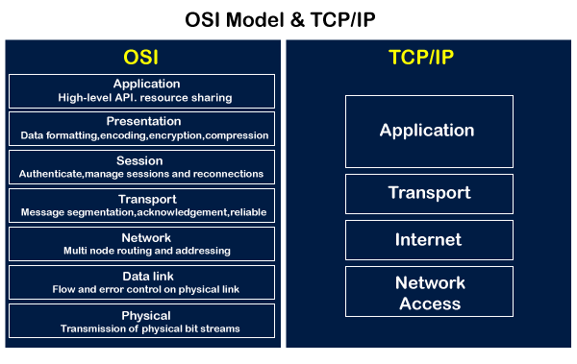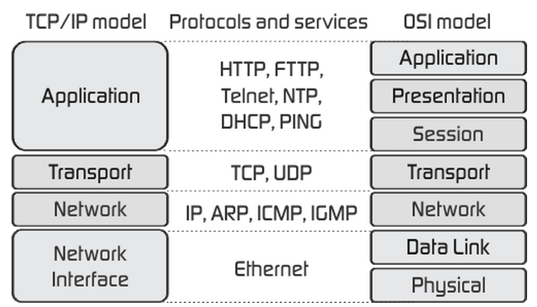
->Application Layer Protocol = it is top level which generally have (HTTP, FTP, DNS, DHCP).
->Transport Layer = To establish end-to-end communication between two different devices in the computer network and reliably deliver data.
- TCP (Transmission control protocol) & UDP (user data protocol)
- TCP is reliable and UPD is unreliable.
-> Internet Layer = To connect different networks, find optimal routes to each network and deliver packets to the destination (IPV4, IPV6, ICMP).
-> Network Access Layer = Transmit data over the physical media (Ethernet). Frame also is a part.
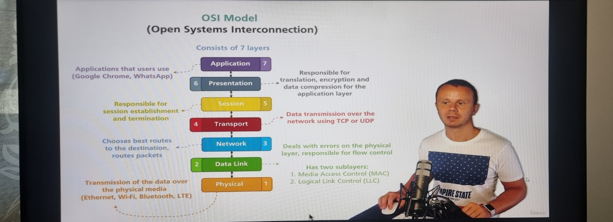
#Bits and Bytes:
-1 Bit (Binary Digit) Basic unit of information = 0 & 1
-1 Byte = 8bits also called as octet.
#PDU’s (Protocol Data Unit): it is the smallest piece of information that is related to specific layer.
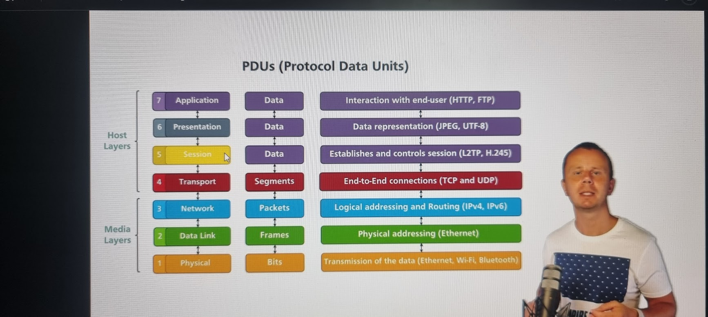
- For example, the PDU for Data layer under media layer is Frames likewise it is common for all layers that is present.
->Encapsulation and Decapsulation in TCP/IP model:
- Encapsulation = Is a process of adding some additional data on each layer of the model.
- Decapsulation = Reverse of Encapsulation (see below image).
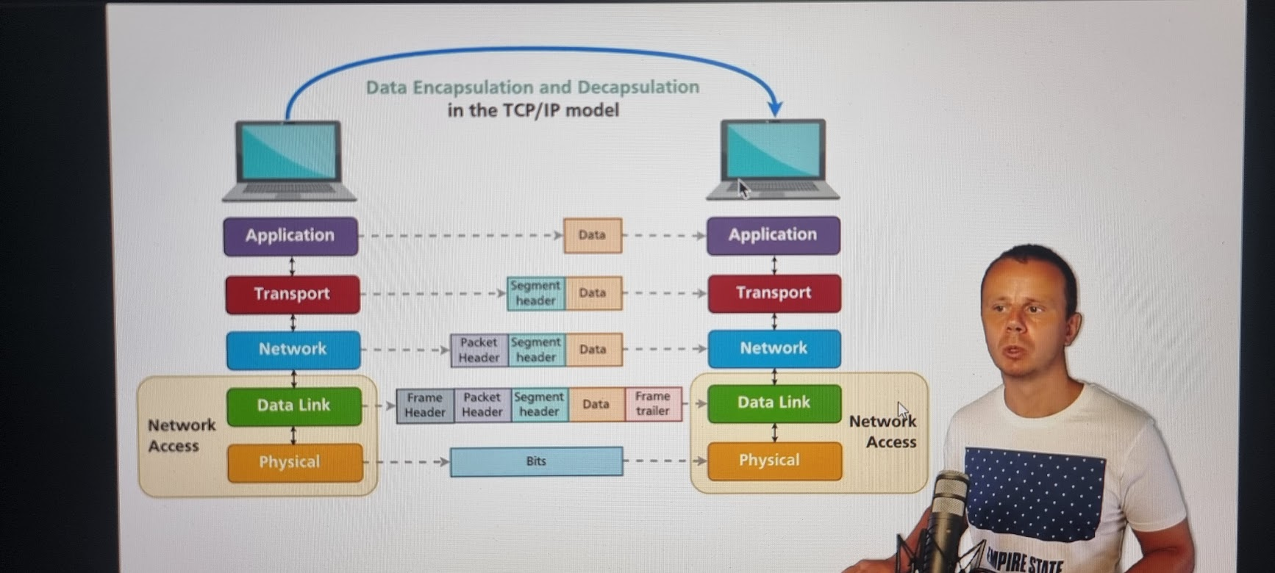
#Ethernet: Set of standards used most in data link layer and physical layer of the AP model.
- IEEE 802.3 for wired connection and IEEE 802.11 for wireless connection.
->NIC: Network Interface Card which is used to connect the internet via wire or wireless.
Example: Wi-Fi router, portable Wi-Fi router, cards.

->MAC Address: Media Access Control address is unique hardware address also a data link address.
- Each Ethernet NIC must have MAC address.
- contains 6 diff sections divided by colon and each section contain 2 diff hexa-decimal characters.
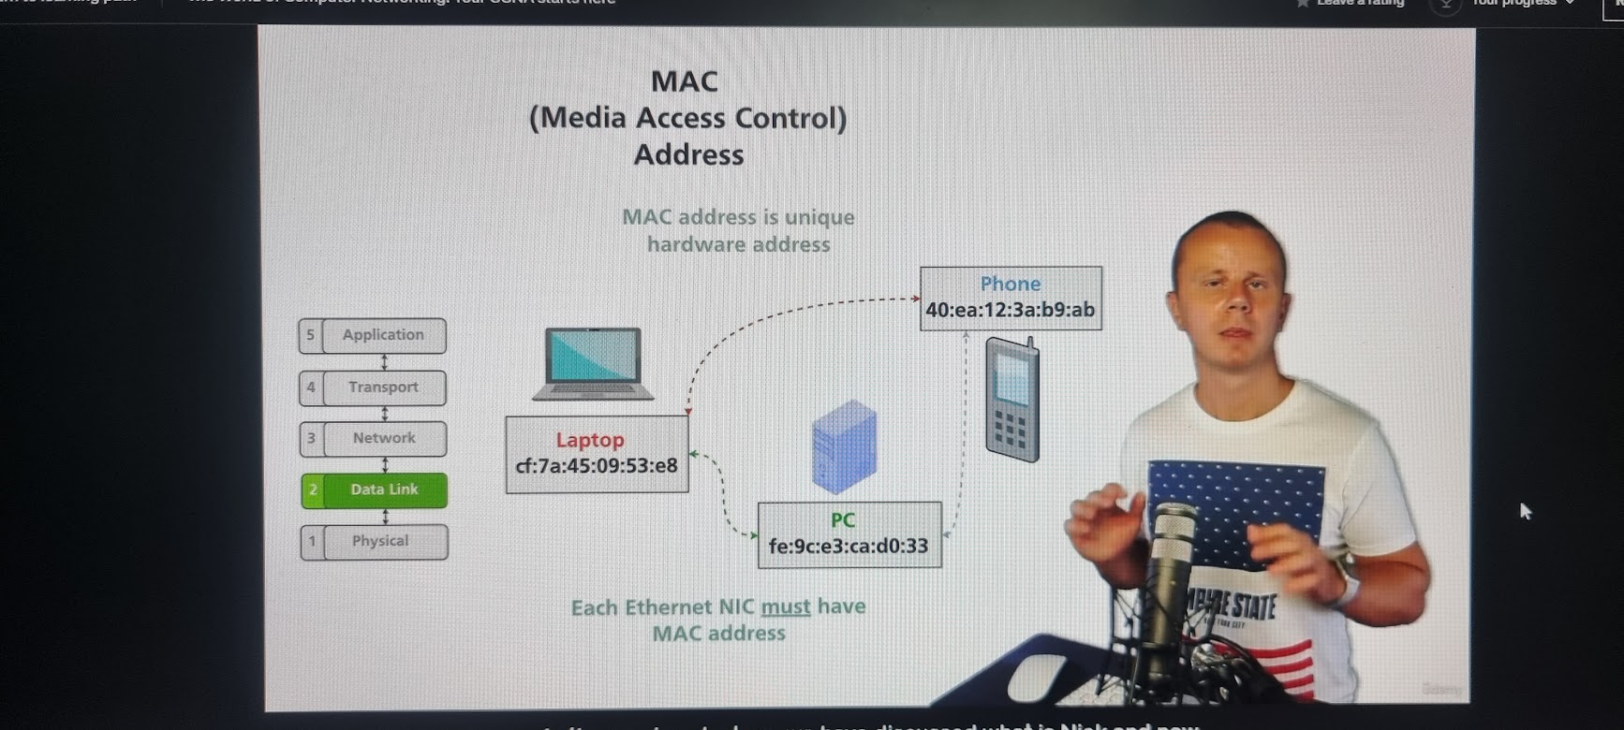
->Hexadecimal and Binary.
- Binary there are only 2 characters 0 & 1
- Hexadecimal has 16 diff characters where 1 hexadecimal character = 4bits.
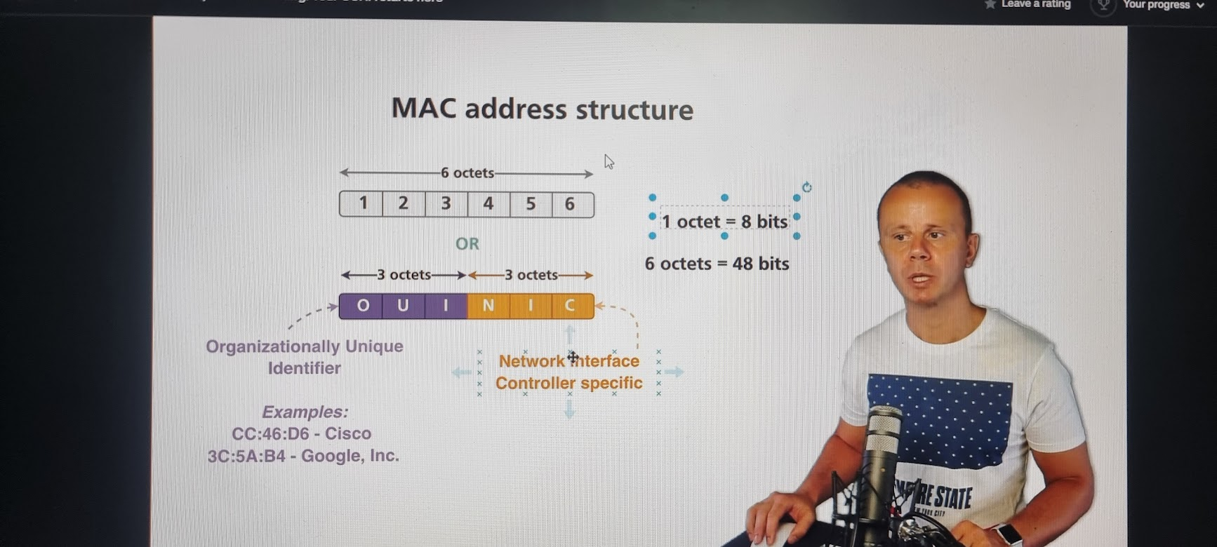
#Network characteristics:
->Bandwidth: maximum number of bits that could be transmitted over the link in specific amount of time.
- example: 5mbps = 5 megabits per second.
->Throughput: Actual amount of data that could be transmitted.
- it can be measured differently since each layer gives the diff values as the load or data increases by layer to layer.

-> Latency: (one-way delay) Data transfer time from one device to another.
- Types:
1-Queueing delay: waiting for others packets to transfer.
2-Processing delay: more data and receiver verification delay
3-Transmission delay: complete the check
4-Propagation delay: check every layer and propagates to the next level.
->Round-trip Time (RTT): Total Time required to send data from one device to another back again.
- also known as “PING”. Example: RTT = 55ms (milli seconds), upload and download.
- We can also check with command = ping 8.8.8.8 in any terminal of OS.
->Jitter: Latency varies over time.
- let say the sender sends the packets 1,2,3 and the receiver gets in the order of 3,1,2 this is jitter it somehow has to maintain the order of the packets it gets.
->Packet loss rate: some time packet loss might happen with unstable internet connection.
#Switches and Data Link Layer:
->Network Switch: operates Physical and Data link
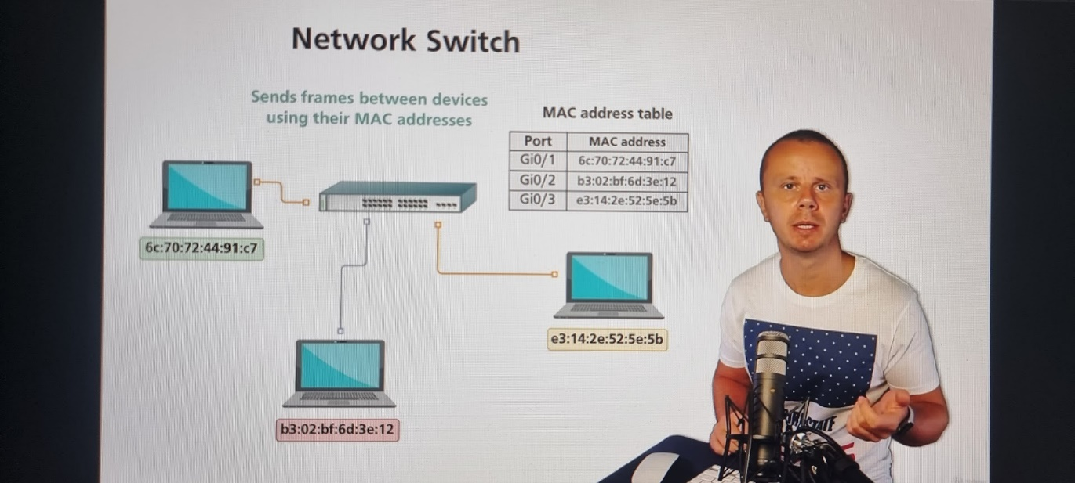
-VLAN = A virtual local area network (VLAN) is a virtualized connection that connects multiple devices and network nodes from different LANs into one logical network.
-> Types of communication:
1-unicast: only 1
2-multicasts: 1 or more
3-broadcasts: To All.
->Types of MAC addresses =
Unicast = phone, tablets etc./ Multicasts = for video or audio/ Broadcasts = send frames to all once.
->Half and Full-Duplex:
-Full duplex: data is transmitted in both directions simultaneously.
-Half duplex: data could be transmitted only in one direction at any moment of time.
->Half-Duplex Collision:
-Collision occurs when data on the same physical media is transmitted by different devices simultaneously.
#Routers and Network layer:
-> switched network dis-adv: - switch send frame with destination broadcast MAC add to all ports.
-As the number of devices increase the Large MAC add tables are created.
-> IP address: It is a logical address of the device in the network.
- IP address may change and dynamic but usually MAC address is not changed and static.
- It consists of 4 sections and divided by colon and will be decimal format Ex: 192.168.1.12
--- #1# ---
->IPv4 vs IPv6:
- Both are logical add of the device in the network.
--- #2# ---
->MAC vs IP: In the switched network devices may have MAC addresses with diff OUI’s (Produced by diff manufactures) But IP addresses must belong to the same network.
->Types of IP Addresses:
1-unicast: That are assigned to specific device, used for one-to-one communication
2-Multicast: specific groups of devices.
3-Broadcast: used when specific device in the network wants to send packet to all the remaining devices in the same switched network.
->Router: Routes the packets between different network layer of TCP, IP model of calls and works on the physical data and network layer.
-> LAN: Local area network is set of devices and interconnections under common administration typically located in the same geographical area
->WAN: wide area network covers large geographical areas, consists of multiple LAN’s Ex: internet
->Router interconnects different networks:
--- #3# ---

#IP Addressing and IP packets:
->IP addresses classes:
--- #4# ---
->Local Host IP Address: 127.0.0.1 , Ex: ping 127.0.0.1
- Reserved localhost IP Address for testing purposes.
Cmd’s = 127.0.0.1:8080, local host IP Address (127.0.0.1) can be used to access web servers. And 8080 is the port that we have added.
->Public and Private IP address:
-Private: That are not suitable in a global internet network and packets will be dropped by them.
-NAT: Network Address Translation it helps provides access to the internet for devices with private IP addresses.
--- #5# ---
->Network:
- it is a logical group of devices and devices in the same network could easily communicate between each other via switches. That don’t require routers.
- every network has 2 different parts: 1-Network Prefix and 2-Network Mask.
- This division is like MAC add: OUI and NIC-specific.
--- #6# ---
-> Private IP Address ranges: divided into 3 classes of different ranges.
--- #7# ---
->Public IP Address ranges: Any IP Address that belong to class A or class B or c is not private.
--- #8# --- & --- #9# ----
-> Static IP Address vs Dynamic IP Address:
-DNS = domain name service.
-DHCP server = Dynamic Host Configuration Protocol.
-Note: usually DHCP servers and hosts remember which IP address were assigned and after re-connection to the network with the same DHCP server hosts usually obtain same IP address as were assigned before.
--- #10# --- & --- #11# ---
#Network:
->Network is actually a logical group of devices and every network and computer network consists of two parts network and host i.e, ( network prefix and network mask ) Ex: 10.0.0.0/8
-> Network address , broadcast address, and host address (it is a common address btw network and broadcast)
--- #12# --- & --- #13# ---
->Private network example:
--- #14# ---
#Conversion
- Decimal vs Binary: --- #15# ---
- Decimal to binary: --- #16# ---
- AND & OR operator: --- #17# --- & --- #18# ---
#Network Mask and subnetting:
- --- #19# ---
- --- #20# ---
- Are host in same network or not with same host? -> --- #21# ---
- Are host in Find same network or not with diff host? -> --- #22# ---
- Are host in Find same network -> --- #23# ---
- How many hosts in the network ex:1? -> --- #24# ---
- How many hosts in the network ex:2? -> --- #25# ---
- How many hosts in the network ex:3? -> --- #26# ---
->Subnetting:
Note:
1-There are classes of IP addresses – A, B and C default masks /8, /16 and /24 correspondingly.
2-Qantity of the available for assignment to the device IP addresses in each network is calculated using formula = 2^(host bits qty) – 2
3-IPv4 addressing space is limited, especially space of the public IPv4 addresses.
-> Subnet: Process of creating multiple subnetworks from the single network.
-allows to use other network masks, not just default /8, /16, and /24
-subnetting decreases quantity of the host IP addresses in the networks.
-it optimizes the usage of IPv4 addresses.
--- #27# ---
-Why subnetting: Increases quantity of the available networks, decreases the host IP add in network.
--- #28# --- & --- #29# ---
-Any subnet mask must always have continuous sequence of 1s at the beginning.
-for 2 bits we can create 4 subnets, for 4 bits it is 2^4 = 16
-Maximum Quantity of hosts in each subnetwork = subnet power to host – subnet bits.
-> Nested subnetting: nesting of subnets where we can create subnets under the subnets.
--- #30# ---
#ARP and ICMP: This two are supporting protocols for end user.
-Default gateway or router is a device that acts as a gateway to our networks expect a local network.
->ARP: Address resolution protocol
--- #31# --- & --- #32# --- & --- #33# ---
-In ARP the destination: broadcast is set (ff:ff:ff:ff:ff:ff), Source: is a MAC address.
- cmd “ arp -a “ = to find all the details of ARP.
- send packets to host from remote network.
--- #34# ---
-If destination IP address is outside of the local subnetwork, on the data link layer host send frame to the Mac address of the default gateway.
->ICMP: Internet control message protocol, it does the connection verification and error detection protocol. It is a unicast Transmission Network Layer.
-There are two ICMP Packets: 1-ICMP Request, 2-ICMP Response.
- Packets to the other networks are sent to the default gateway. And this is performed by putting MAC address of the default gateway into the destination MAC address field on the data Link Layer.
#TCP and UDP:
-Transport layer: it is a layer for different connections to pass and transfer things.
- connection establishment between two different modes of transport layer are Client and server.
--- #35# ---
-once it is connected, It is duplex type data that means some data is sent from client to server and vice versa. And if there is no data exchange happening then the connection is lost.
->Transport Later connection: There are 2 ports present in every layer 1-source port and 2- destination/server port
--- #36# ---
->Application ports: Different Well-Known applications and protocols have different transport layer ports.
Example: 443: HTTPS, 80: HTTP, 22: SSH, 993: IMAPS, 465: SMTPS.
->Multiplexing and de-multiplexing: multiple applications could communicate using Transport Layer.
--- #36# ---
->Port Ranges: Port is 16-bit number Range is 0 - 65535
--- #37# ---
-Note: Client selects unused local port larger than 1024
->Network Sockets: it is a Host endpoint for outgoing and incoming data.
Transport Protocol (TCP or UDP) | Source IP Address | Source Port | Destination IP Address | Destination Port

--- #38# ---- & --- #39# --- & --- #40# ---
Note: Different processes can’t create same sockets, UDP is a connection less protocol.
->cmd the following:
1- “netstat“- can get the details of protocol, local address, foreign address, state.
2- “netstat -anp tcp or udp” – can get the details all TCP or UDP.
3- “netstat -anp tcp | select-string -Pattern 443” – to filter all 443 port and get the details.
Ex: cmd “netstat -anpb tcp” = gives details ,
Ex: cmd “netstat -anp tcp “
->Diff between TCP vs UDP:
--- #41# ---
->TCP – Transmission control protocol (TCP) connection establishment.
--- #42# ---
-TCP header has 16bit source port and 16bit destination port.
-FIN = finalization, RIS = reset.
->UDP user datagram protocol (UDP).
--- #44# ---
-sockets are created from both sides sever and client.
UDP header

16bits | 16bits
Source Port | Destination Port
Length | Checksum

#Routing: routers are responsible for routing the IP packets to the destination network. It is in the network layer.
-Routing table: router keep all routes to the known networks in the routing table.
-routing between 2 networks: connected roads are route to the network where routes own interfaces are attached, and which have IP addresses and are up.
->Routing between two networks: 1-25steps: video num:129 to 132.
->Multiple routers: Each router has its own routing table and makes routing decisions independently from others.
->Default route: default route is the last resort route and is chosen by the router if no other routes matched, and default route is always the last route in the routing table.
#Network address translation.
-NAT and PAT = port add translation.
-
#DHCP and DNS: application level work for UDP.
->Hosts setting in the computer network has:
1-IP add, 2-Network mask, 3-default gateway, 4-DNS server.
->DHCP: Dynamic Host Configuration Protocol (DHCP)
- It is used for dynamic assignment of the IP address, network mask, default gateway and DNS server
-> DNS: Domain name System: Translates domain name to the IP address.
- It is a name that identifies certain hosts in the computer network.
-> URL: uniform resource locator.
-unique identifier web address of the specific resource on the Internet.
https:// | Play. | Google. | Com/ | Store/movie? | Ref=341
protocol | subdomain | domain | TLD | PATH | Query String
Root Domain

-TDL: top level domain
-URL is identifier for specific resource like book or movie. URL is a subnet of URI.
- DNS types: A, AAA, NS, CNAME, TXT, MX etc…
-

