1.What are the two values of the Boolean data type? How do you write them?

**Ans**: **True and False** are two values of Boolean data type. First letter of both words are capital and remaining letter are small.

2. What are the three different types of Boolean operators?

**Ans**: In python **and , or** and **not** areused as Boolean operators.

3. Make a list of each Boolean operator's truth tables (i.e. every possible combination of Boolean values for the operator and what it evaluate).

|  |  |
| --- | --- |
| Boolean operator's | Output of Boolean operator after Condition execution |
| **not**( True) | False |
| **not**(False) | True |
| False **and** False | False |
| False **and** True | False |
| True **and** False | False |
| True **and** True | True |
| False **or** False | False |
| False **or** True | True |
| True **or** False | True |
| True **or** True | True |

4. What are the values of the following expressions?

(5 > 4) and (3 == 5) **Ans: False**

not (5 > 4) **Ans: False**

(5 > 4) or (3 == 5) **Ans: True**

not ((5 > 4) or (3 == 5)) **Ans: False**

(True and True) and (True == False) **Ans: False**

(not False) or (not True) **Ans: True**

5. What are the six comparison operators?

Ans:

|  |  |
| --- | --- |
| comparison operators | Meaning |
| Operand1 **= =** Operand2 | If Operand1 is equal to Operand2 then it will gives output True else False |
| Operand1 ! = Operand2 | If Operand1 is nor equal to Operand2 then it will gives output True else False |
| Operand1 > Operand2 | If Operand1 is greater than Operand2 then it will gives output True else False |
| Operand1 > = Operand2 | If Operand1 is greater than or equal to Operand2 then it will gives output True else False |
| Operand1 < Operand2 | If Operand1 is less than Operand2 then it will gives output True else False |
| Operand1 < = Operand2 | If Operand1 is less than or equal to Operand2 then it will gives output True else False |

6. How do you tell the difference between the equal to and assignment operators? Describe a condition and when you would use one.

Ans: The difference between the equal to (==) and assignment (=) operator is that equal to operator is used to compare two variable having same value or not while in assignment operator it just assign the value to variable.

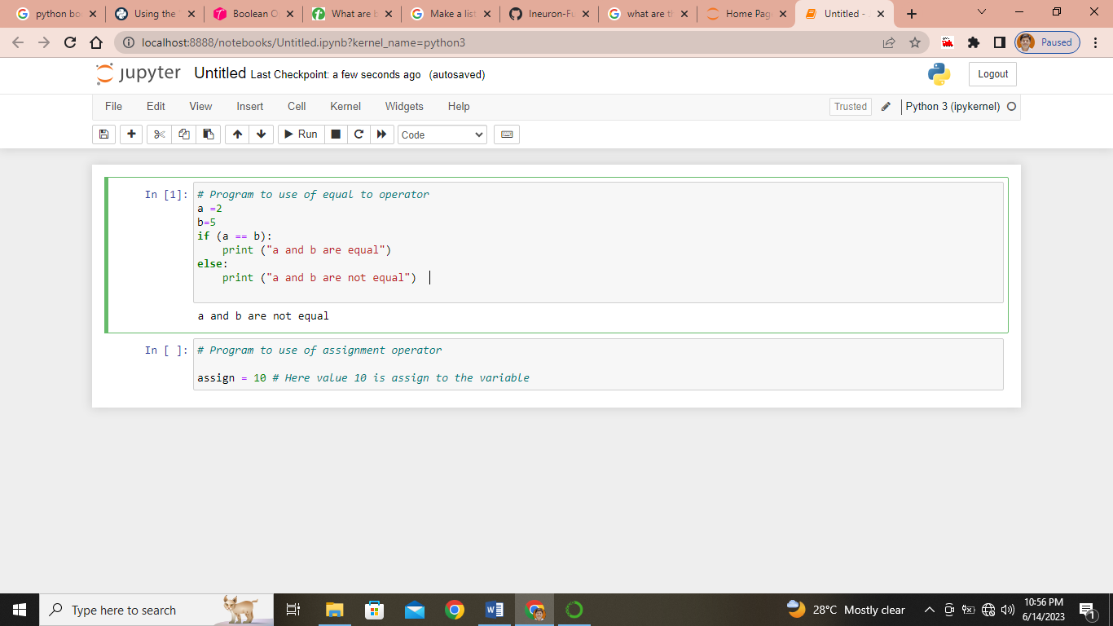

7. Identify the three blocks in this code:

spam = 0

if spam == 10:

print('eggs') #Block 1

if spam > 5:

print('bacon') #Block 2

else:

print('ham') #Block 3

print('spam')

print('spam')

8. Write code that prints Hello if 1 is stored in spam, prints Howdy if 2 is stored in spam, and prints Greetings! if anything else is stored in spam.

**Ans:**

spam = int(input(‘Enter the value of spam = ‘)

if(spam==1):

print (“Hello”)

elif(spam==2)

print(“Howdy”)

else:

print(“Greetings!”)

9.If your programme is stuck in an endless loop, what keys you’ll press?

**Ans:** by pressing **ctrl + C** (it kills the compiler execution)

10. How can you tell the difference between break and continue?

Ans: **break:** it used in loop and when break statement is executed then it come out of the loop.

**continue:** it used to continue with previous execution.

11. In a for loop, what is the difference between range(10), range(0, 10), and range(0, 10, 1)?

**Ans: output** of range(10), range(0, 10), and range(0, 10, 1) is same.

**range(10):** it calls the loop upto 10 (excluding), no information about from where to start.

**range(0, 10):** it tells the loop begin from 0 and ends at 10 (excluding). Here we get the beginning point of the loop but missing increment information.

**range(0, 10,1):** it tells the loop begin from 0 and ends at 10 (excluding) with increment by 1. In this syntax we get clear information.

12. Write a short program that prints the numbers 1 to 10 using a for loop. Then write an equivalent program that prints the numbers 1 to 10 using a while loop.

**Ans:**

**print(“—FOR LOOP---”)**

**for i in range(0,11,1):**

**print(i)**

**print(“—WHILE LOOP---”)**

**i=0**

**while a<11:**

**print(i)**

**i = i+1**

13. If you had a function named bacon() inside a module named spam, how would you call it after importing spam?

**Ans:** it can be called with **spam.bacon().**