Hoare vs Mesa Monitors
So far we have determined that the idiomatic usage of a monitor requires using a while loop as follows. Let's see how the design of monitors affects this recommendation.
while( condition == false ) {
condVar.wait();
}
Once the asleep thread is signaled and wakes up, you may ask why does it need to check for the condition being false again, the signaling thread must have just set the condition to true?
In Mesa monitors - Mesa being a language developed by Xerox researchers in the 1970s - it is possible that the time gap between thread B calls notify() and releases its mutex and the instant at which the asleep thread A, wakes up and reacquires the mutex, the predicate is changed back to false by another thread different than the signaler and the awoken threads! The woken up thread competes with other threads to acquire the mutex once the signaling thread B empties the monitor. On signaling, thread B doesn't give up the monitor just yet; rather it continues to own the monitor until it exits the monitor section.
In contrast, Hoare monitors - Hoare being one of the original inventor of monitors - the signaling thread B yields the monitor to the woken up thread A and thread A enters the monitor, while thread B sits out. This guarantees that the predicate will not have changed and instead of checking for the predicate in a while loop an if-clause would suffice. The woken-up/released thread A immediately starts execution when the signaling thread B signals that the predicate has changed. No other thread gets a chance to change the predicate since no other thread gets to enter the monitor.
Java, in particular, subscribes to Mesa monitor semantics and the developer is always expected to check for condition/predicate in a while loop. Mesa monitors are more efficient than Hoare monitors.

Semaphore vs Monitor
This lesson discusses the differences between a monitor and a semaphore.
Monitor, mutex, and semaphores can be confusing concepts initially. A monitor is made up of a mutex and a condition variable. One can think of a mutex as a subset of a monitor. Differences between a monitor and semaphore are discussed below.

The Difference
- A monitor and a semaphore are interchangeable and theoretically, one can be constructed out of the other or one can be reduced to the other. However, monitors take care of atomically acquiring the necessary locks whereas, with semaphores, the onus of appropriately acquiring and releasing locks is on the developer, which can be error-prone.
- Semaphores are lightweight when compared to monitors, which are bloated. However, the tendency to misuse semaphores is far greater than monitors. When using a semaphore and mutex pair as an alternative to a monitor, it is easy to lock the wrong mutex or just forget to lock altogether. Even though both constructs can be used to solve the same problem, monitors provide a pre-packaged solution with less dependency on a developer's skill to get the locking right.
- Java monitors enforce correct locking by throwing the IllegalMonitorState exception object when methods on a condition variable are invoked without first acquiring the associated lock. The exception is in a way saying that either the object's lock/mutex was not acquired at all or that an incorrect lock was acquired.
- A semaphore can allow several threads access to a given resource or critical section, however, only a single thread at any point in time can own the monitor and access associated resource.
- Semaphores can be used to address the issue of missed signals, however with monitors additional state, called the predicate, needs to be maintained apart from the condition variable and the mutex which make up the monitor, to solve the issue of missed signals.

Amdahl's Law
Blindly adding threads to speed up program execution may not always be a good idea. Find out what Amdahl's Law says about parallelizing a program

Definition
No text on concurrency is complete without mentioning the Amdahl's Law. The law specifies the cap on the maximum speedup that can be achieved when parallelizing the execution of a program.
If you have a poultry farm where a hundred hens lay eggs each day, then no matter how many people you hire to process the laid eggs, you still need to wait an entire day for the 100 eggs to be laid. Increasing the number of workers on the farm can't shorten the time it takes for a hen to lay an egg. Similarly, software programs consist of parts which can't be sped up even if the number of processors is increased. These parts of the program must execute serially and aren't amenable to parallelism.
Amdahl's law describes the theoretical speedup a program can achieve at best by using additional computing resources. We'll skip the mathematical derivation and go straight to the simplified equation expressing Amdahl's law:

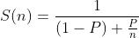

- S(n) is the speed-up achieved by using n cores or threads.
- P is the fraction of the program that is parallelizable
- (1 - P) is the fraction of the program that must be executed serially.

Example
Say our program has a parallelizable portion of P = 90% = 0.9. Now let's see how the speed-up occurs as we increase the number of processes

- n = 1 processor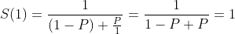
- n = 2 processors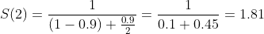
- n = 5 processors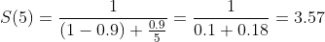
- n = 10 processors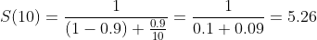
- n = 100 processors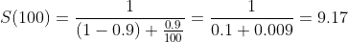
- n = 1000 processors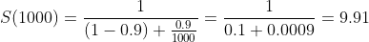
- n = infinite processors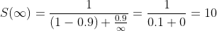

The speed-up steadily increases as we increase the number of processors or threads. However, as you can see the theoretical maximum speed-up for our program with 10% serial execution will be 10. We can't speed-up our program execution more than 10 times compared to when we run the same program on a single CPU or thread. To achieve greater speed-ups than 10 we must optimize or parallelize the serially executed portion of the code.
Another important aspect to realize is that when we speed-up our program execution by roughly 5 times, we do so by employing 10 processors. The utilization of these 10 processors, in turn, decreases by roughly 50% because now the 10 processors remain idle for the rest of the time that a single processor would have been busy. Utilization is defined as the speedup divided by the number of processors.
As an example say the program runs in 10 minutes using a single core. We assumed the parallelizable portion of the program is 90%, which implies 1 minute of the program time must execute serially. The speedup we can achieve with 10 processors is roughly 5 times which comes out to be 2 minutes of total program execution time. Out of those 2 minutes, 1 minute is of mandatory serial execution and the rest can all be parallelized. This implies that 9 of the processors will complete 90% of the non-serial work in 1 minute while 1 processor remains idle and then one out of the 10 processors, will execute the serial portion for another minute. The rest of the 9 processors are idle for that 1 minute during which the serial execution takes place. In effect, the combined utilization of the ten processors drops by 50%.
As N approaches infinity, the Amdahl's law takes the following form:

One should take the calculations using Amdahl's law with a grain of salt. If the formula spits out a speed-up of 5x it doesn't imply that in reality one would observe a similar speed-up. There are other factors such as the memory architecture, cache misses, network and disk I/O etc that can affect the execution time of a program and the actual speed-up might be less than the calculated one.
The Amdahl's law works on a problem of fixed size. However as computing resources are improved, algorithms run on larger and even larger datasets. As the dataset size grows, the parallelizable portion of the program grows faster than the serial portion and a more realistic assessment of performance is given by Gustafson's law, which we won't discuss here as it is beyond the scope of this text.

Moore's Law
Discusses impact of Moore's law on concurrency.

Moore's Law
In this lesson, we'll cover a high-level overview of Moore's law to present a final motivation to the reader for writing multi-threaded applications and realize that concurrency is inevitable in the future of software.
Gordon Moore, co-founder of Intel, observed the number of transistors that can be packed into a given unit of space doubles about every two years and in turn the processing power of computers doubles and the cost halves. Moore's law is more of an observation than a law grounded in formal scientific research. It states that the number of transistors per square inch on a chip will double every two years. This exponential growth has been going on since the 70’s and is only now starting to slow down. The following graph shows the growth of the transistor count.
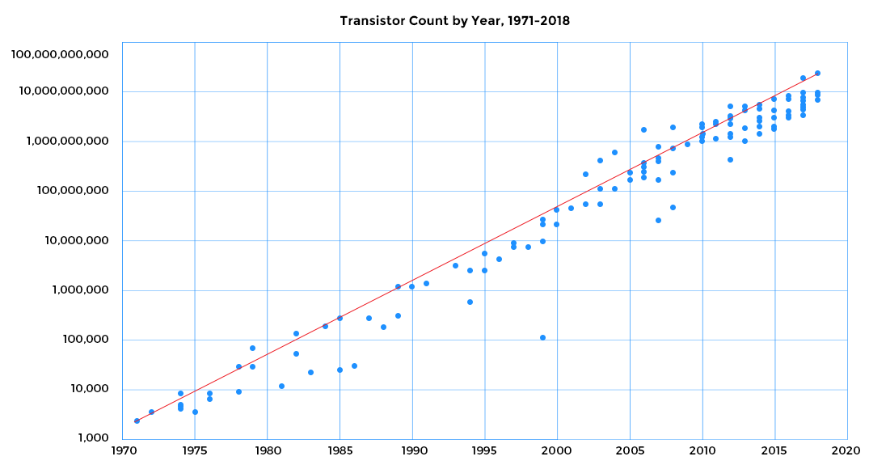
Initially, the clock speeds of processors also doubled along with the transistor count. This is because as transistors get smaller, their frequency increases and propagation delays decrease because now the transistors are packed closer together. However, the promise of exponential growth by Moore’s law came to an end more than a decade ago with respect to clock speeds. The increase in clock speeds of processors has slowed down much faster than the increase in number of transistors that can be placed on a microchip. If we plot clock speeds we find that the linear exponential growth stopped after 2003 and the trend line flattened out. The clock speed (proportional to difference between supply voltage and threshold voltage) cannot increase because the supply voltage is already down to an extent where it cannot be decreased to get dramatic gains in clock speed. In 10 years from 2000 to 2009, clock speed just increased from 1.3 GHz to 2.8 GHz merely doubling in a decade rather than increasing 32 times as expected by Moore's law. The following plot shows the clock speeds flattening out towards 2010.
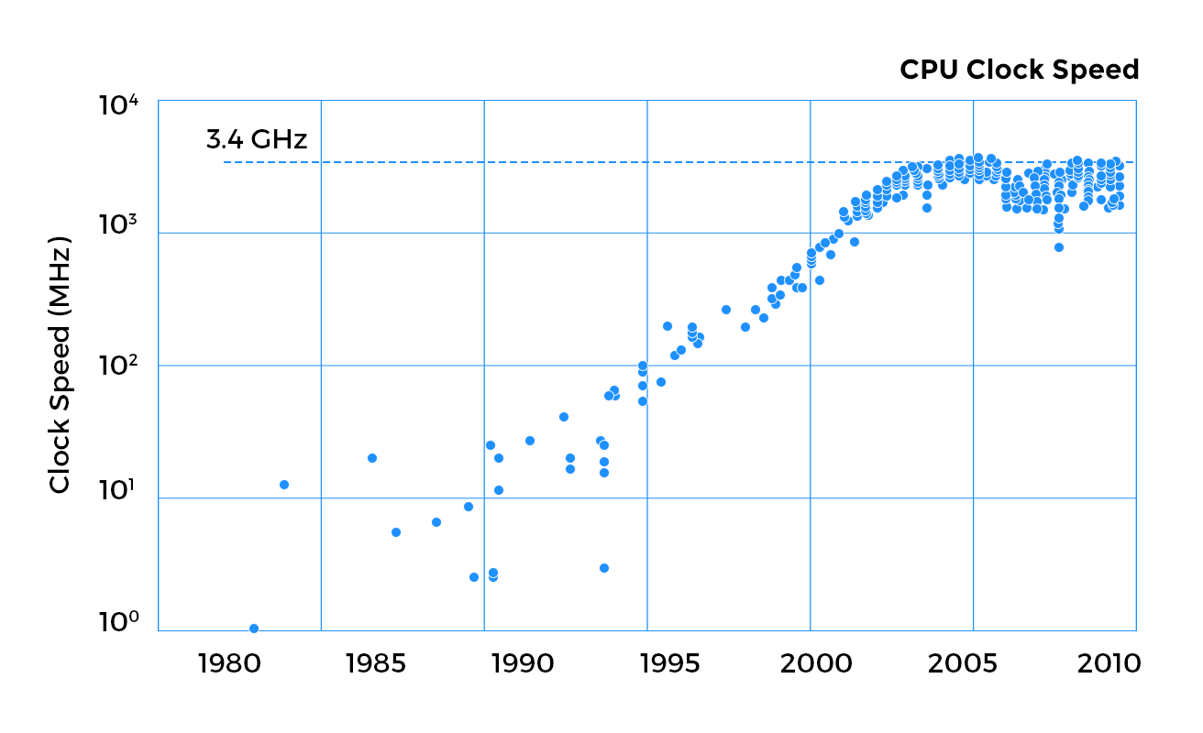
Since processors aren't getting faster as quickly as they use to, we need alternative measures to achieve performance gains. One of the ways to do that is to use multicore processors. Introduced in the early 2000s, multicore processors have more than one CPU on the same machine. To exploit this processing power, programs must be written as multi-threaded applications. A single-threaded application running on an octa-core processor will only use 1/8th of the total throughput of that machine, which is unacceptable in most scenarios.
Another analogy is to think of a bullock cart being pulled by an ox. We can breed the ox to be stronger and more powerful to pull more load but eventually there's a limit to how strong the ox can get. To pull more load, an easier solution is to attach several oxen to the bullock cart. The computing industry is also going in the direction of this analogy.
Multi Threading in Java

Thready Safety & Synchronized
This lesson explains thread-safety and the use of the synchronized keyword.
With the abstract concepts discussed, we'll now turn to the concurrency constructs offered by Java and use them in later sections to solve practical coding problems.

Thread Safe
A class and its public APIs are labelled as thread safe if multiple threads can consume the exposed APIs without causing race conditions or state corruption for the class. Note that composition of two or more thread-safe classes doesn't guarantee the resulting type to be thread-safe.

Synchronized
Java’s most fundamental construct for thread synchronization is the synchronized keyword. It can be used to restrict access to critical sections one thread at a time.
Each object in Java has an entity associated with it called the "monitor lock" or just monitor. Think of it as an exclusive lock. Once a thread gets hold of the monitor of an object, it has exclusive access to all the methods marked as synchronized. No other thread will be allowed to invoke a method on the object that is marked as synchronized and will block, till the first thread releases the monitor which is equivalent of the first thread exiting the synchronized method.
Note carefully:
- For static methods, the monitor will be the class object, which is distinct from the monitor of each instance of the same class.
- If an uncaught exception occurs in a synchronized method, the monitor is still released.
- Furthermore, synchronized blocks can be re-entered.
You may think of "synchronized" as the mutex portion of a monitor.
- class Employee {

- // shared variable
- private String name;

- // method is synchronize on 'this' object
- public synchronized void setName(String name) {
- this.name = name;
- }

- // also synchronized on the same object
- public synchronized void resetName() {

- this.name = "";
- }

- // equivalent of adding synchronized in method
- // definition
- public String getName() {
- synchronized (this) {
- return this.name;
- }
- }
- }
As an example look at the employee class above. All the three methods are synchronized on the "this" object. If we created an object and three different threads attempted to execute each method of the object, only one will get access, and the other two will block. If we synchronized on a different object other than the this object, which is only possible for the getName method given the way we have written the code, then the 'critical sections' of the program become protected by two different locks. In that scenario, since setName and resetName would have been synchronized on the this object only one of the two methods could be executed concurrently. However getName would be synchronized independently of the other two methods and can be executed alongside one of them. The change would look like as follows:
- class Employee {

- // shared variable
- private String name;
- private Object lock = new Object();

- // method is synchronize on 'this' object
- public synchronized void setName(String name) {
- this.name = name;
- }

- // also synchronized on the same object
- public synchronized void resetName() {

- this.name = "";
- }

- // equivalent of adding synchronized in method
- // definition
- public String getName() {
- // Using a different object to synchronize on
- synchronized (lock) {
- return this.name;
- }
- }
- }
All the sections of code that you guard with synchronized blocks on the same object can have at most one thread executing inside of them at any given point in time. These sections of code may belong to different methods, classes or be spread across the code base.
Note with the use of the synchronized keyword, Java forces you to implicitly acquire and release the monitor-lock for the object within the same method! One can't explicitly acquire and release the monitor in different methods. This has an important ramification, the same thread will acquire and release the monitor! In contrast, if we used semaphore, we could acquire/release them in different methods or by different threads.
A classic newbie mistake is to synchronize on an object and then somewhere in the code reassign the object. As an example, look at the code below. We synchronize on a Boolean object in the first thread but sleep before we call wait() on the object. While the first thread is asleep, the second thread goes on to change the flag's value. When the first thread wakes up and attempts to invoke wait(), it is met with a IllegalMonitorState exception! The object the first thread synchronized on before going to sleep has been changed, and now it is attempting to call wait() on an entirely different object without having synchronized on it.

- class Demonstration {
- public static void main( String args[] ) throws InterruptedException {
- IncorrectSynchronization.runExample();
- }
- }

- class IncorrectSynchronization {

- Boolean flag = new Boolean(true);

- public void example() throws InterruptedException {

- Thread t1 = new Thread(new Runnable() {

- public void run() {
- synchronized (flag) {
- try {
- while (flag) {
- System.out.println("First thread about to sleep");
- Thread.sleep(5000);
- System.out.println("Woke up and about to invoke wait()");
- flag.wait();
- }
- } catch (InterruptedException ie) {

- }
- }
- }
- });

- Thread t2 = new Thread(new Runnable() {

- public void run() {
- flag = false;
- System.out.println("Boolean assignment done.");
- }
- });

- t1.start();
- Thread.sleep(1000);
- t2.start();
- t1.join();
- t2.join();
- }

- public static void runExample() throws InterruptedException {
- IncorrectSynchronization incorrectSynchronization = new IncorrectSynchronization();
- incorrectSynchronization.example();
- }
- }

Marking all the methods of a class synchronized in order to make it thread-safe may reduce throughput. As a naive example, consider a class with two completely independent properties accessed by getter methods. Both the getters synchronize on the same object, and while one is being invoked, the other would be blocked because of synchronization on the same object. The solution is to lock at a finer granularity, possibly use two different locks for each property so that both can be accessed in parallel.

Wait & Notify

wait()
The wait method is exposed on each java object. Each Java object can act as a condition variable. When a thread executes the wait method, it releases the monitor for the object and is placed in the wait queue. Note that the thread must be inside a synchronized block of code that synchronizes on the same object as the one on which wait() is being called, or in other words, the thread must hold the monitor of the object on which it'll call wait. If not so, an illegalMonitor exception is raised!

notify()
Like the wait method, notify() can only be called by the thread which owns the monitor for the object on which notify() is being called else an illegal monitor exception is thrown. The notify method, will awaken one of the threads in the associated wait queue, i.e., waiting on the thread's monitor.
However, this thread will not be scheduled for execution immediately and will compete with other active threads that are trying to synchronize on the same object. The thread which executed notify will also need to give up the object's monitor, before any one of the competing threads can acquire the monitor and proceed forward.

notifyAll()
This method is the same as the notify() one except that it wakes up all the threads that are waiting on the object's monitor.

Interrupting Threads

Interrupted Exception
You'll often come across this exception being thrown from functions. When a thread wait()-s or sleep()-s then one way for it to give up waiting/sleeping is to be interrupted. If a thread is interrupted while waiting/sleeping, it'll wake up and immediately throw Interrupted exception.
The thread class exposes the interrupt() method which can be used to interrupt a thread that is blocked in a sleep() or wait() call. Note that invoking the interrupt method only sets a flag that is polled periodically by sleep or wait to know the current thread has been interrupted and an interrupted exception should be thrown.
Below is an example, where a thread is initially made to sleep for an hour but then interrupted by the main thread.
- class Demonstration {

- public static void main(String args[]) throws InterruptedException {
- InterruptExample.example();
- }
- }

- class InterruptExample {

- static public void example() throws InterruptedException {

- final Thread sleepyThread = new Thread(new Runnable() {

- public void run() {
- try {
- System.out.println("I am too sleepy... Let me sleep for an hour.");
- Thread.sleep(1000 * 60 * 60);
- } catch (InterruptedException ie) {
- System.out.println("The interrupt flag is cleard : " + Thread.interrupted() + " " + Thread.currentThread().isInterrupted());
- Thread.currentThread().interrupt();
- System.out.println("Oh someone woke me up ! ");
- System.out.println("The interrupt flag is set now : " + Thread.currentThread().isInterrupted() + " " + Thread.interrupted());
- }
- }
- });

- sleepyThread.start();

- System.out.println("About to wake up the sleepy thread ...");
- sleepyThread.interrupt();
- System.out.println("Woke up sleepy thread ...");

- sleepyThread.join();
- }
- }

Take a minute to go through the output of the above program. Observe the following:
- Once the interrupted exception is thrown, the interrupt status/flag is cleared as the output of line-19 shows.
- On line-20 we again interrupt the thread and no exception is thrown. This is to emphasize that merely calling the interrupt method isn't responsible for throwing the interrupted exception. Rather the implementation should periodically check for the interrupt status and take appropriate action.
- On line 22 we print the interrupt status for the thread, which is set to true because of line 20.
- Note that there are two methods to check for the interrupt status of a thread. One is the static method Thread.interrupted() and the other is Thread.currentThread().isInterrupted(). The important difference between the two is that the static method would return the interrupt status and also clear it at the same time. On line 22 we deliberately call the object method first followed by the static method. If we reverse the ordering of the two method calls on line 22, the output for the line would be true and false, instead of true and true.

Volatile

Volatile
The volatile concept is specific to Java. Its easier to understand volatile, if you understand the problem it solves.
If you have a variable say a counter that is being worked on by a thread, it is possible the thread keeps a copy of the counter variable in the CPU cache and manipulates it rather than writing to the main memory. The JVM will decide when to update the main memory with the value of the counter, even though other threads may read the value of the counter from the main memory and may end up reading a stale value.
If a variable is declared volatile then whenever a thread writes or reads to the volatile variable, the read and write always happen in the main memory. As a further guarantee, all the variables that are visible to the writing thread also get written-out to the main memory alongside the volatile variable. Similarly, all the variables visible to the reading thread alongside the volatile variable will have the latest values visible to the reading thread.
Volatile comes into play because of multiples levels of memory in hardware architecture required for performance enhancements. If there's a single thread that writes to the volatile variable and other threads only read the volatile variable then just using volatile is enough, however, if there's a possibility of multiple threads writing to the volatile variable then "synchronized" would be required to ensure atomic writes to the variable.

Reentrant Locks & Condition Variables

Reentrant Lock
Java's answer to the traditional mutex is the reentrant lock, which comes with additional bells and whistles. It is similar to the implicit monitor lock accessed when using synchronized methods or blocks. With the reentrant lock, you are free to lock and unlock it in different methods but not with different threads. If you attempt to unlock a reentrant lock object by a thread which didn't lock it initially, you'll get an IllegalMonitorStateException. This behavior is similar to when a thread attempts to unlock a pthread mutex.

Condition Variable
We saw how each java object exposes the three methods, wait(),notify() and notifyAll() which can be used to suspend threads till some condition becomes true. You can think of Condition as factoring out these three methods of the object monitor into separate objects so that there can be multiple wait-sets per object. As a reentrant lock replaces synchronized blocks or methods, a condition replaces the object monitor methods. In the same vein, one can't invoke the condition variable's methods without acquiring the associated lock, just like one can't wait on an object's monitor without synchronizing on the object first. In fact, a reentrant lock exposes an API to create new condition variables, like so:
Lock lock = new ReentrantLock();
Condition myCondition = lock.newCondition();
Notice, how can we now have multiple condition variables associated with the same lock. In the synchronized paradigm, we could only have one wait-set associated with each object.

java.util.concurrent
Java's util.concurrent package provides several classes that can be used for solving everyday concurrency problems and should always be preferred than reinventing the wheel. Its offerings include thread-safe data structures such as ConcurrentHashMap.

Missed Signals

Missed Signals
A missed signal happens when a signal is sent by a thread before the other thread starts waiting on a condition. This is exemplified by the following code snippet. Missed signals are caused by using the wrong concurrency constructs. In the example below, a condition variable is used to coordinate between the signaller and the waiter thread. The condition is signaled at a time when no thread is waiting on it causing a missed signal.
In later sections, you'll learn that the way we are using the condition variable's await method is incorrect. The idiomatic way of using await is in a while loop with an associated boolean condition. For now, observe the possibility of losing signals between threads.
- import java.util.concurrent.locks.Condition;
- import java.util.concurrent.locks.ReentrantLock;

- class Demonstration {

- public static void main(String args[]) throws InterruptedException {
- MissedSignalExample.example();
- }
- }

- class MissedSignalExample {

- public static void example() throws InterruptedException {

- final ReentrantLock lock = new ReentrantLock();
- final Condition condition = lock.newCondition();

- Thread signaller = new Thread(new Runnable() {

- public void run() {
- lock.lock();
- condition.signal();
- System.out.println("Sent signal");
- lock.unlock();
- }
- });

- Thread waiter = new Thread(new Runnable() {

- public void run() {

- lock.lock();

- try {
- condition.await();
- System.out.println("Received signal");
- } catch (InterruptedException ie) {
- // handle interruption
- }

- lock.unlock();

- }
- });

- signaller.start();
- signaller.join();

- waiter.start();
- waiter.join();

- System.out.println("Program Exiting.");
- }
- }

Missed Signal Example
The above code when ran, will never print the statement Program Exiting and execution would time out. Apart from refactoring the code to match the idiomatic usage of condition variables in a while loop, the other possible fix is to use a semaphore for signalling between the two threads as shown below
- import java.util.concurrent.Semaphore;

- class Demonstration {

- public static void main(String args[]) throws InterruptedException {
- FixedMissedSignalExample.example();
- }
- }

- class FixedMissedSignalExample {

- public static void example() throws InterruptedException {

- final Semaphore semaphore = new Semaphore(1);

- Thread signaller = new Thread(new Runnable() {

- public void run() {
- semaphore.release();
- System.out.println("Sent signal");
- }
- });

- Thread waiter = new Thread(new Runnable() {

- public void run() {
- try {
- semaphore.acquire();
- System.out.println("Received signal");
- } catch (InterruptedException ie) {
- // handle interruption
- }
- }
- });

- signaller.start();
- signaller.join();
- Thread.sleep(5000);
- waiter.start();
- waiter.join();

- System.out.println("Program Exiting.");
- }
- }

Semaphore in Java

Semaphore
Java's semaphore can be releas()-ed or acquire()-d for signalling amongst threads. However the important call out when using semaphores is to make sure that the permits acquired should equal permits returned. Take a look at the following example, where a runtime exception causes a deadlock.
- import java.util.concurrent.Semaphore;

- class Demonstration {

- public static void main(String args[]) throws InterruptedException {
- IncorrectSemaphoreExample.example();
- }
- }

- class IncorrectSemaphoreExample {

- public static void example() throws InterruptedException {

- final Semaphore semaphore = new Semaphore(1);

- Thread badThread = new Thread(new Runnable() {

- public void run() {

- while (true) {

- try {
- semaphore.acquire();
- } catch (InterruptedException ie) {
- // handle thread interruption
- }

- // Thread was meant to run forever but runs into an
- // exception that causes the thread to crash.
- throw new RuntimeException("exception happens at runtime.");

- // The following line to signal the semaphore is never reached
- // semaphore.release();
- }
- }
- });

- badThread.start();

- // Wait for the bad thread to go belly-up
- Thread.sleep(1000);

- final Thread goodThread = new Thread(new Runnable() {

- public void run() {
- System.out.println("Good thread patiently waiting to be signalled.");
- try {
- semaphore.acquire();
- } catch (InterruptedException ie) {
- // handle thread interruption
- }
- }
- });

- goodThread.start();
- badThread.join();
- goodThread.join();
- System.out.println("Exiting Program");
- }
- }

Incorrect Use of Semaphore
The above code when run would time out and show that one of the threads threw an exception. The code is never able to release the semaphore causing the other thread to block forever. Whenever using locks or semaphores, remember to unlock or release the semaphore in a finally block. The corrected version appears below.

import java.util.concurrent.Semaphore;

- class Demonstration {

- public static void main(String args[]) throws InterruptedException {
- CorrectSemaphoreExample.example();
- }
- }

- class CorrectSemaphoreExample {

- public static void example() throws InterruptedException {

- final Semaphore semaphore = new Semaphore(1);

- Thread badThread = new Thread(new Runnable() {

- public void run() {

- while (true) {

- try {
- semaphore.acquire();
- try {
- throw new RuntimeException("");
- } catch (Exception e) {
- // handle any program logic exception and exit the function
- return;
- } finally {
- System.out.println("Bad thread releasing semahore.");
- semaphore.release();
- }

- } catch (InterruptedException ie) {
- // handle thread interruption
- }
- }
- }
- });

- badThread.start();

- // Wait for the bad thread to go belly-up
- Thread.sleep(1000);

- final Thread goodThread = new Thread(new Runnable() {

- public void run() {
- System.out.println("Good thread patiently waiting to be signalled.");
- try {
- semaphore.acquire();
- } catch (InterruptedException ie) {
- // handle thread interruption
- }
- }
- });

- goodThread.start();
- badThread.join();
- goodThread.join();
- System.out.println("Exiting Program");
- }
- }

Running the above code will print the Exiting Program statement.

Spurious Wakeups
Spurious mean fake or false. A spurious wakeup means a thread is woken up even though no signal has been received. Spurious wakeups are a reality and are one of the reasons why the pattern for waiting on a condition variable happens in a while loop as discussed in earlier chapters. There are technical reasons beyond our current scope as to why spurious wakeups happen, but for the curious on POSIX based operating systems when a process is signaled, all its waiting threads are woken up. Below comment is a directly lifted from Java's documentation for the wait(long timeout) method.
* A thread can also wake up without being notified, interrupted, or
* timing out, a so-called <i>spurious wakeup</i>. While this will rarely
* occur in practice, applications must guard against it by testing for
* the condition that should have caused the thread to be awakened and
* continuing to wait if the condition is not satisfied. In other words,
* waits should always occur in loops, like this one:
*
* synchronized (obj) {
* while (condition does not hold)
* obj.wait(timeout);
* ... // Perform action appropriate to condition
* }
*

Miscellaneous Topics

Lock Fairness
We'll briefly touch on the topic of fairness in locks since its out of scope for this course. When locks get acquired by threads, there's no guarantee of the order in which threads are granted access to a lock. A thread requesting lock access more frequently may be able to acquire the lock unfairly greater number of times than other locks. Java locks can be turned into fair locks by passing in the fair constructor parameter. However, fair locks exhibit lower throughput and are slower compared to their unfair counterparts.

Thread Pools
Imagine an application that creates threads to undertake short-lived tasks. The application would incur a performance penalty for first creating hundreds of threads and then tearing down the allocated resources for each thread at the ends of its life. The general way programming frameworks solve this problem is by creating a pool of threads, which are handed out to execute each concurrent task and once completed, the thread is returned to the pool
Java offers thread pools via its Executor Framework. The framework includes classes such as the ThreadPoolExecutor for creating thread pools.

Java Memory Model
This lesson lays out the ground work for understanding the Java Memory Model.
A memory model is defined as the set of rules according to which the compiler, the processor or the runtime is permitted to reorder memory operations. Reordering operations allow compilers and the like to apply optimizations that can result in better performance. However, this freedom can wreak havoc in a multithreaded program when the memory model is not well-understood with unexpected program outcomes.
Consider the below code snippet executed in our main thread. Assume the application also spawns a couple of other threads, that'll execute the method runMethodForOtherThreads()
1. public class BadExample {
2.
3. int myVariable = 0;
4. boolean neverQuit = true;
5.
6. public void runMethodForMainThread() {
7.
8. // Change the variable value to lucky 7
9. myVariable = 7;
10. }
11.
12. public void runMethodForOtherThreads() {
13.
14. while (neverQuit) {
15. System.out.println("myVariable : " + myVariable);
16. }
17. }
18. }
Now you would expect that the other threads would see the myVariable value change to 7 as soon as the main thread executes the assignment on line 9. This assumption is false in modern architectures and other threads may see the change in the value of the variable myVariable with a delay or not at all. Below are some of the reasons that can cause this to happen
- Use of sophisticated multi-level memory caches or processor caches
- Reordering of statements by the compiler which may differ from the source code ordering
- Other optimizations that the hardware, runtime or the compiler may apply.
One likely scenario can be that the variable is updated with the new value in the processor's cache but not in the main memory. When another thread running on another core requests the variable myVariable's value from the memory, it still sees the stale value of 0. This is a specific example of the cache coherence problem. Different processor architectures have different policies as to when an individual processor's cache is reconciled with the main memory
The above discussion then begets the question: "Under what circumstances does a thread reading the myVariable value would see the updated value of 7". This can be answered by understanding the Java memory model (JMM).

Within-Thread as-if-serial
The Java language specification (JLS) mandates the JVM to maintain within-thread as-if-serial semantics. What this means is that, as long as the result of the program is exactly the same if it were to be executed in a strictly sequential environment (think single thread, single processor) then the JVM is free to undertake any optimizations it may deem necessary. Over the years, much of the performance improvements have come from these clever optimizations as clock rates for processors become harder to increase. However, when data is shared between threads, these very optimizations can result in concurrency errors and the developer needs to inform the JVM through synchronization constructs of when data is being shared.
Let's see in the next lesson how these optimizations can give surprising results in multithreaded scenarios.

Reordering Effects
This lesson discusses the compiler, runtime or hardware optimizations that can cause reordering of program instructions
Take a look at the following program and try to come up with all the possible outcomes for the variables ping and pong.
- class Demonstration {
- public static void main( String args[] ) throws Exception {
- (new ReorderingExample()).reorderTest();
- }
- }

- class ReorderingExample {

- private int ping = 0;
- private int pong = 0;
- private int foo = 0;
- private int bar = 0;

- public void reorderTest() throws InterruptedException {

- Thread t1 = new Thread(new Runnable() {

- public void run() {
- foo = 1;
- ping = bar;
- }
- });

- Thread t2 = new Thread(new Runnable() {

- public void run() {
- bar = 1;
- pong = foo;
- }
- });

- t1.start();
- t2.start();
- t1.join();
- t2.join();
- System.out.println(ping + " " + pong);

- }
- }

Effect of reordering on program output
Most folks would come up with the following possible outcomes:
- 1 and 1
- 1 and 0
- 0 and 1
However, it might surprise many but the program can very well print 0 and 0! How is that even possible? Think from the point of view of a compiler, it sees the following instructions for thread t1's run() method:
bar = 1;
pong = foo;
The compiler doesn't know that the variable bar is being used by another thread so it may take the liberty to reorder the statements like so:
pong = foo;
bar = 1;
The two statements don't have a dependence on each other in the sense that they are working off of completely different variables. For performance reasons, the compiler may decide to switch their ordering. Other forces are also at play, for instance, the value of one of the variables may get flushed out to the main memory from the processor cache but not for the other variable.
Note that with the reordering of the statements the JVM still is able to honor the within-thread as-if-serial semantics and is completely justified to move the statements around. Such performance and optimization tricks by the compiler, runtime or hardware catch unsuspecting developers off-guard and lead to bugs which are very hard to reproduce in production.

Platform
Java is touts the famous code once, run anywhere mantra as one of its strengths. However, this isn't possible without Java shielding us from the vagrancies of the multitude of memory architectures that exist in the wild. For instance, the frequency of reconciling a processor's cache with the main memory depends on the processor architecture. A processor may relax its memory coherence guarantees in favor of better performance. The architecture's memory model specifies the guarantees a program can expect from the memory model. It will also specify instructions required to get additional memory coordination guarantees when data is being shared among threads. These instructions are usually called memory fences or barriers but the Java developer can rely on the JVM to interface with the underlying platform's memory model through its own memory model called JMM (Java Memory Model) and insert these platform memory specific instructions appropriately. Conversely, the JVM relies on the developer to identify when data is shared through the use of proper synchronization.
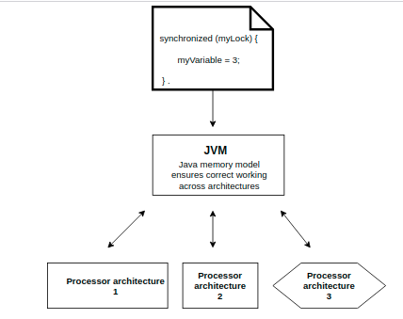

The happens-before Relationship
This lesson continues the in-depth discussion of Java memory model
The JMM defines a partial ordering on all actions within a program. This might sound like a loaded statement so bear with me as I explain below.

Total Order
You are already familiar with total ordering, the sequence of natural numbers i.e. 1, 2, 3 4, .... is a total ordering. Each element is either greater or smaller than any other element in the set of natural numbers (Totality). If 2 < 4 and 4 < 7 then we know that 2 < 7 necessarily (Transitivity). And finally if 3 < 5 then 5 can't be less than 3 (Asymmetry).

Partial Order
Elements of a set will exhibit partial ordering when they possess transitivity and asymmetry but not totality. As an example think about your family tree. Your father is your ancestor, your grandfather is your father's ancestor. By transitivity, your grandfather is also your ancestor. However, your father or grandfather aren't ancestors of your mother and in a sense they are incomparable.

Java Memory Model Details
The compiler in the spirit of optimization is free to reorder statements however it must make sure that the outcome of the program is the same as without reordering. The sources of reordering can be numerous. Some examples include:
- If two fields X and Y are being assigned but don't depend on each other, then the compiler is free to reorder them
- Processors may execute instructions out of order under some circumstances
- Data may be juggled around in the registers, processor cache or the main memory in an order not specified by the program e.g. Y can be flushed to main memory before X.
Note that all these reorderings may happen behind the scenes in a single-threaded program but the program sees no ill-effects of these reorderings as the JMM guarantees that the outcome of the program would be the same as if these reorderings never happened.
However, when multiple threads are involved then these reorderings take on an altogether different meaning. Without proper synchronization, these same optimizations can wreak havoc and program output would be unpredictable.
The JMM is defined in terms of actions which can be any of the following
- read and writes of variables
- locks and unlocks of monitors
- starting and joining of threads
The JMM enforces a happens-before ordering on these actions. When an action A happens-before an action B, it implies that A is guaranteed to be ordered before B and visible to B. Consider the below program
public class ReorderingExample {

int x = 3;
int y = 7;
int a = 4;
int b = 9;
Object lock1 = new Object();
Object lock2 = new Object();

public void writerThread() {

// BLOCK#1
// The statements in block#1 and block#2 aren't dependent
// on eachother and the two blocks can be reordered by the
// compiler
x = a;

// BLOCK#2
// These two writes within block#2 can't be reordered, as
// they are dependent on eachother. Though this block can
// be ordered before block#1
y += y;
y *= y;

// BLOCK#3
// Because this block uses x and y, it can't be placed before
// the assignments to the two variables, i.e. block#1 and block#2
synchronized (lock1) {
x *= x;
y *= y;
}

// BLOCK#4
// Since this block is also not dependent on block#3, it can be
// placed before block#3 or block#2. But it can't be placed before
// block#1, as that would assign a different value to x
synchronized (lock2) {
a *= a;
b *= b;
}
}
}
Now note that even though all this reordering magic can happen in the background but the notion of program order is still maintained i.e. the final outcome is exactly the same as without the ordering. Furthermore, block#1 will appear to happen-before block#2 even if block#2 gets executed before. Also note that block#2 and block#4 have no ordering dependency on each other.
One can see that there's no partial ordering between block#1 and block#2 but there's a partial ordering between block#1 and block#3 where block#3 must come after block#1.
The reordering tricks are harmless in case of a single threaded program but all hell will break loose when we introduce another thread that shares the data that is being read or written to in the writerThread method. Consider the addition of the following method to the previous class.
public void readerThread() {

a *= 10;

// BLOCK#4
// Moved out to here from writerThread method
synchronized (lock2) {
a *= a;
b *= b;
}
}
Note we moved out block#4 into the new method readerThread. Say if the readerThread runs to completion, it is possible for the writerThread to never see the updated value of the variable a as it may never have been flushed out to the main memory, where the writerThread would attempt to read from. There's no happens before relationship between the two code snippets executed in two different threads!
To make sure that the changes done by one thread to shared data are visible immediately to the next thread accessing those same variables, we must establish a happens-before relationship between the execution of the two threads. A happens before relationship can be established in the following ways.
- Each action in a thread happens-before every action in that thread that comes later in the program's order. However, for a single-threaded program, instructions can be reordered but the semantics of the program order is still preserved.
- An unlock on a monitor happens-before every subsequent lock on that same monitor. The synchronization block is equivalent of a monitor.
- A write to a volatile field happens-before every subsequent read of that same volatile.
- A call to start() on a thread happens-before any actions in the started thread.
- All actions in a thread happen-before any other thread successfully returns from a join() on that thread.
- The constructor for an object happens-before the start of the finalizer for that object
- A thread interrupting another thread happens-before the interrupted thread detects it has been interrupted.
This implies that any memory operations which were visible to a thread before exiting a synchronized block are visible to any thread after it enters a synchronized block protected by the same monitor, since all the memory operations happen before the release, and the release happens before the acquire. Exiting a synchronized block causes the cache to be flushed to the main memory so that the writes made by the exiting thread are visible to other threads. Similarly, entering a synchronized block has the effect of invalidating the local processor cache and reloading of variables from the main memory so that the entering thread is able to see the latest values.
In our readerThread if we synchronize on the same lock object as the one we synchronize on in the writerThread then we would establish a happens-before relationship between the two threads. Don't confuse it to mean that one thread executes before the other. All it means is that when readerThread releases the monitor, up till that point, whatever shared variables it has manipulated will have their latest values visible to the writerThread as soon as it acquires the same monitor. If it acquires a different monitor then there's no happens-before relationship and it may or may not see the latest values for the shared variables
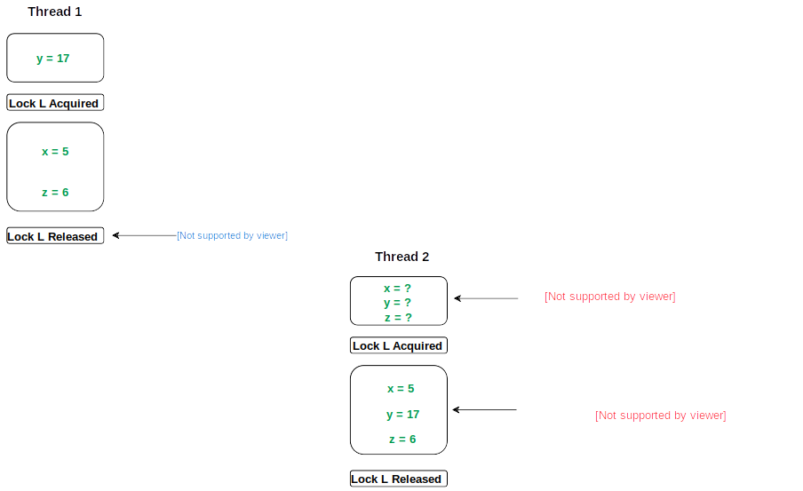
Happens-Before Relationship

