**Number to Word API documentation**

Project comprise of 3 projects as shown below:

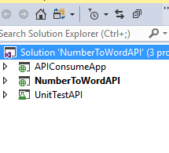

APIConsumeApp project is the client application that will consume WebApi using JQuery as shown below:

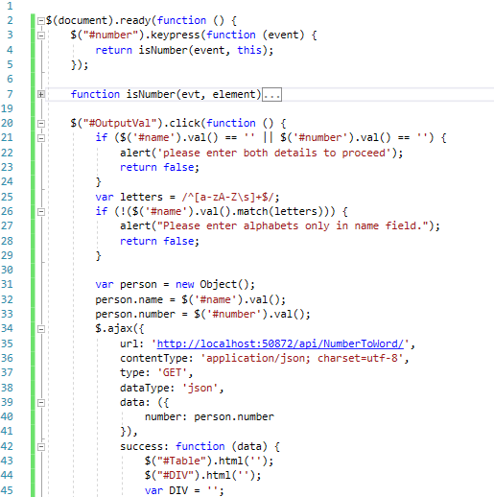

**NumberToWordAPI** is the API that has main code to convert number to word currency.

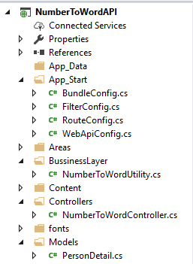

BussinessLayer has conversion code logic which is being called from NumberToWordAPI controller class.

**Unit test project** confirm whether number passed is correctly converting to currency word or not.

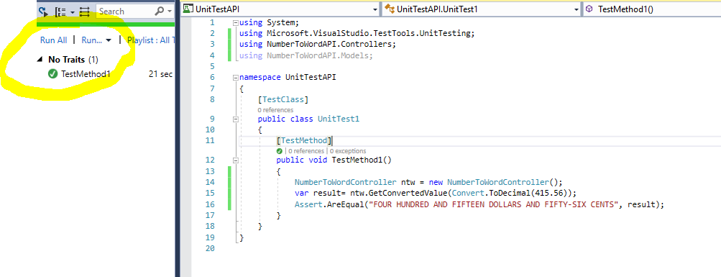

**Validations used at Client application**

If both text fields are left blank or either of anyone, then pop up alert will show to enter details to proceed.

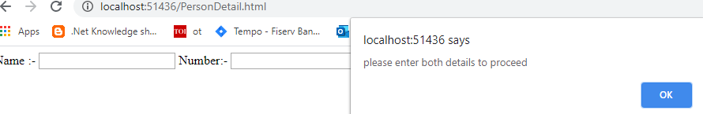

If I try to add number in Name text field then pop up message will pop up to enter only alphabet.

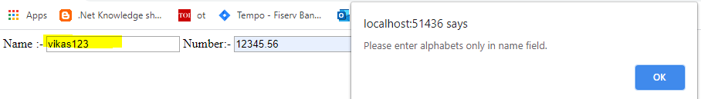

Also user won’t be able to enter anything except number or decimal in number text field. This validation has been applied on its key press function.

**Output 1:**

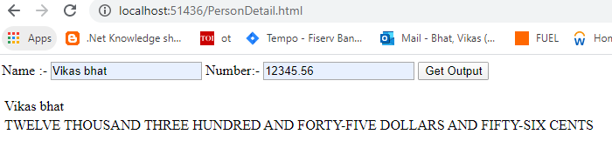

**Output 2:**

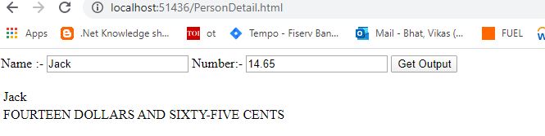

**Steps to run application**

I haven’t configured application on IIS. Just set API project as startup project and hit F5.It will not show anything on webpage.

Now browse client application URL in browser as shown in above output screenshot and then enter name and number.

User will check that finally API will return name and converted number.