**PROJECT PLAN**

Title: **XML Parser for Salesforce Role and relationship between them.**

**Project Description:** It converts any XML file to CSV(Comma Separated Values) and then translate text into desired language.

**Prerequisites**:   
 -Java version 7 or higher  
 -Operating System : Windows

-Apache Maven 3

**Flow Chart:**

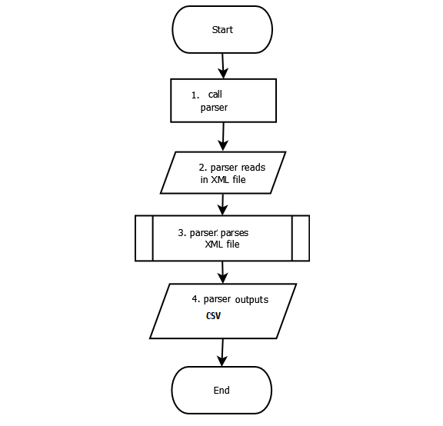

**Project Structure:** The major important files in the project are showing here with their purpose:

**/.git :**  .git folder contain all the information that is necessary for project in version control and all the information about commits remote repo address etc.All are present in this folder. It also contain a log which store your commit history so that you can roll back to history. If we delete .git then project will no longer be a git project. It is created by git init command.

**/src :** package which contains the whole source code. It is mainly classified in:

**/main :** The main package will contain some sub-packages with the .java files.

For example:

If the below file is .java file then Junit test case will be at:

/main/java/com/geminidsystems/xmlparser/abc.java (Java File)

**.gitignore:** contains files which we don’t want git to track.

For example: **/target**

**pom.xml:** an XML file that contains information about the project and configuration details used by Maven to build the project. Examples for this is the build directory, which is target; the source directory, which is src/main/java; the test source directory, which is src/test/java.

**README.md** **:** A README file can have license, contribution guidelines and code to install and run project so it will contain all such details.

### **Version 1.0.0**

Initial release.

|  |  |  |
| --- | --- | --- |
| Milestones | Description | Date |
| Complete software configuration management tools | Read about build tool Maven, Version control git, IDE (Eclipse, Netbeans, Intellij Idea), Font Awesome, Relational Databases | 28/March/2017 |
| Understand Sample Project | Setup, run and understand the Sample project. (Project Structure, Coding conventions) | 30/March/2017 |
| Complete the Day one Issues | Commented on gitlab and slack, project plan is also done but delay due to link issue. (Link opened at 8 PM) | 30/March/2017 |
| Hard code | Commit on gitlab XML.java file which Reads all the <label> tag which are inside the <field> tags and display them on console. | 06/April/2017 |
| Project completed | Final day. Completed all the desired Stuff. | 07/April/2017 |

**References:**

1. Git Documentation :<https://git-scm.com/book/en/v1/Getting-Started>
2. Apache Maven :<https://maven.apache.org>
3. Stackoverflow.com
4. Whatsmate API