**CANDIDATE’S DECLARATION**

I hereby declare that the work presented in this training report entitled **“Indian Bus”**, submitted in partial fulfilment of the requirement for the award of the degree of Bachelor of Technology in **Computer Science And Engineering**, submitted to **Asia Pacific Institute Of Information & Technology, Kurukshetra University, Kurukshetra, India** is anauthentic record of my own work carried out during the period from **1 August, 2020** to **1st May, 2021.**

The work reported in this project report has not been submitted by me for the award of any other degree or diploma.

|  |  |
| --- | --- |
| Date: 01/08/2020 – 01/05/2021  Place: Panipat | Vikas Dhiman (8617111) |

**CERTIFICATE**

This is to certify that the summer training report entitled **“Indian Bus”** done by **Vikas Dhiman , Roll No. 8617111** is an authentic work carried out by him at ICSD under my guidance. The matter embodied in this project work has not been submitted earlier for the award of any degree or diploma to the best of my knowledge and belief.

Mrs. Anshu Sharma

Assistant Professor, CSE

Mr. Prateek Mishra

Training Incharge, CSE

Mr. Ravi Sachidava

HOD , CSE

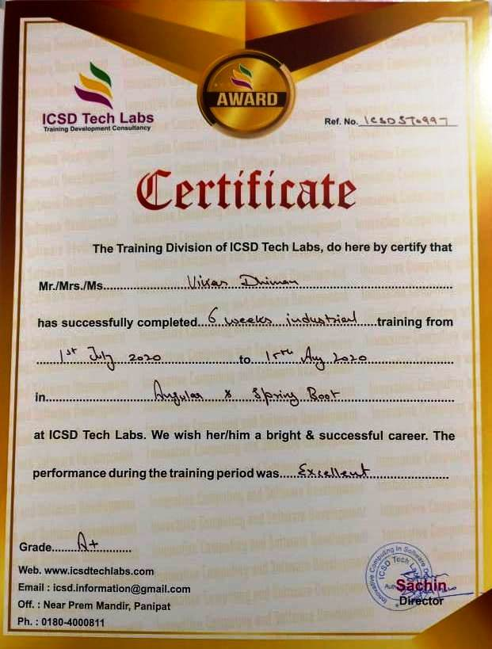

**ACKNOWLEDGEMENT**

I express my sincere thanks of gratitude to **Mr.Sachin Tuli** , my trainee at **ICSD** who taught me so well that helped me to develop the project **“Indian Bus”** and guided me throughout the project without which it would have been a back-breaking task for me.

It was a great chance of learning which I got through training at ICSD and I consider myself as a very lucky individual to be a part of it. I also got chance to meet many professionals who lead me through my training. I would like to thank**, Mrs. Anshu Sharma (Assistant Professor , APIIT) , Mr. Prateek Mishra (Training Incharge,APIIT)** for guiding me.

I would also not forget to thank my parents and my friends for their co-operation and encouraging me time to time by helping me out with their abilities in completion of my project.

This opportunity was a big milestone in my career. I will try to use my gained skills and knowledge in every possible way and will try to improve more in the same, in order to achieve desired career goals.

(Vikas Dhiman)

**ABSTRACT**

Our project is based on test conduction in which a Indian Bus booking service to get the information about the Bus Service to be choose on the basic of marks which will help them in future.

In this project, we can firstly make advance login and registration and also a social login. And after the user can book the sheet in this project. After there is a payment gateway for the payment service.

After this. The ordered food will be added into his cart and then the payment page can be open at which he can pay the payment for the food and after paying the book the sheet in the bus can be successful and he can also see his bill.

**Features**

* Passenger login
* Bus user login
* Passenger Register
* Bus User register
* Check Your Bus Availability
* Bus Booking
* Check your Bus Status
* Add Bus
* Add Multiple Check Points

**CHAPTER**

|  |  |  |  |
| --- | --- | --- | --- |
| **CHAPTER NO** |  | **DESCRIPTION** | **PAGE NO.** |
| **Chapter 1:** |  | **Introduction** | **1-5** |
| 1.1 |  | Overview | 1-1 |
| 1.2 |  | Introduction of Angular | 1-3 |
| 1.3 |  | Introduction of Spring Boot | 3-4 |
| 1.4 |  | Introduction of Microservices | 4-5 |
| 1.5 |  | Introduction to MySQL | 5-5 |
| **Chapter 2:** |  | **Software and Hardware Requirements** | 6-6 |
| 2.1 |  | Software Requirements | 6-6 |
| 2.2 |  | Hardware Requirements | 6-6 |
| **Chapter 3:** |  | **Software Requirements and Analysis** | 7-8 |
| 3.1 |  | Analysis | 7-8 |
| 3.2 |  | Requirement Specification | 8-8 |
| **Chapter 4:** |  | **Software Design** | **9-11** |
| 4.1 |  | Entity Relationship Diagram | 9-10 |
| 4.2 |  | E-R Diagram | 10-11 |
| **Chapter 5:** |  | **Coding** | **12-37** |
| 5.1 |  | Angular Connectivity with Spring Boot | 12-13 |
| 5.2 |  | UI Code | 13-29 |
| 5.3 |  | Backend Code | 29-37 |
| **Chapter 6:** |  | **Output Screens of the Project** | **38-55** |
| 6.1 |  | Project Output Screens | 38-50 |
| 6.2 |  | Eureka Server Screen | 50-50 |
| 6.3 |  | Database output Screens | 51-55 |
| **Chapter 7:** |  | **References** | **56** |
| 7.1 |  | References Website and links | 56 |

**LIST OF FIGURES**

|  |  |  |
| --- | --- | --- |
| **Figure No.** | **Figure Name** | **Page No.** |
| 1.1 | Angular Icon | 1 |
| 1.2 | Spring Icon | 3 |
| 1.3 | Micro-services Icon | 4 |
| 1.4 | MySQL Icon | 5 |
| 4.2.1 | Diagram for Project Users | 10 |
| 4.2.2 | Diagram for Data Binding | 10 |
| 4.2.3 | Diagram for Data Binding | 11 |
| 5.2.1 | Angular Project Structure | 13 |
| 5.3.1 | Project | 29 |
| 5.3.2 | Eureka Server | 29 |
| 5.3.3 | Zuul Server | 30 |
| 5.3.4 | User Server | 34 |
| 5.3.5 | Bus Server | 36 |
| 6.1.1 | URL | 38 |
| 6.1.2 | Home Page | 38 |
| 6.1.3 | Login Page | 39 |
| 6.1.4 | Register Page | 39 |
| 6.1.5 | Forget Password | 40 |
| 6.1.6 | Login with Social Id’s | 40 |
| 6.1.7 | User Home Page | 41 |
| 6.1.8 | User Profile | 41 |
| 6.1.9 | Add Address | 42 |
| 6.1.10 | Edit Profile | 42 |
| 6.1.11 | Check Bus | 43 |
| 6.1.12 | Book Bus | 43 |
| 6.1.13 | Verify Bill | 44 |
| 6.1.14 | Payment Page | 44 |
| 6.1.15 | Order Placed | 45 |
| 6.1.16 | Contact Page | 45 |
| 6.1.17 | Change Password | 46 |
| 6.1.18 | Booking History | 46 |
| 6.1.19 | Bus Profile | 47 |
| 6.1.20 | Add Bus | 47 |
| 6.1.21 | Bus List | 48 |
| 6.1.22 | Show Main Bus | 48 |
| 6.1.23 | Update Bus | 49 |
| 6.1.24 | Add Check Points | 49 |
| 6.1.25 | Verify Bus Stops | 50 |
| 6.2.1 | Eureka Server | 50 |
| 6.4.1 | Bus Data Table Structure | 51 |
| 6.4.2 | User Table Structure | 52 |
| 6.3.1 | User Details Table | 53 |
| 6.3.2 | Book Seat Booking List | 53 |
| 6.3.3 | User Address | 53 |
| 6.3.4 | User Booking | 53 |
| 6.3.5 | User Booking List no List | 54 |
| 6.3.6 | User Bus Data Details | 54 |
| 6.3.7 | User Bus Payment Status | 54 |
| 6.3.8 | Bus Data | 55 |
| 6.3.9 | Bus Seats | 55 |
| 6.3.10 | Travel Details | 55 |
| 6.3.11 | Bus weeks | 55 |