AgriFlow Foods
Agricultural Supply Chain Analytics — Instructor Solution Report

1. Executive Baseline
Metric | Reference Result
Procurement spend | INR 47.6 bn
Net sales in customer-order feed | INR 7.5 bn
Average fill rate | 94.1%
Strict project OTIF | 10.9%
Quality rejection rate | 6.2%
Transport loss rate | 5.8%
Temperature-excursion rate | 52.9%
Current spoilage value | INR 578.8 m
Forecast holdout WAPE | 10.4%
Simulated recall lot | LOT0005168
Recall-affected customers | 19
The OTIF definition in this training case is deliberately strict (in-full and on/before promised date), creating a visibly underperforming baseline that learners must diagnose rather than normalize away.

2. Supplier / Procurement Diagnosis
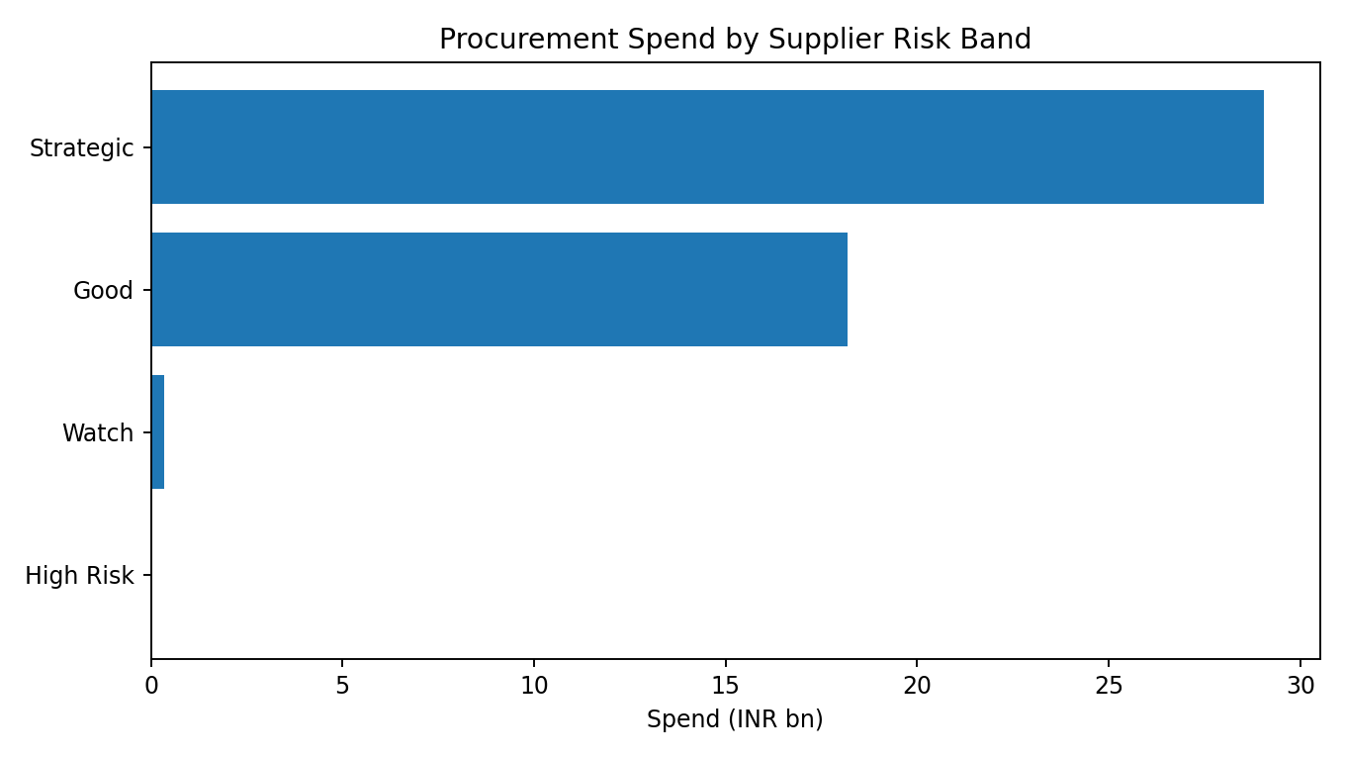
Supplier ranking should combine yield attainment, quality acceptance, compliance and procurement price variance. A low farm-gate price is not necessarily a good sourcing decision if it increases reject, delay or loss downstream.

3. Cold Chain & Logistics
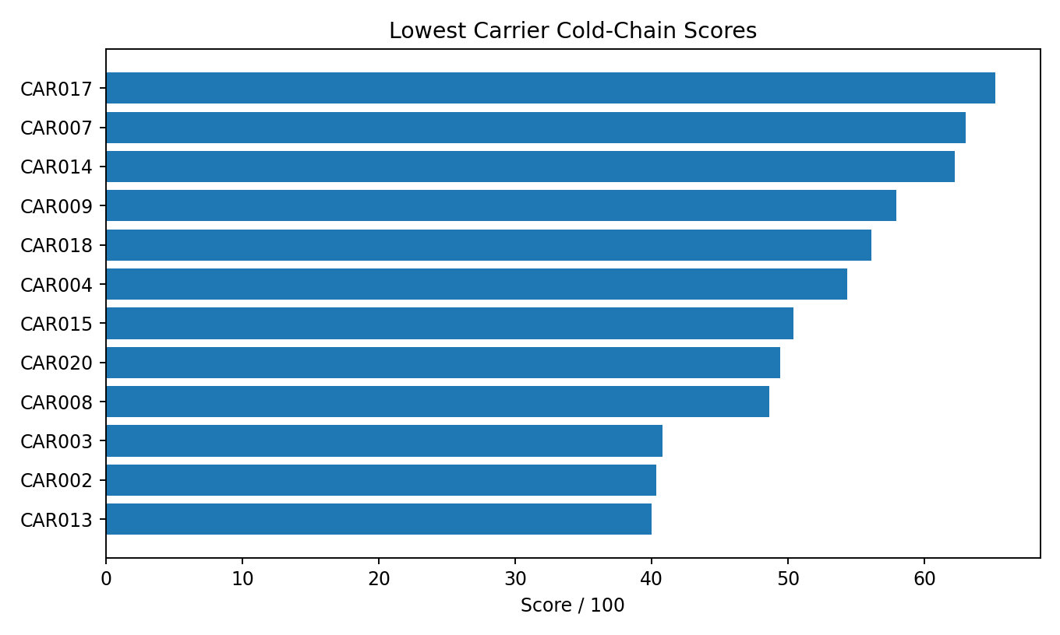
Approximately 52.9% of inbound shipments record more than two hours of temperature excursion in the synthetic baseline. The appropriate response is lane/carrier/product targeting, not blanket cold-chain capex.

4. Warehouse / Shelf-Life / Spoilage
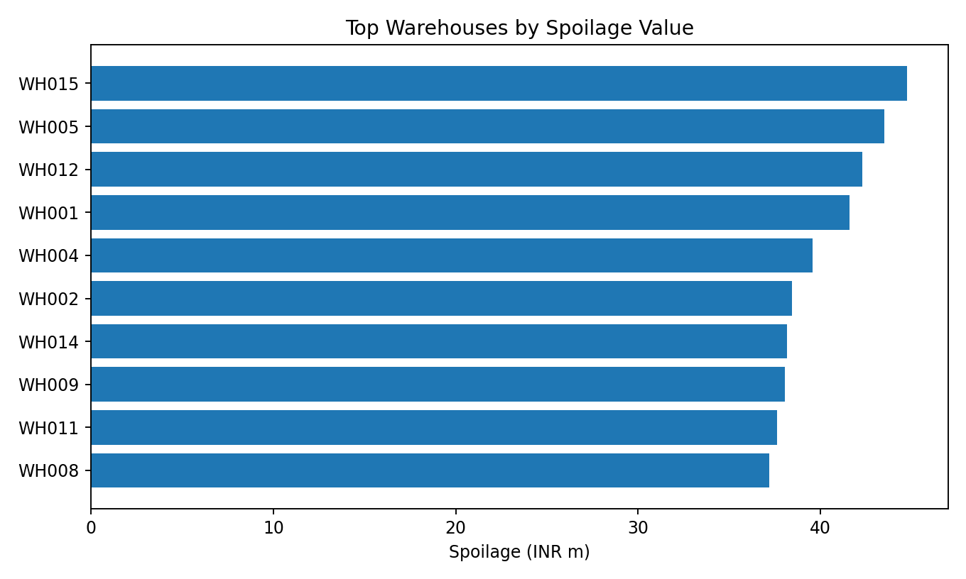
The current residual-stock spoilage value is approximately INR 578.8m. Use warehouse, product, remaining shelf life and temperature history to isolate where FEFO, planning or cold-storage controls have the greatest value.

5. Demand Forecasting & Inventory Policy
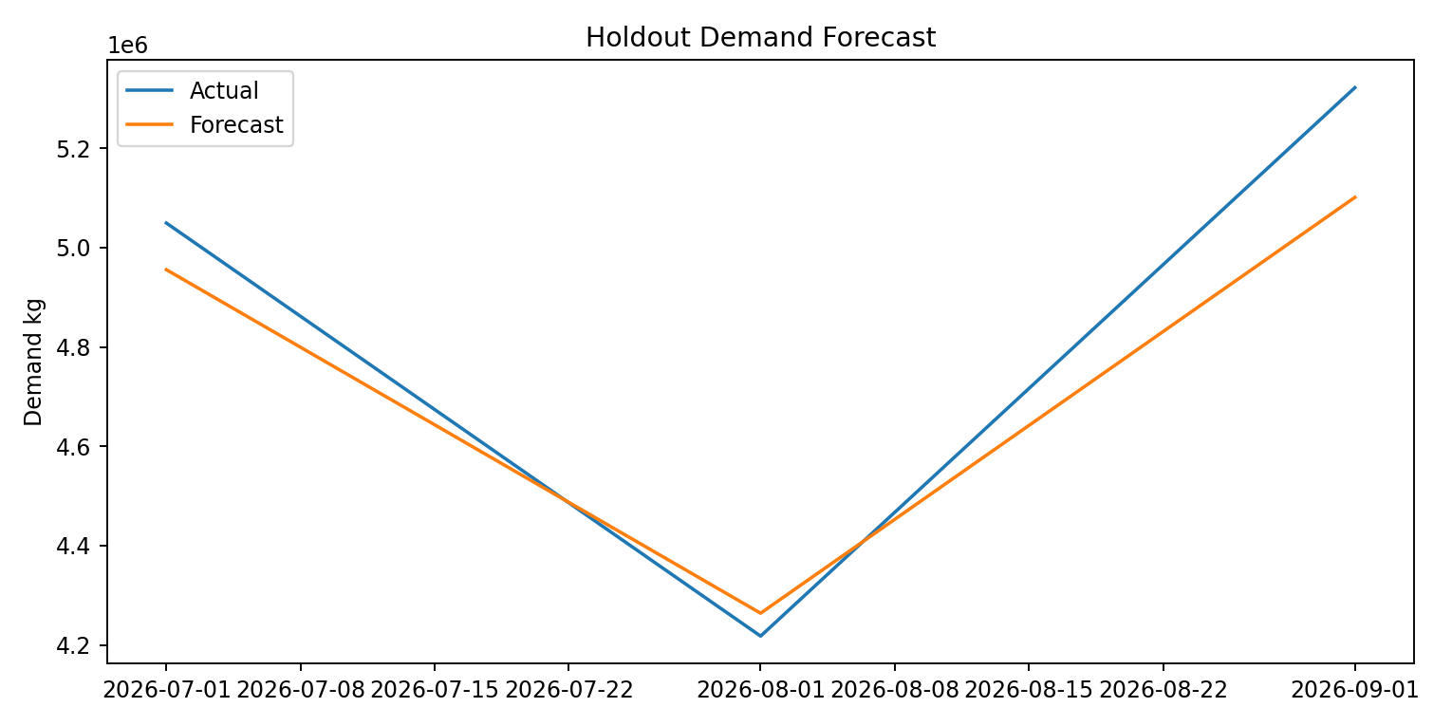
The reference lag-based Random Forest produces a holdout WAPE of 10.4%. Learners should then translate forecast/demand variability and average lead time into product-specific safety stock and reorder points, while considering shelf life for perishable items.

6. Traceability / Recall
Field | Reference
Suspect lot | LOT0005168
Affected orders | 20
Affected customers | 19
Allocated quantity kg | 65,071
Sales exposure INR | 2,909,163
The recall exercise is a key differentiator: the learner must start from one lot, identify its farm and warehouse path, and enumerate every downstream order/customer. In a real food business, this is both an analytics and governance requirement.

7. Financial Opportunity Sizing
Initiative | Addressable Pool | Low | Base | High
Cold-chain excursion reduction | INR 420.9m | 8% | 18% | 30%
Supplier quality improvement | INR 3,052.0m | 6% | 12% | 20%
Fill-rate recovery | INR 440.8m | 10% | 25% | 40%
Inventory expiry reduction | INR 578.8m | 5% | 12% | 22%
The reference base-case capture assumptions imply about INR 621.6m of potential impact. This is a scenario, not a commitment; real investment cost, implementation constraints and causal validation would be required.

8. Reference 90-Day Management Agenda
Priority | Action | Primary KPI
1 | Carrier/lane cold-chain control tower for high-perishability products | Excursion rate; transport loss
2 | Supplier quality improvement / reallocation for high-spend low-score farms | Quality rejection; supplier score
3 | Shelf-life & FEFO exception queue at high-loss warehouses | Spoilage value; critical shelf-life inventory
4 | Product-level S&OP reset using forecast WAPE, lead time and shelf life | Fill rate; safety stock; expiry
5 | Lot-level recall playbook and traceability dashboard | Trace completion time; affected orders identified

9. Grading Guidance
- Reward correct physical-flow reasoning, not just technically valid code.
- Require reconciliation of kilograms and INR before recommendations.
- Look for total-delivered-cost thinking rather than cheapest-source logic.
- Require forecast validation on a holdout period, not in-sample fit.
- Require explicit assumptions in safety stock and opportunity sizing.
- The final answer should be a short management agenda supported by evidence, not a tour of every chart.

