Northstar Cloud
SaaS Subscription Analytics — Instructor Solution Report

1. Executive Baseline
Metric | Reference Result
Latest active ARR | £1,092.6m
Active logos | 4,328
Latest NRR | 97.8%
Latest GRR | 95.6%
Critical / At-Risk active ARR | £47.1m
Annualized excess-discount leakage | £20.90m
Healthy + ≥80% utilization ARR pool | £166.9m
Diagnostic churn-model AUC | 0.634
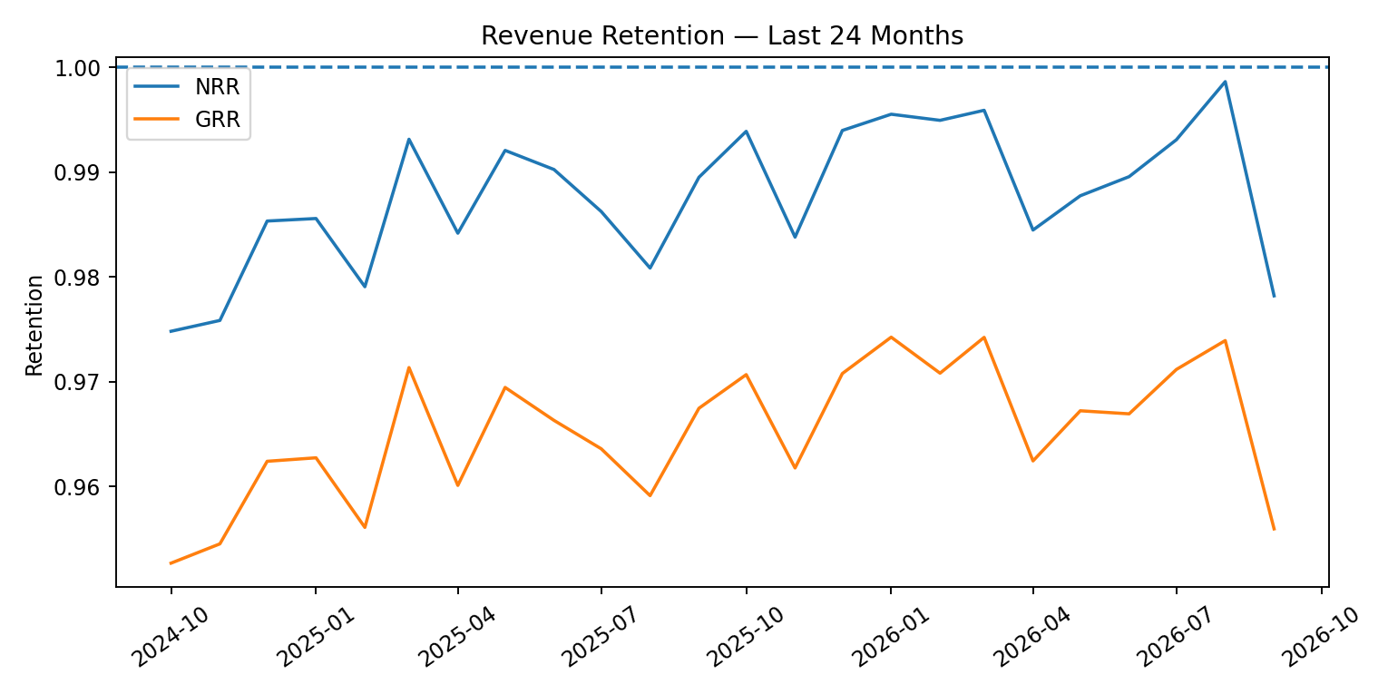

2. Data Quality Solution
The learner raw layer deliberately includes controlled defects. Fix them before constructing recurring-revenue metrics.
Table | Column | Issue | Fix
dim_accounts | industry | Case inconsistency | Normalize with INITCAP/TRIM
dim_accounts | region | Category inconsistency | Map to canonical value
dim_accounts | acquisition_channel | Whitespace | TRIM
dim_accounts | employee_count | Missing values | Impute/flag based on use case
fact_monthly_account_snapshot | seat_utilization | Missing values | Recalculate active_users / seats
fact_monthly_account_snapshot | discount_pct | Scale error | If >1 divide by 100
fact_monthly_account_snapshot | nps_score | Invalid range | Set outside 0–10 to NULL
fact_invoices | invoice_id | Duplicate rows | Deduplicate on invoice_id
fact_invoices | payment_status | Case inconsistency | INITCAP/TRIM
fact_support_tickets | ticket_type | Case inconsistency | Canonical mapping

3. Revenue Retention
Latest NRR is 97.8% while GRR is 95.6%. Expansion offsets part of gross leakage, but the installed base is not fully self-compounding. Retention, contraction and expansion therefore need separate management actions.
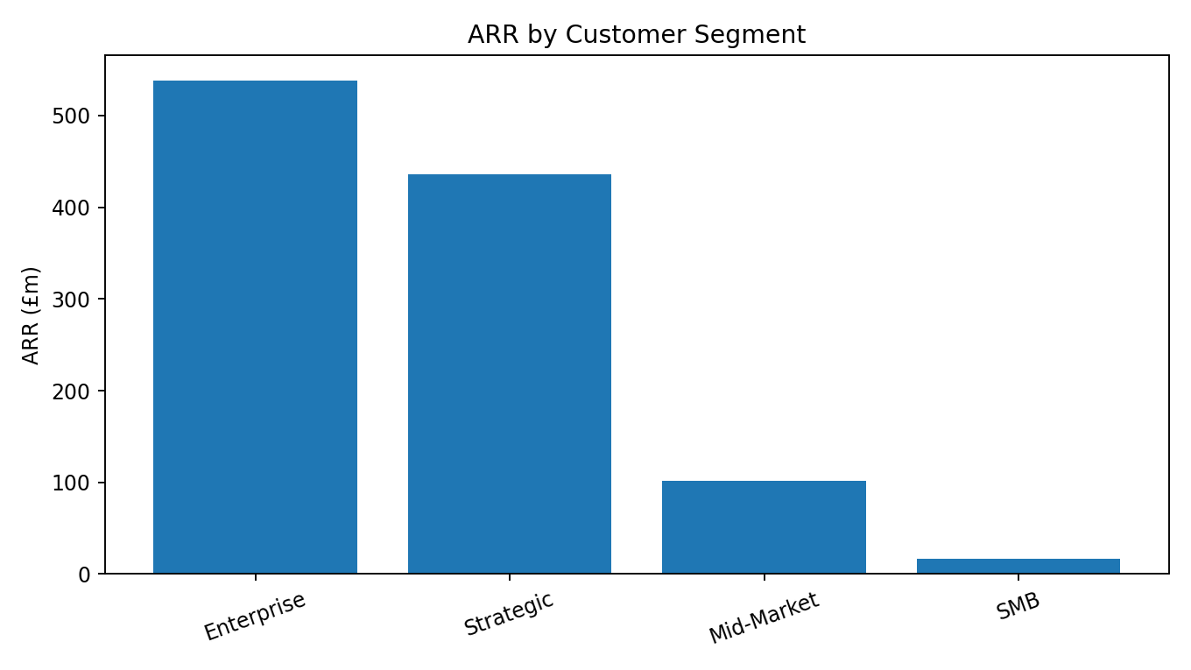

4. Customer Health
Reference health weights: 35% usage, 20% NPS, 18% support, 12% payment behaviour and 15% revenue trend. The score is a prioritization heuristic, not a causal claim.
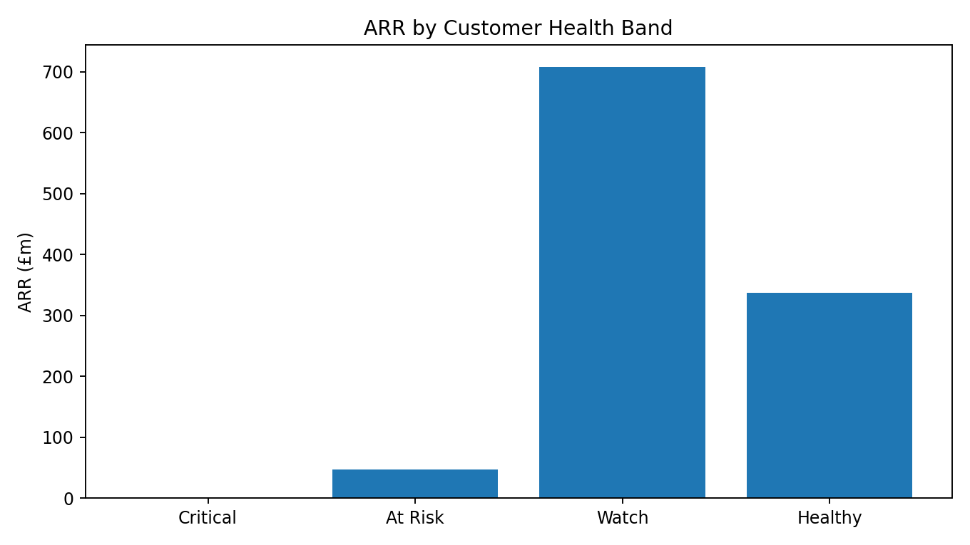
Health Band | Accounts | ARR (£m)
At Risk | 257 | 47.1
Healthy | 1202 | 337.2
Watch | 2869 | 708.2

5. Pricing & Monetization
Excess discounting represents approximately £20.90m annualized leakage. Treat this as an addressable pool and apply a realistic capture rate.
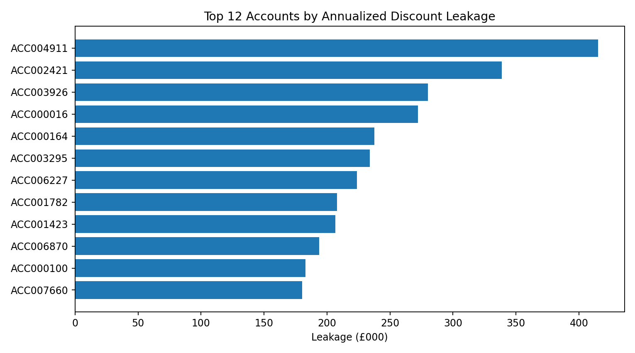

6. Expansion & Renewal Prioritization
- Healthy, ≥80% utilized accounts represent £166.9m of active ARR suitable for targeted expansion analysis.
- The 90-day renewal queue contains 1,558 current active accounts.
- Use account drill-through to validate usage, NPS, critical support events and payments before action.

7. CSM Operating Model
CSM | Accounts | Portfolio ARR £m | Risk ARR £m | Capacity
AM027 | 116 | 32.2 | 5.8 | 194.4%
AM006 | 118 | 29.1 | 4.0 | 97.9%
AM023 | 103 | 27.8 | 2.8 | 106.2%
AM039 | 135 | 33.4 | 2.5 | 185.4%
AM009 | 128 | 41.0 | 2.3 | 163.4%
AM030 | 112 | 23.6 | 2.3 | 123.8%
AM021 | 104 | 26.8 | 2.1 | 184.8%
AM025 | 122 | 37.0 | 2.0 | 112.4%
AM034 | 115 | 19.1 | 1.8 | 56.1%
AM003 | 93 | 22.1 | 1.7 | 66.3%

8. Reference 90-Day Recommendations
Priority | Recommendation | Why | KPI
1 | Retention command center | Protect high-value ARR before renewal | ARR at risk; GRR
2 | Adoption rescue | Low utilization is actionable before churn | Seat utilization
3 | Discount governance | Recover value without acquiring logos | Pricing leakage
4 | Targeted expansion | Healthy/high-use accounts are credible upsell targets | Expansion MRR; NRR
5 | CSM rebalance | Coverage should follow value and risk | Risk ARR per CSM

9. Consulting Interpretation
The solution should end with a small number of quantified actions, not a list of charts. Opportunity pools must be converted to low/base/high impact using explicit capture assumptions.

