1. None of the Services when I click on them work, please review.

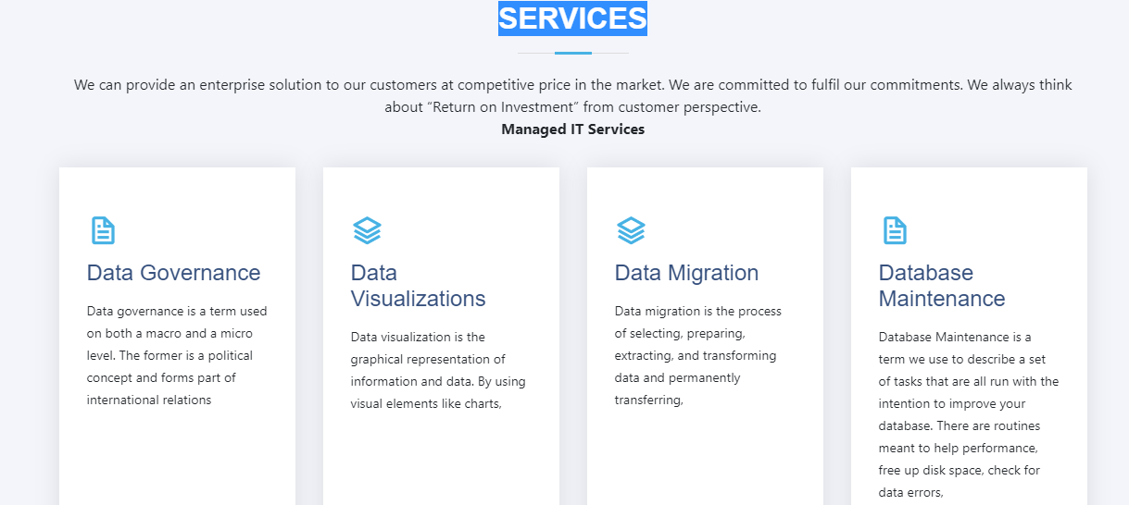

2) Refocus is coming up 2 times on the main website.

Also, we need to remove the Clients coming up on the website main page as shown below.



3) Instead of Client tel we should use the words Client Reviews

4) The below words should be Post a review, also the Post Review button should

    be close to the Post a review.

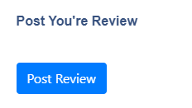

5) In the “About us” description need to replace a) with b)

a)

**OUR STORY**  
Founded in 2019, Saiom SCG Pvt Ltd has come a long way from its beginnings, in city of Diversity 'New York' When we started out, our passion for "providing technical solutions that work for the betterment of everyday life". drove us to start

b)

**OUR STORY**  
Founded in 2019, Saiom SCG Pvt Ltd has come a long way from its beginnings, in city of ‘Diversity’ New York. When we started out, our passion for "providing technical solutions that work for the betterment of everyday life" drove us to start this business.

6) for the mission statement need to replace a) with b)

a)

**OUR MISSION**  
Our mission is to Create a Brighter Tomorrow while bringing Comfort for All by Revolutionizing and creating Affordable software solutions.

b)

**OUR MISSION**  
Our mission is to create a brighter tomorrow while bringing comfort for all by creating affordable software solutions.

7) In the Services section replace a) with b)

a)

**SERVICES**

We can provide an enterprise solution to our customers at competitive price in the market. We are committed to fulfil our commitments. We always think about “Return on Investment” from customer perspective.

b)

**SERVICES**

We can provide an enterprise solution to our customers at a competitive price. We are dedicated to fulfilling our commitments. We always think about “Return on Investment” from customer perspective.