Desktop Planning Assessment Report
Steven Gavagna
67 Williams Street, Watson ACT 2602
Completed on 17th March 2026

Steven,
Thank you for the opportunity to provide a Planning Assessment Report (report) for development on your property at 67 Williams Street, Watson ACT 2602.
The purpose of this report is to provide you with a written assessment on the likelihood of obtaining a development/building approval for a new structure on your property within the ACT.
We will ideally step through this report together at a Planning Assessment meeting, either online (via Zoom/MS Teams), or face to face in our Canberra office or at your property. If you have received this report via email and have questions prior to our meeting, please email or call me.
We note that you may only be investigating the planning parameters regarding an Extension/a Secondary Residence/Dual Occupancy Housing now, however, to provide you with all practical options the report encompasses extensions, Secondary Residences and as appropriate, Dual Occupancy Housing, for your property in the event you change your objectives during the process.
Within this report we have taken into consideration ACT Planning law requirements and provided:
- An overview of residential development in the ACT and the approval requirements that may impacts the design, planning, approval, and construction of your development.
- The conditions that will need to be met to achieve building and development approval for the development on your project. See the Planning Assessment Summary in this document for specific considerations and conclusions for your block.
- Considerations, in the form of frequently asked questions, that will enable you to make informed decisions about development on your property. These are based on our experience with previous projects and customers.
- The next steps on how to engage our services.
This report will form our agenda for the Planning Assessment meeting where we will:
- Discuss the most suitable design for your needs and block
- Step through the considerations provided in this document to ensure a common understanding of decisions made for development on your block
- Outline project timelines and identify value/budget considerations.
Last year we helped over 60 Canberra families with their home extension and/or Secondary Residence projects. This year, we would love to assist you in designing, planning and building of your residential project.
Thank you for taking the time to read this report.

Kind regards

Frank Walmsley – Client Services Manager
0400446605 – clientservices@cgfb.com.au
Table of Contents

Client Overview 4
Development in the Australian Capital Territory (ACT) 6
ACT planning – Approval requirements 6
ACT planning – Residential zones 6
ACT Planning – Development 7
Helpful links 8
Planning assessment summary 9
Planning assessment considerations for your property 9
Planning assessment conclusion 10
Boundary Setbacks Schedule 1 – Front boundary setbacks 11
Boundary Setbacks Schedule 2 – Side and rear boundary setbacks 12
Progressing the development on your property 16
Stage: Formalise your intentions with CGFB 16
Stage: Design process 17
Stage: Planning approval and selection of final inclusions 18
Stage: Building and delivery 18
Frequently asked questions 19
Desktop Planning Report Appendix 22
Table 1 – Assessment Requirements (Mandatory) 22
Table 2 – Assessment Outcomes 24
Table 3 – The scope of plans and documents 26
Planning pathways and potential issues diagrams 27
CGFB Example Plans 39

Client Overview

Client | Steven Gavagna
Client Address | TBC
Project Address | 67 Williams Street, Watson ACT 2602
Property Type | Owner Occupier / Investment Property
Block Number | 1
Section Number | 32
Suburb/Division | Watson
Land Use Zone | RZ1: Suburban
Housing Code | TBC
ACTMapi Link | https://www.actmapi.act.gov.au/
Pricefinder Link | https://app.pricefinder.com.au/v4/app?page=property/PropertyLink&service=external&action=property&propertyid=26179768
Block Size and Approval | 720 m²
When the block was approved | TBC
Block Type | Large block
Plot ratio for block type | 50%
Site Coverage rule for the block | 40%
Site Coverage Maximum | 40%
Easements | Drainage Easement  Position – West [Corner] Boundary  Size – 3.18 meter wide from Boundary
Heritage Status | NA
Protected, registered or regulated trees | Yes
Lease Purpose | NA
Unimproved Value | $847,000 for (2025/2026)
Rates | $4,852 for (2025/2026)
Land Tax | $10,048 for (2025/2026)
Settlement date  Relevant for ICON works form | TBC
Who Created | Sachin 17/03/2026

Development in the Australian Capital Territory (ACT)

ACT planning – Approval requirements
All development in the ACT is governed by the ACT Planning Act 2023, the Territory Plan (2023) and associated documents. Extensions, Secondary Residence and Dual Occupancy Housing require building approval and, depending on size and complexity, developments may also require development approval.

Building Approval (BA)
- BA ensures your project is built safely and follows the laws and codes.
- In some cases, you might be exempt and not need building approval, see Building (General) Regulation 2008 Part 2 Section 6 Exempt buildings and building work generally for more detail.
- BA is an assessment and clearance of the design completed by a private building certifier.

Development Approval (DA)
- A development outcomes report (DO report) is a formal application submitted to the Territory Planning Authority for permission to build a new structure in your area.
- The DA process considers the assessment requirements and the assessment outcomes in the Territory Plan (2023) as they relate to your area and your property.
- Residential Zone Policy – Assessment requirements are mandatory development controls specific to development types and must be addressed in the DO report – there are 22 requirements, documented in the Territory Plan (2023) Part E Zone Policies E1 – Residential Zones Policy.
- Residential Zone Policy – Assessment outcomes must be addressed in the DO report – there are 27 outcomes, documented in detail in the Planning (Residential Zones) technical Specifications 2023 (No 2). The DO report must demonstrate consistency with the assessment outcomes.
- Extensions can sometimes be exempt from DA.
- All secondary residences and dual occupancy housing require a DA.
- The Territory Planning Authority is responsible for deciding applications for approval to undertake development – Part 3.2 Section 18 (k) ACT Planning Act 2023

ACT planning – Residential zones
The Territory Plan (2023) Part E Zone Policies E1 – Residential Zones Policy identifies permissible land uses and development types in residential zones RZ1 – RZ5. This document is primarily focused on extensions, secondary residences, and dual occupancy housing in the following zones:
- RZ1 – Suburban Zone – achieve and/or maintain low density residential neighborhoods in suburban areas.
- RZ2 – Suburban Core Zone – facilitate development or redevelopment of sites within reasonable proximity to local services to achieve a mix of low to medium density housing.

ACT Planning – Development
All development in the ACT:
- Must meet a set of mandatory assessment requirements related to both residential zones and site coverage. See appendix Table 1 Assessment Requirements for detail or refer to Territory Plan (2023) Part E Zone Policies E1 – Residential Zones Policy.
- Site coverage means the proportion of actual site covered by buildings, including balconies, basements, and any roofed structures such as terraces, pergolas, patios, and decks but excluding any part of awnings, eaves, and the like.
- Needs to demonstrate compliance with multiple assessment outcomes. See appendix Table 2 for a summary of the assessment outcomes, see Planning (Residential Zones) Technical Specifications 2023 (No 2) for further detail.

Extensions
Extensions are a residential redevelopment (RZ1 & RZ2) involving substantial alterations to an existing dwelling that would result in a significant change to the scale and/or character of the dwelling and:
- Must meet assessment requirements 1, 15, 16, 17, 19 – see appendix Table 1 Assessment Requirements.
- Site coverage for single dwellings including proposed extension:
Block size | Block area
Large | 40%
Mid-size | 60%
Compact | 70%

Secondary residences
Secondary residences are a second dwelling on a block which is subordinate to the principal dwelling on the block and:
- Must meet assessment requirements 1, 10, 11, 12, 13, 17, 19 – see appendix Table 1 Assessment Requirements.
- The minimum block size for a secondary residence is 500m².
- The maximum dwelling size of a secondary residence is 90m². Dwelling size is the gross floor area measured to the outside face of external walls (including internal walls between the living areas and the garage) but excludes class 10 (ie: garage).
- Site coverage for single dwelling including secondary residence:
Block size | Block area
Large | 40%
Mid-size | 60%
Compact | 70%

Dual occupancy housing
Dual occupancy housing, also referred to as multi-unit housing, allows a compliant block to be rezoned and treated as two separate blocks with separate titles and:
- Must meet assessment requirements 1, 2, 4, 5, 7, 9, 10, 11, 12, 13, 17, 19 – see appendix Table 1 Assessment Requirements.
- Dual occupancy housing (multi-unit housing) in RZ1:
  - Site coverage is a maximum of 45% of the block area
  - Minimum block area for more than one dwelling: 800m²
- Dual occupancy housing in RZ2:
  - Site coverage is a maximum of 45% of the block area
  - Minimum block area for more than one dwelling: 700m²

Helpful links

ACT Government
The following are links to all relevant ACT Government resources used to develop this document:
- ACT Planning website
- Planning Act 2023
- The Territory Plan
- Part A – Administration and Governance
- Part B – Territory Plan Maps
- Part C – Planning and Principles and Strategic Links
- Part D – District Policies
- Part E – Zone Policies
- Part G – Dictionary
- District Specifications
- Zone Specifications: Z1 Planning (Residential Zones) Technical Specifications 2023 (No 2)
- Building Act 2004
- Nature Conservation Act 2014
- Urban Forest Act 2023
- Heritage Act 2004

Canberra Granny Flat Builders & Fixed Price Extensions
Our primary websites cgfb.com.au and fixedpriceextensions.com.au include several links you may find helpful:
- Design gallery for Secondary Residences: Link
- Design gallery for Fixed Price Extensions: Link
- Project Walkthrough videos Secondary Residences: Link
- Project Walkthrough videos Fixed Price Extensions: Link
- Project Walkthrough videos Custom Designs: Link
- Customer testimonials: Link
- The Process: Link
- Frequently Asked Questions: Link
- Our inclusions guide: Link
- Link to google reviews: Link
On a quarterly basis we do hold display homes and we would encourage you to attend one of these.

Planning assessment summary
On a yearly basis we assist 100s of families and clients across Canberra to manage their designs and planning approvals.
As you can see from the information provided previously, the ACT has a complex planning process. CGFB services include accountability for the end-to-end management and delivery of all stages of your development including initial design, inclusions, approvals, and build. We employ specialist teams dedicated to ensuring your design obtains all required planning approvals to commence, and complete, your build as efficiently as possible.

Planning assessment considerations for your property
Property address: 67 Williams Street, Watson ACT 2602
Site and land use
Residential zone | RZ1
Block type | Large
Site coverage | Current:
Heritage status | No
Public space and amenity
Private open space | Table 2 – Assessment Outcomes
Build form and building design
Building envelope
Easements | Drainage Easement  Position – West [Corner] Boundary  Size – 3.18 meter wide from Boundary
Boundary setbacks | Boundary Setbacks Schedule 1 – Front boundary setbacks
Solar building envelope & solar access | Table 2 – Assessment Outcomes
Building separation | Table 2 – Assessment Outcomes
Fences and walls | Table 2 – Assessment Outcomes
Sustainability and environment
Protected, registered, or regulated trees | Yes. See appendix for diagram detail.
Parking, services, and utilities
Electric vehicle parking & charging | Table 2 – Assessment Outcomes
Car parking | Table 2 – Assessment Outcomes

Planning assessment conclusion
Based on the current information available to us it is our conclusion that you could proceed with the following:
Property Type | Does your block meet the Property Type? | % probability of building a compliant property | Possible Approvals required to build your project
Extension | Yes/No | 99% | - Building approval ☐  - Development approval ☐
Secondary residence | Yes/No | 90% | - Building approval ☐  - Development approval ☐
Dual occupancy housing | Yes/No | Please refer to your UTPAR Report | - Building approval ☐  - Development approval ☐
Please note we only undertake a development application if we believed it has a greater than 90% likelihood of approval.

Boundary Setbacks Schedule 1 – Front boundary setbacks

Planning (Residential Zones) Technical Specifications 2023 (No 2)

Table 1: Single dwelling front boundary setbacks – blocks in subdivisions approved originally before 18 October 1993
 | Block size | front boundary setback | exceptions
 |  |  | front boundary setback to secondary street frontage | front boundary setback to public open space or pedestrian paths wider than 6m at the widest point | front boundary setbacks to public open space or pedestrian paths of 6m or less at the widest point
lower floor level | Large | 6m | 4m | 4m | 1.5m
 | Mid-sized |  | 3m
 | Compact
upper floor level | Large | 6m | 6m | 4m | 1.5m
 | Mid-sized |  | 3m
 | Compact
garage or carport |  | 6m | 5.5m | 4m | 0m

Table 2: Single dwelling front boundary setbacks –blocks in subdivisions approved on or after 18 October 1993 but before 31 March 2008
 | Block size | front boundary setback | exceptions
 |  |  | front boundary setback to secondary street frontage | front boundary setback to public open space or pedestrian paths wider than 6m at the widest point | front boundary setbacks to rear lane, public open space or pedestrian paths of 6m or less at the widest point
lower floor level | Large | 4m | 4m | 4m | 1.5m
 | Mid-sized |  | 3m
 | Compact
upper floor level | Large | 6m | 6m | 4m | 1.5m
 | Mid-sized |  | 3m
 | Compact
garage or carport |  | 5.5m with a minimum of 1.5 m behind the front building line | 5.5m | 4m | 0m

Table 3: Single dwelling front boundary setbacks – blocks in subdivisions approved on or after 31 March 2008
 | Block size | front boundary setback | exceptions
 |  |  | front boundary setback to secondary street frontage | front boundary setback to public open space or pedestrian paths wider than 6m at the widest point | front boundary setbacks to rear lane, public open space or pedestrian paths of 6m or less at the widest point
lower floor level | Large | 4m | 3m | 4m | 0m
 | Mid-sized | 4m* |  | 3m
 | Compact | 3m
upper floor level | Large | 6m | 3m | 4m | 0m
 | Mid-sized | 4m |  | 3m
 | Compact | 3m
garage or carport |  | 5.5m with a minimum of 1.5m behind the front building line except where there is a courtyard wall in the front zone |  | 4m | 0m
*Articulation elements can extend up to 1m into the front setback. Elements can include verandahs, porches, awnings, shade devices, pergolas and the like (a carport is not considered an articulation element)

Boundary Setbacks Schedule 2 – Side and rear boundary setbacks

Planning (Residential Zones) Technical Specifications 2023 (N0 2)

Table 5: Single dwelling side and rear setbacks – large blocks
 | minimum side boundary setback  within the primary building zone | minimum side boundary setback within the rear zone | minimum rear boundary setback
 | side boundary | side boundary
lower floor level – external wall | 1.5m | 1.5m | 3m
upper floor level – external wall | 3m | 6m | 6m
upper floor level – unscreened element | 6m | 6m | 6m
garage or carport | 0m* | 0m* | 3m
* A 0m setback is only permitted on one boundary

Table 6: Single dwelling side and rear setbacks – mid sized blocks in subdivisions approved before
2 October 2009
 | minimum side boundary setback  within the primary building zone |  | minimum side boundary setback within the rear zone |  | minimum rear boundary setback
 | side boundary 1 | side boundary 2 | side boundary 1 | side boundary 2
lower floor level | 3m | >15m frontage 1.5m  <15m frontage  0m | 3m | 1.5m | 3m
upper floor level – external wall | 3m | 3m | 6m | 6m | 6m
upper floor level – unscreened element | 6m | 6m | 6m | 6m | 6m
garage or carport | 3m | 0m | 3m | 0m | 3m

Table 7: Single dwelling side and rear setbacks – mid sized blocks in subdivisions approved on or after 2 October 2009
 | minimum side boundary setback  within the primary building zone |  | minimum side boundary setback within the rear zone |  | minimum rear boundary setback
 | side boundary 1 | side boundary 2 | side boundary 1 | side boundary 2
lower floor level | 1.5m | 0m | 3m | 0.9m | 3m  0m*
upper floor level – external wall | 3m | 1.5m  0m* | 6m | 6m | 6m  0m*
upper floor level – unscreened element | 6m | 6m | 6m | 6m | 6m
* only where specifically permitted under a district policy/specification.

Table 8: Single dwelling side and rear setbacks – compact blocks
 | minimum side boundary setback |  |  | Minimum rear boundary setback
 | side boundary 1 or longer side boundary of a corner block | side boundary 2 | shorter side boundary of a corner block
lower floor level – external wall | 0m | 0m | 3m | 3m  0m*
lower floor level – unscreened element | 1.5m | 1.5m | 3m | 3m
upper floor level – external wall | 0m** | 0m** | 3m | 4m  0m*
upper floor level – unscreened element | 1.5m | 1.5m | 3m | 4m
garage or carport | 0m | 0m | 0m | 3m  0m*
* only where specifically permitted under a district policy/specification.
** only where the lower floor level is built to the boundary

Table 9: Multi-unit housing side and rear setbacks – RZ1 and RZ2
RZ1 and RZ2 - Side and Rear Boundary Setbacks
 | Minimum side boundary setback within the primary building zone | Minimum side boundary setback within  the rear zone | Minimum rear boundary setback
Lower floor level – external wall, unscreened element and basement | 3m | 3m | 3m
Upper floor level – external wall | 3m | 6m | 6m
Upper floor level – unscreened element | 6m | 6m | 6m

Table 10: Multi-unit housing side and rear setbacks – RZ3, RZ4 and RZ5
RZ3, RZ4, RZ5 - Side and Rear Boundary Setbacks
 | Minimum side boundary setback  within the primary building zone | Minimum side boundary setback within  the rear zone | Minimum rear boundary setback
lower floor level – external wall | 0m^ | 3m | 3m
lower floor level – unscreened element | 1m | 3m | 3m
first upper floor level – external wall | 0m^ | 3m | 6m
first upper floor level – unscreened element | 6m | 6m | 6m
second upper floor level – external wall | 0m^ | 6m | 6m
second upper floor level – unscreened element | 6m | 6m | 6m
^ does not apply to that part of a wall with a window of any sort

Table 11: Multi-unit housing side and rear setbacks – RZ5 – buildings over 4 storeys
Side and Rear Boundary Setbacks - buildings with 4 or more storeys
parts of buildings | minimum side boundary setback | minimum rear boundary setback
first 4 storeys - external wall | 3m | 3m
first 4 storeys - unscreened element | 6m | 6m
between 5 and 8 storeys - external wall | 4.5m | 4.5m
between 5 and 8 storeys - unscreened element | 6m | 6m
9 storeys or more - external wall or unscreened element | 6m | 6m

Progressing the development on your property

Stage: Formalise your intentions with CGFB
Now that we have provided the potential for your block, we need you to confirm what type of project you require, including detailed plans so we can confirm your likelihood of approval. As the customer we need you to:
Decide which type of development – extension, secondary residence, dual occupancy housing – you wish to proceed with.
We have developed a standard flat rate design agreement which includes working exclusively with our Designs team to customise your unique floorplan and exteriors. At a flat rate of $3,500, all you need to do is bring your ideas to us and we will provide you with layouts for you to consider for whichever project best suites your requirements, including Extensions (with or without Renovations), Secondary Residences and/or Dual Occupancy.
Using the CGFB Design Agreement, which we will provide to you, please sign Form 1 to enter into a CGFB design agreement with us.

Next Steps:
- Complete the following forms located at the back of the CGFB Design Agreement
Form | Purpose of the form  Steps to complete the prefilled forms | Check  list
Form 1: Customer Design Authority – Terms and Conditions Form | This Form confirms that you will engage CGFB to work with you to progress with a full set of drawings and project plans – valued at $3,500.
Form 2: Building File Search Authority Form | This form authorises CGFB to access your registered Building File which identifies approved structures, existing structure plans and any pre-existing approvals which will assist with your project.  Please note this form must be hand signed by the Title holder/s. The title holder/s is/are those persons who names are registered on the title papers as per the official record at the ACT Land Titles Register.  - Sign and date the form.
Form 3: Contours Survey and Street Sign Agreement | Detailed Contours Survey: The ACT Government mandates a contours survey of your property be undertaken with a registered surveyor to be able to lodge a building or development application in the ACT. You can choose to have the survey organised by CGFB or you can provide your own survey.  - CGFB organises your survey – there is a minimum fee of $1100 to cover the cost of a professional site survey. These fees are dependent on block size and complexity and can vary between $1100 – $2400. This cost is additional to the design agreement cost.  - Provide your own survey – the survey must be dated within the last 12 months, and CGFB will require both the PDF and DWG files from your surveyor. If the survey is older than 12 months or you are unable to provide the DWG files you will require a new survey.  CGFB Street Sign: Allow us to place our Street Sign on your property during the Designs Phase and save $750. Our CGFB streets signs are installed at the front of your property by a qualified person and regularly checked to ensure they have not been damaged. Damaged signs are replaced within 24hrs.  - Decide how you want to progress with the contours survey.  - Decide if you want a CGFB street sign installed during the design phase and we will waive the $750 fee.  - Complete the form.
Form 4: Icon Minor Works Form | To accelerate the planning approval process, we will submit your designs to the utility company – via icon water. Icon will then send you a letter with their finding.  - Sign and date the form.
- Return the forms to CGFB. If you are unable to return the forms to us yourself, we are happy to arrange for a courier to pick the forms up from you. Please call our office on 1300 979 658.

Stage: Design process
Once CGFB have received the signed forms we will complete ours, and ACT government’s paperwork, and arrange to meet with you, on-site in approx. 14 working days.
From there we will arrange to meet on a regular basis with you to progress your design until all parties agree the design is complete. During this process you will meet and work with our in-house Customer Designers to create your design, ensuring we consider all your stated objectives and any planning considerations identified.
For a complete list of information we will provide to you at the end of the design stage see appendix Table 3 The scope of plans and documents.
Once you have reviewed the documents provided you will be asked to sign off on the floorplans. This will enable CGFB to calculate and present you with a fixed price proposal for the project you have designed with us.
CGFB will provide you with 2 documents:
- CGFB Project Proposal: A comprehensive set of plans, inclusions, total price, milestones, timelines, third party expenses, introduction to CGFB team, CGFB key guarantees.
- CGFB Site Scope Works:
We call this the turnkey price, and it means there are no hidden fees and charges. The average duration of the design process is from 12 weeks up to 16 – 20 weeks.

Stage: Planning approval and selection of final inclusions
Once you agree with the Project and Site Scope Proposals, you will be asked to sign a HIA Agreement. The HIA Agreement will outline your project payment schedule and requires a deposit from you to initiate a project kick-off meeting with our entire team. CGFB will progress both the building approval and/or development application for the project, as well as assign you a Inclusions coordinator to help you finalise all your interior fittings, materials and exterior colours.
The duration of the development approval process is generally 14 to 26 weeks based on the complexity of the development application. Please note the ACT government does not always meet its legal timeframes for development applications and this can impact CGFB’s ability to progress your project within our initially agreed timeframes.
In the event the development application is unsuccessful because of law changes or departmental decision-making, only the investment of the planning process will apply as per the fixed price agreement. This has never occurred thankfully as of November 2022.
Whilst CGFB manages the planning approvals our inclusions team will work simultaneously with you to finalise the selection of your inclusions.

Stage: Building and delivery
As soon as the development application has been approved, we will commence the construction of your project.
The duration to build and deliver the project is an average of 18-22 weeks. The average duration is 20 weeks for a Secondary Residence and 18 weeks for an extension.

Frequently asked questions
All types of build: Extension, Secondary Residence and Dual Occupancy Housing
- Does Canberra Granny Flat Builders manage the process to completion?
Yes. We manage every aspect of the build until it’s ready to be occupied. Our turnkey guarantee means that we take full ownership and accountability from start to finish.
- Do I get to choose the inclusions for my development??
Yes, if you wish to. We also offer a concierge service, for a fee, where one of our team will meet you at the retail supplier, record your choices and provide to our construction team.
Secondary Residence
- What is a Secondary Residence?
Commonly known as a Secondary Residence or extension, a secondary residency in the ACT is a self-contained residential structure built on a block of land which is in addition to an existing residence.
The legislation provides that a Secondary Residence can be rented separately to an existing residence. This means that separate electrical, water and gas metering can be achieved on the majority of Secondary Residences.
- What size can a Secondary Residence be?
A Secondary Residence should have a minimum size of 40m² floor area up to a maximum of 90m² floor area.
In addition to your Secondary Residence or extension., you can build additional structures such as garages, carports, alfresco areas and pergolas. These additional structures do not count towards the total gross floor area of the Secondary Residence; however, considerations may need to be taken account as it relates the total plot ratio allowable on your block.
- What is the minimum block size you can build a Secondary Residence on?
A Secondary Residence can be considered on a minimum block size of 500m².
- Do you require development approval to build a Secondary Residence?
Yes. A development approval application must be submitted to gain approval to build a Secondary Residence.
- Development approvals are submitted to and assessed by the Territory Planning Authority Once development approval is granted, do we also need to obtain building approval?
Yes. Once we have secured development approval, we will need to complete building approval through a private building certifier.
- What does adaptable housing mean and how does it relate to our Secondary Residence?
Secondary Residences are to be designed to be easily adaptable to meet the needs of people with a disability. This means that the dwelling should be designed to easily meet the Australian Standard AS 4299 (Adaptable Housing).
- What building classification will the Secondary Residence need to be?
Secondary Residences are classified as a Class 1a building. This is clearly defined in the Building Code of Australia. Structures like decks, garages, carports, stairs or ramps are classed as 10a buildings.
- How many bedrooms can a Secondary Residence have?
Canberra Granny Flat Builders generally build Secondary Residences which have one to three bedrooms, with one to two bathrooms, a number of living spaces and a kitchen and laundry.
- Will a Secondary Residence in my backyard increase my rates or land tax?
Secondary Residence and rates: Rates are not increased as per legislation in-force at this time.
Secondary Residence and land tax: Land tax applies to ACT properties that are not your principal place of residence. This includes both rented properties and those which are vacant, properties owned as a trustee, and rented dwellings on the same property as your home (such as a granny flat) refer: Revenue.act.gov.au/land-tax/overview.
- Can a Secondary Residence be rented?
Yes, if all the correct planning approvals are obtained. You will need these approvals for insurance purposes.
- How much will a Secondary Residence cost me?
It depends on the design and function (number of bedrooms, bathrooms etc.).
- Can I customise the layout and floorplans to a Secondary Residence?
Yes, you can. Whilst we have several floorplans to choose from, these can be used as guides to provide you with a starting point. You can then choose to change the windows, doors, or kitchen locations, sizes and ceiling height. However, be aware that changes may introduce additional investment.
- Are the Secondary Residences built on-site or are they prefabricated in a factory?
We build the Secondary Residences on-site with locally based and licensed tradesmen and ensure compliance with the applicable ACT laws.
Dual Occupancy Housing
- What is Dual Occupancy housing?
Dual occupancy housing allows a compliant block to be rezoned and treated as two separate blocks with separate titles.
- What are the rules for dual occupancy housing in RZ1?
The block must be at least 800m² and one dwelling must be no more than 120m2 in floor area (excluding the area of the garage). The maximum site coverage for the block area is 45%.
- What are the rules for dual occupancy housing in RZ2?
The block must be at least 700m². The maximum site coverage for the block area is 45%.
- How do I put a dual occupancy development on my property?
You need to engage a suitably qualified professional to assist in preparing a design response and development application that can then be lodged with the Territory Planning Authority. A dual occupancy development does not meet the requirements for exempt development under the Planning Act 2023.
- What is unit titling?
Unit titling is property ownership where a unit titled dwelling can be sold separately to other dwellings. A unit title permits multiple dwellings with different owners on the same block.
- How do I unit title my block?
Check your Crown lease. If the Crown lease does not specify the number of units permitted on the land you will need to submit a development application to vary the Crown lease. This can be done at the same time as development approval for the design and siting of the dual occupancy.
Extensions
- What is an extension?
An extension refers to a new structure which is attached via a link/connector or integrated with the primary residence.
- What is a detached extension
A detached extension is a permanent structure separated from the primary residence. It is ideally designed to give growing families more room and can include a bathroom, toilet, living space.
Legally the initial build does not include a kitchen or laundry as to do so could change the extension to a secondary dwelling. However, once we have received the certificate of occupancy the installation of a kitchen or laundry can be installed as an internal renovation.

Desktop Planning Report Appendix

Table 1 – Assessment Requirements (Mandatory)

(Territory Plan Part E Zone Policies E1 – Residential Zones Policy)
Control | Assessment requirement | Extension | Secondary residence | Dual Occupancy
Site coverage – single dwellings | 1. Site coverage for single dwellings (including a secondary residence) is a maximum of:
 | a) For large blocks: 40% of the block area | X | X
 | b) For mid-sized blocks: 60% of the block area | X | X
 | c) For compact blocks: 70% of the block area | X | X
Site coverage – multi-unit housing – RZ1 and RZ2 | 2. Site coverage for multi-unit housing in RZ1 and RZ2 is a maximum of 45% of the block area. |  |  | X
Site coverage – multi-unit housing – RZ3, RZ4 and RZ5 | 3. Site coverage for multi-unit housing in RZ3, RZ4 and RZ5 is a maximum of 50% of the block area.
Housing density and minimum block areas (excluding secondary residence developments) | 4. Multi-unit housing – for blocks in RZ1:  a) Minimum block area for more than one dwelling: 800m²  b) Maximum number of dwellings per standard block: 2. |  |  | X
 | 5. Multi-unit housing – for surrendered residential blocks in RZ1:  a) Minimum block area for more than one dwelling: 700m²  b) Maximum number of dwellings per block: 2. |  |  | X
 | 6. Supportive housing and community housing in RZ1:  a) Minimum block area for more than one dwelling: 600m²  b) Maximum number of dwellings per block: 1 additional dwelling for every 250m² (or part thereof) over the minimum. |  |  | X
 | 7. Multi-unit housing – for blocks in RZ2:  a) Minimum block area for more than one dwelling: 700m²  b) Maximum number of dwellings per block: 1 additional dwelling for every 250m² (or part thereof) over the minimum. |  |  | X
8. Multi-unit adaptable housing in RZ2:
a) Minimum block area for more than one dwelling: 600m²
b) Maximum number of dwellings per block: 1 additional for every 250m² (or part thereof) over the minimum and all dwelling are built to be adaptable.
 | 9. Irrespective of above requirements, for RZ2 blocks with a street frontage less than 20m wide (measured at the property boundary), the maximum number of dwellings per block is 3. |  |  | X
Secondary residences | 10. A secondary residence is developed only in association with single dwelling housing. |  | X
 | 11. The maximum dwelling size* of a secondary residence is 90m². *For the purpose of this requirement, dwelling size is the floor area measured to the outside face of external walls (including internal walls between the living areas and garage) but excludes the garage. |  | X
 | 12. The minimum block size for a secondary residence is 500m². |  | X
 | 13. Maximum of one secondary dwelling per block. |  | X
Co-housing | 14. The minimum block size for a co-housing development is 1,050m².
Home business | 15. At least 1 worker who genuinely lives on the lease is employed at any one time by the home business operating from the lease. | X | X | X
 | 16. A home business does not, or is unlikely to, cause pollution, create a health hazard or present danger which is prohibited under any relevant Territory legislation and/or Code of Practice (as may vary from time to time). | X | X | X
Number of storeys – RZ1 and RZ2 | 17. RZ1: Maximum 2 storeys.  19. RZ2: Maximum 2 storeys. | X | X | X
Height of buildings – RZ3, RZ4 and RZ5 | 20. Maximum height of building is: a) RZ3 – 9.5m b) RZ4 – 12.5m c) RZ5 – 21.5m
Apartments | 21. No new apartments are permitted in RZ1.
Re-development | 22. Where a lawfully constructed building already exceeds the maximum set by an assessment requirement (such as site coverage, building height or number of storeys), a new building may be permitted to the same maximum as the existing building provided there are no additional adverse impacts on adjoining properties including, but not limited to, solar access. |  |  | X
* Greyed out rows are not applicable to extensions, secondary residences, and dual occupancy housing.

Table 2 – Assessment Outcomes

(Planning (Residential Zones) Technical Specifications 2023 (No 2))
Assessment outcome | Assessment outcome summary | Extension | Secondary residence | Dual Occupancy
Urban Structure and Natural Systems | - Biodiversity connectivity is maintained across the landscape. | X | X | X
 | - Loss of native habitat and biodiversity is avoided and/or minimised. | X | X | X
 | - The health and functionality of waterways and catchments is maintained, including through application of water sensitive urban design principles. | X | X | X
Site and Land Use | - The functionality and usability of the development is appropriate for its intended purpose/use. | X | X | X
 | - The proposed use and scale of development are appropriate to the site and zone. | X | X | X
 | - Adverse impacts of development on surrounding uses (both within a site and on adjoining sites) is minimised and residential amenity protected. This includes between residential uses and between non-residential and residential uses. | X | X | X
Access and Movement | - The functionality and layout of the development is accessible and adaptable, while achieving good connections with the surrounding area. This includes consideration of passive surveillance. | X | X | X
 | - The development encourages active travel through safe and convenient access to the active travel network. | X | X | X
Public Space and Amenity | - The development achieves reasonable solar access and microclimate conditions to public areas and streets to support their use by the community. | X | X | X
 | - Private open space and communal open space provides sufficient space and facilities for residents and visitors to recreate and relax, as well as providing area for service functions. Spaces are readily accessible for a range of activities. | X | X | X
 | - Reasonable levels of active ground floor interface and passive surveillance to public spaces and streets is achieved. | X | X | X
 | - Any advertising or signs are suitable for their context and do not have a detrimental impact on the surrounding area (for instance due to size or light emission). | X | X | X
Build Form and Building Design | - The height, bulk and scale of the development is appropriate, noting the desired zone policy outcomes and the streetscape. This includes consideration of building envelope and setbacks. | X | X | X
 | - Reasonable solar access to dwellings and private open space within a block and on adjoining residential blocks is achieved. This includes solar access into main living spaces within a dwelling. | X | X | X
 | - Reasonable levels of privacy to dwellings and private open space within a block and on adjoining residential blocks is achieved. | X | X | X
 | - The dwelling mix and the internal size, scale and layout of dwellings in multi-unit housing provide for a comfortable living environment that meets the changing needs of residents. |  |  | X
 | - Courtyard walls and fences do not have an adverse impact on the streetscape. |  | X | X
Sustainability and Environment | - Sufficient planting area and canopy trees are provided, and roofed areas and hard surfaces limited, to reduce urban heat island effects, minimise stormwater run-off and maintain ecosystem services. This includes consideration of water sensitive urban design measures. | X | X | X
 | - Deep soil zones are provided on site to support healthy tree growth and provide adequate room for canopy trees. | X | X | X
 | - Threats to biodiversity such as noise, light pollution, invasive species incursion or establishment, chemical pollution, or site disturbance are avoided or minimised through good design. | X | X | X
 | - Minimise cut and fill to protect natural hydrological function and limit soil erosion and site disturbance. | X | X | X
 | - The development considers, addresses, and mitigates site constraints and environmental risks, including natural features, topography, noise, bushfire, flooding, contamination, air quality or hazardous materials are appropriately considered for the site. | X | X | X
Parking, Services and Utilities | - The development provides electric vehicle parking and access to charging locations in multi-unit housing. |  |  | X
 | - The development provides appropriate end-of-trip facilities in multi-unit housing which includes secure bicycle parking. | NA | NA | NA
 | - Vehicle and bicycle parking, access and egress sufficiently caters for the development while permitting safe and legible movement for all users (including pedestrians) and minimising visual impacts from the street or public space. This includes consideration of parking dimensions, the number of spaces provided, vehicle maneuverability and access routes. | X | X | X
 | - Waste is appropriately managed on site without having a detrimental impact on residents and the surrounding area. | X | X | X
 | - The site is appropriately serviced in terms of infrastructure and utility services and any associated amenity impacts are minimised. | X | X | X

Table 3 – The scope of plans and documents
Document/Process | Custom Design
Site Scope Report | Yes
Project Proposal | Yes
Demolition Plan (PDF) | Yes
Site Map (PDF) | Yes
Existing site aerial plan | Yes
Dimensional Floor Plan (PDF) | Yes
Furniture Floor Plan (PDF) | Yes
Elevations Plans (North, South, East, West) (PDF) | Yes
Access and Mobility Plan (Secondary Residence) | Yes
Services Plan | Yes
Erosion and Sediment Control Plan | Yes
Area Plan (PDF) | Yes
Living infrastructure plan | Yes
Building zone plan | Yes
Public Register Floor Plan (PDF) | Yes
Solar and building envelope plan | Yes
Shadow diagrams (Winter) | Yes
Solar analysis video of new design | Yes
Snapshot 2D image of design (PDF) | Yes
High quality 3D Render | Yes
Number of changes | Unlimited
Architectural files (ArchiCAD) or DWG | Not available

Planning pathways and potential issues diagrams

Aerial View of the Project Block
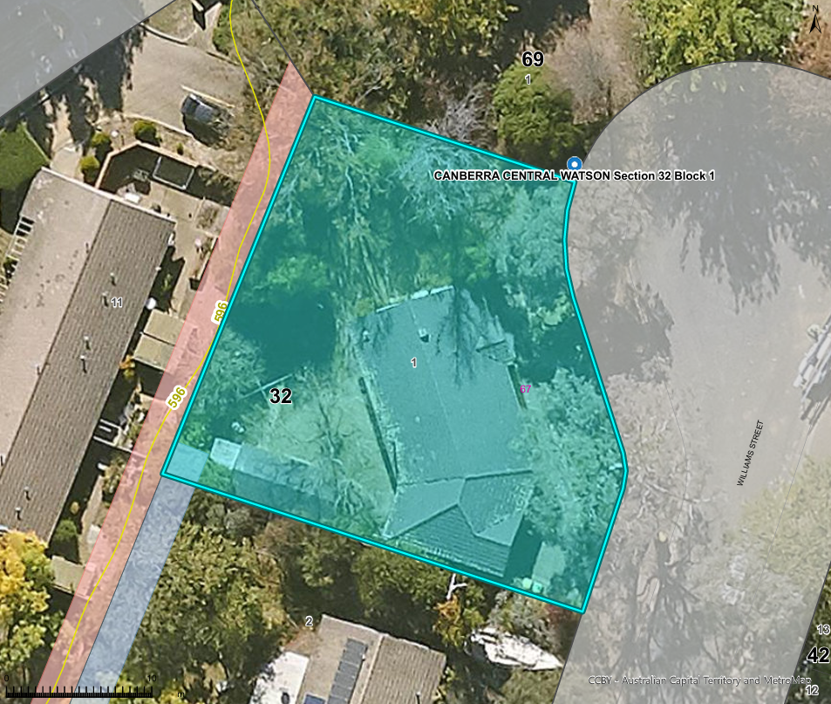

Aerial View of the Project Block with Contours and Easement
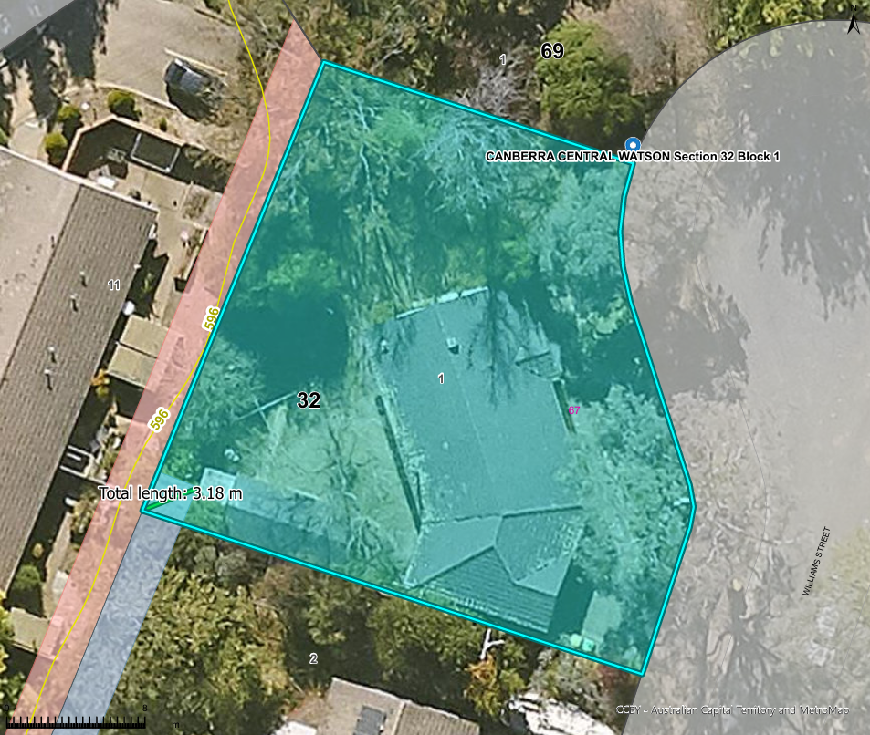

Aerial View of the Project Block with Building Offsets and Building Zone
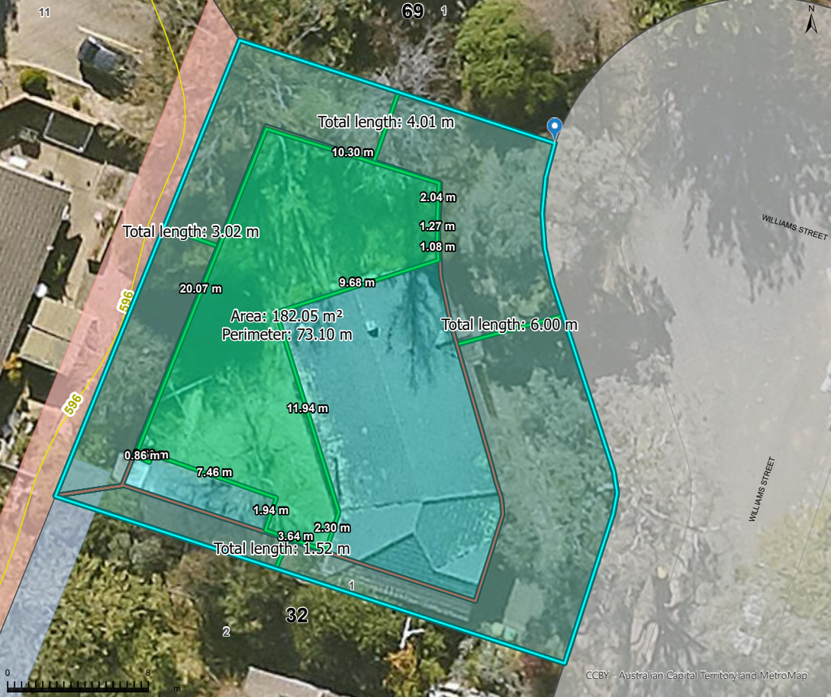

Sketch up with measurements of roofing envelopes
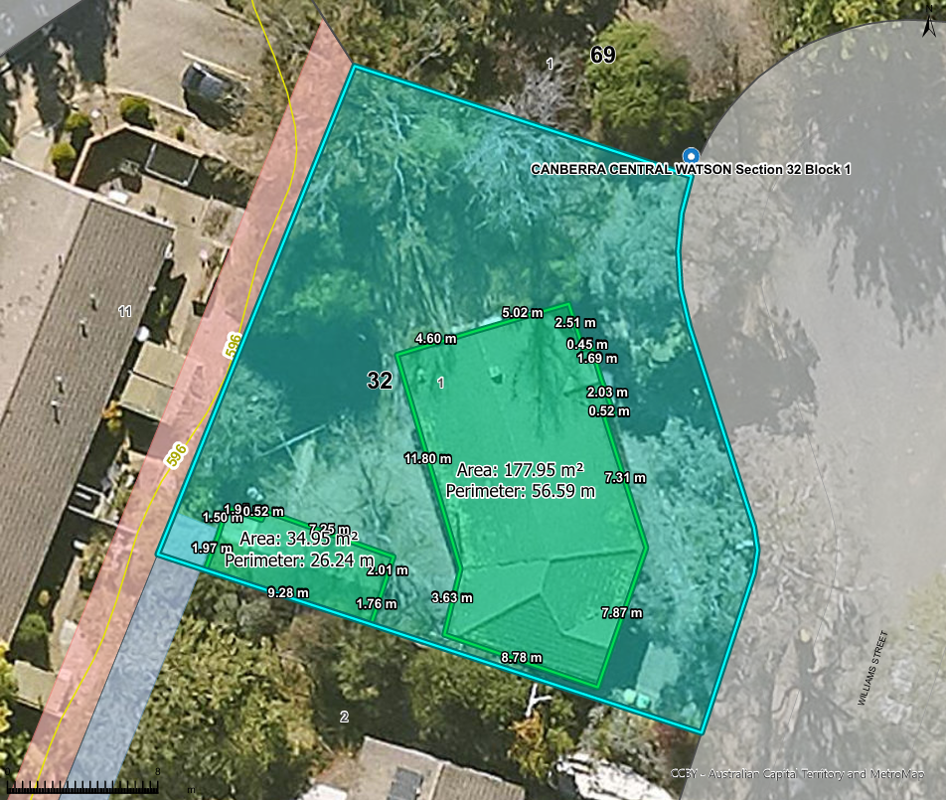

Lengths of boundaries
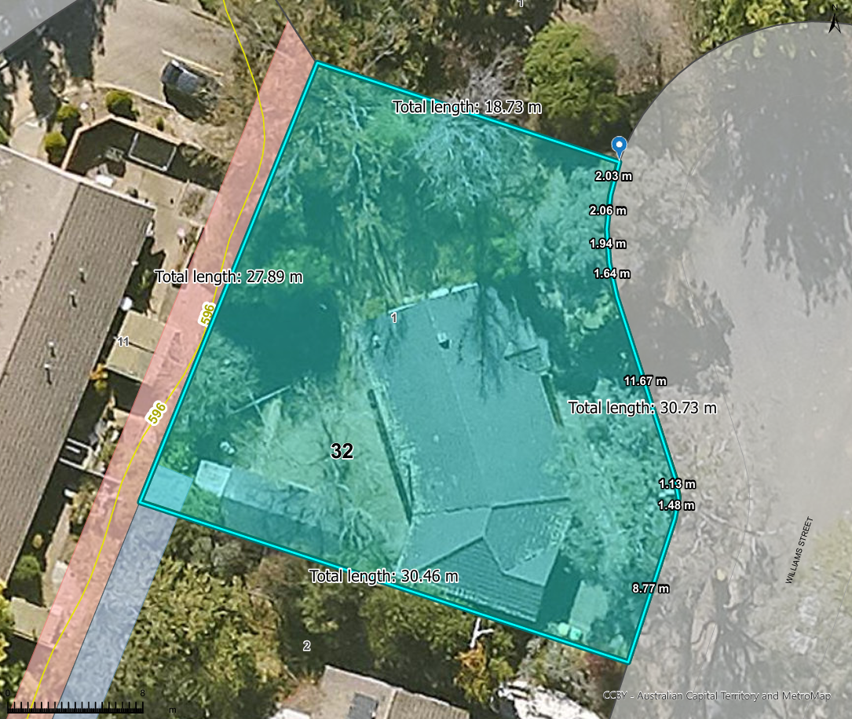

Verge distance
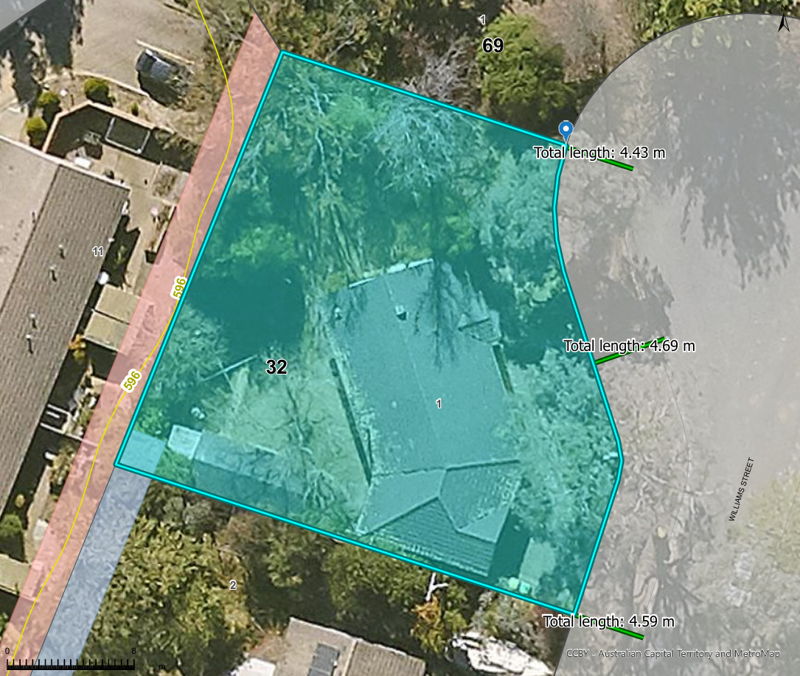

Upper-level setbacks
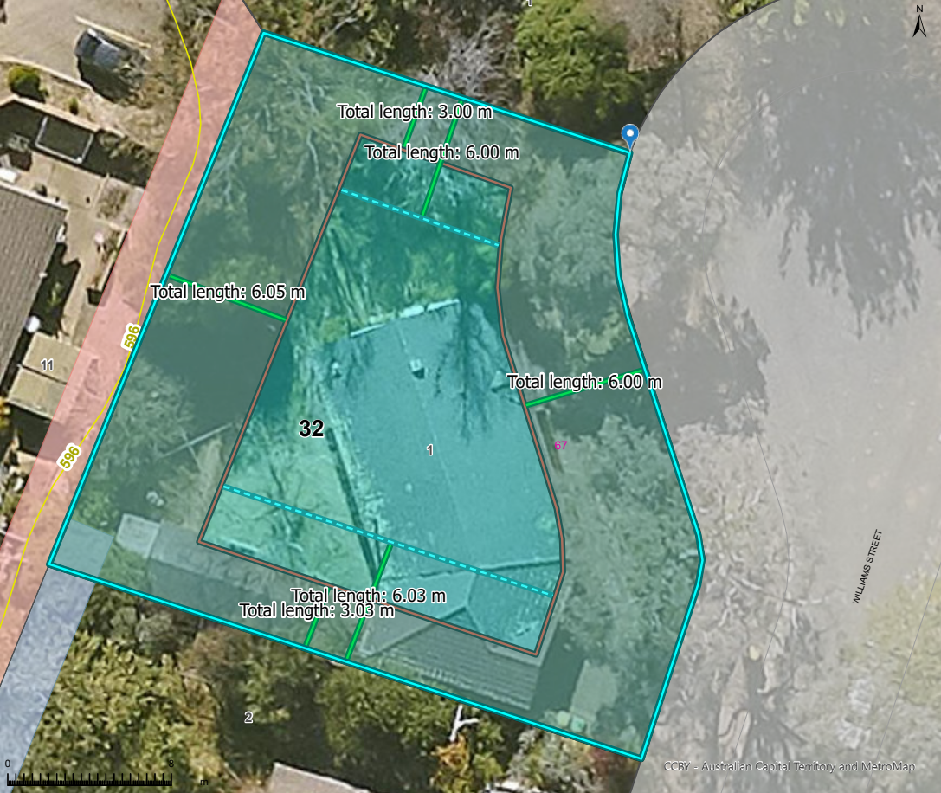
External wall offset:
Unscreened element offset:

Front Access
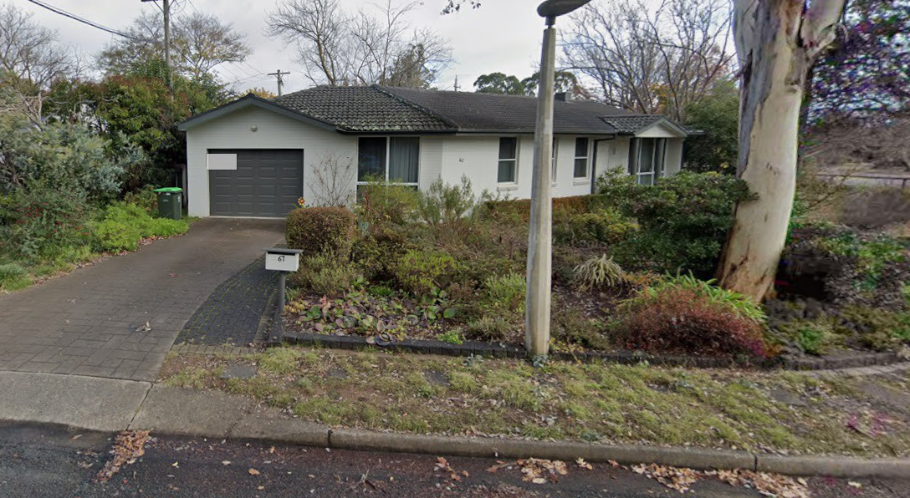

Block dimensions
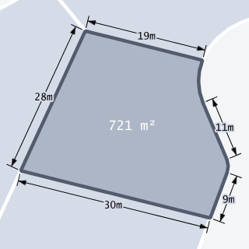

Floorplan (Price Finder)
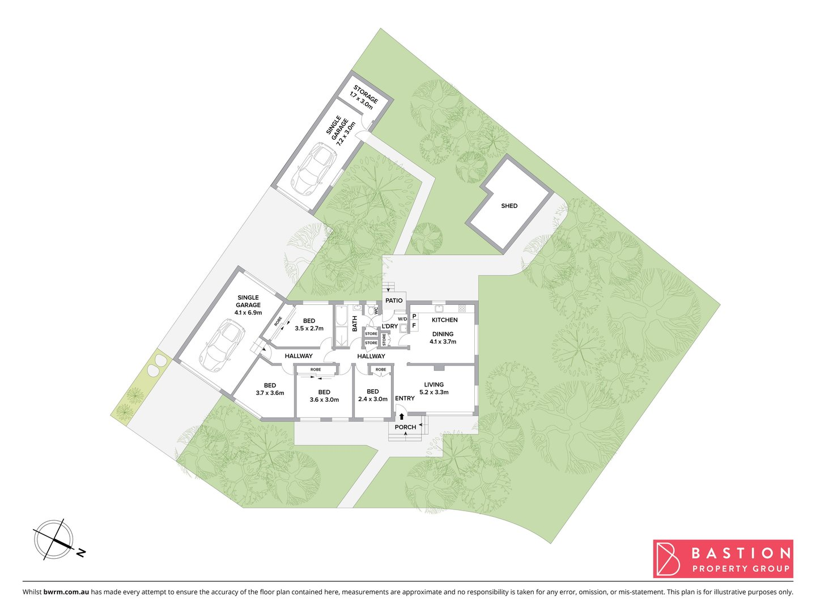

Potential Protected, Registered or Regulated Trees


Plumbing Tie Search
On the Tie Image, red lines indicate sewerage, green lines indicate storm water and blue lines indicate water supply. This search will only display the measurements and depth of the tie location for the selected block.
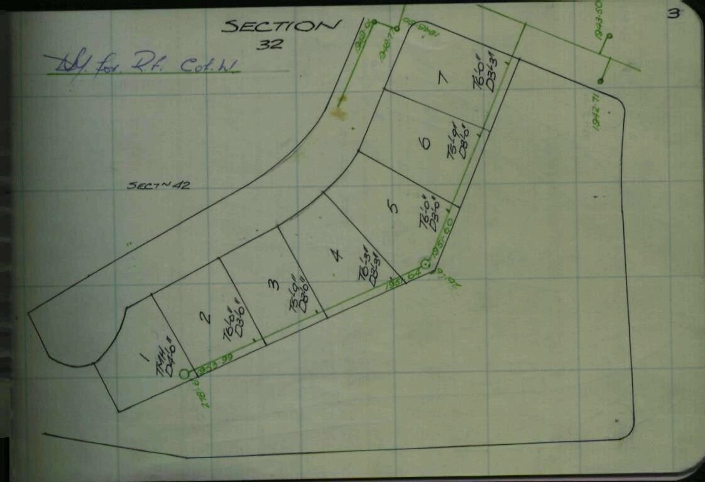

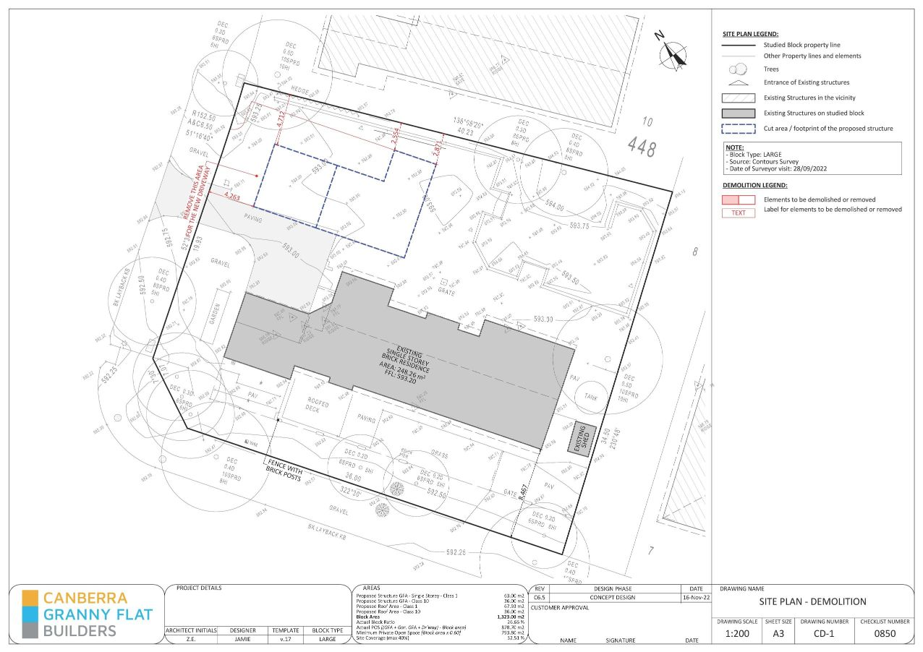
CGFB Example Plans

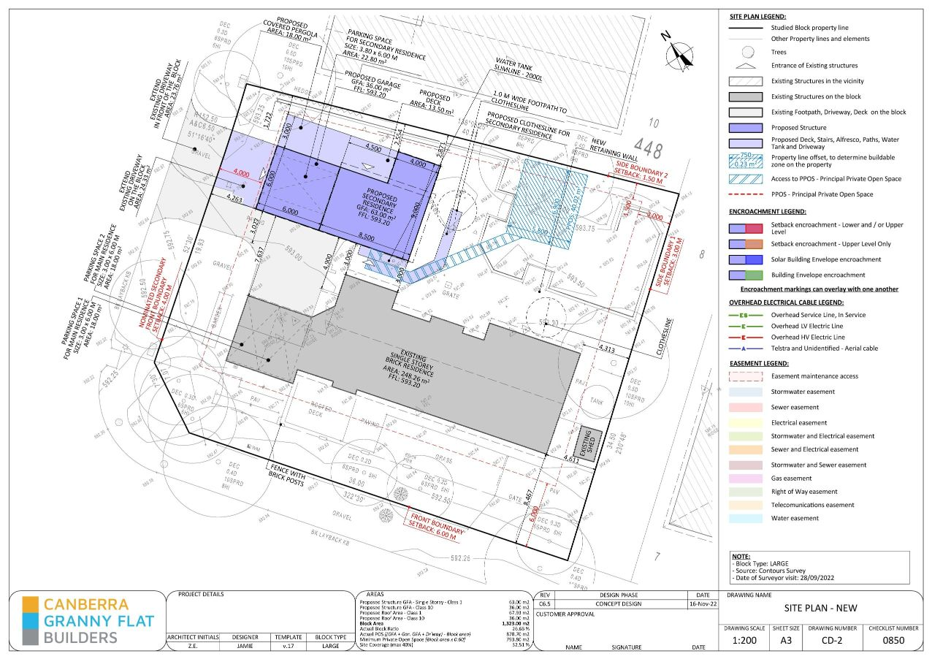

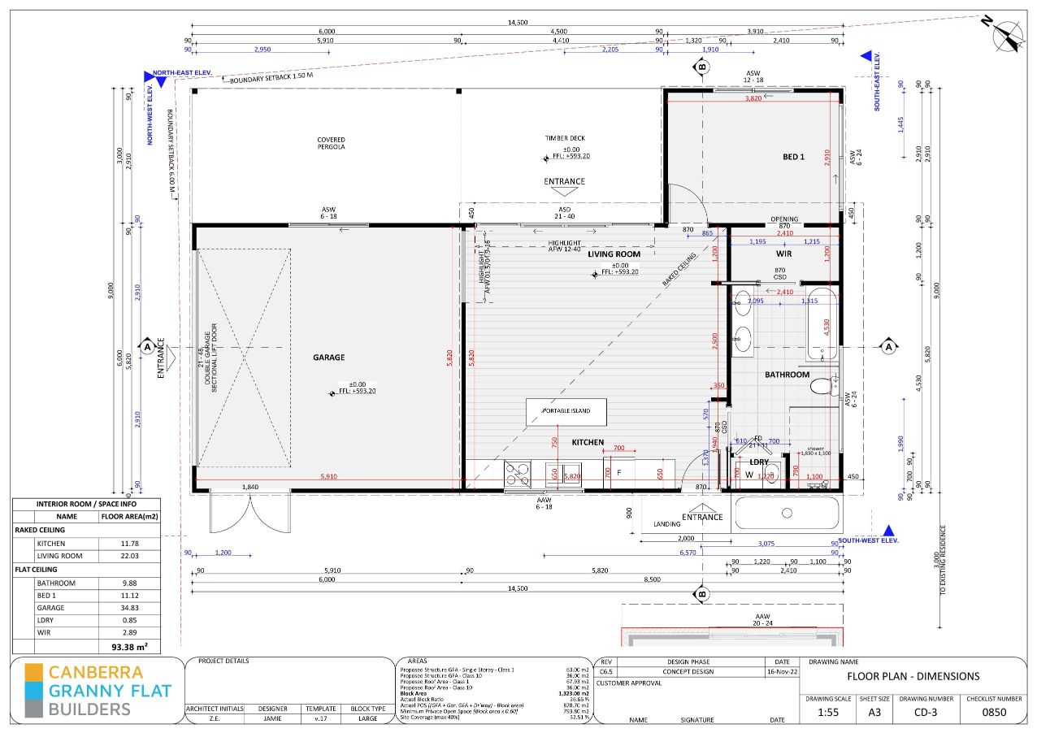

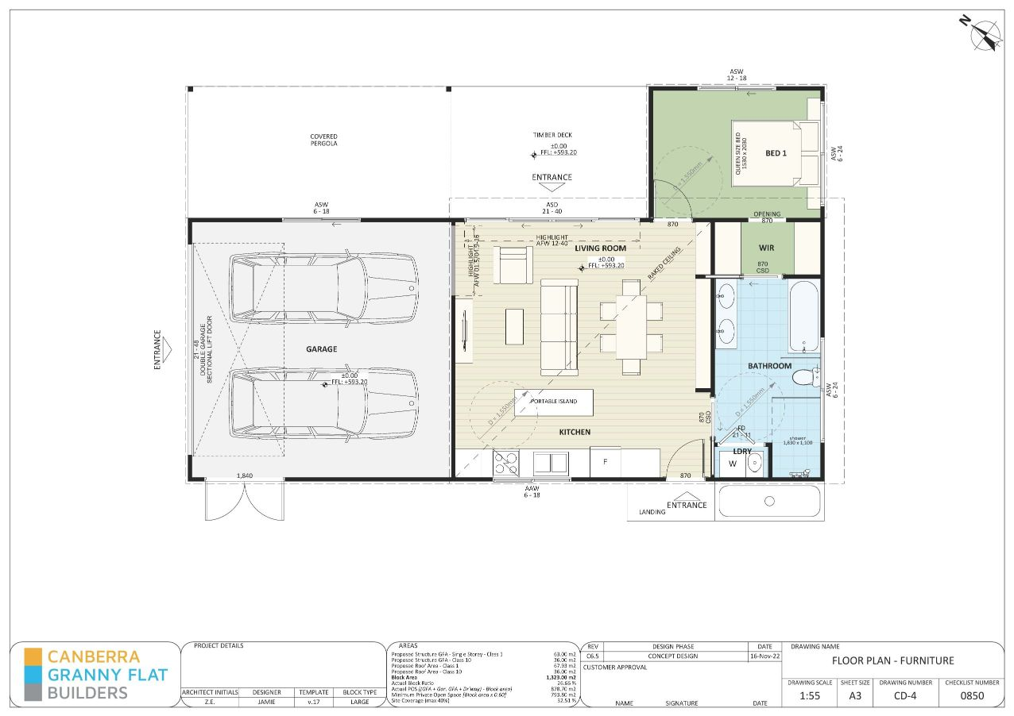

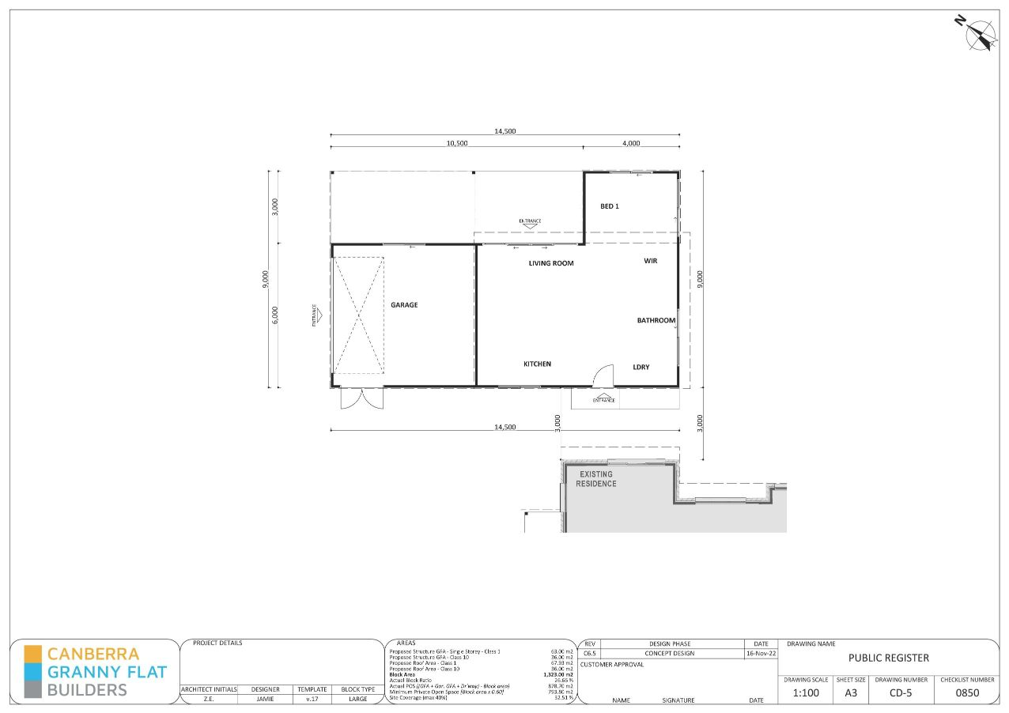

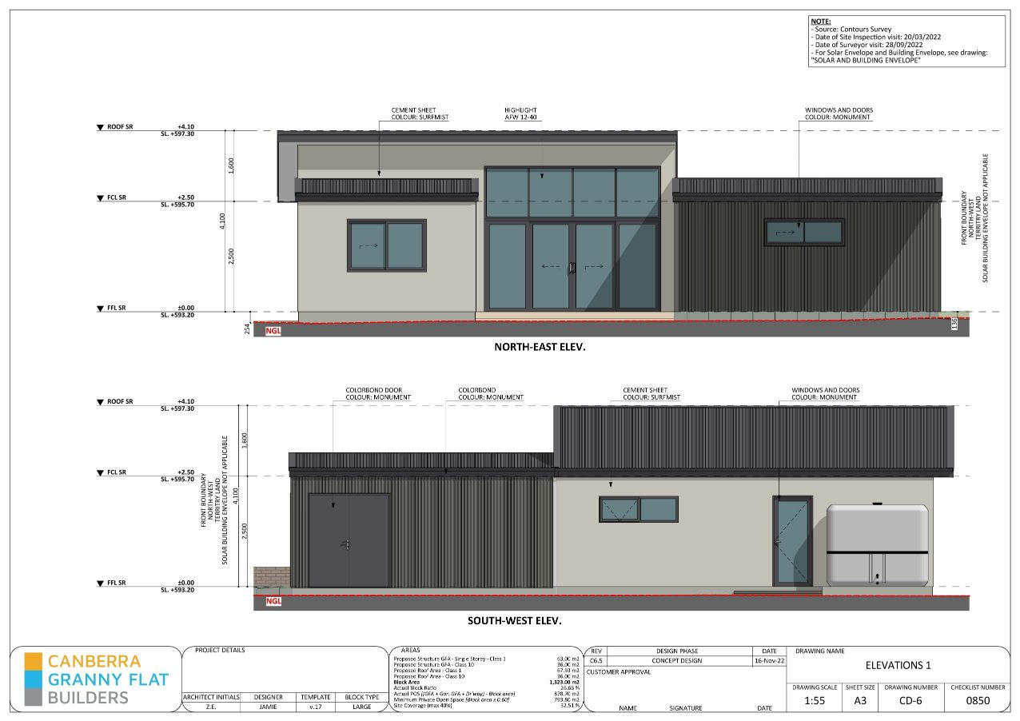

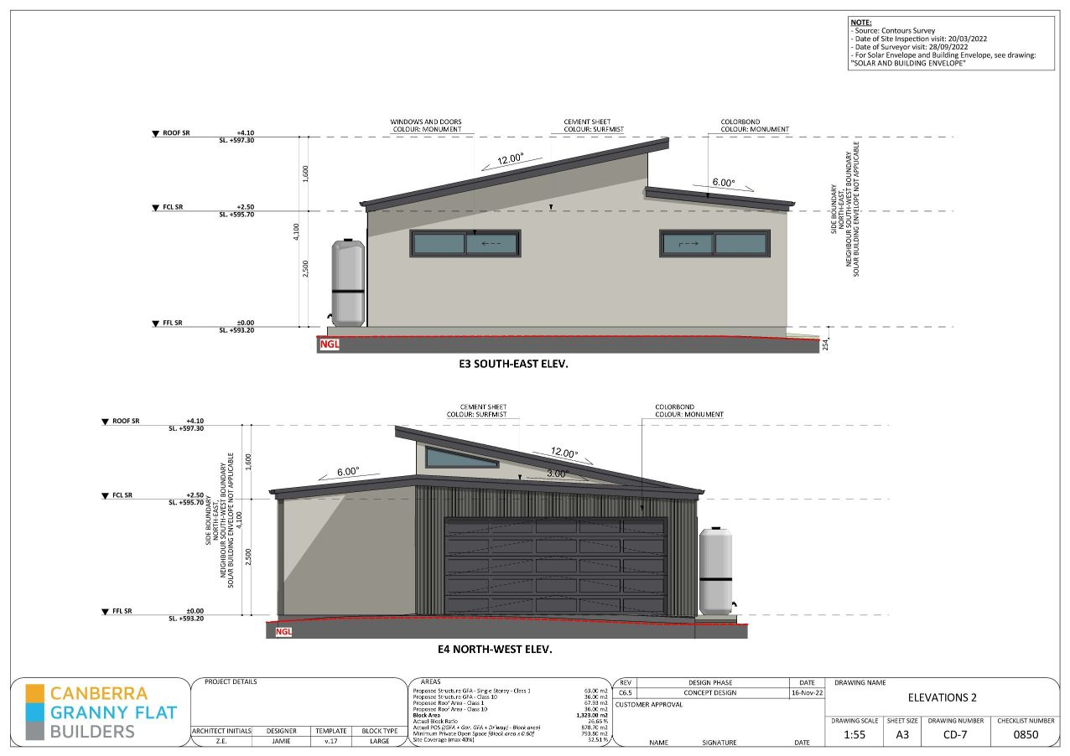

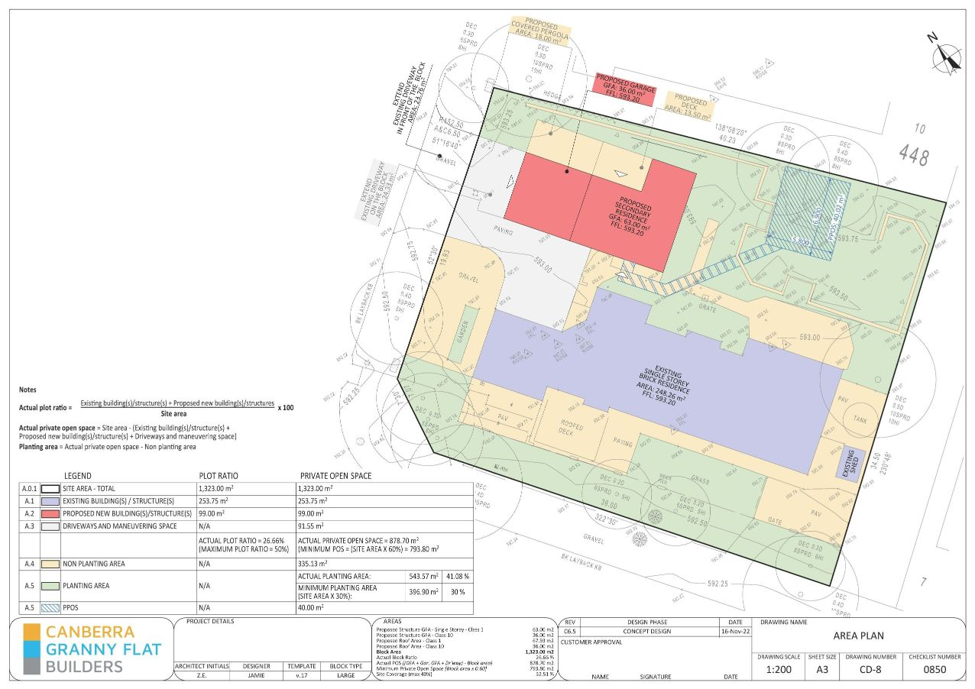

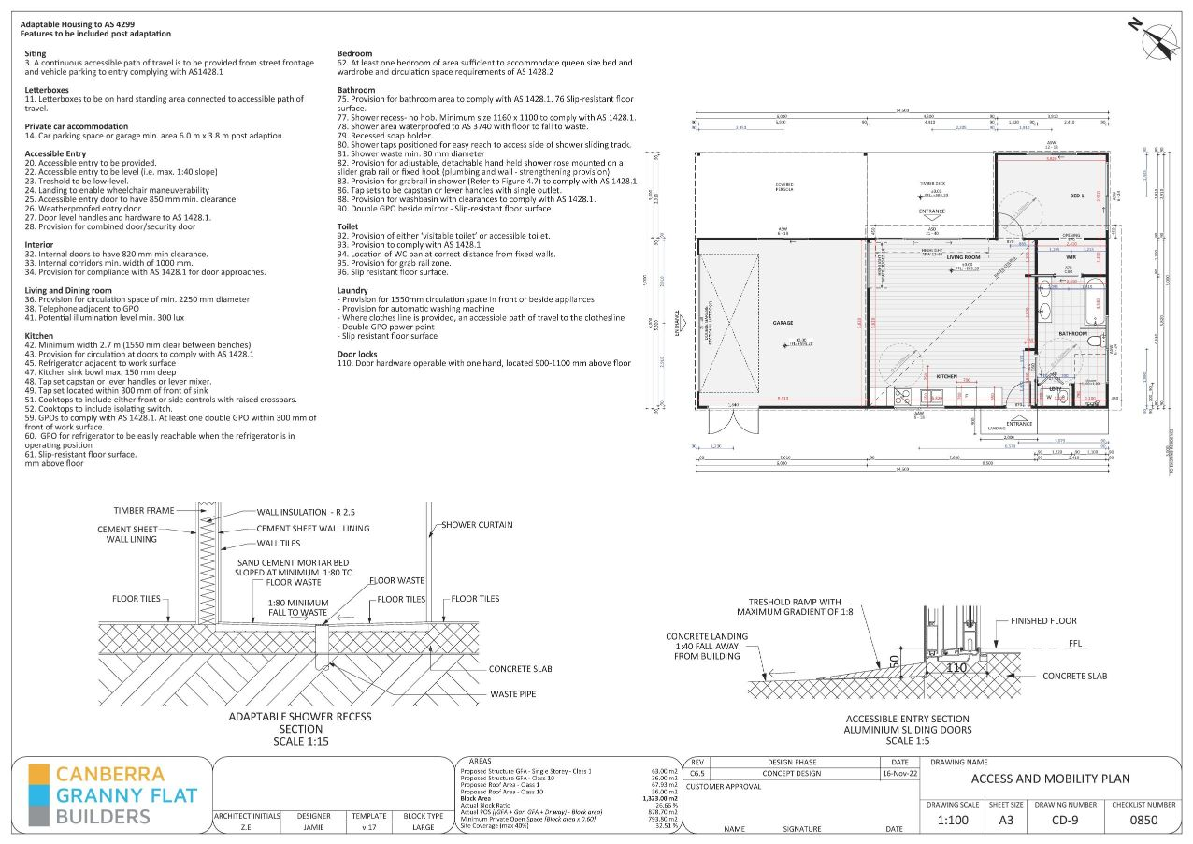

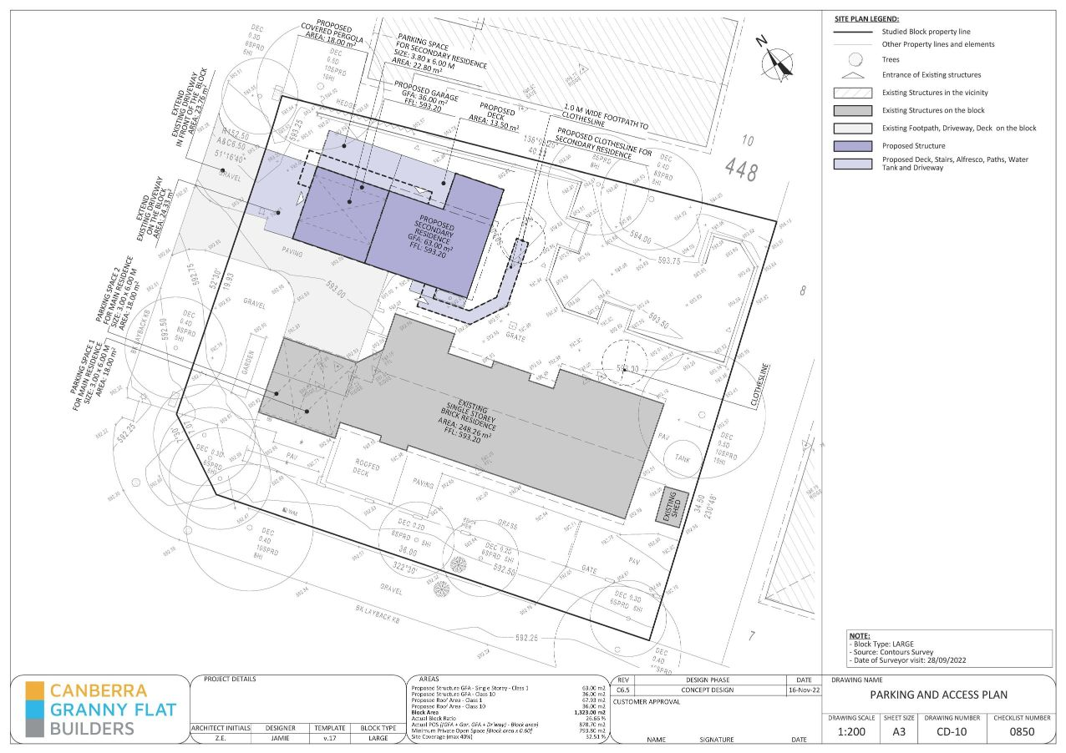

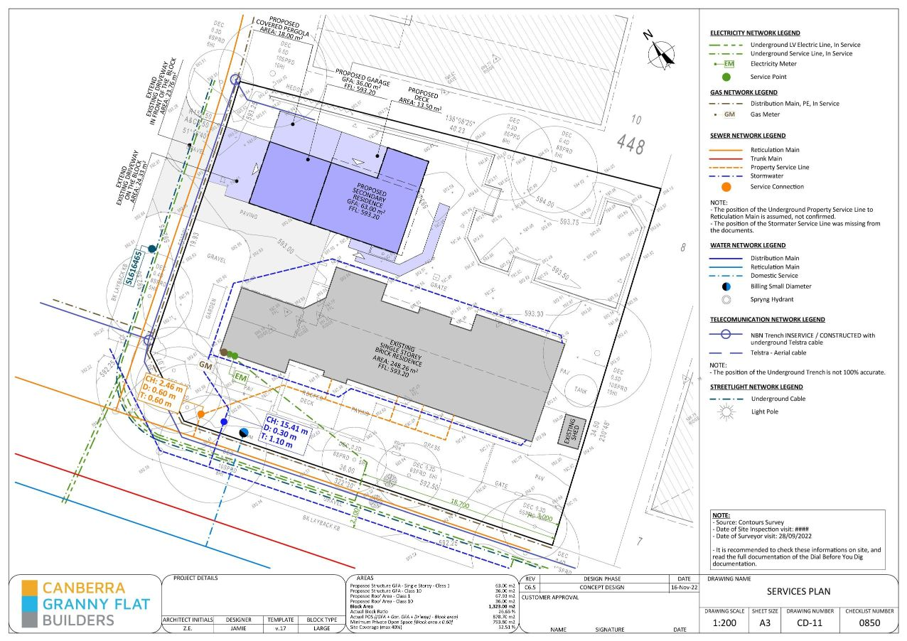

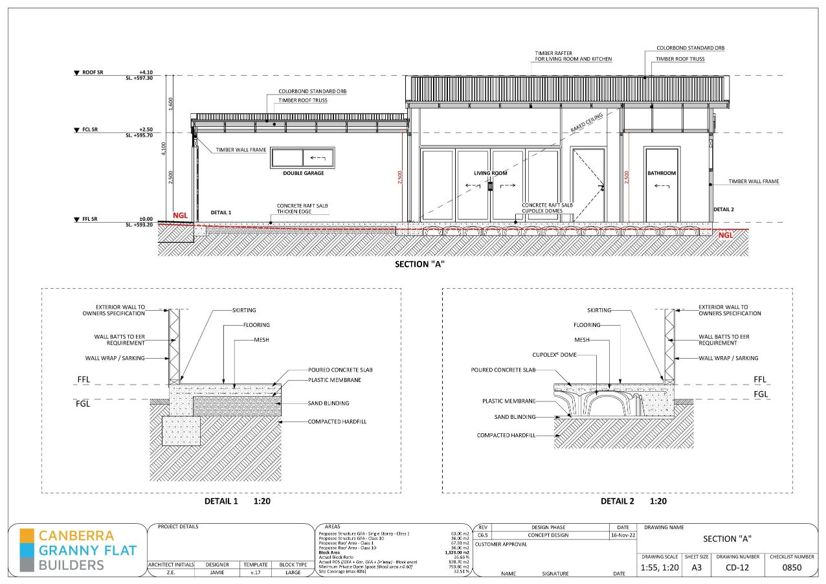

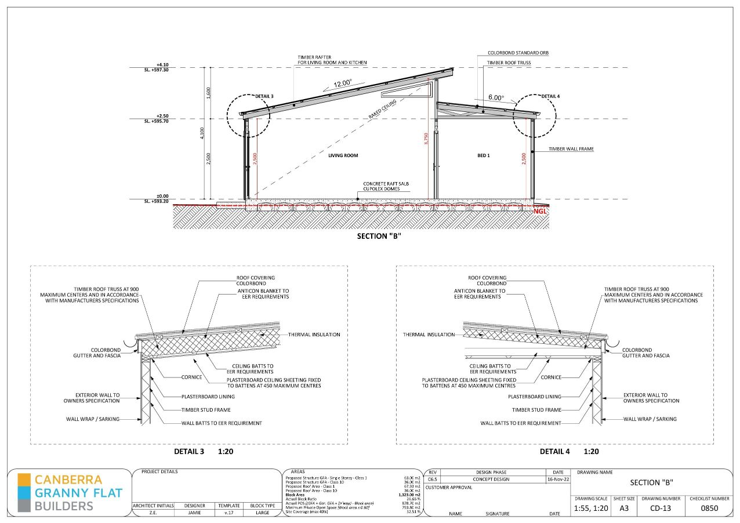

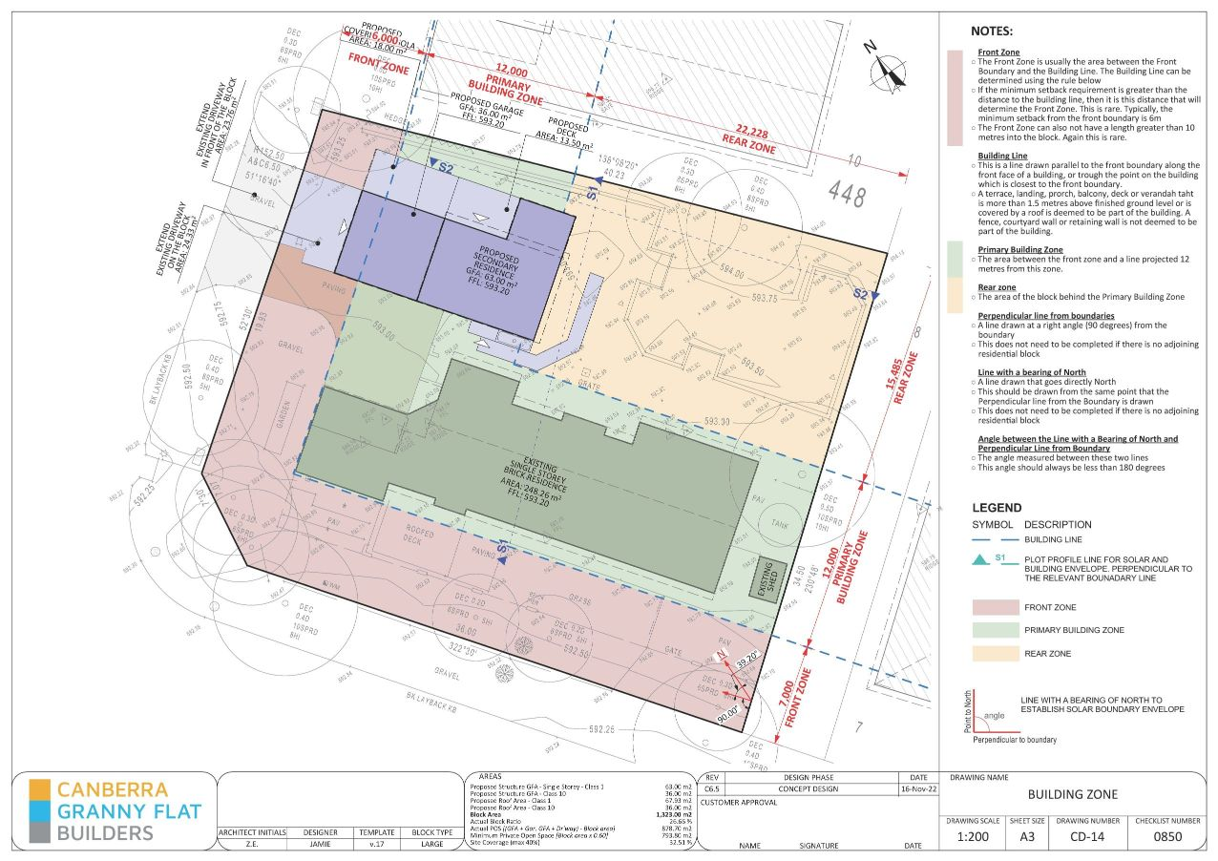

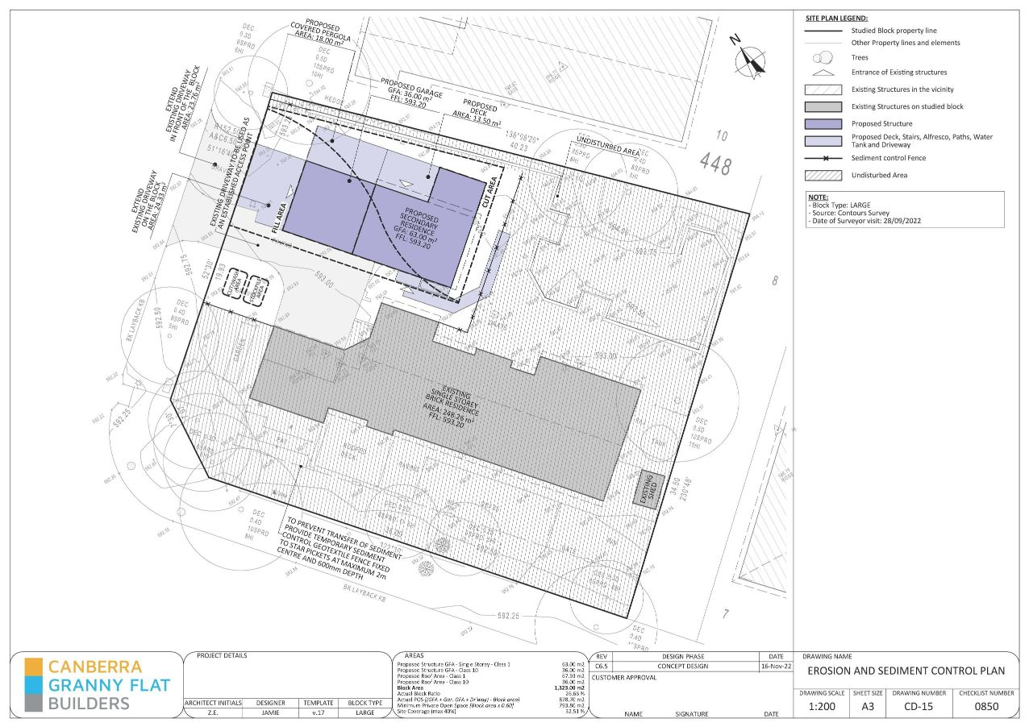

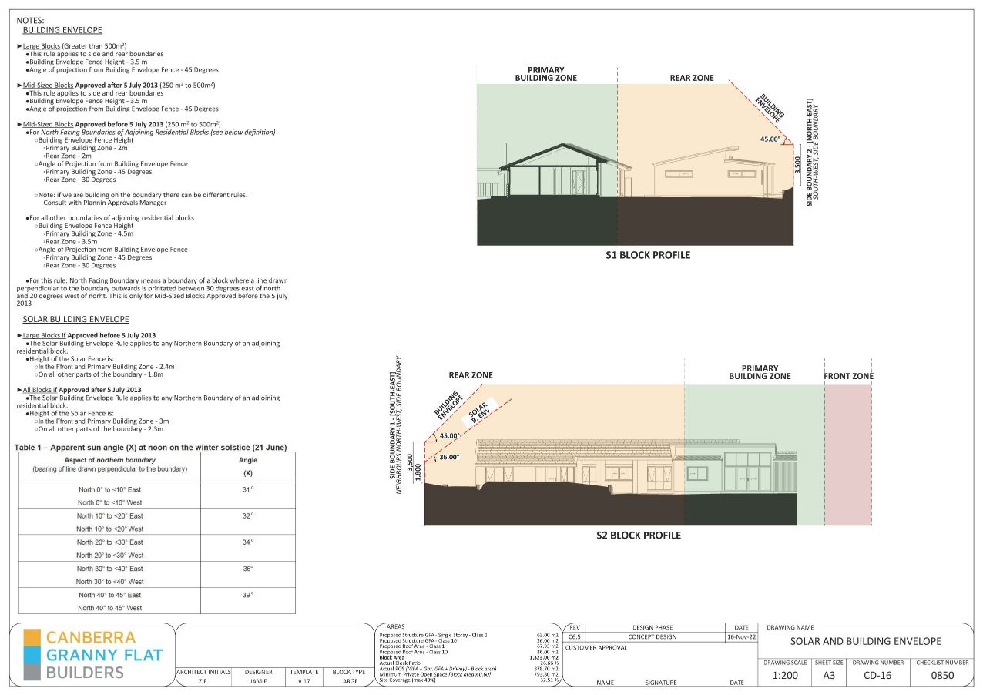

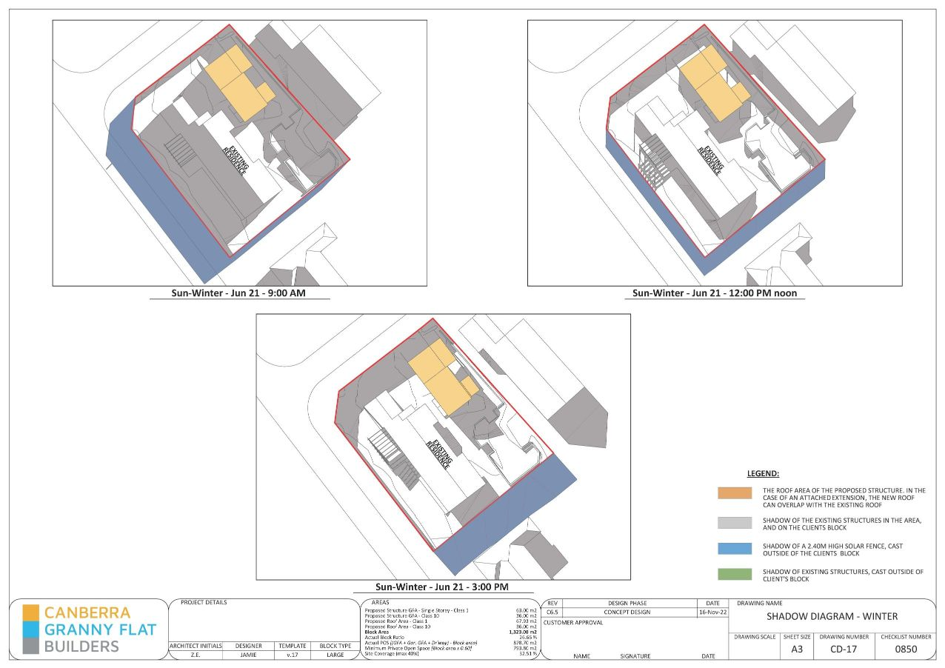

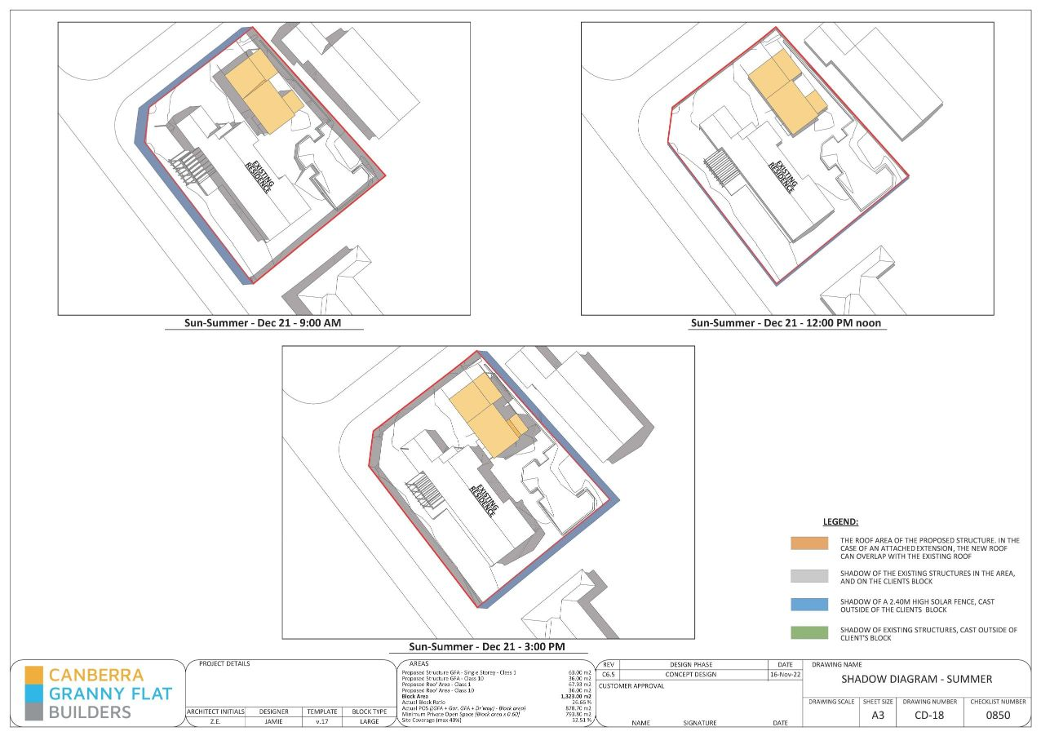

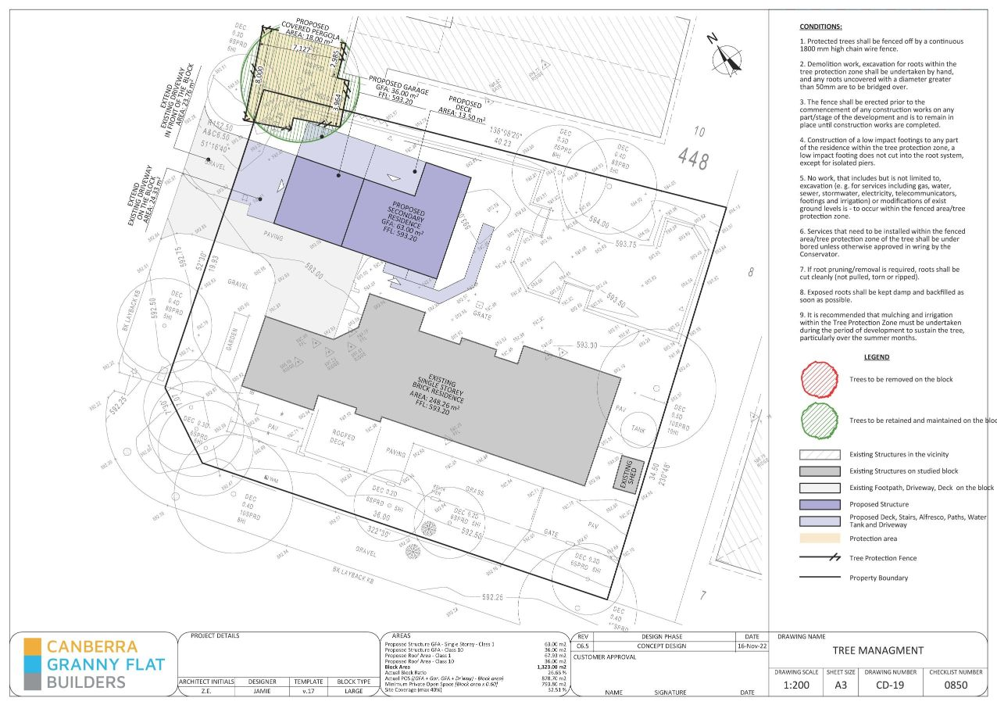

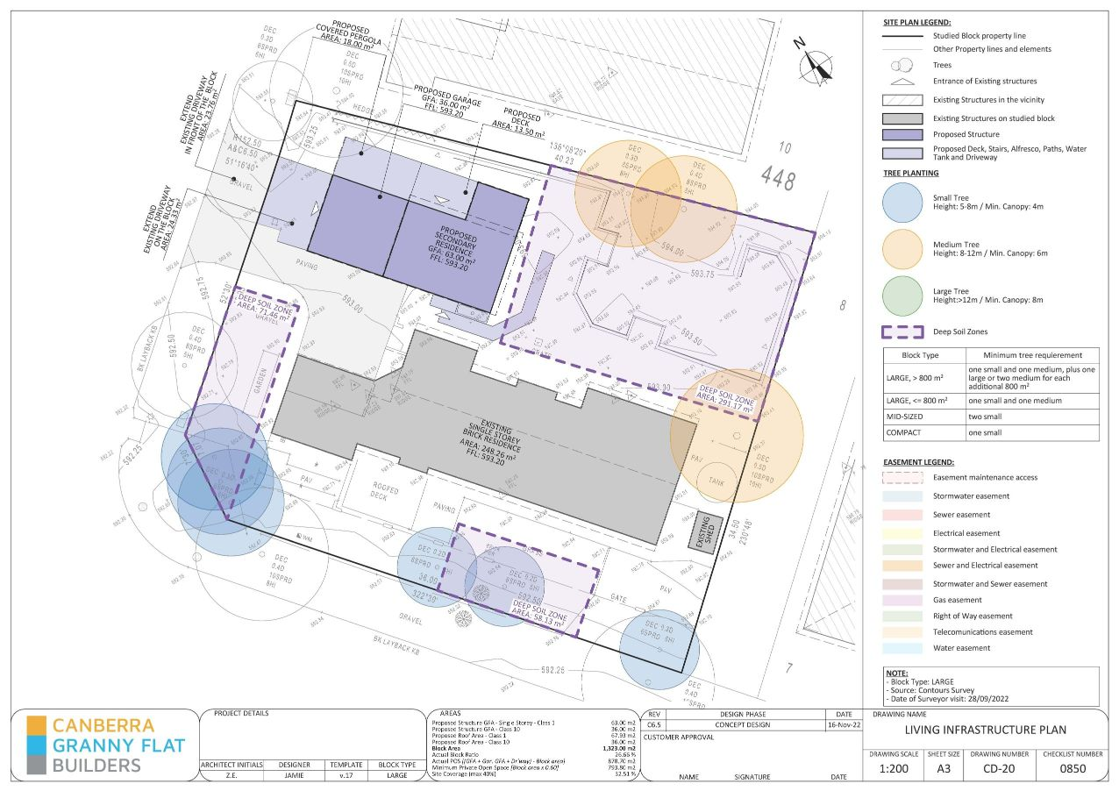

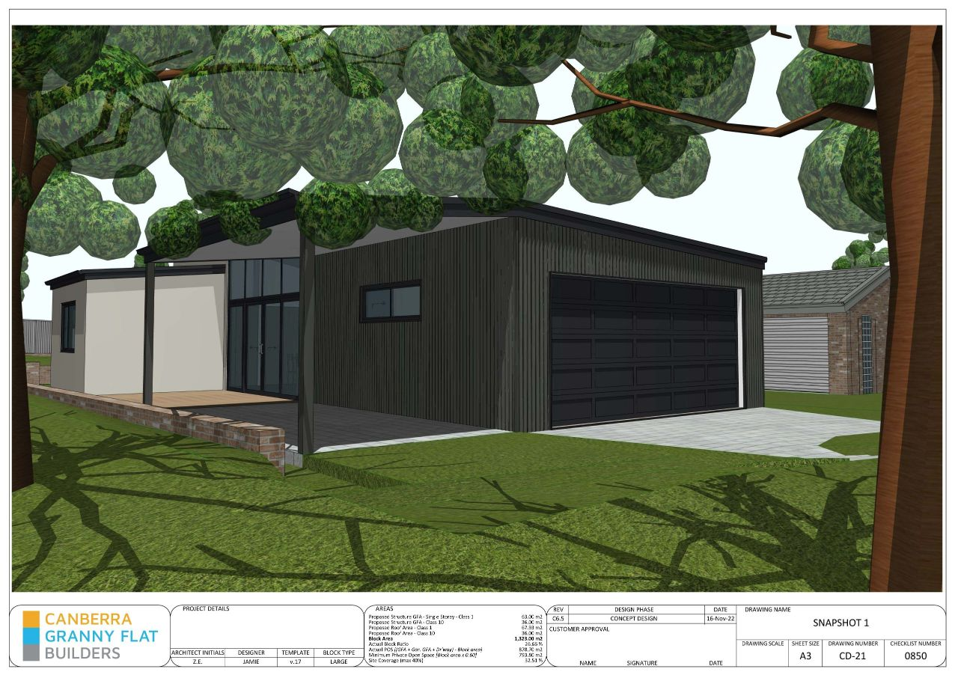

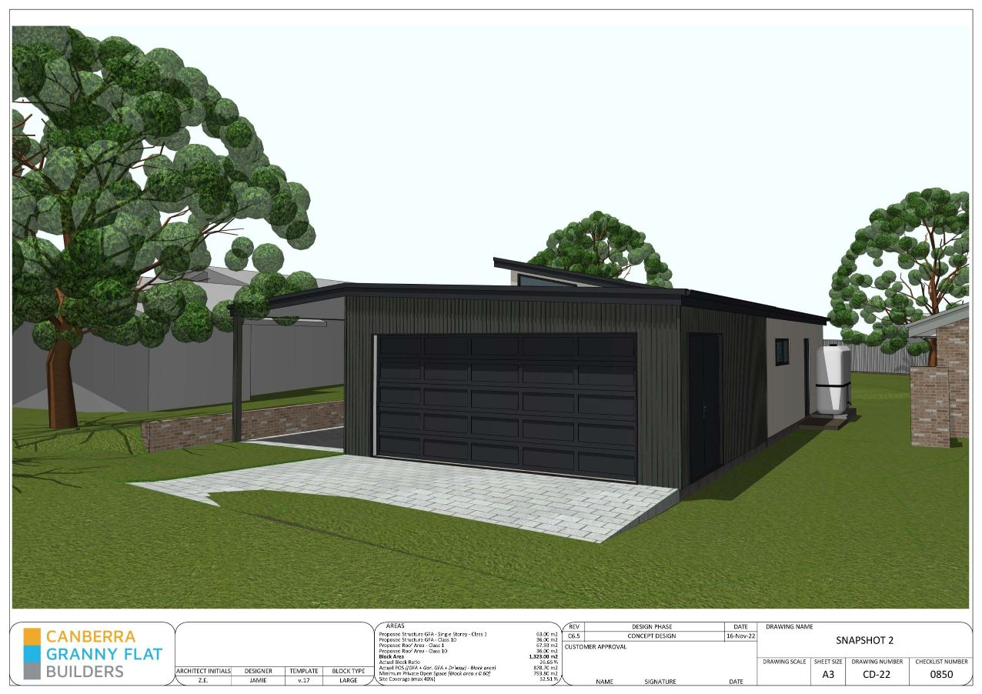

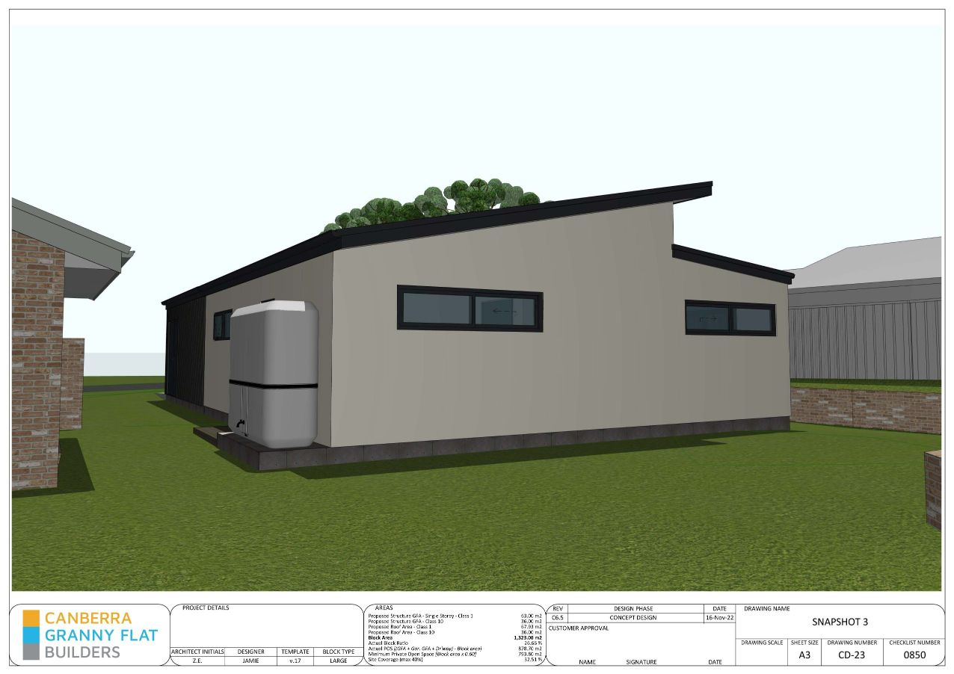

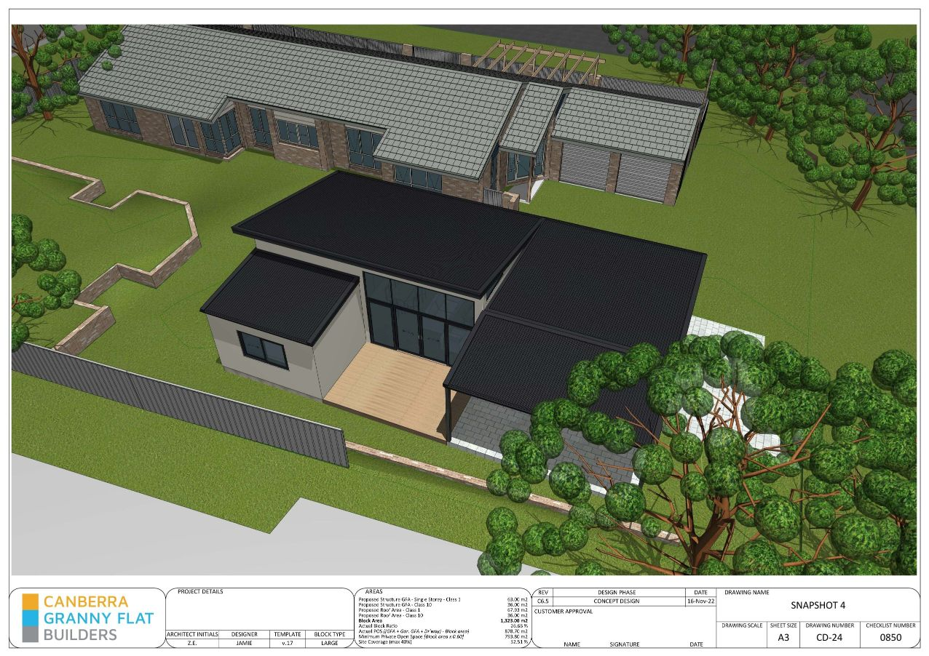

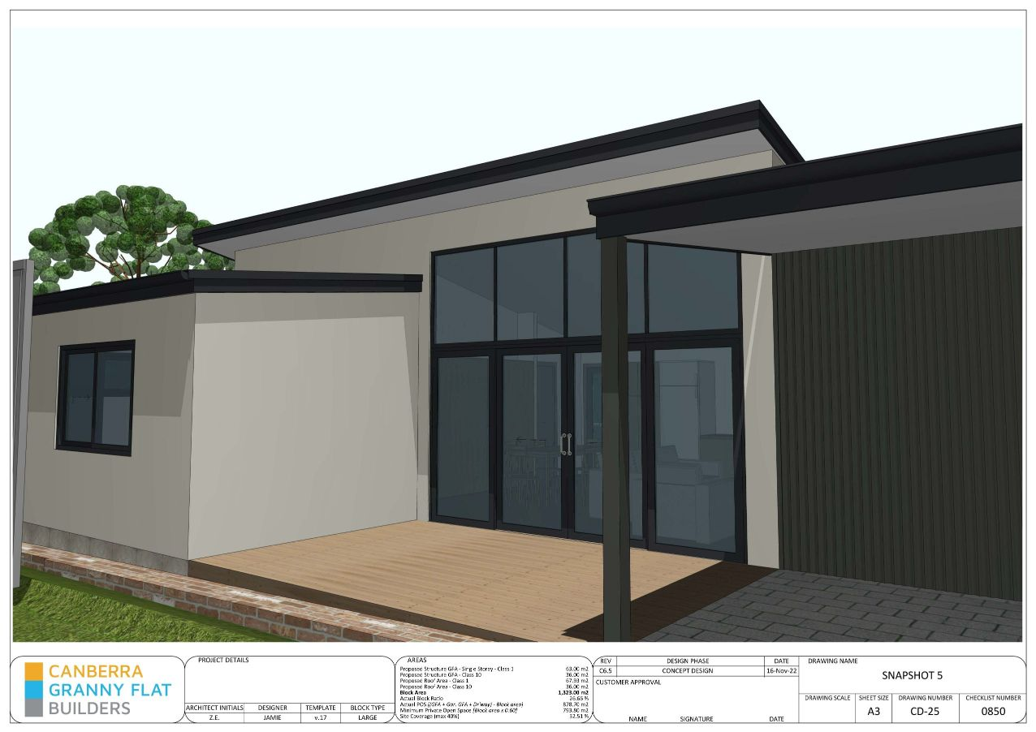

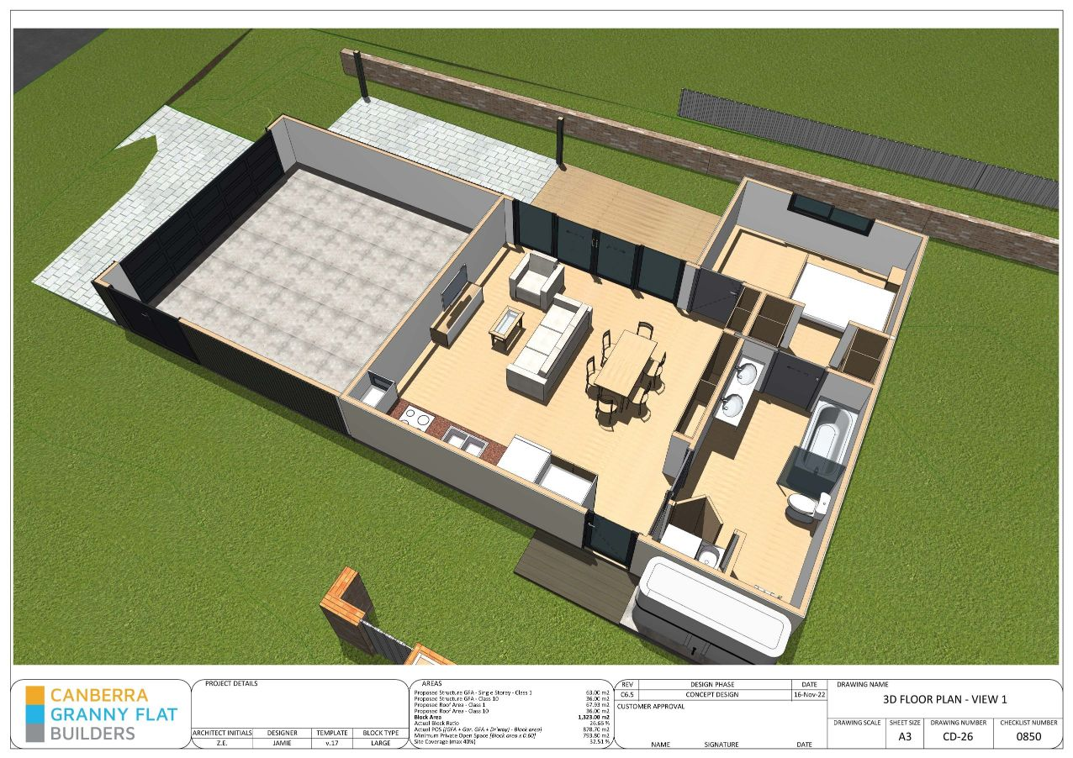

We will provide as many changes as reasonably possible (on average 10 revisions), however we reserve the right to place a limit on changes if the designs is evolving into a totally separate designs or starting from scratch in which case we may ask you to sign an additional flat rate fee.

