The design report improvement

Remove
- HIA column please this is not used.
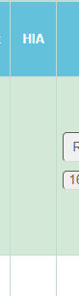

Remove:
- Actual Design Approved Date
- SSP Complete
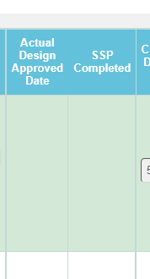

Remove
- Project Proposal Date
- Designs they like
- Date finalize sent request
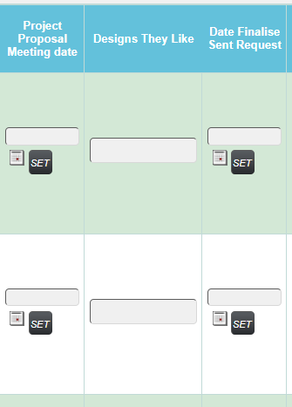

Move the building file
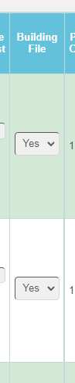
This column needs to be closer to the Survey
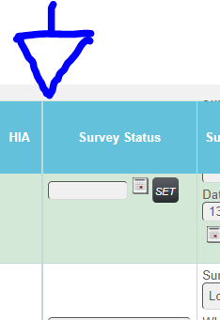
Please add a new column and function called Pricing Red Light
This is exactly the same as
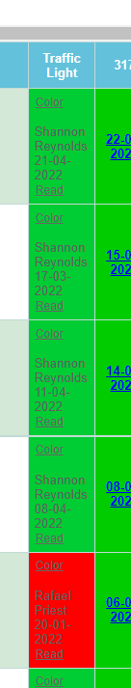
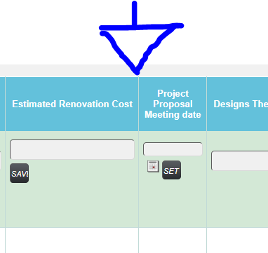

Please add a text box called rules of the report
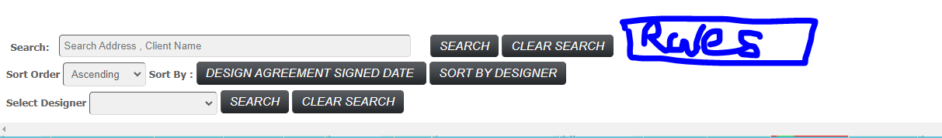

When you click this a separate page opens where you can read the rules of this report
Like the characters that you cant use.
The use simply types in text.
Designreportrules

Dump
Design Report Improvement Meeting Summary with Yana
- Expand the view to allow more rows to be viewed at the same time
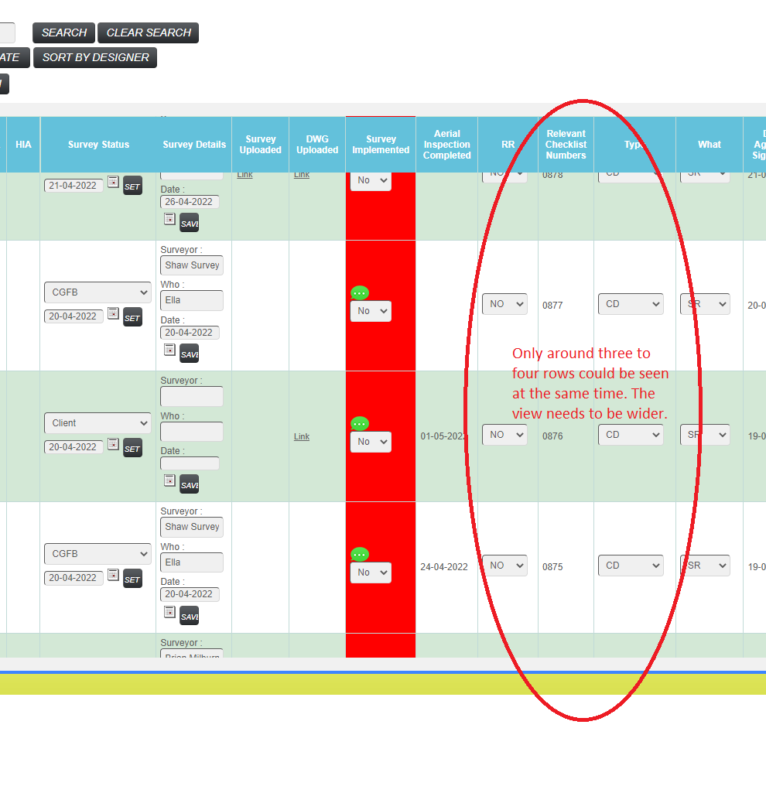

- All data fields need to save data after refreshing or go to another page
  - Yana does not want to have any save buttons. She does not want to click the save button after she updates every time
  - Clicking save buttons will refresh the whole page
  - Instead, she would like all the new entered data to be saved upon refreshing or leaving the page without clicking any save buttons
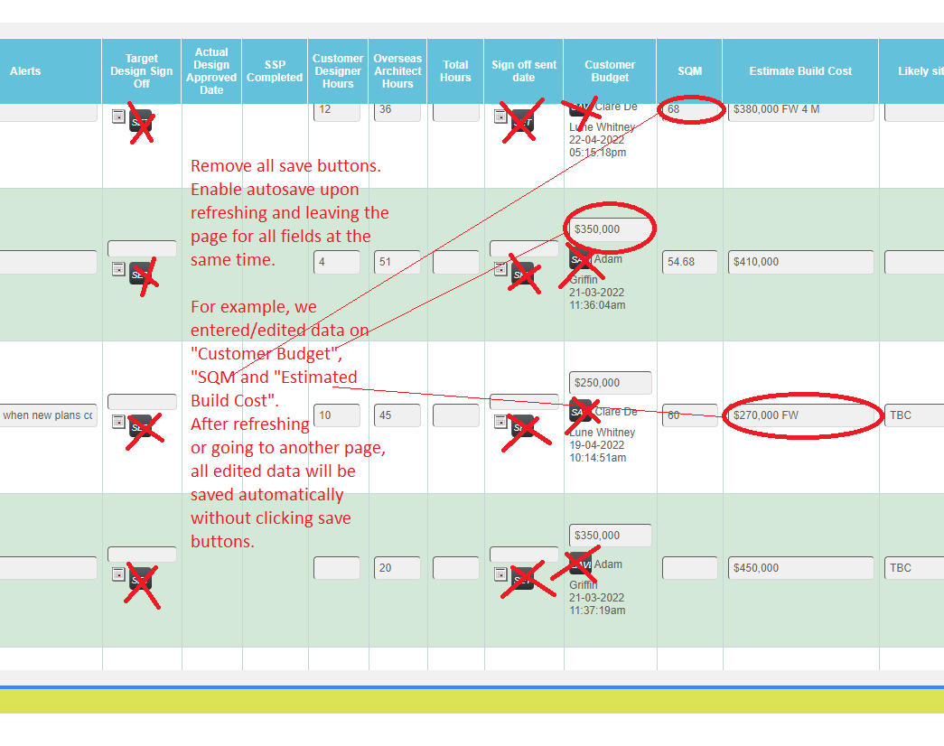

- Some of the data fields distorted the entered data and saved wrong information
  - Entered data is changed unintentionally and saved in different content
  - Such problems occurred in “Customer Design Hours”, “Overseas Architect Hours”, “Total Hours”, “SQM”, “Estimated Build Cost”, and more

- Exported excel file columns modification
  - In the exported excel file of Design Report, remove the column “Initial Design Sent”
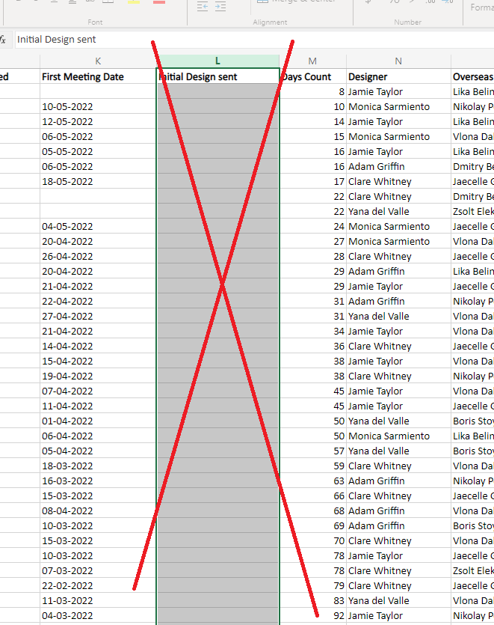

- Filtered Designs Report
  - Create one report for each existing designer (Yana, Jamie, and Clare)
  - All these reports are connected to the Designs Report
    - Data of Filtered Designs Report are retreived from the master Designs Report
    - Data changed in the master Designs Report will also be changed in Filtered Designs Report, and vice versa
    - The Filtered Designs Report has less columns, as specified in the following:
      - Project Address
      - Customer Detail
      - Rating
      - Design Agreement
      - Summary Status
      - Relevant Checklist Number
      - Type
      - What
      - Design Agreement Date
      - Designer
      - Overseas Architects
      - % Complete
      - Where are we at
      - Letter Text
      - Customer Budget
      - SQM
      - Estimated Build Cost
      - Estimated Renovation Cost

