Fixed Price Landscapes – Proposal Builder

Below is the Style Text Report Function in GCONS.
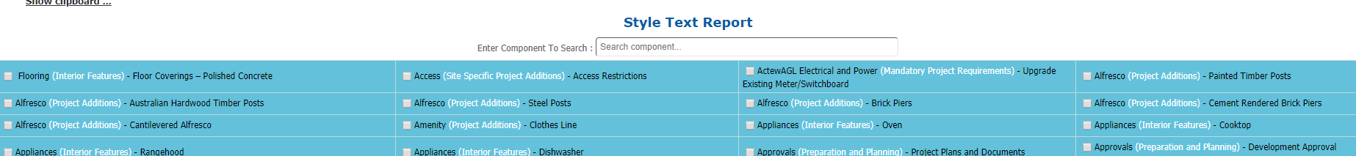
The report builder function will be like this.
The change however the enhanced function will be the
- Unit/Quantity measurement.
- The % measurement.
So in the functionality of this you select the component that you want added to the Proposal in word.
The enhanced features are that when you select the item it will have a pop-up request the Unit or Quantity Number and the % you want to add to the price.
So you would select the item that you want included in the report.
When you select that item
There would be a pop up.
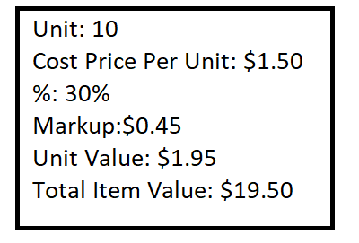
- The user would enter the number of Units into the POP Up – 10 in this example.
- The cost price would be set in the style guide and formulas section – fixed.
- You would enter the value -100-100% for markup the value could be -100% to 100%
- The unit price would be multiplied by the %. If the value was $100 and the was 45% then the Unit value would be $145.
- Total Item Value: would the Unit number multiplied by the unit value: $1450.

This is a example of the existing Style Guide and Formulas
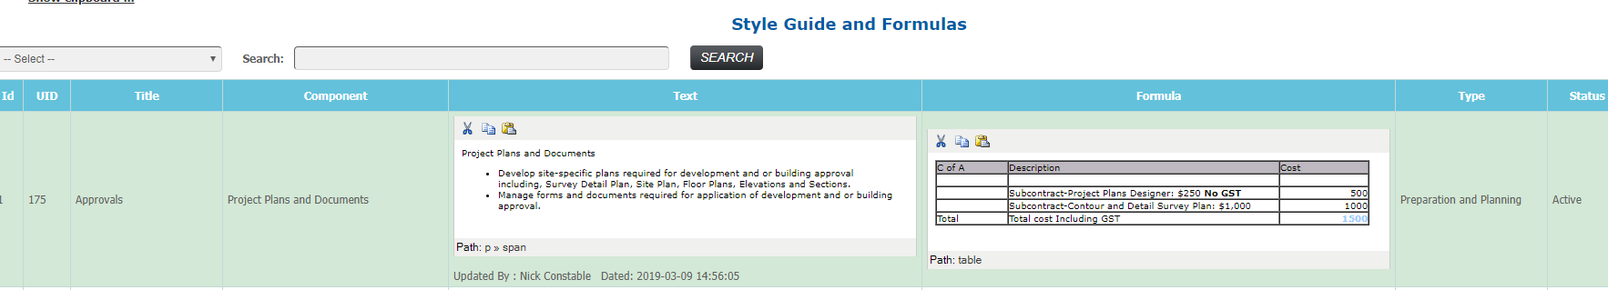
This functionality remains constant with style guide that is current within GONS with three added features
- Linked Image
- Unit Measurement
- Cost Including GST
The unit measurement will be predefined in the Style Guide and Formulas
Unit measurement will be predefined text such as
- Lineal Meters
- SQM
- Plants
- M3
- Items
The Cost including GST will be a dollar value
- $1209
The linked image will be HI RES and either a PDF image or JPEG
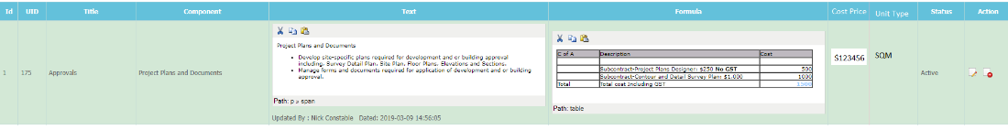

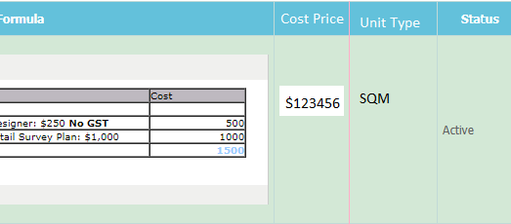

Where it will be located and what will it be named:

Next to staff bulletin.

What will be the options.
